# A STUDY ON THE PROCESS OF ADJECTIVE WORD FORMATION IN BODO LANGUAGE WITH SPECIAL REFERENCE TO AFFIXATION, COMPOUNDING AND REDUPLICATION.

DISSERTATION SUBMITTED TO BODOLAND UNIVERSITY FOR THE AWARD OF THE DEGREE OF MASTER OF PHILOSOPHY IN BODO

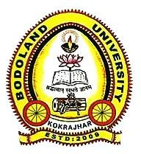

BY

SANHANG MUSHAHARY

DEPARTMENT OF BODO

ROLL NO. : MPLBDO19P002

UNDER THE FACULTY OF LANGUAGE BODOLAND UNIVERSITY

2021