I

Dr. Indira Boro Professor Department of Bodo Bodoland University

Residence:

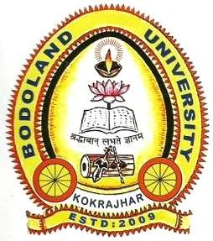
Maibang Nwgwr, W/No-5
P.O. Kokrajhar
Dist: Kokrajhar, BTAD,

Rangalikhata, Kokrajhar-783370 Mobile No. 9954280379 Assam, India

Ref. No:…………………….. Date:………………………

CERTIFICATE

This is to certify that the Dissertation entitled: “A STUDY ON THE PROCESS OF ADJECTIVE WORD FORMATION IN BODO LANGUAGE WITH SPECIAL REFERENCE TO AFFIXATION, COMPOUNDING AND REDUPLICATION” is the bonafide record of original research work done by Sanhang Mushahary. He carried the research under my supervision that to the best of my knowledge and belief, the Dissertation has not previously formed the basis for the award of any other research Degree, Diploma or other title in this University or anywhere else.

I am pleased to forward the Dissertation to the Bodoland University for its evaluation by the concerned examiners.

(Dr. Indira Boro)
Supervisor
Place: Bodoland University Professor
Date:……………………………………. Department of Bodo Bodoland University

