**Chapter 3**

**Isotropic Robertson-Walker model universe with dynamical cosmological parameter $Λ$ in Brans-Dicke Theory of Gravitation**

**3.1 Introduction**

The Brans-Dicke (B-D) theory (Brans and Dicke 1961) of gravitation is one of the simplest and best understood scalar-tensor theories and has been used to study cosmological models by many authors (Banerjee and Beesham 1997, Singh and Rai 1983, Pimentel 1985, Azar and Riazi 1995, Etoh et al. 1997, Singh and Beesham 1999, Sen et al. 2001, Reddy, et al. 2007, Adhav, et al. 2009). The cosmological and astronomical data obtained from various experiments support the discovery of accelerated expansion of the present day universe. The accelerated expansion of universe is due to the presence of dark energy which has positive energy density and adequate negative pressure (Padmanabhan 2003, Sahni and Starobinsky 2000). Chen and Wu (1990) considered $Λ$ varying as $R^{-2}$, Carvalho and Lima (1992) generalized it. Beesham (1994), Tiwari (2014), Harpreet and Tiwari (2015), Kotambkar et al. (2015) studied cosmological models with variable $G$ and $Λ$ in different case. Nojiri and Odintsov(2005), Capozziello (2006), Chavanis (2013), Sharma and Rantnapal (2013), Takisa et al. (2014), Feroze and Siddiqui (2014), are some of the researchers who have investigated cosmological models with equation of state in quadratic nature. With the help of quadratic equation of state Ngudelanga et al. (2015) studied about a star and Reddy et al. (2015), Adhav et al. (2015) investigated cosmological models.

**3.2 Metric and Solutions of field equations**

The spherically symmetric Robertson-Walker metric is

$ds^{2}=dt^{2}-R^{2}(t)\left[\frac{dr^{2}}{1-kr^{2}}+r^{2}\left(dθ^{2}+\sin^{2}θ dφ^{2}\right)\right]$ (3.1)

where $k$ is the curvature index which can take values $-1,0, 1$.

The action of the Brans-Dicke (B-D) theory of gravity is

$S=\int{d^{4}x\sqrt{\left|g\right|}}\left[\frac{1}{16π}\left(ϕR-\frac{ω}{ϕ}g^{sl}ϕ_{,l}ϕ_{,s}\right)+L_{m}\right]$ (3.2)

where $R$ represents the curvature scalar associated with the metric $g_{ij}; g$ is the determinant of $g_{ij};ϕ$ is a scalar field; $ω$ is a dimensionless coupling constant; $L_{m}$ is the Lagrangian of the ordinary matter component.

The Einstein field equations in the most general form are given by

$R_{ij}-\frac{1}{2}Rg_{ij}+Λ g_{ij}=-\frac{κ}{ϕ}T_{ij}-\frac{ω}{ϕ^{2}}[ϕ_{,i}ϕ_{,j}-\frac{1}{2}g_{ij}ϕ^{,s}ϕ_{,s}]-\frac{1}{ϕ}(ϕ_{ij}-g_{ij}{ϕ_{;s}}^{,s})$ (3.3)

where

$\left(3+2ω\right){ϕ_{;s}}^{,s}=8π T,$ (3.4)

where $T$ is the trace of $T_{ij}, Λ$ is the cosmological constant, $R_{ij}$ is Ricci-tensor, $g_{ij}$ is metric tensor and $ϕ_{,i}$ is the partial differentiation with respect to $x^{i}$ coordinate.

The energy-momentum tensor for the perfect fluid distribution is

$T_{ij}=(p+ρ)u_{i}u_{j}-pg_{ij},$ (3.5)

with $u_{1}=u_{2}=u_{3}=0 , u_{4}=1, u_{i}$ is four velocity vector satisfying $g^{ij}u_{i}u_{j}=1$, $p$ is the pressure and $ρ$ is the energy density.

Here a comma $(,)$ or semicolon $(;)$ followed by a subscript denotes partial differentiation or a covariant differentiation respectively. Also the velocity of light is assumed as unity.

Now for the metric (3.1), (3.3) and (3.4) gives

$\frac{k}{R^{2}}+\frac{{\dot{R}}^{2} }{R^{2}}+2\frac{\ddot{R}}{R}-Λ=-\frac{8π p}{ϕ}-\frac{ω}{2}\frac{{\dot{ϕ}}^{2}}{ϕ^{2}}-2\frac{\dot{R}}{R}\frac{\dot{ϕ}}{ϕ}-\frac{\ddot{ϕ}}{ϕ}$ (3.6)

$3\left(\frac{k}{R^{2}}+\frac{{\dot{R}}^{2} }{R^{2}}\right)-Λ=\frac{8πρ}{ϕ}+\frac{ω}{2}\frac{{\dot{ϕ}}^{2}}{ϕ^{2}}-3\frac{\dot{R}}{R}\frac{\dot{ϕ}}{ϕ}$ (3.7)

$(3+2ω)[3\frac{\dot{R}\dot{ϕ}}{R}+\ddot{ϕ}]=8π(ρ-3p),$ (3.8)

The energy-momentum equation ${T^{ij}}_{;j}=0$ leads to the form

$\dot{ρ}+3H\left(ρ+p\right)=0$ (3.9)

We consider (Arbab 1997) ansatz

$Λ=βH^{2}$ (3.10)

and equation of state in quadratic form as

$p=αρ^{2}-ρ$ (3.11)

where $α≠0$.

Equations (3.9) and (3.11) gives

$ρ=R^{-3α}$ (3.12)

and,

$p=α{\left[R^{-3α} \right]}^{2}-R^{-3α}$ (3.13)

From equations (3.6), (3.7), (3.8) and (3.10), we get

$\frac{3k}{R^{2}}+(3-2β)\frac{{\dot{R}}^{2} }{R^{2}}+3\frac{\ddot{R}}{R}=ω\left[\frac{\ddot{ϕ}}{ϕ}-\frac{1}{2}\frac{{\dot{ϕ}}^{2}}{ϕ^{2}}+3\frac{\dot{R}}{R}\frac{\dot{ϕ}}{ϕ}\right]$ (3.14)

where a dot (.) denotes differentiation with respect to time $t$.

To solve equation (3.19) we consider separation constant as zero. So, we can take

$\frac{3k}{R^{2}}+\left(3-2β\right)\frac{{\dot{R}}^{2} }{R^{2}}+3\frac{\ddot{R}}{R}=0$ (3.15)

and

$\frac{\ddot{ϕ}}{ϕ}-\frac{1}{2}\frac{{\dot{ϕ}}^{2}}{ϕ^{2}}+3\frac{\dot{R}}{R}\frac{\dot{ϕ}}{ϕ}=0$ (3.16)

The gravitational variable (Weinberg 1971) is defined as

$G=\frac{1}{ϕ}\left(\frac{4+2ω}{3+2ω}\right)$ (3.17)

The anisotropy parameter is defined as

$Δ=\frac{1}{3}\sum_{i=1}^{3}{{\left(\frac{H_{i}-H}{H}\right)}^{2}}$ (3.18)

Shear scalar is defined as

$σ^{2}=\frac{1}{2}\left(\sum_{i=1}^{3}{{H_{i}}^{2}}-3H^{2}\right)$ (3.19)

Case I: $k=0$ and $0<β<3$

From (3.15), we get

$R=M_{1}{\left\{c_{1}(3-β)(c_{1}t+c_{2})\right\}}^{\frac{3}{2(3-β)}}$ (3.20)

where $M_{1}=2^{-\frac{3}{2(β-3)}}3^{-\frac{3}{2(β-3)}}$ and $c_{1}, c_{2}$ are constants.

From equation (3.16), we get

$ϕ=A^{2}2^{\frac{9}{β-3}}3^{-\frac{3}{β-3}}{\left\{c_{1}(3-β)\right\}}^{\frac{9}{(β-3)}}{\left(\frac{β-3}{2β+3}\right)}^{2}{\left\{(c_{1}t+c_{2})\right\}}^{\frac{2β+3}{(β-3)}}$ (3.21)

where $A$ is a constant.

The gravitational variable is

$G=\left(\frac{4+2ω}{3+2ω}\right){\left[A^{2}2^{\frac{9}{β-3}}3^{-\frac{3}{β-3}}{\left\{c_{1}(3-β)\right\}}^{\frac{9}{(β-3)}}{\left(\frac{β-3}{2β+3}\right)}^{2}{\left\{(c_{1}t+c_{2})\right\}}^{\frac{2β+3}{(β-3)}}\right]}^{-1}$ (3.22)

Equations (3.12) and (3.13) gives

$ρ={\left[M_{1}{\left\{c_{1}(3-β)(c_{1}t+c_{2})\right\}}^{\frac{3}{2(3-β)}}\right]}^{-3α}$ (3.23)

$p=α{\left[M_{1}{\left\{c_{1}\left(3-β\right)\left(c_{1}t+c_{2}\right)\right\}}^{\frac{3}{2\left(3-β\right)}}\right]}^{-6α}-{\left[M_{1}{\left\{c_{1}\left(3-β\right)\left(c_{1}t+c_{2}\right)\right\}}^{\frac{3}{2\left(3-β\right)}}\right]}^{-3α}$ (3.24)

Spatial volume is

${V=\left[M_{1}{\left\{c_{1}\left(3-β\right)\left(c_{1}t+c_{2}\right)\right\}}^{\frac{3}{2\left(3-β\right)}}\right]}^{3}$ (3.25)

Hubble's parameter is

$H=\frac{3}{2c_{1}{\left(3-β\right)}^{2}\left(c_{1}t+c_{2}\right)}$ (3.26)

Scalar expansion is

$Θ=\frac{9}{2c_{1}{\left(3-β\right)}^{2}\left(c_{1}t+c_{2}\right)}$ (3.27)

Deceleration parameter is

$q=-\left(\frac{2β-5}{3}\right)$ (3.28)

The anisotropy parameter is

$Δ=0$ (3.29)

Shear scalar is

$σ=0$ (3.30)

Cosmological constant is

$Λ=β {\left[\frac{3}{2c_{1}(3-β)(c_{1}t+c_{2})}\right]}^{2}$ (3.31)

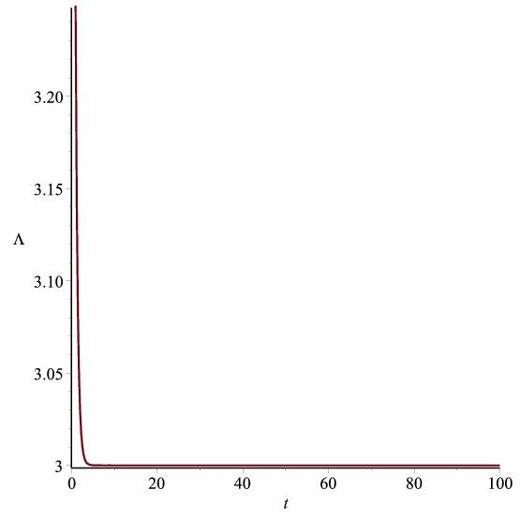

Figure 3.1: Graph of $Λ vs. t$ according to (3.31)

Case II: $k=-1$ and $β=3$

From (3.15), we get

$R=M_{2}\left[e^{\frac{c_{4}}{c_{3}}}e^{\frac{t}{c_{3}}}+e^{-\frac{c_{4}}{c_{3}}}e^{-\frac{t}{c_{3}}}\right]$ (3.32)

where $M_{2}=\frac{c_{3}}{2},c_{3}, c_{4}$ are constants.

From equation (16), we get

$ϕ=c_{5}{\left[\frac{2e^{2\frac{c_{4}}{c_{3}}}e^{2\frac{t}{c_{3}}}+1}{{4\left(e^{2\frac{c_{4}}{c_{3}}}e^{2\frac{t}{c_{3}}}+1\right)}^{2}}\right]}^{2}$ (3.33)

where $c_{5}={M_{2}}^{-6}$ is a constant.

The gravitational variable is

$G={c_{5}}^{-1}\left(\frac{4+2ω}{3+2ω}\right){\left[\frac{2e^{2\frac{c_{4}}{c_{3}}}e^{2\frac{t}{c_{3}}}+1}{{4\left(e^{2\frac{c_{4}}{c_{3}}}e^{2\frac{t}{c_{3}}}+1\right)}^{2}}\right]}^{-2}$ (3.34)

Equations (3.12) and (3.13) gives

$ρ={\left[M_{2}\left(e^{\frac{c_{4}}{c_{3}}}e^{\frac{t}{c_{3}}}+e^{-\frac{c_{4}}{c_{3}}}e^{-\frac{t}{c_{3}}}\right)\right]}^{-3α}$ (3.35)

$p=α{\left[M_{2}\left(e^{\frac{c_{4}}{c_{3}}}e^{\frac{t}{c_{3}}}+e^{-\frac{c_{4}}{c_{3}}}e^{-\frac{t}{c_{3}}}\right)\right]}^{-6α}-{\left[M_{2}\left(e^{\frac{c_{4}}{c_{3}}}e^{\frac{t}{c_{3}}}+e^{-\frac{c_{4}}{c_{3}}}e^{-\frac{t}{c_{3}}}\right)\right]}^{-3α}$ (3.36)

Spatial volume is

$V={\left[M_{2}\left(e^{\frac{c_{4}}{c_{3}}}e^{\frac{t}{c_{3}}}+e^{-\frac{c_{4}}{c_{3}}}e^{-\frac{t}{c_{3}}}\right)\right]}^{3}$ (3.37)

Hubble's parameter is

$H=\frac{1}{c_{3}}\left[\frac{1-e^{-2\frac{c_{4}}{c_{3}}}e^{-2\frac{t}{c_{3}}}}{1+e^{-2\frac{c_{4}}{c_{3}}}e^{-2\frac{t}{c_{3}}}}\right]$ (3.38)

Scalar expansion is

$Θ=\frac{3}{c_{3}}\left[\frac{1-e^{-2\frac{c_{4}}{c_{3}}}e^{-2\frac{t}{c_{3}}}}{1+e^{-2\frac{c_{4}}{c_{3}}}e^{-2\frac{t}{c_{3}}}}\right]$ (3.39)

Deceleration parameter is

$q=-{\left[\frac{1+e^{-2\frac{c_{4}}{c_{3}}}e^{-2\frac{t}{c_{3}}}}{1-e^{-2\frac{c_{4}}{c_{3}}}e^{-2\frac{t}{c_{3}}}}\right]}^{2}$ (3.40)

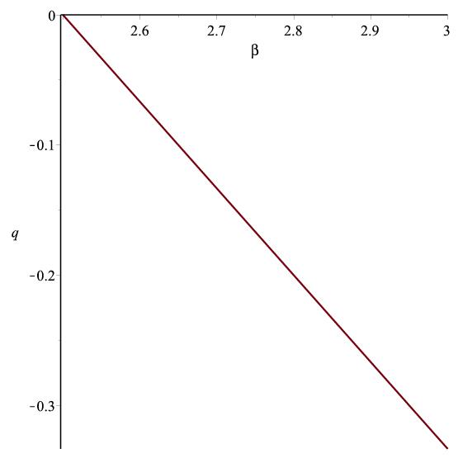

Figure 3.2: Graph of $q vs. t$ according to (3.40)

The anisotropy parameter is

$Δ=0$ (3.41)

Shear scalar is

$σ=0$ (3.42)

Cosmological constant is

$Λ=\frac{3}{{c_{3}}^{2}}{\left[\frac{1-e^{-2\frac{c_{4}}{c_{3}}}e^{-2\frac{t}{c_{3}}}}{1+e^{-2\frac{c_{4}}{c_{3}}}e^{-2\frac{t}{c_{3}}}}\right]}^{2}$ (3.43)

Case III: $k=1$ and $β=3$.

From (3.15), we get

$R=M_{3}\left[e^{\frac{c_{7}}{c_{6}}}e^{\frac{t}{c_{6}}}-e^{-\frac{c_{7}}{c_{6}}}e^{-\frac{t}{c_{6}}}\right]$ (3.44)

where $M_{3}=\frac{c_{6 }}{2},c_{6}, c_{7}$ are constants.

From equation (3.16), we get

$ϕ=c_{8}{\left[\frac{2e^{2\frac{c_{7}}{c_{6}}}e^{2\frac{t}{c_{3}}}-1}{{4\left(e^{2\frac{c_{7}}{c_{6}}}e^{2\frac{t}{c_{3}}}-1\right)}^{2}}\right]}^{2}$ (3.45)

where $c_{8}={M_{3}}^{-6}$ is a constant.

The gravitational variable is

$G={c_{8}}^{-1}\left(\frac{4+2ω}{3+2ω}\right){\left[\frac{2e^{2\frac{c_{7}}{c_{6}}}e^{2\frac{t}{c_{6}}}-1}{{4\left(e^{2\frac{c_{7}}{c_{6}}}e^{2\frac{t}{c_{6}}}-1\right)}^{2}}\right]}^{-2}$ (3.46)

Equations (3.12) and (3.13) gives

$ρ={\left[M_{3}\left(e^{\frac{c_{7}}{c_{6}}}e^{\frac{t}{c_{6}}}-e^{-\frac{c_{7}}{c_{6}}}e^{-\frac{t}{c_{6}}}\right)\right]}^{-3α}$ (3.47)

$p=α{\left[M_{3}\left(e^{\frac{c_{7}}{c_{6}}}e^{\frac{t}{c_{6}}}-e^{-\frac{c_{7}}{c_{6}}}e^{-\frac{t}{c_{6}}}\right)\right]}^{-6α}-{\left[M_{3}\left(e^{\frac{c_{7}}{c_{6}}}e^{\frac{t}{c_{6}}}-e^{-\frac{c_{7}}{c_{6}}}e^{-\frac{t}{c_{6}}}\right)\right]}^{-3α}$ (3.48)

Spatial volume is

$V={\left[M_{3}\left(e^{\frac{c_{7}}{c_{6}}}e^{\frac{t}{c_{6}}}-e^{-\frac{c_{7}}{c_{6}}}e^{-\frac{t}{c_{6}}}\right)\right]}^{3}$ (3.49)

Hubble's parameter is

$H=\frac{1}{c_{6}}\left[\frac{1+e^{-2\frac{c_{7}}{c_{6}}}e^{-2\frac{t}{c_{6}}}}{1-e^{-2\frac{c_{7}}{c_{6}}}e^{-2\frac{t}{c_{6}}}}\right]$ (3.50)

Scalar expansion is

$Θ=\frac{3}{c_{6}}\left[\frac{1+e^{-2\frac{c_{7}}{c_{6}}}e^{-2\frac{t}{c_{6}}}}{1-e^{-2\frac{c_{7}}{c_{6}}}e^{-2\frac{t}{c_{6}}}}\right]$ (3.51)

Deceleration parameter is

$q=-\left[\frac{1-e^{-2\frac{c_{7}}{c_{6}}}e^{-2\frac{t}{c_{6}}}}{1+e^{-2\frac{c_{7}}{c_{6}}}e^{-2\frac{t}{c_{6}}}}\right]$ (3.52)

The anisotropy parameter is

$Δ=0$ (3.53)

Shear scalar is

$σ=0$ (3.54)

Cosmological constant is

$Λ=\frac{3}{{c_{6}}^{2}}{\left[\frac{1+e^{-2\frac{c_{7}}{c_{6}}}e^{-2\frac{t}{c_{6}}}}{1-e^{-2\frac{c_{7}}{c_{6}}}e^{-2\frac{t}{c_{6}}}}\right]}^{2}$ (3.55)

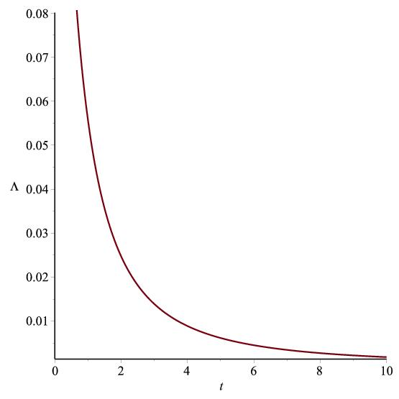

Figure 3.3: Graph of $Λ vs. t$ according to (3.55)

**3.3 Conclusion**

In this chapter, we have investigated cosmological model in Brans-Dicke theory of gravitation with equation of state in quadratic form. In the case-I, for initial period i.e. at $t=0$, scale factor, scalar field, gravitational varianble, Hubble parameter, cosmological constant are finite. Also, for $2<β<3, q≤ 0$, the deceleration parameter falls in the range $-1≤ q≤0$ which is in agreement with the observational data( Riess et al. 1998 and Perlmutter et al. 1999).

In the case-II, $H,Θ$ remain finite for $t→∞$. Again $R,ϕ,G,H,Θ,V,Λ$ remain finite for $t=0$. Here, as $t→∞$, the deceleration parameter is in the range $-1≤ q≤0$ which gives accelerated expansion of the universe.

In the case-III, $H,Θ,Λ$ become finite for $t→∞$. For t $=0, R,ϕ,G,H,Θ,V,Λ$ remain finite. As $t→∞$, the deceleration parameter is in the range $-1≤ q≤0$ which supports the observational data for accelerating universe.

For all the cases I, II, III, scale factor $R→∞$ as $→∞$, thus expanding model is seen to exist. Also, B-D scalar field $ϕ$, scalar expansion $Θ$ decreases as time increases. Also, for $α<0$, energy density is positive while pressure is negative. Also we may get different dark energy models as phantom energy for $α<-1$ or quintessence for $-1<α<0$ or vacuum fluid $α=-1$. Here for all the cases $Δ \& σ$ vanishes indicating isotropic and shear free model universe. The variable cosmological constant term for the model becomes small and positive as $t→∞$. Thus, all the parameters indicate accelerating expansion of the universe.