**Chapter 4**

**Robertson-Walker model universe with special form of deceleration parameter in Brans-Dicke Theory of Gravitation**

**4.1 Introduction**

Recent cosmological observations explains a lot about accelerated phase of the present day universe. Many relativists ( Banerjee and Beesham 1997, Azar and Riazi 1995, Etoh et al. 1997, Singh and Beesham 1999, Banerjee and Pavon 2001, Chakraborty et al. 2003) has been studying cosmological models in different cases in B-D theory. Also, electromagnetic field in cosmological models are investigated by authors (Singh and Usham 1989, Reddy and Rao 1981, Bohra and Mehra 1978, Jimanez et al. 2009, El-Nabulsi 2012, Pandolfi 2014, Tripathy et al. 2015). Singha and Debnath (2008), Adhav et al. (2013) investigated cosmological models by using a special form of deceleration parameter $q=-1+\frac{ζ}{1+R^{ζ}}$  
 , where $ζ$ is a constant and R is average scale factor. Recently with the same type of deceleration parameter Ghate et al. (2015) studied anisotropic Bianchi Type-IX dark energy cosmological models. Researchers (Al-Rawaft and Taha 1996, Overduin and Cooperstock 1998, Al-Rawaft 1998, Arbab 2003, Khadekar et al. 2006) studied cosmological models with the time-dependent cosmological constant of the form $Λ∝\frac{\ddot{R}}{R}$ and some other form. In this chapter, we studied Robertson-Walker model with Van der Waals equation of state in the presence of Brans-Dicke field and Electromagnetic field with variable cosmological constant.

**4.2 Metric and Field equations**

The spherically symmetric Robertson-Walker metric is

$ds^{2}=dt^{2}-R^{2}(t)\left[\frac{dr^{2}}{1-kr^{2}}+r^{2}\left(dθ^{2}+\sin^{2}θ dφ^{2}\right)\right]$ (4.1) where $k$ is the curvature index which can take values - $1,0, 1$.

The B-D theory of gravity is described by the action (in units $h=c = 8π G = 1$)

$S=\int{d^{4}x\sqrt{\left|g\right|}}\left[\frac{1}{16π}\left(ϕR-\frac{ω}{ϕ}g^{sl}ϕ_{,l}ϕ_{,s}\right)+L_{m}\right]$ (4.2)

where $R$ represents the curvature scalar; $g$ is the determinant of $g_{ij}$; $ϕ$ is a scalar field; $ω$ is a dimensionless coupling constant; $L_{m}$ is the Lagrangian of the ordinary matter component.

The Einstein field equations in the most general form are given by

$R_{ij}-\frac{1}{2}Rg_{ij}+Λ g_{ij}=-\frac{κ}{ϕ}T_{ij}-\frac{ω}{ϕ^{2}}[ϕ_{,i}ϕ_{,j}-\frac{1}{2}g_{ij}ϕ^{,s}ϕ_{,s}]-\frac{1}{ϕ}(ϕ_{ij}-g_{ij}{ϕ_{;s}}^{,s})$ (4.3)

where

$\left(3+2ω\right){ϕ_{;s}}^{,s}=8πT,$ (4.4)

where $T$ is the trace of $T_{ij}, Λ$ is the cosmological constant, $R_{ij}$ is Ricci-tensor, $g_{ij}$ is metric tensor and $ϕ_{,i}$ is the partial differentiation with respect to $x^{i}$ coordinate.

The energy-momentum tensor is

$T_{ij}=M_{ij}+E_{ij}$ (4.5)

where

$M_{ij}=(p+ρ)u_{i}u_{j}-pg_{ij},$ (4.6)

and

$E_{ij}=-F_{il}{F_{j}}^{l}+\frac{1}{4}g_{ij}F_{lm}F^{lm}$ (4.7)

with $u_{1}=u_{2}=u_{3}=0 , u_{4}=1, u_{i}$ is four velocity vector satisfying $g^{ij}u_{i}u_{j}=1$, $p$ is the pressure and $ρ$ is the energy density.

Here a comma $(,)$ or semicolon $(;)$ followed by a subscript denotes partial differentiation or a covariant differentiation respectively. Also the velocity of light is assumed as unity.

The non-vanishing electromagnetic energy-momentum tensor ${E_{j}}^{i}$ are

${E_{1}}^{1}=-{E_{2}}^{2}=-{E_{3}}^{3}={E_{4}}^{4}=-\frac{1}{2}g^{11}g^{44}{F_{14}}^{2}=\frac{1}{2}\frac{1-kr^{2}}{R^{2}}{F^{2}}_{14}$ (4.8)

Shear scalar is defined as

$σ^{2}=\frac{1}{2}\left(\sum_{i=1}^{3}{{H_{i}}^{2}}-3H^{2}\right)$ (4.9)

The average anisotropy parameter $Δ$ is defined as

$Δ=\frac{1}{3}\sum_{i=1}^{3}{{\left(\frac{H_{i}-H}{H}\right)}^{2}}$ (4.10)

where $H_{i},i=1,2,3$ represent the directional Hubble parameters in $x,y,z$ directions respectively.

Gravitational variable is defined as

$G=\frac{1}{ϕ}\left(\frac{4+2ω}{3+2ω}\right)$ (4.11)

The deceleration parameter is defined as

$q=-\frac{R\ddot{R}}{{\dot{R}}^{2}}$ (4.12)

where $q$ is the measure of the cosmic acceleration of the universe in cosmology.

**4.3 Solutions of field equations**

Assuming $ϕ^{'}=0$, the metric (4.1) along with field equations (4.3)-(4.5) gives

$\frac{k}{R^{2}}+\frac{{\dot{R}}^{2} }{R^{2}}+2\frac{\ddot{R}}{R}-Λ=-\frac{8π \overline{p}}{ϕ}-\frac{4π}{ϕ}\frac{1-kr^{2}}{R^{2}}{F^{2}}_{14}-\frac{ω}{2}\frac{{\dot{ϕ}}^{2}}{ϕ^{2}}-2\frac{\dot{R}}{R}\frac{\dot{ϕ}}{ϕ}-\frac{\ddot{ϕ}}{ϕ}$ (4.13)

$3\left(\frac{k}{R^{2}}+\frac{{\dot{R}}^{2} }{R^{2}}\right)-Λ=\frac{8πρ}{ϕ}+\frac{4π}{ϕ}\frac{1-kr^{2}}{R^{2}}{F^{2}}_{14}+\frac{ω}{2}\frac{{\dot{ϕ}}^{2}}{ϕ^{2}}-3\frac{\dot{R}}{R}\frac{\dot{ϕ}}{ϕ}$ (4.14)

$(3+2ω)[3\frac{\dot{R}\dot{ϕ}}{R}+\ddot{ϕ}]=8π(ρ-3\overline{p}),$ (4.15)

From eqs. (4.13), (4.14) and (4.15), we get

$6(\frac{k}{R^{2}}+\frac{{\dot{R}}^{2} }{R^{2}}+\frac{\ddot{R}}{R})-4Λ =-\frac{8π}{ϕ}\frac{1-kr^{2}}{R^{2}}{F^{2}}_{14}+ω [6\frac{\dot{R}}{R}\frac{\dot{ϕ}}{ϕ}+2\frac{\ddot{ϕ}}{ϕ}-\frac{{\dot{ϕ}}^{2}}{ϕ^{2}}]$ (4.16)

Van der Waals equation of state (Thirukkanesh and Ragel 2014) is

$p=α { ρ}^{2}+\frac{β ρ}{1+γρ}-δ$ (4.17)

where $α, β, γ, δ$ are constants.

Here, we consider relation between scale factor $R$ and scalar field $ϕ$ as

$ϕ=ϕ_{0}R^{\frac{1}{ω}}$ (4.18)

$ϕ_{0}$ is a constant.

Using eq. (4.18), eq. (4.16) becomes

${F^{2}}_{14}=\frac{ϕ_{0}}{8π}\frac{R^{\frac{1+2ω}{ω}}}{1-kr^{2}}\left[\left(\frac{1-2ω}{ω}\right)\frac{{\dot{R}}^{2} }{R^{2}}-4\frac{\ddot{R}}{R}-\frac{6k}{R^{2}}+4Λ\right]$ (4.19)

**4.4 Models with Special form of Deceleration Parameter**

We assume the special form of deceleration parameter (Singha and Debnath 2008,Adhav et al. 2013,Ghate et al. 2015)as:

$q=-1+\frac{ζ}{1+R^{ζ}}$ (4.20)

where $R$ is the scale factor, $ζ>0$.

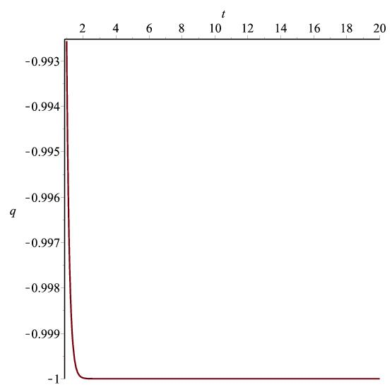

Figure 4.1: Graph of $q vs. t$ according to (4.20)

From eq. (4.20), we get

$R={\left(α_{1}e^{α_{2}ζt}-1\right)}^{\frac{1}{ζ}}$ (4.21)

where $α_{1}$ $α_{2}$ and $ζ$ are positive constants.

Using eq. (4.21), eq. (4.18) gives Brans-Dicke scalar field as

$ϕ=ϕ_{0}{\left(α_{1}e^{α_{2}ζt}-1\right)}^{\frac{1}{ζω}}$ (4.22)

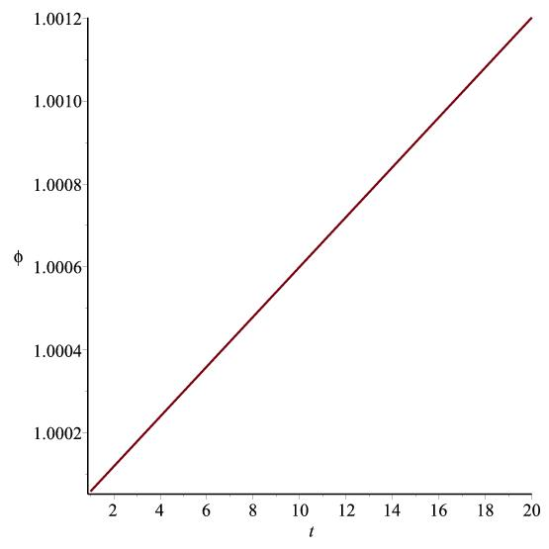

Figure 4.2: Graph of $ϕ vs. t$ according to (4.22)

The Gravitaional variable is obtained from eq. (4.11) with the help of eq.(4.22) as

$G=\left(\frac{4+2ω}{3+2ω}\right){ϕ_{0}}^{-1}{\left(α_{1}e^{α_{2}ζt}-1\right)}^{-\frac{1}{ζω}}$ (4.23)

Spatial volume is

$V={\left(α_{1}e^{α_{2}ζt}-1\right)}^{\frac{3}{ζ}}$ (4.24)

Hubble's parameter is

$H=α_{1}α_{2}{\left(α_{1}-e^{-α_{2}ζt}\right)}^{-1}$ (4.25)

Scalar expansion is

$Θ=3α_{1}α_{2}{\left(α_{1}-e^{-α_{2}ζt}\right)}^{-1}$ (4.26)

The directional Hubble's parameter on the $x, y, z$ axes are

$H_{x}=H_{y}=H_{z}=α_{1}α_{2}{\left(α_{1}-e^{-α_{2}ζt}\right)}^{-1}$ (4.27)

The anisotropy parameter is

$Δ=0$ (4.28)

This corresponds to isotropic expansion.

Shear scalar is

$σ^{2}=0$ (4.29)

This gives a shear free model.

Red shift of the model is

$z={\left(α_{1}e^{α_{2}ζt}-1\right)}^{-\frac{1}{ζ}}-1$ (4.30)

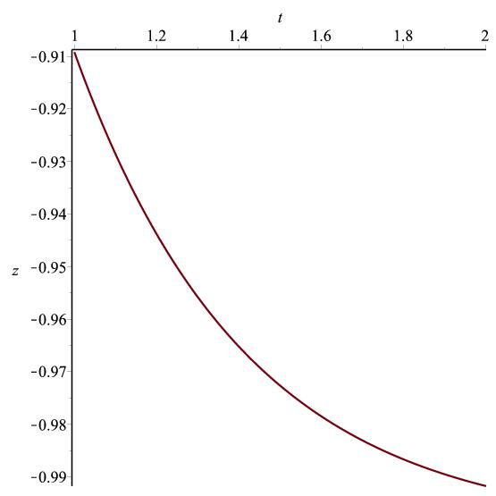

Figure 4.3: Graph of $z vs. t$ according to (4.30)

Case I: Flat model $k=0$, $Λ=\frac{1}{4}\frac{\ddot{R}}{R}$

Using eq. (4.21), eq. (4.19) becomes

${F^{2}}_{14}=\frac{ϕ_{0}{\left(α_{1}e^{α_{2}ζt}-1\right)}^{\frac{1+2ω}{ζω}}}{8π}\left[B_{1}{\left(α_{1}-e^{-α_{2}ζt}\right)}^{-2}-{B_{2}\left(α_{1}-e^{-α_{2}ζt}\right)}^{-1}\right]$ (4.31)

Using eqs. (4.18), (4.21) and (4.31), eq. (4.14) gives

$ρ=\frac{ϕ_{0}{\left(α_{1}e^{α_{2}ζt}-1\right)}^{\frac{1}{ζω}}}{8π}\left[A_{1}{\left(α_{1}-e^{-α_{2}ζt}\right)}^{-2}+{A_{2}\left(α_{1}-e^{-α_{2}ζt}\right)}^{-1}\right]$ (4.32)

Using eq. (4.32) in eq. (4.17) we get

$p=α{\left[\frac{ϕ_{0}{\left(α_{1}e^{α_{2}ζt}-1\right)}^{\frac{1}{ζω}}}{8π}\left\{A_{1}{\left(α_{1}-e^{-α_{2}ζt}\right)}^{-2}+{A_{2}\left(α_{1}-e^{-α_{2}ζt}\right)}^{-1}\right\}\right]}^{2}$

$+\frac{β\frac{ϕ_{0}{\left(α_{1}e^{α_{2}ζt}-1\right)}^{\frac{1}{ζω}}}{8π}\left[A_{1}{\left(α_{1}-e^{-α_{2}ζt}\right)}^{-2}+{A_{2}\left(α_{1}-e^{-α_{2}ζt}\right)}^{-1}\right]}{1+γ\frac{ϕ_{0}{\left(α_{1}e^{α_{2}ζt}-1\right)}^{\frac{1}{ζω}}}{8π}\left[A_{1}{\left(α_{1}-e^{-α_{2}ζt}\right)}^{-2}+{A_{2}\left(α_{1}-e^{-α_{2}ζt}\right)}^{-1}\right]}-δ$ (4.33)

Case II: Open model $k=-1$ and $Λ=\frac{1}{4}\frac{\ddot{R}}{R}$

Using eq. (4.21) , eq. (4.19) becomes

${F^{2}}_{14}=\frac{ϕ_{0}{\left(α_{1}e^{α_{2}ζt}-1\right)}^{\frac{1+2ω}{ζω}}}{8π}\left[B_{1}{\left(α_{1}-e^{-α_{2}ζt}\right)}^{-2}-{B_{2}\left(α_{1}-e^{-α_{2}ζt}\right)}^{-1}+6{\left(α_{1}e^{α_{2}ζt}-1\right)}^{-\frac{2}{ζ}} \right]$. (4.34)

Using eqs. (4.18), (4.21) and (4.34), eq. (4.14) gives

$ρ=\frac{ϕ_{0}{\left(α_{1}e^{α_{2}ζt}-1\right)}^{\frac{1}{ζω}}}{8π}\left[A_{1}{\left(α_{1}-e^{-α_{2}ζt}\right)}^{-2}+{A_{2}\left(α_{1}-e^{-α_{2}ζt}\right)}^{-1}-6{\left(α_{1}e^{α_{2}ζt}-1\right)}^{-\frac{2}{ζ}}\right]$ (4.35)

Using eq. (4.32) in eq. (4.17) we get

$$p=α{\left[\frac{ϕ_{0}{\left(α_{1}e^{α_{2}ζt}-1\right)}^{\frac{1}{ζω}}}{8π}\left\{A_{1}{\left(α_{1}-e^{-α_{2}ζt}\right)}^{-2}+{A_{2}\left(α_{1}-e^{-α_{2}ζt}\right)}^{-1}-6{\left(α_{1}e^{α_{2}ζt}-1\right)}^{-\frac{2}{ζ}}\right\}\right]}^{2}$$

$+\frac{β\frac{ϕ_{0}{\left(α_{1}e^{α_{2}ζt}-1\right)}^{\frac{1}{ζω}}}{8π}\left[A_{1}{\left(α_{1}-e^{-α_{2}ζt}\right)}^{-2}+{A_{2}\left(α_{1}-e^{-α_{2}ζt}\right)}^{-1}-6{\left(α_{1}e^{α_{2}ζt}-1\right)}^{-\frac{2}{ζ}}\right]}{1+γ\frac{ϕ_{0}{\left(α_{1}e^{α_{2}ζt}-1\right)}^{\frac{1}{ζω}}}{8π}\left[A_{1}{\left(α_{1}-e^{-α_{2}ζt}\right)}^{-2}+{A_{2}\left(α_{1}-e^{-α_{2}ζt}\right)}^{-1}-6{\left(α_{1}e^{α_{2}ζt}-1\right)}^{-\frac{2}{ζ}}\right]}-δ$ (4.36)

where $B_{1}=\left(\frac{3ζω-5ω+1}{ω}\right){α_{1}}^{2}{α_{2}}^{2}$, $B_{2}=3α_{1}{α_{2}}^{2}$, $A_{1}=\left(\frac{21ω-5ζω+8}{4ω}\right){α_{1}}^{2}{α_{2}}^{2}$ and $B_{2}={\frac{5}{4}α}_{1}{α_{2}}^{2}ζ$.

Variable cosmological constant is

$Λ=\frac{1}{4}(1-ζ){α_{1}}^{2}{α_{2}}^{2}{\left(α_{1}-e^{-α_{2}ζt}\right)}^{-2}+{\frac{1}{4}α}_{1}{α_{2}}^{2}ζ{\left(α_{1}-e^{-α_{2}ζt}\right)}^{-1}$ (4.37)

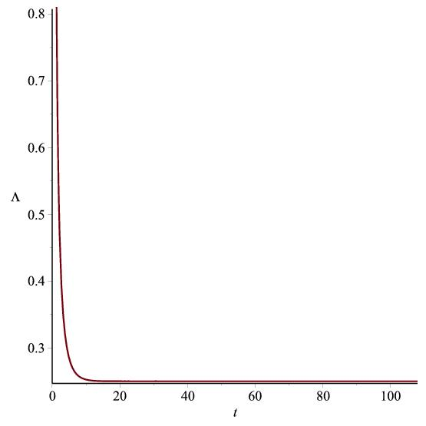

Figure 4.4: Graph of $Λ vs. t$ according to (4.37)

**4.5 Conclusion**

In this chapter, we have considered Robertson-Walker model in Brans-Dicke Theory with the special form of deceleration parameter $q=-1+\frac{ζ}{1+R^{ζ}}$. This yields time-dependent scale factor as $R={\left(α_{1}e^{α_{2}ζt}-1\right)}^{\frac{1}{ζ}}$. Here, scale factor and spatial volume are the exponential functions of time, tends to infinity as $t→∞$, so the model universes are expanding with acceleration. Hubble's parameter and scalar expansion tends to $α_{2}$ and $3α_{2}$ as time tends to infinity. The models found here are non-singular. At the initial phase of the universe, the value of deceleration parameter is positive ( i.e. at $t=0$, $q=\frac{ζ}{1+{(α_{1}-1)}^{\frac{1}{ζ}}}-1$) while as $t→∞$, the value of $q$ becomes $-1$. So, the universe had a early deceleration and later it has accelerated expansion. For $2<ζ≤4$ and $ω>40000$ (Faraoni 2004, Calcagni et al. 2012), the electromagnetic field component $F_{14}→∞$ as time $t→∞$ in Flat and open model. For $2<ζ≤4$, $α<0$ and $β<0$, fluid density is positive but pressure is negative. Here, we found that the scalar field $ϕ$ is also increasing function of time $t$ only. So, the gravitational variable $G$ is decreases as time increases. As time increases the red-shift decreases for both flat and open models. Here dynamical cosmological constant tends to $\frac{{α_{2}}^{2}}{4}$ as $t→∞$ which is positive and small. For $ω>40000$, the dark energy is present in both cases which helps in accelerated expansion of the universe.