**Chapter 9**

**Robertson-Walker model universe interacting with Electromagnetic field and Brans-Dicke field in the presence of Hybrid scale factor**

**9.1 Introduction**

Ahmadi-Azar and Riazi (1995), Etoh et al. (1997), Singh and Beesham (1999), Banerjee and Pavon (2001), Chakraborty et al. (2003) discussed different cosmological models in B-D theory with various cases. Researchers (Bohra and Mehra 1978, Reddy and Rao 1981,Singh and Usham 1989) also investigated cosmological models with electromatnetic and B-D field. In many papers various researchers ( El-Nabulsi 2008, Pradhan et al. 2009, Jimanez et al. 2009, El-Nabulsi 2012,Bykov et al. 2012, Pandolfi, 2014, Tripathy et al. 2015) stdudied electromagnetic field in cosmological models. El-Nabulsi discussed the dependence of the Hubble parameter with the scalar field in his number of papers (El-Nabulsi 2010, 2011, 2013,2015). These works have played a important role in this chapter for taking power law relation between scale factor and scalar field. With the help of hybrid scale factor there have been lots of work done in cosmological models by authors ( Saha et al.2012, El-Nabulsi, 2013, Akarsu et al. 2014, Mishra and Tripathy, 2015,, El-Nabulsi 2016, Aviles et al. 2016). In this chapter, we have studied electromagnetic field and Brans-Dicke field considering hybrid scale factor in Robertson-Walker model.

**9.2 Metric and Field equations**

The spherically symmetric Robertson-Walker metric is

$ds^{2}=dt^{2}-R^{2}(t)\left[\frac{dr^{2}}{1-kr^{2}}+r^{2}\left(dθ^{2}+\sin^{2}θ dφ^{2}\right)\right]$ (9.1) where $k$ is the curvature index which can take values - $1,0, 1$.

The B-D theory of gravity is described by the action (in units $h=c = 8π G = 1$)

$S=\int{d^{4}x\sqrt{\left|g\right|}}\left[\frac{1}{16π}\left(ϕR-\frac{ω}{ϕ}g^{sl}ϕ_{,l}ϕ_{,s}\right)+L_{m}\right]$ (9.2)

where $R$ represents the curvature scalar; $g$ is the determinant of $g_{ij}$; $ϕ$ is a scalar field; $ω$ is a dimensionless coupling constant; $L_{m}$ is the Lagrangian of the ordinary matter component.

The Einstein field equations in the most general form are given by

$R_{ij}-\frac{1}{2}Rg_{ij}+Λ g_{ij}=-\frac{κ}{ϕ}T_{ij}-\frac{ω}{ϕ^{2}}[ϕ_{,i}ϕ_{,j}-\frac{1}{2}g_{ij}ϕ^{,s}ϕ_{,s}]-\frac{1}{ϕ}(ϕ_{ij}-g_{ij}{ϕ_{;s}}^{,s})$ (9.3)

where

$\left(3+2ω\right){ϕ_{;s}}^{,s}=κ T,$ (9.4)

where $κ=8π, T$ is the trace of $T_{ij}, Λ$ is the cosmological constant, $R_{ij}$ is Ricci-tensor, $g_{ij}$ is metric tensor and $ϕ_{,i}$ is the partial differentiation with respect to $x^{i}$ coordinate.

The energy-momentum tensor is

$T_{ij}=M_{ij}+E_{ij}$ (9.5)

where

$M_{ij}=(p+ρ)u_{i}u_{j}-pg_{ij},$ (9.6)

and

$E_{ij}=-F_{il}{F_{j}}^{l}+\frac{1}{4}g_{ij}F_{lm}F^{lm}$ (9.7)

with $u_{1}=u_{2}=u_{3}=0 , u_{4}=1, u_{i}$ is four velocity vector satisfying $g^{ij}u_{i}u_{j}=1$, $p$ is the pressure and $ρ$ is the energy density.

Here a comma $(,)$ or semicolon $(;)$ followed by a subscript denotes partial differentiation or a covariant differentiation respectively. Also the velocity of light is assumed as unity.

The non-vanishing electromagnetic energy-momentum tensor ${E_{j}}^{i}$ are

${E_{1}}^{1}=-{E_{2}}^{2}=-{E_{3}}^{3}={E_{4}}^{4}=-\frac{1}{2}g^{11}g^{44}{F_{14}}^{2}=\frac{1}{2}\frac{1-kr^{2}}{R^{2}}{F^{2}}_{14}$ (9.8)

Shear scalar is defined as

$σ^{2}=\frac{1}{2}\left(\sum_{i=1}^{3}{{H_{i}}^{2}}-3H^{2}\right)$ (9.9)

The average anisotropy parameter $Δ$ is defined as

$Δ=\frac{1}{3}\sum_{i=1}^{3}{{\left(\frac{H_{i}-H}{H}\right)}^{2}}$ (9.10)

where $H_{i},i=1,2,3$ represent the directional Hubble parameters in $x,y,z$ directions respectively and $Δ=0$ corresponds to isotropic expansion.

Gravitational variable (Weinberg 1972) is defined as

$G=\frac{1}{ϕ}\left(\frac{4+2ω}{3+2ω}\right)$ (9.11)

The deceleration parameter is defined as

$q=-\frac{R\ddot{R}}{{\dot{R}}^{2}}$ (9.12)

where $q$ is the measure of the cosmic acceleration of the universe in cosmology.

**9.3 Solutions of field equations**

Assuming $ϕ^{'}=0$, for the metric (9.1), (9.3)-(9.5) gives

$\frac{k}{R^{2}}+\frac{{\dot{R}}^{2} }{R^{2}}+2\frac{\ddot{R}}{R}-Λ=-\frac{8π p}{ϕ}-\frac{4π}{ϕ}\frac{1-kr^{2}}{R^{2}}{F^{2}}_{14}-\frac{ω}{2}\frac{{\dot{ϕ}}^{2}}{ϕ^{2}}-2\frac{\dot{R}}{R}\frac{\dot{ϕ}}{ϕ}-\frac{\ddot{ϕ}}{ϕ}$ (9.13)

$3\left(\frac{k}{R^{2}}+\frac{{\dot{R}}^{2} }{R^{2}}\right)-Λ=\frac{8πρ}{ϕ}+\frac{4π}{ϕ}\frac{1-kr^{2}}{R^{2}}{F^{2}}_{14}+\frac{ω}{2}\frac{{\dot{ϕ}}^{2}}{ϕ^{2}}-3\frac{\dot{R}}{R}\frac{\dot{ϕ}}{ϕ}$ (9.14)

$(3+2ω)[3\frac{\dot{R}\dot{ϕ}}{R}+\ddot{ϕ}]=8π(ρ-3p),$ (9.15)

From equations (9.13), (9.14) and (9.15) we get

$6\left[\frac{k}{R^{2}}+\frac{{\dot{R}}^{2} }{R^{2}}+\frac{\ddot{R}}{R}\right]-4Λ =-\frac{8π}{ϕ}\frac{1-kr^{2}}{R^{2}}{F^{2}}_{14}+ω \left[6\frac{\dot{R}}{R}\frac{\dot{ϕ}}{ϕ}+2\frac{\ddot{ϕ}}{ϕ}-\frac{{\dot{ϕ}}^{2}}{ϕ^{2}}\right]$ (9.16)

Here we assume (Johri and Desikan 1994)

$ϕ=MR^{n}$ (9.17)

where $-6<n<-2$ and $M$ is a constant.

Using (9.17), (9.16) becomes

${F^{2}}_{14}=\frac{ϕ}{8π}\frac{R^{2}}{1-kr^{2}}\left[\{\left(n^{ 2}+4n\right)ω-6\}\frac{{\dot{R}}^{2} }{R^{2}}+2(nω-3)\frac{\ddot{R}}{R}-\frac{6k}{R^{2}}+4Λ\right]$ (9.18)

We assume the Hybrid Scale Factor (Mishra and Tripathy 2015) as

$R=t^{b}e^{at}$ (9.19)

where $a$ and $b$ are positive constants.

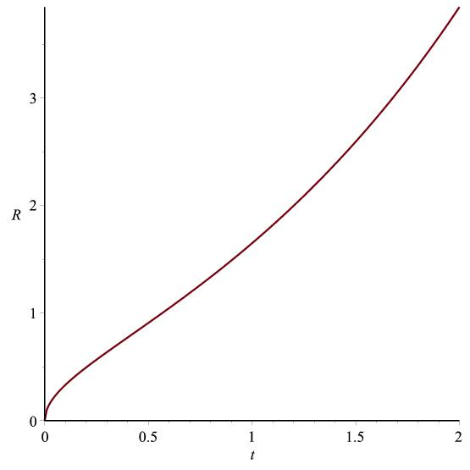

Figure 9.1: Graph of $R vs. t$ according to (9.19)

**9.3.1 Case I: Flat model $k=0, Λ=0$**

From (9.18) and (9.19) we get

${F^{2}}_{14}=\frac{M{[t^{b}e^{at}]}^{n+2}}{8π}[\left\{\left(n^{ 2}+6n\right)ω-12\right\}{\left(\frac{b}{t}+a\right)}^{2}-2(nω-3)\frac{b}{t^{2}}]$ (9.20)

Using (9.19)-(9.20), (9.13) and (9.14) gives

$ρ=\frac{M{[t^{b}e^{at}]}^{n}}{8π}[\left\{15+3n-6nω-\frac{3}{2}n^{ 2}ω\right\}{\left(\frac{b}{t}+a\right)}^{2}+2(nω-3)\frac{b}{t^{2}}]$ (9.21)

$p=-\frac{M{[t^{b}e^{at}]}^{n}}{8π}[\left\{n^{ 2}\left(\frac{2+3ω}{2}\right)+\left(2+6ω\right)n-9\right\}{\left(\frac{b}{t}+a\right)}^{2}+(8+n-2nω)\frac{b}{t^{2}}]$ (9.22)

where $-6<n<-2$

**9.3.2 Case II: Open model $k=-1$ and $Λ=0$**

From (9.18) and (9.19) we get

${F^{2}}_{14}=\frac{M{[t^{b}e^{at}]}^{n+2}}{8π}[\left\{\left(n^{ 2}+6n\right)ω-12\right\}{\left(\frac{b}{t}+a\right)}^{2}-2\left(nω-3\right)\frac{b}{t^{2}}+6{(t^{b}e^{at})}^{-2}]$ (9.23)

Using (9.19)-(9.20), (9.13) and (9.14) gives

$ρ=\frac{M{\left[t^{b}e^{at}\right]}^{n}}{8π}\left[\left\{15+3n-6nω-\frac{3n^{ 2}}{2}ω\right\}{\left(\frac{b}{t}+a\right)}^{2}+2\left(nω-3\right)\frac{b}{t^{2}}-3{\left(t^{b}e^{at}\right)}^{-2}\right]$ (9.24)

$p=-\frac{M{[t^{b}e^{at}]}^{n}}{8π}[\left\{n^{ 2}\left(\frac{2+3ω}{2}\right)+\left(2+6ω\right)n-9\right\}{\left(\frac{b}{t}+a\right)}^{2}+\left(8+n-2nω\right)\frac{b}{t^{2}}-{(t^{b}e^{at})}^{-2}]$ (9.25)

where $-6<n<-2$

**9.3.3 For both Flat and Open models**

Brans-Dicke scalar field is

$ϕ=M{[t^{b}e^{at}]}^{n}$ (9.26)

Hubble's parameter and Scalar expansion are given by

$H=\frac{b}{t}+a,$ (9.27)

$Θ=3\left(\frac{b}{t}+a\right)$ (9.28)

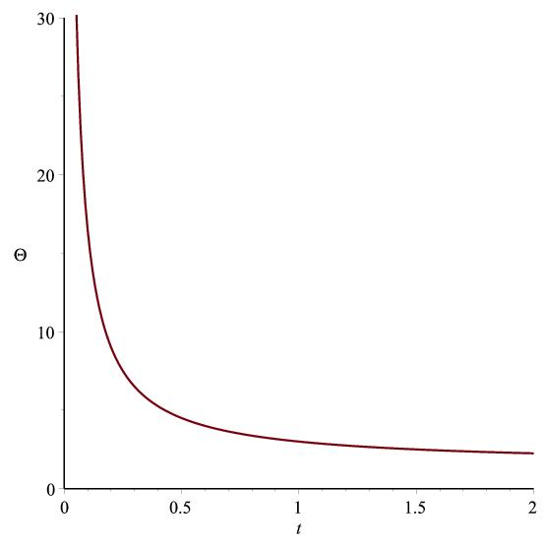

Figure 9.2: Graph of $Θ vs. t$ according to (9.28)

The Gravitaional variable is

$G=\left(\frac{4+2ω}{3+2ω}\right)M^{-1}{[t^{b}e^{at}]}^{-n}$ (9.29)

Deceleration parameter is

$q=-1+\frac{b}{{(at+b)}^{2}}$ (9.30)

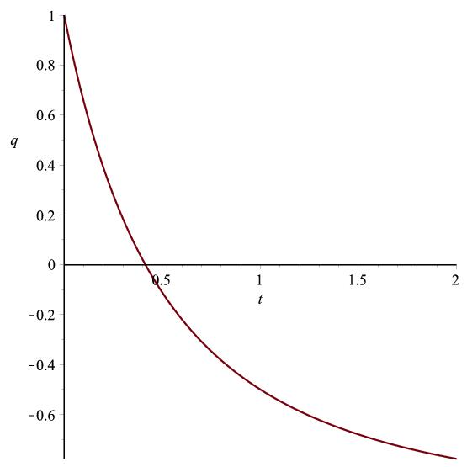

Figure 9.3: Graph of $q vs. t$ according to (9.30)

Spatial volume is

$V=t^{3b}e^{3at}$ (9.31)

The directional Hubble's parameter on the $x, y, z$ axes are

$H_{x}=H_{y}=H_{z}=\frac{b}{t}+a$ (9.32)

The anisotropy parameter is

$Δ=0$ (9.33)

Shear scalar is

$σ^{2}=0$ (9.34)

Redshift is

$z=t^{-b}e^{-at}-1$ (9.35)

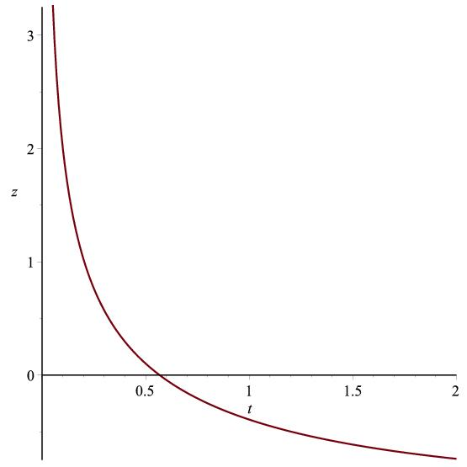

Figure 9.4: Graph of $z vs. t$ according to eq. (9.35)

**9.4 Conclusion**

For the Case-I model the metric comes out to be

$ds^{2}=dt^{2}-t^{2b}e^{2at}\left[dr^{2}+r^{2}\left(dθ^{2}+\sin^{2}θ dφ^{2}\right)\right]$ (9.36)

For the $k=0$, the electromagnetic field component $F_{14}→0$ as $t→∞$. $F_{14}$ is physically realistic as $ω>40000$ ( Reasenberg et al. 1979, Faraoni 2004, Calcagni et al. 2012 ). and $-6<n<-2$. The pressure and fluid density are functions of time t alone. For $-6<n<-2$ fluid density is positive and pressure is negative and tends to zero as time tends to infinity.

For the Case-II model the metric comes out to be

$ds^{2}=dt^{2}-t^{2b}e^{2at}\left[\frac{dr^{2}}{1+r^{2}}+r^{2}\left(dθ^{2}+\sin^{2}θ dφ^{2}\right)\right]$ (9.37)

For $k=-1$, the electromagnetic field component $F_{14}$ is found to be decreasing function of $r$ as well as $t$ and it tends to zero as

$r→∞$ or $t→∞$. For $-6<n<-2$ the solutions of $F_{14}$ is physically realistic as the coupling constant $ω>40000$. Here, pressure is found to be negative while fluid density is positive.

For both the cases, the scale factor and spatial volume increases exponentially as $t→∞$, so the model universes are expanding with acceleration. Hubble's parameter $H→ a$ and scalar expansion $Θ→ 3a$ as $t→∞$. From equation (9.26), we find that the scalar field $ϕ$ is a decreasing function of $t$ only. The solution for $ϕ$ remains physically realistic even when $→∞$. The gravitational variable $G$ becomes infinitely large as time $t→∞.$

Again, the deceleration parameter changes from positive to negative value as $t→∞$ which is supported by observational data for early deceleration and late time acceleration. The red-shift decreases as $t→∞$. An isotropic as well as shear-free model is found. For both the models, dark energy confirms accelerated expansion of the universes.