**Chapter 6**

**Viscous Robertson-Walker model with Barotropic equation of state in Brans-Dicke Theory of Gravitation interacting with Electromagnetic field**

**6.1 Introduction**

The present belief about our universe is that the current universe is in accelerating phase which supported by recent cosmological observations. Many relativist ( Banerjee and Beesham 1997, Azar and Riazi 1995, Etoh et al. 1997, Singh and Beesham 1999, Banerjee and Pavon 2001, Chakraborty et al., 2003) has used the Brans-Dicke theory to investigate cosmological models. Also, various cosmological models filled with electromagnetic field were discussed in number of papers (Bohra and Mehra 1978, Reddy and Rao 1981, Singh and Usham 1989, Jimanez et al. 2009, El-Nabulsi 2012, Pandolfi 2014, Tripathy et al., 2015). Scale factor and the scalar field relationship has been used in different cosmological models (El-Nabulsi 2010,2011,2013, 2015). Pasqua and Chattopadhyay (2013) have investigated cosmological model by using logamediate form of scale factor. Different authors like (Al-Rawaft and Taha 1996, Al-Rawaft 1998, Overduin and Cooperstock 1998, Arbab 2003, Khadekar et al. 2006) like Al-Rawaft and Taha, Al-Rawaft, Overduin and Cooperstock, Arbab, Khadekar et al. studied about cosmological models with the variable cosmological constant of the form $Λ∝ \frac{\ddot{R}}{R}$ and some other form. In this paper, we studied Robertson-Walker model with Barotropic equation of state in Brans-Dicke Theory of Gravitation interacting with Electromagnetic field.

**6.2 Metric and Field equations**

The spherically symmetric Robertson-Walker metric is

$ds^{2}=dt^{2}-R^{2}(t)\left[\frac{dr^{2}}{1-kr^{2}}+r^{2}\left(dθ^{2}+\sin^{2}θ dφ^{2}\right)\right]$ (6.1)

where $k$ is the curvature index which can take values - $1,0, 1$.

The B-D theory of gravity is described by the action (in units $h=c = 8π G = 1$)

$S=\int{d^{4}x\sqrt{\left|g\right|}}\left[\frac{1}{16π}\left(ϕR-\frac{ω}{ϕ}g^{sl}ϕ_{,l}ϕ_{,s}\right)+L_{m}\right]$ (6.2)

where $R$ represents the curvature scalar; $g$ is the determinant of $g_{ij}$; $ϕ$ is a scalar field; $ω$ is a dimensionless coupling constant; $L_{m}$ is the Lagrangian of the ordinary matter component.

The Einstein field equations in the most general form are given by

$R_{ij}-\frac{1}{2}Rg_{ij}+Λ g_{ij}=-\frac{κ}{ϕ}T_{ij}-\frac{ω}{ϕ^{2}}[ϕ_{,i}ϕ_{,j}-\frac{1}{2}g_{ij}ϕ^{,s}ϕ_{,s}]-\frac{1}{ϕ}(ϕ_{ij}-g_{ij}{ϕ_{;s}}^{,s})$ (6.3)

where

$\left(3+2ω\right){ϕ_{;s}}^{,s}=κ T,$ (6.4)

where $κ=8π, T$ is the trace of $T_{ij}, Λ$ is the cosmological constant, $R_{ij}$ is Ricci-tensor, $g_{ij}$ is metric tensor and $ϕ_{,i}$ is the partial differentiation with respect to $x^{i}$ coordinate.

The energy-momentum tensor is

$T_{ij}=M_{ij}+E_{ij}$ (6.5)

where

$M_{ij}=(\overline{p}+ρ)u_{i}u_{j}-pg_{ij},$ (6.6)

$\overline{p}=p-η{u_{;i}}^{i}$ (6.7)

$E_{ij}=-F_{il}{F_{j}}^{l}+\frac{1}{4}g_{ij}F_{lm}F^{lm}$ (6.8)

with $u_{1}=u_{2}=u_{3}=0 , u_{4}=1, u_{i}$ is four velocity vector satisfying $g^{ij}u_{i}u_{j}=1$, $p$ is the pressure and $ρ$ is the energy density.

Here a comma $(,)$ or semicolon $(;)$ followed by a subscript denotes partial differentiation or a covariant differentiation respectively. Also the velocity of light is assumed as unity.

The non-vanishing electromagnetic energy-momentum tensor ${E_{j}}^{i}$ are

${E_{1}}^{1}=-{E_{2}}^{2}=-{E_{3}}^{3}={E_{4}}^{4}=-\frac{1}{2}g^{11}g^{44}{F_{14}}^{2}=\frac{1}{2}\frac{1-kr^{2}}{R^{2}}{F^{2}}_{14}$ (6.9)

Shear scalar is defined as

$σ^{2}=\frac{1}{2}\left(\sum_{i=1}^{3}{{H_{i}}^{2}}-3H^{2}\right)$ (6.10)

The average anisotropy parameter $Δ$ is defined as

$Δ=\frac{1}{3}\sum_{i=1}^{3}{{\left(\frac{H_{i}-H}{H}\right)}^{2}}$ (6.11)

where $H_{i},i=1,2,3$ represent the directional Hubble parameters in $x,y,z$ directions respectively.

Gravitational variable is defined as

$G=\frac{1}{ϕ}\left(\frac{4+2ω}{3+2ω}\right)$ (6.12)

The deceleration parameter is defined as

$q=-\frac{R\ddot{R}}{{\dot{R}}^{2}}$ (6.13)

where $q$ is the measure of the cosmic acceleration of the universe in cosmology

**6.3 Solutions of field equations**

Assuming $ϕ^{'}=0$, the metric (6.1) along with field equations (6.3)-(6.5) gives

$\frac{k}{R^{2}}+\frac{{\dot{R}}^{2} }{R^{2}}+2\frac{\ddot{R}}{R}-Λ=-\frac{8π \overline{p}}{ϕ}-\frac{4π}{ϕ}\frac{1-kr^{2}}{R^{2}}{F^{2}}_{14}-\frac{ω}{2}\frac{{\dot{ϕ}}^{2}}{ϕ^{2}}-2\frac{\dot{R}}{R}\frac{\dot{ϕ}}{ϕ}-\frac{\ddot{ϕ}}{ϕ}$ (6.14)

$3\left(\frac{k}{R^{2}}+\frac{{\dot{R}}^{2} }{R^{2}}\right)-Λ=\frac{8πρ}{ϕ}+\frac{4π}{ϕ}\frac{1-kr^{2}}{R^{2}}{F^{2}}_{14}+\frac{ω}{2}\frac{{\dot{ϕ}}^{2}}{ϕ^{2}}-3\frac{\dot{R}}{R}\frac{\dot{ϕ}}{ϕ}$ (6.15)

$(3+2ω)[3\frac{\dot{R}\dot{ϕ}}{R}+\ddot{ϕ}]=8π(ρ-3\overline{p}),$ (6.16)

From eqs. (6.13), (6.14) and (6.15), we get

$6(\frac{k}{R^{2}}+\frac{{\dot{R}}^{2} }{R^{2}}+\frac{\ddot{R}}{R})-4Λ =-\frac{8π}{ϕ}\frac{1-kr^{2}}{R^{2}}{F^{2}}_{14}+ω [6\frac{\dot{R}}{R}\frac{\dot{ϕ}}{ϕ}+2\frac{\ddot{ϕ}}{ϕ}-\frac{{\dot{ϕ}}^{2}}{ϕ^{2}}]$ (6.17)

Here, we consider relation between scale factor $R$ and scalar field $\phi$ as

$ϕ=ϕ_{0}R^{\frac{1}{ω}}$ (6.18)

$ϕ_{0}$ is a constant.

Using eq. (6.17), (6.16) becomes

${F^{2}}_{14}=\frac{ϕ_{0}}{8π}\frac{R^{\frac{1+2ω}{ω}}}{1-kr^{2}}\left[\left(\frac{1-2ω}{ω}\right)\frac{{\dot{R}}^{2} }{R^{2}}-4\frac{\ddot{R}}{R}-\frac{6k}{R^{2}}+4Λ\right]$ (6.19)

The logamediate form of Scale factor (Pasqua and Chattopadhyay 2013, Barrow and Nunes 2007) is given by

$R=e^{A(log{t)}^{α}}$ (6.20)

where $A$ and $α$ are two constant parameters which satisfy the condition $Aα>0$ and $α>1$.

Barrow and Nunes (2007) found that the observational ranges of the parameters $A$ and $α$ are $1.5 ×{10}^{-92}≤ A≤2.1×{10}^{-2}$ and $2≤α≤50$ with their model.

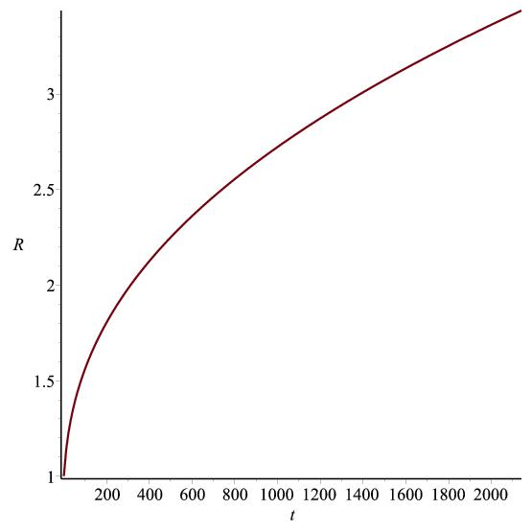

Figure 6.1: Graph of $R vs. t$ according to (6.20)

From eq. (6.20), we get

$q=-1+\frac{1}{Aα{(logt)}^{α-1}}+\frac{1-α}{Aα{(logt)}^{α}}$ (6.21)

Brans-Dicke scalar field is obtained as

$ϕ=ϕ_{0}e^{\frac{A(log{t)}^{α}}{ω}}$ (6.22)

The Gravitaional variable is

$G=\left(\frac{4+2ω}{3+2ω}\right){ϕ_{0}}^{-1}e^{-\frac{A(log{t)}^{α}}{ω}}$ (6.23)

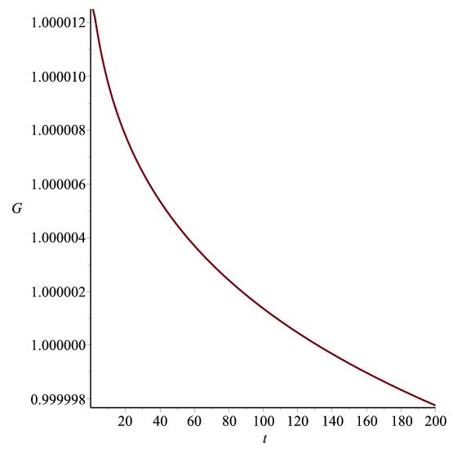

Figure 6.2: Graph of $G vs. t$ according to (6.23)

Spatial volume, Hubble's parameter and Scalar expansion are given by

$V=e^{3A(log{t)}^{α}}$ (6.24)

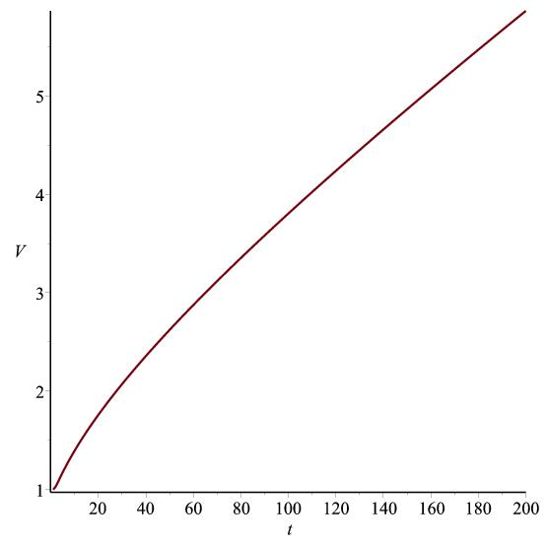

Figure 6.3: Graph of $V vs. t$ according to (6.24)

$H=\frac{Aα}{t}{(log t)}^{α-1}$ (6.25)

$Θ=\frac{3Aα}{t}{(log t)}^{α-1}$ (6.26)

The directional Hubble's parameter on the $x, y, z$ axes are

$H_{x}=H_{y}=H_{z}=\frac{Aα}{t}{(log t)}^{α-1}$ (6.27)

The anisotropy parameter, Shear scalar, Redshift and dynamical cosmological constant of the expansion are obtained as

$Δ=0$ (6.28)

This corresponds to isotropic expansion.

$σ^{2}=0$ (6.29)

This gives a shear free model.

$z=e^{-A(log{t)}^{α}}-1$ (6.30)

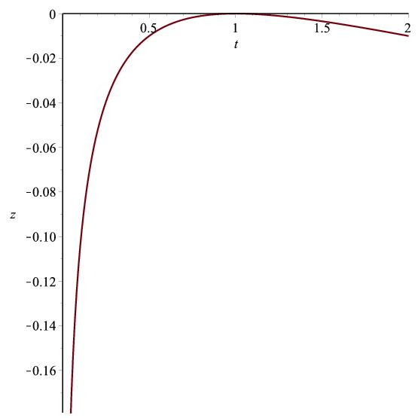

Figure 6.4: Graph of $z vs. t$ according to (6.30)

6.3.1 Case A: Flat model $k=0,$ $Λ=a{\left(\frac{\dot{R}}{R}\right)}^{2}+b\frac{\ddot{R}}{R}$

Using eq. (6.21) , eq. (6.18) becomes

${F^{2}}_{14}=\frac{ϕ_{0}e^{\frac{\left(1+2ω\right)A(log{t)}^{α}}{ω}}}{8π}\left[B_{1}{\left\{\frac{Aα}{t}{(log t)}^{α-1}\right\}}^{2}+B_{2}\left\{\frac{Aα}{t^{2}}{(log t)}^{α-1}+\frac{Aα(1-α)}{t^{2}}{(log t)}^{α-2}\right\}\right]$ (6.31)

where $B_{1}=\frac{\left\{4\left(a+b\right)-6\right\}ω+1}{ω} , B_{2}=4\left(1-b\right)$

$\overline{p}=-\frac{ϕ_{0}e^{\frac{A(log{t)}^{α}}{ω}}}{8π}\left[L_{1}{\left\{\frac{Aα}{t}{(log t)}^{α-1}\right\}}^{2}+L_{2}\left\{\frac{Aα}{t^{2}}{(log t)}^{α-1}+\frac{Aα(1-α)}{t^{2}}{(log t)}^{α-2}\right\}\right]$ (6.32)

$ρ=\frac{ϕ_{0}e^{\frac{A(log{t)}^{α}}{ω}}}{8π}\left[M_{1}{\left\{\frac{Aα}{t}{(log t)}^{α-1}\right\}}^{2}+M_{2}\left\{\frac{Aα}{t^{2}}{(log t)}^{α-1}+\frac{Aα(1-α)}{t^{2}}{(log t)}^{α-2}\right\}\right]$ (6.33)

Now limiting the distribution by considering Barotropic equation of state as

$p=\left(γ-1\right)ρ, 0≤γ≤2$ (6.34)

and using eq. (6.7), we obtain the explicit form of physical quantities $p$ and $η$ as

$ρ=\frac{\left(γ-1\right)ϕ_{0}e^{\frac{Bt^{β}}{ω}}}{8π}\left[M_{1}{\left\{\frac{Aα}{t}{(log t)}^{α-1}\right\}}^{2}+M_{2}\left\{\frac{Aα}{t^{2}}{(log t)}^{α-1}+\frac{Aα(1-α)}{t^{2}}{(log t)}^{α-2}\right\}\right]$ (6.35)

$η=\frac{ϕ_{0}e^{\frac{A(log{t)}^{α}}{ω}}}{24π}\left[N_{1}\left\{\frac{Aα}{t}{(log t)}^{α-1}\right\}+N_{2}\left\{1+\frac{(1-α)}{t(log t)}\right\}\right]$ (6.36)

where $N_{1}=\frac{\left\{6\left(γ-1\right)+\left(4-3γ\right)\left(a+b\right)\right\}ω^{2}+5ω+1}{ω^{2}}, N_{2}=\frac{\left\{\left(3γ-4\right)b+2\left(1-γ\right)\right\}ω-1}{ω}$

6.3.2 Case B: Open model $k=-1$ and $Λ=a{\left(\frac{\dot{R}}{R}\right)}^{2}+b\frac{\ddot{R}}{R}$

Using eq. (6.21) , eq. (6.18) becomes

${F^{2}}_{14}=\frac{ϕ_{0}e^{\frac{\left(1+2ω\right)A(log{t)}^{α}}{ω}}}{8π}\left[B_{1}{\left\{\frac{Aα}{t}{(log t)}^{α-1}\right\}}^{2}+B_{2}\left\{\frac{Aα}{t^{2}}{(log t)}^{α-1}+\frac{Aα(1-α)}{t^{2}}{(log t)}^{α-2}\right\}+6e^{-2A(log{t)}^{α}}\right]$ (6.37)

where $B_{1}=\frac{\left\{4\left(a+b\right)-6\right\}ω+1}{ω} , B_{2}=4\left(1-b\right)$

$\overline{p}=-\frac{ϕ_{0}e^{\frac{A(log{t)}^{α}}{ω}}}{8π}\left[L_{1}{\left\{\frac{Aα}{t}{(log t)}^{α-1}\right\}}^{2}+L_{2}\left\{\frac{Aα}{t^{2}}{(log t)}^{α-1}+\frac{Aα(1-α)}{t^{2}}{(log t)}^{α-2}\right\}+2e^{-2A(log{t)}^{α}}\right]$ (6.38)

$ρ=\frac{ϕ_{0}e^{\frac{A(log{t)}^{α}}{ω}}}{8π}\left[M_{1}{\left\{\frac{Aα}{t}{(log t)}^{α-1}\right\}}^{2}+M_{2}\left\{\frac{Aα}{t^{2}}{(log t)}^{α-1}+\frac{Aα(1-α)}{t^{2}}{(log t)}^{α-2}\right\}-3e^{-2A(log{t)}^{α}}\right]$ (6.39)

Now limiting the distribution by considering Barotropic equation of state as

$p=\left(γ-1\right)ρ, 0≤γ≤2$ (6.40)

and using eq. (6.7), we obtain the explicit form of physical quantities $p$ and $η$ as

$p=\frac{\left(γ-1\right)ϕ_{0}e^{\frac{A(log{t)}^{α}}{ω}}}{8π}\left[M_{1}{\left\{\frac{Aα}{t}{(log t)}^{α-1}\right\}}^{2}+M_{2}\left\{\frac{Aα}{t^{2}}{(log t)}^{α-1}+\frac{Aα(1-α)}{t^{2}}{(log t)}^{α-2}\right\}-3e^{-2A(log{t)}^{α}}\right]$ (6.41)

$η=\frac{ϕ_{0}e^{\frac{A(log{t)}^{α}}{ω}}}{24π}\left[N_{1}\left\{\frac{Aα}{t}{\left(\log{t}\right)}^{α-1}\right\}+N_{2}\left\{1+\frac{\left(1-α\right)}{t\left(\log{t}\right)}\right\}+(5-3γ)e^{-2A(log{t)}^{α}}\right]$ (6.42)

where $L_{1}=\frac{\left(a+b\right)ω^{2}-3ω+1}{ω^{2}}, L_{2}=\frac{bω+1}{ω}, M_{1}=\frac{6ω-3\left(a+b\right)ω+2}{ω}$, $M_{2}= 3b-$ 2,

$N_{1}=\frac{\left\{6\left(γ-1\right)+\left(4-3γ\right)\left(a+b\right)\right\}ω^{2}+5ω+1}{ω^{2}},$ $N_{2}=\frac{\{(3γ-4)b+2\left(1-γ \right)ω-1\}}{ω}$

Lastly we obtain the $Λ$ parameter as

$Λ=(a+b)\frac{Aα}{t}{\left(logt\right)}^{α-1}+b\left\{\frac{Aα}{t^{2}}{(logt)}^{α-1}+\frac{Aα(1-α)}{t^{2}}{(logt)}^{α-2}\right\}$ (6.43)

**6.4 Some physical models**

For both the Flat and Open model the line element comes out to be

$ds^{2}=dt^{2}-e^{2A(log{t)}^{α}}\left[\frac{dr^{2}}{1-kr^{2}}+r^{2}\left(dθ^{2}+\sin^{2}θ dφ^{2}\right)\right]$ (6.44)

where $k$ is the curvature index which can take values $-1,0$.

Corresponding to the three extreme cases of equation of state $p=\left(γ-1\right)ρ$, we discuss three physical models.

**6.4.1 Case I: False vacuum model $γ=0$**

We have the false vacuum model when $γ=0$. The cosmological model in this case is given by eq. (6.44) and the physical quantities in this case take the form

$ρ=-p=\frac{ϕ_{0}e^{\frac{A(log{t)}^{α}}{ω}}}{8π}\left[M_{1}{\left\{\frac{Aα}{t}{(log t)}^{α-1}\right\}}^{2}+M_{2}\left\{\frac{Aα}{t^{2}}{(log t)}^{α-1}+\frac{Aα(1-α)}{t^{2}}{(log t)}^{α-2}\right\}+3ke^{-2A(log{t)}^{α}}\right]$ (6.45)

$η=\frac{ϕ_{0}e^{\frac{A(log{t)}^{α}}{ω}}}{24π}\left[N_{1}\left\{\frac{Aα}{t}{\left(\log{t}\right)}^{α-1}\right\}+N_{2}\left\{1+\frac{\left(1-α\right)}{t\left(\log{t}\right)}\right\}-5ke^{-2A(log{t)}^{α}}\right]$ (6.46)

**6.4.2 Case II: Stiff fluid model $γ=2$**

For $γ=2$, the distribution reduces to the equation of state $ρ=p$ which is known as Zeldovich fluid or bulk viscous stiff fluid model. The cosmological model in this case is given by eq. (6.44) and the physical quantities in this case take the form

$ρ=p=\frac{ϕ_{0}e^{\frac{A(log{t)}^{α}}{ω}}}{8π}\left[M_{1}{\left\{\frac{Aα}{t}{(log t)}^{α-1}\right\}}^{2}+M_{2}\left\{\frac{Aα}{t^{2}}{(log t)}^{α-1}+\frac{Aα(1-α)}{t^{2}}{(log t)}^{α-2}\right\}+3ke^{-2A(log{t)}^{α}}\right]$ (6.47)

$η=\frac{ϕ_{0}e^{\frac{A(log{t)}^{α}}{ω}}}{24π}\left[N_{1}\left\{\frac{Aα}{t}{\left(\log{t}\right)}^{α-1}\right\}+N_{2}\left\{1+\frac{\left(1-α\right)}{t\left(\log{t}\right)}\right\}+ke^{-2A(log{t)}^{α}}\right]$ (6.48)

**6.4.3 Case III: Radiation model $γ=\frac{4}{3}$**

For $γ=\frac{4}{3}$, the distribution reduces to the special case with equation of state $\rho=3p$ which is known as Radiation dominated model. The cosmological model in this case is given by eq. (6.44) and the physical quantities in this case take the form

$ρ=\frac{ϕ_{0}e^{\frac{A(log{t)}^{α}}{ω}}}{8π}\left[M_{1}{\left\{\frac{Aα}{t}{(log t)}^{α-1}\right\}}^{2}+M_{2}\left\{\frac{Aα}{t^{2}}{(log t)}^{α-1}+\frac{Aα(1-α)}{t^{2}}{(log t)}^{α-2}\right\}+3ke^{-2A(log{t)}^{α}}\right]$ (6.49)

$p=3ρ=\frac{{3ϕ}_{0}e^{\frac{A(log{t)}^{α}}{ω}}}{8π}\left[M_{1}{\left\{\frac{Aα}{t}{(log t)}^{α-1}\right\}}^{2}+M_{2}\left\{\frac{Aα}{t^{2}}{(log t)}^{α-1}+\frac{Aα(1-α)}{t^{2}}{(log t)}^{α-2}\right\}+3ke^{-2A(log{t)}^{α}}\right]$ (6.50)

$η=\frac{ϕ_{0}e^{\frac{A(log{t)}^{α}}{ω}}}{24π}\left[N_{1}\left\{\frac{Aα}{t}{\left(\log{t}\right)}^{α-1}\right\}+N_{2}\left\{1+\frac{\left(1-α\right)}{t\left(\log{t}\right)}\right\}-ke^{-2A(log{t)}^{α}}\right]$ (6.51)

**6.5 Conclusion**

In this chapter, we have considered the logamediate form of Scale factor $R=e^{A(log{t)}^{α}}$ 
. This gives spatial volume as the exponential functions of time. This provides the exponential expansion of the universe, so the model universes are accelerating. Hubble's parameter and scalar expansion tend to zero as time tends to infinity for the range of $A$ and $α$ given by Barrow and Nunes (2007). The value of deceleration parameter also lies within the range of observational data as time increases. For $ω>40000$ (Reasenberg et al. 1979, Faraoni 2004, Calcagni et al. 2012) found that accelerated expansion of the model universe can be achieved. For all the models, the electromagnetic field component $F_{14}$ is an increasing function of time. Here the fluid density is positive which is again a function of time $t$ alone. Here, we find that the scalar field $ϕ$ is also increasing function of $t$ only. The gravitational variable $G$ is decreasing function of $t$ and as $t→∞$, $G→0$. For all model universes, the coefficient of bulk viscosity exists and the red-shift decreases with time. Here the cosmological constant decreases with time from large value at an initial epoch to small positive value at late time of evolution which in conformity with the experimental evidence. For $γ=0$ we can get false vacuum model. For $γ=2$ we get Stiff fluid model. For $γ=\frac{4}{3}$ we get Radiation dominated model.