**Chapter 7**

**Interaction of electromagnetic field and Brans-Dicke field in Robertson-Walker cosmological model with time-dependent deceleration parameter**

**7.1 Introduction**

The B-D theory has been used by Banerjee and Beesham (1997) to discuss exponential and power-law solutions for the flat Robertson-Walker cosmological model. Ahmadi-Azar and Riazi (1995), Etoh et. al. (1997), Singh and Beesham (1999), Banerjee and Pavon (2001), Chakraborty et al. (2003) investigated various B-D cosmological models. Also, many researchers (Bohra and Mehra 1978, Reddy and Rao 1981, Singh and Usham 1989, El-Nabulsi 2008, Pradhan et al. 2009, El-Nabulsi 2012, Pandolfi 2014, Tripathy et al. 2015) obtained cosmological model universes with the existence of electromagnetic field their papers. El-Nabulsi discussed relation concerning the dependence of the Hubble parameter with the scalar field has been discussed by in his number of papers ( El-Nabulsi 2010,2011,2013,2015). Pradhan et al. (2006) proposed the variable deceleration parameter as $q=-\frac{R\ddot{R}}{{\dot{R}}^{2}}=B(Variable)$ where $R$ is the average scale factor. With the help of variable deceleration parameter Yadav (2011) investigated string cosmological models. Later using different metric, researchers (Tripathi et al. 2012, Chawla et al. 2013, Ghate et al. 2015) have studied cosmological models with time-dependent deceleration parameter. Recently, Maurya et al. (2016) investigated anisotropic cosmological model with time-dependent deceleration parameter. In this chapter, we have investigated presence of electromagnetic field and B-D scalar field with time-dependent deceleration parameter for flat space-time.

**7.2 Metric and field equations**

The spherically symmetric Robertson-Walker metric is

$ds^{2}=dt^{2}-R^{2}(t)\left[\frac{dr^{2}}{1-kr^{2}}+r^{2}\left(dθ^{2}+\sin^{2}θ dφ^{2}\right)\right]$ (7.1)

where $k$ is the curvature index which can take values - $1,0, 1$.

The B-D theory of gravity is described by the action (in units $h=c = 8π G = 1$)

$S=\int{d^{4}x\sqrt{\left|g\right|}}\left[\frac{1}{16π}\left(ϕR-\frac{ω}{ϕ}g^{sl}ϕ_{,l}ϕ_{,s}\right)+L_{m}\right]$ (7.2)

where $R$ represents the curvature scalar; $g$ is the determinant of $g_{ij}$; $ϕ$ is a scalar field; $ω$ is a dimensionless coupling constant; $L_{m}$ is the Lagrangian of the ordinary matter component.

The Einstein field equations in the most general form are given by

$R_{ij}-\frac{1}{2}Rg_{ij}+Λ g_{ij}=-\frac{κ}{ϕ}T_{ij}-\frac{ω}{ϕ^{2}}[ϕ_{,i}ϕ_{,j}-\frac{1}{2}g_{ij}ϕ^{,s}ϕ_{,s}]-\frac{1}{ϕ}(ϕ_{ij}-g_{ij}{ϕ_{;s}}^{,s})$ (7.3)

where

$\left(3+2ω\right){ϕ_{;s}}^{,s}=8π T,$ (7.4)

where $T$ is the trace of $T_{ij}, Λ$ is the cosmological constant, $R_{ij}$ is Ricci-tensor, $g_{ij}$ is metric tensor and $ϕ_{,i}$ is the partial differentiation with respect to $x^{i}$ coordinate.

The energy-momentum tensor is

$T_{ij}=M_{ij}+E_{ij}$ (7.5)

where

$M_{ij}=(p+ρ)u_{i}u_{j}-pg_{ij},$ (7.6)

and

$E_{ij}=-F_{il}{F_{j}}^{l}+\frac{1}{4}g_{ij}F_{lm}F^{lm}$ (7.7)

with $u_{1}=u_{2}=u_{3}=0 , u_{4}=1, u_{i}$ is four velocity vector satisfying $g^{ij}u_{i}u_{j}=1$, $p$ is the pressure and $ρ$ is the energy density.

Here a comma $(,)$ or semicolon $(;)$ followed by a subscript denotes partial differentiation or a covariant differentiation respectively. Also the velocity of light is assumed as unity.

The non-vanishing electromagnetic energy-momentum tensor ${E_{j}}^{i}$ are

${E_{1}}^{1}=-{E_{2}}^{2}=-{E_{3}}^{3}={E_{4}}^{4}=-\frac{1}{2}g^{11}g^{44}{F_{14}}^{2}=\frac{1}{2}\frac{1-kr^{2}}{R^{2}}{F^{2}}_{14}$ (7.8)

Shear scalar is defined as

$σ^{2}=\frac{1}{2}\left(\sum_{i=1}^{3}{{H_{i}}^{2}}-3H^{2}\right)$ (7.9)

The average anisotropy parameter $Δ$ is defined as

$Δ=\frac{1}{3}\sum_{i=1}^{3}{{\left(\frac{H_{i}-H}{H}\right)}^{2}}$ (7.10)

where $H_{i},i=1,2,3$ represent the directional Hubble parameters in $x,y,z$ directions respectively.

Gravitational variable is defined as

$G=\frac{1}{ϕ}\left(\frac{4+2ω}{3+2ω}\right)$ (7.11)

The deceleration parameter is defined as

$q=-\frac{R\ddot{R}}{{\dot{R}}^{2}}$ (7.12)

**7.3 Solutions of field equations**

Assuming $\phi^{'}=0$, the metric (7.1) along with eqs. (7.3)-(7.5) gives

$\frac{k}{R^{2}}+\frac{{\dot{R}}^{2} }{R^{2}}+2\frac{\ddot{R}}{R}-Λ=-\frac{8π p}{ϕ}-\frac{4π}{ϕ}\frac{1-kr^{2}}{R^{2}}{F^{2}}_{14}-\frac{ω}{2}\frac{{\dot{ϕ}}^{2}}{ϕ^{2}}-2\frac{\dot{R}}{R}\frac{\dot{ϕ}}{ϕ}-\frac{\ddot{ϕ}}{ϕ}$ (7.13)

$3\left(\frac{k}{R^{2}}+\frac{{\dot{R}}^{2} }{R^{2}}\right)-Λ=\frac{8πρ}{ϕ}+\frac{4π}{ϕ}\frac{1-kr^{2}}{R^{2}}{F^{2}}_{14}+\frac{ω}{2}\frac{{\dot{ϕ}}^{2}}{ϕ^{2}}-3\frac{\dot{R}}{R}\frac{\dot{ϕ}}{ϕ}$ (7.14)

$(3+2ω)[3\frac{\dot{R}\dot{ϕ}}{R}+\ddot{ϕ}]=8π(ρ-3p),$ (7.15)

From eqs. (7.13), (7.14) and (7.15) we get

$6(\frac{k}{R^{2}}+\frac{{\dot{R}}^{2} }{R^{2}}+\frac{\ddot{R}}{R})-4Λ =-\frac{8π}{ϕ}\frac{1-kr^{2}}{R^{2}}{F^{2}}_{14}+ω [6\frac{\dot{R}}{R}\frac{\dot{ϕ}}{ϕ}+2\frac{\ddot{ϕ}}{ϕ}-\frac{{\dot{ϕ}}^{2}}{ϕ^{2}}]$ (7.16)

**7.4 Flat model $k=0$ and $Λ=0$**

We consider relation between scale factor $R$ and scalar field $ϕ$ in the context of Robertson-Walker Brans-Dicke model as

$ϕ={\left(\frac{ω+1}{2}\right)}^{\frac{1}{ω+1}}R^{\frac{2}{ω+1}}$ (7.17)

where $ω$ is coupling constant.

Using eq. (7.17), (7.16) becomes

${F^{2}}_{14}=\frac{{\left(\frac{ω+1}{2}\right)}^{\frac{1}{ω+1}}R^{\frac{2(ω+2)}{ω+1}}}{8π}\left[-\frac{4ω^{2}}{{(ω+1)}^{2}}\frac{{\dot{R}}^{2} }{R^{2}}+\frac{4ω}{ω+1}\frac{\ddot{R}}{R}\right]$ (7.18)

**7.5 Model with Time-dependent Deceleration Parameter**

We consider the time-dependent deceleration parameter (Pradhan et al. 2006, Yadav 2011, Tripathi et al. 2012, Chawla et al. 2013, Ghate et al. 2015, Maurya et al. 2016) as:

$q=-\frac{R\ddot{R}}{{\dot{R}}^{2}}=-1+m{sech}^{2}(αt)$ (7.19)

where $R$ is the scale factor, $α>0 , m>0$ are constants.

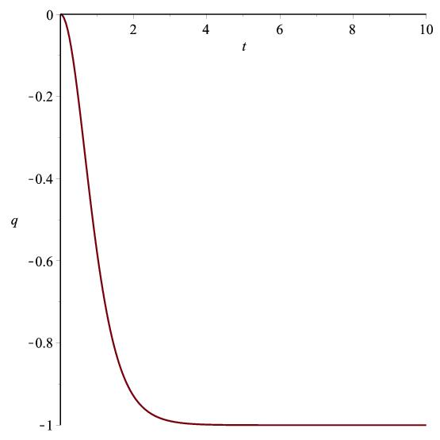

Figure 7.1: Graph of $q vs. t$ according to (7.19)

From eq. (7.19), we get

$R={\left[sinh⁡(αt)\right]}^{\frac{1}{m}}$ (7.20)

where $m$ is positive constant.

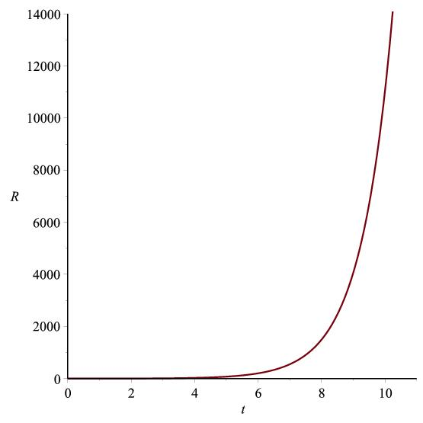

Figure 7.2: Graph of $R vs. t$ according to (7.20)

**7.6 Some Physical Properties of the model**

Brans-Dicke scalar field is

$ϕ={\left(\frac{ω+1}{2}\right)}^{\frac{1}{ω+1}}{\left[sinh⁡(αt)\right]}^{\frac{2}{m(ω+1)}}$ (7.21)

The Gravitaional variable is

$G=\left(\frac{4+2ω}{3+2ω}\right){\left(\frac{ω+1}{2}\right)}^{-\frac{1}{ω+1}}{\left[sinh⁡(αt)\right]}^{-\frac{2}{m(ω+1)}}$ (7.22)

Spatial volume is

$V={\left[sinh⁡(αt)\right]}^{\frac{3}{m}}$ (7.23)

Hubble's parameter is

$H=\frac{α}{m}coth⁡(αt)$ (7.24)

Scalar expansion is

$Θ=\frac{3α}{m}coth⁡(αt)$ (7.25)

The directional Hubble's parameter on the $x, y, z$ axes are

$H_{x}=H_{y}=H_{z}=\frac{α}{m}coth⁡(αt)$ (7.26)

The anisotropy parameter is

$Δ=0$ (7.27)

This corresponds to isotropic expansion.

Shear scalar is

$σ^{2}=0$ (7.28)

This gives a shear free model.

Red shift is

$z={\left[sinh⁡(αt)\right]}^{-\frac{1}{m}}-1$ (7.29)

Using eq. (7.20), eq. (7.18) becomes

${F^{2}}_{14}=\frac{{\left(\frac{ω+1}{2}\right)}^{\frac{1}{ω+1}}{\left[sinh⁡(αt)\right]}^{\frac{2(ω+2)}{ω+1}}}{8π}\left[\frac{4ω}{{(ω+1)}^{2}}\frac{α^{2}}{m^{2}}{coth⁡}^{2}(αt)-\frac{4ω}{ω+1}\frac{α^{2}}{m}{cosech⁡}^{2}(αt)\right]$ (7.30)

Using eqs. (7.20) and (7.21), eqs. (7.13) and (7.14) gives

$ρ=\frac{{\left(\frac{ω+1}{2}\right)}^{\frac{1}{ω+1}}{\left[sinh⁡(αt)\right]}^{\frac{2(ω+2)}{ω+1}}}{8π}\left[\frac{3ω^{2}+8ω+9}{{\left(ω+1\right)}^{2}}\frac{α^{2}}{m^{2}}\coth^{2}\left(αt\right)+\frac{2ω}{ω+1}\frac{α^{2}}{m}{cosech⁡}^{2}(αt)\right]$ (7.31)

$p=-\frac{{\left(\frac{ω+1}{2}\right)}^{\frac{1}{ω+1}}{\left[sinh⁡(αt)\right]}^{\frac{2(ω+2)}{ω+1}}}{8π}\left[\frac{5ω^{2}+16ω+11}{{(ω+1)}^{2}}\frac{α^{2}}{m^{2}}{coth⁡}^{2}(αt)-\frac{2(3ω+2)}{ω+1}\frac{α^{2}}{m}{cosech⁡}^{2}(αt)\right]$ (7.32)

**7.7 Conclusion**

In this chapter, we have considered a flat cosmological model with time-dependent deceleration parameter. Also, cosmological constant $Λ$ is taken to be absent. We observed that scale factor and spatial volume increases as time increases. i.e. the universe starts with zero volume at $t = 0$ and expands with cosmic time $t$. The parameters $H,Θ$ tends to zero for $t→∞$. Here the model is isotropic and shear free throughout the evolution of the universe. For this model universe, the electromagnetic field component $F_{14}→∞$ as time $t→∞$. The pressure and fluid density are functions of time t. For $ω>40000$ (Faraoni 2004, Calcagni et al. 2012 ) we found that the scalar field $ϕ$ is a increasing function of $t$ only. The gravitational variable tends to zero as time tends to infinity. Again, the deceleration parameter is positive for $t<α^{-1}\tanh^{-1}{(1-\frac{1}{m})}^{\frac{1}{2}}$ and negative for $t>α^{-1}\tanh^{-1}{(1-\frac{1}{m})}^{\frac{1}{2}}$. This indiactes that the model is decelerating at early phase and accelerating in later phase of time. Here fluid density is positive while pressure is found to be negative. Hence the dark energy model is consistent with the recent cosmological observations made by relativists. The red-shift is seen to decrease as time passes.