**Chapter 8**

**Viscous Robertson-Walker model with Polytropic equation of state and charge in Brans-Dicke Theory of Gravitation**

**8.1 Introduction**

The Brans-Dicke (B-D) theory (Brans and Dicke 1961) has been used by relativist (Azar and Riazi 1995, Etoh et al. 1997, Singh and Beesham 1999, Banerjee and Pavon 2001, Chakraborty et al. 2003) to study different cosmological models. Different authors ( Bohra and Mehra 1978, Reddy and Rao 1981, Jimanez et al. 2009, Bykov et al. 2012, Pandolfi 2014, Tripathy et al. 2015) have worked a lot on cosmological models with electromagnetic field. Different Polytropic gas models are investigated by some of the relativists ( Mukhopadhyay et al. 2008, Sarkar 2016, Kleidis and Spyrou 2015, Rahman and Ansari 2014, Rahman and Ansari 2014, Asadzadeh et al. 2014, Malekjani 2013,Malekjani and Khodam-Mohammadi 2012, Malekjani, Khodam-Mohammadi and Taji 2011). Al-Rawaft and Taha (1996), Al-Rawaft (1998), Overduin and Cooperstock (1998), Arbab (2003), Khadekar et al. (2006) are some of the many authors who studied cosmological models with variable cosmological constant $Λ$ term. In this chapter, we have investigated cosmological model with electromagnetic field with B-D field by using Polytropic equation of state. The energy density $(ρ),$ pressure $(p)$ and coefficient of bulk viscosity $(η)$ have been obtained for flat as well as closed models with $Λ=a{\left(\frac{\dot{R}}{R}\right)}^{2}+b\frac{\ddot{R}}{R}$.

**8.2 Metric and Field equations**

The spherically symmetric Robertson-Walker metric is

$ds^{2}=dt^{2}-R^{2}(t)\left[\frac{dr^{2}}{1-kr^{2}}+r^{2}\left(dθ^{2}+\sin^{2}θ dφ^{2}\right)\right]$ (8.1) where $k$ is the curvature index which can take values - $1,0, 1$.

The B-D theory of gravity is described by the action (in units $h=c = 8π G = 1$)

$S=\int{d^{4}x\sqrt{\left|g\right|}}\left[\frac{1}{16π}\left(ϕR-\frac{ω}{ϕ}g^{sl}ϕ_{,l}ϕ_{,s}\right)+L_{m}\right]$ (8.2)

where $R$ represents the curvature scalar; $g$ is the determinant of $g_{ij}$; $ϕ$ is a scalar field; $ω$ is a dimensionless coupling constant; $L_{m}$ is the Lagrangian of the ordinary matter component.

The Einstein field equations in the most general form are given by

$R_{ij}-\frac{1}{2}Rg_{ij}+Λ g_{ij}=-\frac{κ}{ϕ}T_{ij}-\frac{ω}{ϕ^{2}}[ϕ_{,i}ϕ_{,j}-\frac{1}{2}g_{ij}ϕ^{,s}ϕ_{,s}]-\frac{1}{ϕ}(ϕ_{ij}-g_{ij}{ϕ_{;s}}^{,s})$ (8.3)

where

$\left(3+2ω\right){ϕ_{;s}}^{,s}=κ T,$ (8.4)

where $κ=8π, T$ is the trace of $T_{ij}, Λ$ is the cosmological constant, $R_{ij}$ is Ricci-tensor, $g_{ij}$ is metric tensor and $ϕ_{,i}$ is the partial differentiation with respect to $x^{i}$ coordinate.

The energy-momentum tensor is

$T_{ij}=M_{ij}+E_{ij}$ (8.5)

where

$M_{ij}=(p+ρ)u_{i}u_{j}-pg_{ij},$ (8.6)

$\overline{p}=p-η{u^{i}}_{;i}$ (8.7)

and

$E_{ij}=-F_{il}{F_{j}}^{l}+\frac{1}{4}g_{ij}F_{lm}F^{lm}$ (8.8)

with $u_{1}=u_{2}=u_{3}=0 , u_{4}=1, u_{i}$ is four velocity vector satisfying $g^{ij}u_{i}u_{j}=1$, $p$ is the pressure , $ρ$ is the energy density and $F_{il}$ is the electromagnetic field component.

Here a comma $(,)$ or semicolon $(;)$ followed by a subscript denotes partial differentiation or a covariant differentiation respectively. Also the velocity of light is assumed as unity.

The non-vanishing electromagnetic energy-momentum tensor ${E_{j}}^{i}$ are

${E_{1}}^{1}=-{E_{2}}^{2}=-{E_{3}}^{3}={E_{4}}^{4}=-\frac{1}{2}g^{11}g^{44}{F_{14}}^{2}=\frac{1}{2}\frac{1-kr^{2}}{R^{2}}{F^{2}}_{14}$ (8.9)

Shear scalar is defined as

$σ^{2}=\frac{1}{2}\left(\sum_{i=1}^{3}{{H_{i}}^{2}}-3H^{2}\right)$ (8.10)

The average anisotropy parameter $Δ$ is defined as

$Δ=\frac{1}{3}\sum_{i=1}^{3}{{\left(\frac{H_{i}-H}{H}\right)}^{2}}$ (8.11)

where $H_{i},i=1,2,3$ represent the directional Hubble parameters in $x,y,z$ directions respectively. Gravitational variable (Weinberg 1972) is defined as

$G=\frac{1}{ϕ}\left(\frac{4+2ω}{3+2ω}\right)$ (8.12)

The deceleration parameter is defined as

$q=-\frac{R\ddot{R}}{{\dot{R}}^{2}}$ (8.13)

**8.3 Solutions of field equations**

Assuming Brans-Dicke scalar field $ϕ$ to be a function of time $t$ only, the metric (8.1) along with field equations (8.3)-(8.5) gives

$\frac{k}{R^{2}}+\frac{{\dot{R}}^{2} }{R^{2}}+2\frac{\ddot{R}}{R}-Λ=-\frac{8π \overline{p}}{ϕ}-\frac{4π}{ϕ}\frac{1-kr^{2}}{R^{2}}{F^{2}}_{14}-\frac{ω}{2}\frac{{\dot{ϕ}}^{2}}{ϕ^{2}}-2\frac{\dot{R}}{R}\frac{\dot{ϕ}}{ϕ}-\frac{\ddot{ϕ}}{ϕ}$ (8.14)

$3\left(\frac{k}{R^{2}}+\frac{{\dot{R}}^{2} }{R^{2}}\right)-Λ=\frac{8πρ}{ϕ}+\frac{4π}{ϕ}\frac{1-kr^{2}}{R^{2}}{F^{2}}_{14}+\frac{ω}{2}\frac{{\dot{ϕ}}^{2}}{ϕ^{2}}-3\frac{\dot{R}}{R}\frac{\dot{ϕ}}{ϕ}$ (8.15)

$(3+2ω)[3\frac{\dot{R}\dot{ϕ}}{R}+\ddot{ϕ}]=8π(ρ-3\overline{p}),$ (8.16)

From eqs. (8.13), (8.14) and (8.15), we get

$6(\frac{k}{R^{2}}+\frac{{\dot{R}}^{2} }{R^{2}}+\frac{\ddot{R}}{R})-4Λ =-\frac{8π}{ϕ}\frac{1-kr^{2}}{R^{2}}{F^{2}}_{14}+ω [6\frac{\dot{R}}{R}\frac{\dot{ϕ}}{ϕ}+2\frac{\ddot{ϕ}}{ϕ}-\frac{{\dot{ϕ}}^{2}}{ϕ^{2}}]$ (8.17)

Here, we consider

$ϕ=ϕ_{0}R^{\frac{1}{ω}}$ (8.18)

$ϕ_{0}$ is a constant.

Using eq. (8.17), (8.16) becomes

${F^{2}}_{14}=\frac{ϕ_{0}}{8π}\frac{R^{\frac{1+2ω}{ω}}}{1-kr^{2}}\left[\left(\frac{1-2ω}{ω}\right)\frac{{\dot{R}}^{2} }{R^{2}}-4\frac{\ddot{R}}{R}-\frac{6k}{R^{2}}+4Λ\right]$ (8.19)

We assume the scale factor (Pasqua and Chattopadhyay 2013, Barrow and Liddle 1993) as

$R=e^{Bt^{β}}$ (8.20)

where $B, β$ are positive constant parameters satisfying the conditions $Bβ>0, B>0$ and $0<β<1$.

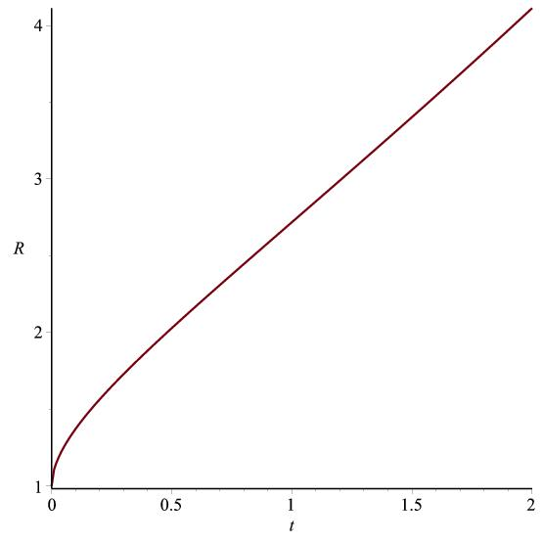

Figure 8.1: Graph of $R vs. t$ according to (8.20)

From eq. (8.20) and (8.13), we get

$q=-1+\frac{1-β}{Bβt^{β}}$ (8.21)

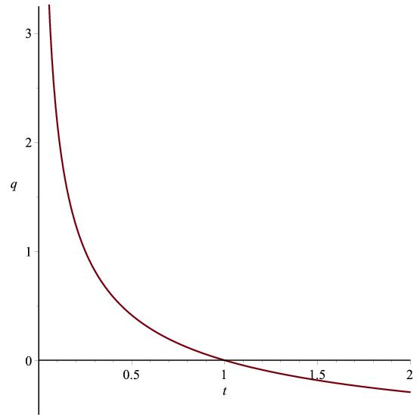

Figure 8.2: Graph of $q vs. t$ according to (8.21)

Brans-Dicke scalar field is

$ϕ=ϕ_{0}e^{\frac{Bt^{β}}{ω}}$ (8.22)

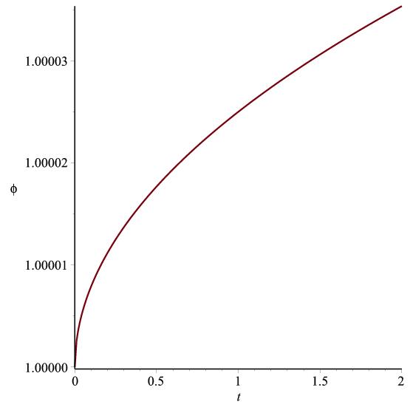

Figure 8.3: Graph of $ϕ vs. t$ according to (8.22)

The Gravitaional variable is

$G=\left(\frac{4+2ω}{3+2ω}\right){ϕ_{0}}^{-1}e^{-\frac{Bt^{β}}{ω}}$ (8.23)

Spatial volume, Hubble's parameter and Scalar expansion are given by

$V=e^{3Bt^{β}}$ (8.24)

$H=\frac{Bβ}{t^{1-β}}$ (8.25)

$Θ=\frac{3Bβ}{t^{1-β}}$ (8.26)

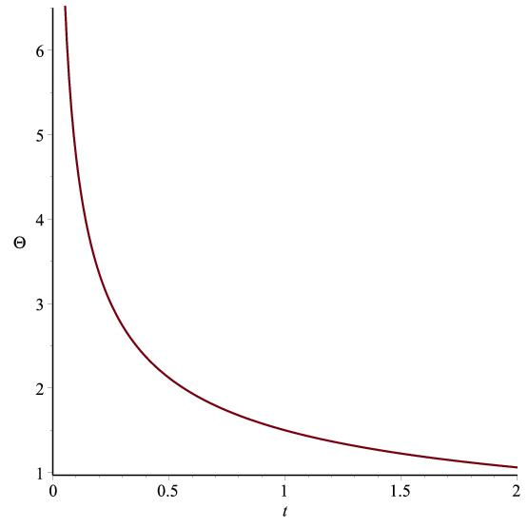

Figure 8.4: Graph of $Θ vs. t$ according to (8.26)

The directional Hubble's parameter on the $x, y, z$ axes are

$H_{x}=H_{y}=H_{z}=\frac{Bβ}{t^{1-β}}$ (8.27)

The anisotropy parameter, Shear scalar, Red shift and dynamical cosmological constant of the expansion are obtained as

$Δ=0$ (8.28)

This corresponds to isotropic expansion.

$σ^{2}=0$ (8.29)

which gives shear free model.

$z=e^{-Bt^{β}}-1$ (8.30)

**8.3.1 Case I: Flat model $k=0$, $Λ=a{\left(\frac{\dot{R}}{R}\right)}^{2}+b\frac{\ddot{R}}{R}$**

Using eq. (8.21) , eq. (8.18) becomes

${F^{2}}_{14}=\frac{ϕ_{0}e^{\frac{\left(1+2ω\right)Bt^{β}}{ω}}}{8π}\left[B_{1}{\left(\frac{1}{t^{1-β}}\right)}^{2}+B_{2}\frac{1}{t^{2-β}}\right]$ (8.31)

where $B_{1}=\frac{\left\{4\left(a+b\right)-6\right\}ω+1}{ω}B^{2}β^{2} , B_{2}=4\left(1-b\right)\left(1-β\right)Bβ$

$\overline{p}=-\frac{ϕ_{0}e^{\frac{Bt^{β}}{ω}}}{8π}\left[L_{1}{\left(\frac{1}{t^{1-β}}\right)}^{2}+L_{2}\frac{1}{t^{2-β}}\right]$ (8.32)

$ρ=\frac{ϕ_{0}e^{\frac{Bt^{β}}{ω}}}{8π}\left[M_{1}{\left(\frac{1}{t^{1-β}}\right)}^{2}+M_{2}\frac{1}{t^{2-β}}\right]$ (8.33)

Now, restricting the distribution by considering Polytropic equation of state as

$p=αρ^{n}$ (8.34)

where $α$ and $n$ are polytropic constant and index respectively.

and using eq. (8.7), we obtain the explicit form of physical quantities $p$ and $η$ as

$p=α{\left[\frac{ϕ_{0}e^{\frac{Bt^{β}}{ω}}}{8π}\left\{M_{1}{\left(\frac{1}{t^{1-β}}\right)}^{2}+M_{2}\frac{1}{t^{2-β}}\right\}\right]}^{n}$ (8.35)

$η=\frac{αt^{1-β}}{3Bβ}{\left[\frac{ϕ_{0}e^{\frac{Bt^{β}}{ω}}}{8π}\left\{M_{1}{\left(\frac{1}{t^{1-β}}\right)}^{2}+M_{2}\frac{1}{t^{2-β}}\right\}\right]}^{n}+\frac{ϕ_{0}t^{1-β}e^{\frac{Bt^{β}}{ω}}}{24Bβπ}\left[L_{1}{\left(\frac{1}{t^{1-β}}\right)}^{2}+L_{2}\frac{1}{t^{2-β}}\right]$ (8.36)

**8.3.2 Case II: Open model $k=-1$ and $Λ=a{\left(\frac{\dot{R}}{R}\right)}^{2}+b\frac{\ddot{R}}{R}$**

Using eq. (8.21) , eq. (8.18) becomes

${F^{2}}_{14}=\frac{ϕ_{0}e^{\frac{\left(1+2ω\right)Bt^{β}}{ω}}}{8π(1+r^{2})}\left[B_{1}{\left(\frac{1}{t^{1-β}}\right)}^{2}+B_{2}\frac{1}{t^{2-β}}+6e^{-2Bt^{β}}\right]$ (8.37)

where $B_{1}=\frac{\left\{4\left(a+b\right)-6\right\}ω+1}{ω}B^{2}β^{2} , B_{2}=4\left(1-b\right)\left(1-β\right)Bβ$

$\overline{p}=-\frac{ϕ_{0}e^{\frac{Bt^{β}}{ω}}}{8π}\left[L_{1}{\left(\frac{1}{t^{1-β}}\right)}^{2}+L_{2}\frac{1}{t^{2-β}}+{2e}^{-2Bt^{β}}\right]$ (8.38)

$ρ=\frac{ϕ_{0}e^{\frac{Bt^{β}}{ω}}}{8π}\left[M_{1}{\left(\frac{1}{t^{1-β}}\right)}^{2}+M_{2}\frac{1}{t^{2-β}}-3e^{-2Bt^{β}}\right]$ (8.39)

Again, restricting the distribution by considering Polytropic equation of state as

$p=αρ^{n}$ (8.40)

and using eq. (8.7), we obtain the explicit form of physical quantities $p$ and $η$ as

$p=α{\left[\frac{ϕ_{0}e^{\frac{Bt^{β}}{ω}}}{8π}\left\{M_{1}{\left(\frac{1}{t^{1-β}}\right)}^{2}+M_{2}\frac{1}{t^{2-β}}-3e^{-2Bt^{β}}\right\}\right]}^{n}$ (8.41)

$η=\frac{αt^{1-β}}{3Bβ}{\left[\frac{ϕ_{0}e^{\frac{Bt^{β}}{ω}}}{8π}\left\{M_{1}{\left(\frac{1}{t^{1-β}}\right)}^{2}+M_{2}\frac{1}{t^{2-β}}-3e^{-2Bt^{β}}\right\}\right]}^{n}+\frac{ϕ_{0}t^{1-β}e^{\frac{Bt^{β}}{ω}}}{24Bβπ}\left[L_{1}{\left(\frac{1}{t^{1-β}}\right)}^{2}+L_{2}\frac{1}{t^{2-β}}+{2e}^{-2Bt^{β}}\right]$ (8.42)

where $L_{1}=\frac{\left(a+b\right)ω^{2}+3ω+1}{ω^{2}} ,L_{2}=\frac{bω+1}{ω}, L_{1}=\frac{6ω-3\left(a+b\right)ω+2}{ω}B^{2}β^{2}, M_{2}=\left(3b-2\right)\left(1-β\right)Bβ$.

Cosmological constant takes the form

$Λ=a{\left(\frac{Bβ}{t^{1-β}}\right)}^{2}+b\frac{Bβ(β-1)}{t^{2-β}}$ (8.43)

where $.5≤a≤1,.5≤b≤1$ and $1.5≤a+b≤2.$

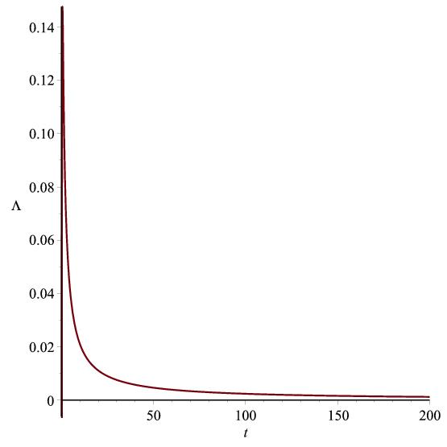

Figure 8.5: Graph of $Λ vs. t$ according to (8.43)

**8.4 Conclusion**

In this chapter, we have assumed scale factor as $R=e^{Bt^{β}}$  
. So, spatial volume becomes exponential function of time and tends to infinity as $t→∞$, so the model universes are expanding with acceleration. Hubble's parameter and scalar expansion tend to zero as time tends to infinity. The deceleration parameter changes from positive to negative value as time tends to infinity. For all the cases accelerated expansion can be found for large values of $ω$. For both the models, $F_{14}$ increases as time increases. Here the fluid density is positive and increase as time increases. From equation (8.22), we observe that the scalar field $ϕ→∞$ as $t→∞$. The gravitational variable $G$ decreases as time passes and for $t→∞$, $G→0$. This helps in expanding the model universe. For both the universes, the red-shift is seen to decrease as time increases. For $α=0$, we have $p = 0$, any value of $n$ in the equation of state so we can say that for dust-filled Universe, there is no distinction between barotropic and polytropic equations of state. For non-dust cases we get dark energy models as phantom energy ($α<-1$) or quintessence $(-1<α<0)$ or vacuum fluid $(α=-1)$. So, using the polytropic equation of state it has been possible to show that non-dust cases admit the presence of a driving force behind inflation in the form of either quintessence or vacuum fluid or phantom energy and in the dust cases there is no distinction between different equations of states. The $Λ$ term decreases with time from a large value at an initial stage to a small positive value at the late time of evolution.