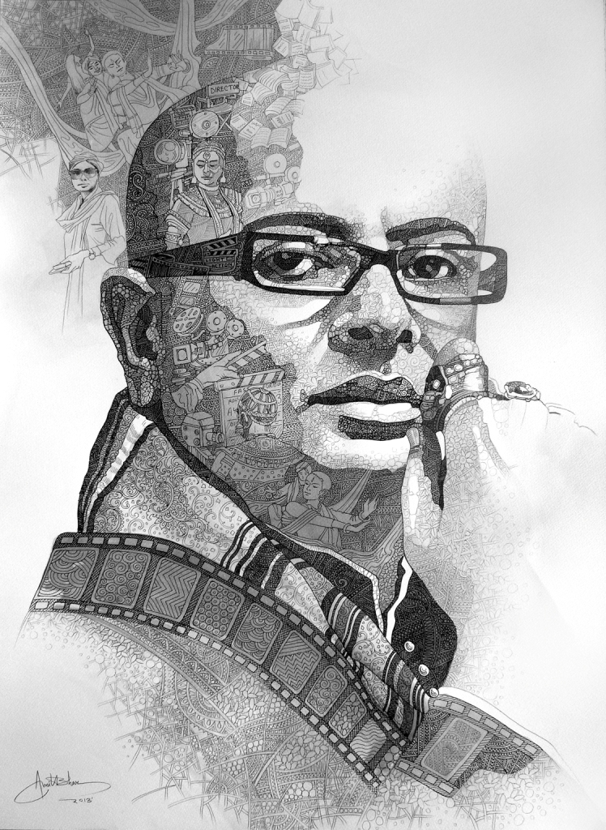

Rituparno Ghosh (1963-2013)

Picture courtesy: Google Images