CHAPTER-I
Introduction

  - Introduction
Study of nutritional qualities of small fishes is an important aspect in context with life food security. Fish is one of the important sources of animal protein and also many nutrients which are essentially required in human diets (Fawolee et al., 2007). Fishes are consumed by large number of population throughout the world. Fish tissues contain fats, proteins, vitamins, minerals and many other vital components of balanced diet (Stancheva et al., 2010). Vital nutritional components of human body are provided by the fish food. Fishes play the key role of energy supplement for the human beings (Ojewola 2006; Suthershiny 2011). Fish proteins are easily digestible and stated to be the supplement of the protein needs of human body (Abdul et al., 2012). Nutritionists recommend that people should include fish in their daily diets (Blanchet et al., 2000; Balk 2004). Risks of life threatening diseases like cancer, dementia, Alzheimer’s disease (Grant, 1997) are minimized by the regular consumption of fish. The defence mechanism for protection against invasion of human pathogens is increased by the intake of fish in human diet due to the presence of antimicrobial peptides (Ravichandran et al., 2010). Breast feeding mothers who consume fish regularly are blessed with babies having better eyesight. It may be due to the omega-3 fatty acids transmitted to breast milk. Fish foods prevent the cardiovascular diseases (Cahu et al., 2004). Fishes are enriched in vitamins and minerals equally required for both young and old age people (Edem 2009; Meghadedan et al., 2007). Fishes show an excellent role in the prevention of kwashiorkor and marasmus, a chronic disease originated by the protein-calorie malnutrition (Mahanty et al., 2012). Many of researchers studied that fish oil contain high amount of poly unsaturated fatty acids that are essential in lowering the serum cholesterol for the prevention of coronary heart diseases (Nordov et al.,2001; Turkmen et al.,2005).Many researchers concluded that fish oil may be used in the treatment of dis-lipidemia in diabetes. Consumption of fish during pregnancy plays the role of reducing the risk of delivering premature baby (Olsen & Secher, 2002). Fish food is enriched in good quality and highly digestible proteins made of ten essential amino acids in required quantities for human consumption. It had been scientifically inferred by many studies that fishes contain important omega-3 fatty acids ,vitamins A,B,D&E and also many vital minerals like iron, copper, iodine, calcium, zinc, potassium, phosphorus which are essential food supplements for adults as well as infants (Ackman et al.,1988; Huss,1988; Owaga et al., 2010;Salito et al.,1997). Fish industries might be assumed to contribute positively towards the prevention of food insecurity if they are scientifically developed (Owaga et al.,2010).
According to (CSIR, 1962) fish flesh contains upto 15-25% protein, 80% water,1-2% mineral matter. As per (FAO, 1991) report it was established that fish contains 72% water,19%protein & 5% calcium . In amounting the weight of food consumed, fish stands in the third position after rice and vegetables (Minkin et al., 1997; Hels et al.,2002). Rice donot contain the nutrients like Vitamin A and C. The minerals such as iron, calcium, zinc and iodine are also not obtained from rice. These must be obtained from other sources. Small fishes are eaten whole with bones and heads ,the organs rich in calcium iron and zinc..The small indigenous fishes were investigated to be the key source of vitamin A (Thilsted et al., 1997). They show a great importance as a vital source of micronutrients as like as calcium, zinc, iron and fatty acids (Roos et al., 2003) to the rural poor people as well as an opportunity for livinghood of many fishers. Nutritional and medicinal knowledge about these fishes are traditionally high amongst the villagers. Such species are considered as very important part of the diet for a pregnant lady or lactating mother in the rural area. The scientific information about the small fishes is most essential for quality control purposes in the processing industries (Ray et al., 2014). Fishes are not only used as food but also highly demanded for use as feed (Daniel et al., 2015). Fish meat is found to contain low lipid and high water as compared to the beef or chicken (Nestel et al., 2000). Fish lipids are prime source of long chain polyunsaturated fatty acids which cannot be synthesized by human body (Alasalvar et al., 2012) . These polyunsaturated fatty acids are reported to be effective in the prevention of arterial hypertension, cancers and inflammatory diseases (Turkmen et al., 2005). The analysis of biochemical composition of the freshwater fishes is very important for the nutritionists. They are in search of most abundant sources of foods of low cost and containing high protein as the fresh species of small fishes (Mozaffarian et al., 2003; Foran et al., 2005). The proper estimation of nutrients contained in the fishes are of high interest to the food scientists who undergo researches in developing them into high grade animal protein ensuring the best quality flavor, colour, odour, texture and safety obtainable with maximum nutritive value (Elagba et al.,2010). Proximate composition is the analysis of water, ash, protein and fat contents of fish (Ali ,2012) . For centuries, fishes are recognized as a perfect diet for human being because of having higher contents of unsaturated fatty acids, essential amino acids and important minerals for the formation of functional and structural proteins (Kumar, 1992) . Most of the essential nutrients for the high health status of human body are provided by fish (Andrew, 2001). In India fishes play a significant role for the livelihood baskets. Small indigenous fishes are very much enriched in nutrients. Previously these small fish species were overlooked for their low price and commercial unimportance. In present time, they receive good interests by the researchers and are included in planned farming as well. The small fishes are the source of protein and most of the fat soluble vitamins for the rural poor people (Hossain & Afsana, 1999).
The lacking in sufficient protein is the major nutritional deficiencies in many tropical countries (Eyo, 2001 ). Fish meat contains all of the essential amino acids. The protein content of fish have its importance in the qualitative analysis & texture of fish meat (Mozid , 2001).Fishes are energetic in the form of lipids. Good amount of polyunsaturated fatty acids in the fish oil help in reducing the serum cholesterol which prevent many coronary heart diseases. Generally marine fishes contain more minerals than fresh water fishes (Omotosho, 1995). The n-3 PUFAs are greatly used for neurodevelopment, brain functioning and eye health for the infants (Conner, 2000; Gokce, 2004). The fishes under the extensive and semi intensive conditions have higher nutritive values for human consumption in comparison to the ones found in the wild (Ahmed et al., 2012).
Fishes are one of the stable items in the diet of many people. India stands in the ninth position as the country of fresh water mega biodiversity (Mitterneier & Mittermeier, 1997). The northeastern region of India is declared to be one of the hotspots of fresh water fish biodiversity in the world (Kottelat & Whitten, 1996; Ramanujam et al., 2010). The state of Assam forms about 30% of the north east region and is enriched with Brahmaputra and Barak system with a number of tributaries.
Fish quality is measured by the nutritional excellence possessed by the fish (Kaiser et al., 2017). Fish have the energy gradient in the form of lipids. The amount of protein in fish muscle is generally 15 to 20 percent (Anusuya et al., 2014). Normally the nutritional values of a freshwater living fish detoriates when it is cooked with salt (Farid et al., 2016). A set of complex biochemical procedures occur during salt ripening of fishes and these physicochemical changes evaluate the total sensory qualities of salted fish products (Farid et al., 2016). Fish feed makes about halves of the total cost of fish production (Craig et al., 2002). Sustainability of the industry of aquaculture mainly depends on the sources of feeds and management ( Magondu et al., 2016). Besides the nutritional value, fish is an excellent source of income (Teame et al., 2016). Generally, the knowledge about the chemical composition of fish species is essential to the concerned nutritionists with easily available sources of low fat, high protein foods. In general, the composition of live-weight, whole fish is 70-80% water 20-30% protein and 2-12% lipid (Das & Sahu, 2001). Quantification of the proximate profiles of a fish ensures their ability to meet up the need of food regulations and commercial specification. The scientific documentation of biochemical composition is very important to calculate the energy value of the fish such that properly planning is done for the sake of industrial us well as commercial processing (Tsegay Teame et al., 2016). Fish are one of the cheapest sources of protein enriched with almost all the essential amino acids (Funmilayo, 2016). The amino acids are vitally needed for foctal development and growth. Dietary protein and the amino acids are required mainly for growth, metabolism and maintenance especially in young ones (Adefemi, 2011). The essential amino acids are the first indicator of protein quality (Chukwuemeka, 2008). The nutritional as well as medicinal status of fish products are highlighted by the contents of proteins, lipids, minerals and vitamins (Njinkoue et al., 2016). The fair contents of protein present in the fish flesh make them Biologically valuable (Salma et al., 2015). Being one of the potentially significant sources of health nutrients, fish is vitally important for diversified and healthy diets (Karl et al., 2016). For the rapid rise in population and environmental fluctuations, the aquatic lives are in crisis. As a result the gap between the demand and supply of fish is maximized. The poor people can not include the fishes in their regular food item (Mazumder et al, 2016). Generally, fish is low in saturated fats, carbohydrates and cholesterol.
Fish species are able to increase the biomass within a shorter time period. Rather than omega-3- fatty acids, fish lipids also contain fat soluble vitamins which are exclusively provided by the fish food. Omega-3 and Omega-6 fatty acids jointly play a vital role in the development of brain function and acceleration of the normal growth. Polyunsaturated fatty acids ( PUFAs) enhance skin and hair growth, smoothens bone and reproductive health and help in regulating metabolism process (Stancheva et al., 2010) . The nutritive qualities of the fishes are known by the knowledge of its amino acid composition (Romharsha, 2014). Fish also contains a good bundle of lysine which is low in cereal, milk or any other foods (FAO, 2005). Fish food provides the important minerals including selenium, calcium, iron, phosphorus etc.
Fish makes up almost half of the total number of vertebrates in the world. India is one of the mega biodiversity countries in the world (Mittermeier & Mittermeir., 1997). The northeast part of India has been specified as a hotspot of biodiversity by the World Conservation Monitoring Centre (WCMC, 1998). The hills and the undulating valley of the northeast region creates many torrential hills streams leading to popular large rivers that constitute part of the Ganga-Brahmaputra-Barak-Chindwin-Kolodyne-Gomatie-Meghna system (Kar., 2003).The conservation Assessment and Management Plan Workshop (Molur & Walker, 1993) made valuable contributions to assess the status of selected fishes of northeast India. However no detailed systematic fish inventory has been available on the ichthyo fauna of Kokrajhar district BTAD, Assam.
Adverse effect of environment, climate changes, increasing water temperature (Parihar & Dubey, 1995) are declining the water level of different rivers, ponds and other water bodies (Dubey et al., 2011).Tremendous use of pesticides and xenobiotic compound (Dubey,1995) negatively fall on the fish communities. The fisheries productivities are affected by the city garbages and garlanding in the aquatic bodies. The number of fish species in the aquatic ecosystem is declined. Recently many new species have been documented from the states of northeast India (Sen & Biswas, 1994; Biswas, 1997; Menon, et al 2000; Vishwanath & Shanta., 2004) opening the scope for exploring on the nutritional qualities of the fishes. The fish food is included in the diet of almost all the communities of all religions of the country. The analysis of the quality of fish food will ensure the people about their food values and the required quantities of consumption of fish foods in different age groups. Although many more researches have been done on the nutritional status of fish foods, but less studies have been reported so far on the small fish species.
The present study mainly aimed at the study of the nutritional contents of the small fish species available in the Korkrajhar district BTAD, Assam. These fishes are commercially unexploited. The well known popular large fishes are mostly attractive to study and also to exploit from the commercial point of view. Due to their high price they are not affordable by the common people, specially the poor villagers. They consume the small fishes deliciously and also sail in market to maintain their livelihood.
The nutritional composition of fish varies largely from one species to another species depending on age, feed intake, sex and sexual changes connected with spawning the environment and season. Fish belongs to high protein and low lipid class. According to the research studies fish foods contain low caloric content per unit of protein than do lipid and they provide the animal protein for use in contolled diets (Silva et al., 1991)
Small indigenous fish species are defined as these of having maximum length of 25cm (Felt et al., 1998; Roos et al., 2003). In many parts of the world including India, a large diversity of small fishes are found in open waters and closed water bodies. The small indigenous species are reachable to the poor and rural classes of the country due to their low price and maximum availability. Researchers suggest that these are major source of protein and micro-nutrients like calcium, zinc, iron and fatty acids (Roos et al., 2003). In many parts of our country basically amongst the rural societies, such species are often considered as essential part of the diet of pregnant woman and lactating mothers. Moreover the fish species also posses several antioxidant activity (Ray et al.,2014). The small fish species are thus excellent sources of nutrient and antioxidant. Fish flesh is easily digestible due to its long muscle fibres. Fish foods have been linked to health benefits like some types of cancer, including colon, breast and prostate (Marchioli et al., 2002; Sidhu et al., 2003).
1.2 Structure of fish muscle
Fish muscle is comprised of moisture, protein and fat as a major nutrient components and carbohydrates, vitamins and minerals as minor components. That is why most of the nutrient components essential for human body is found in fish muscle. Animal protein is associated with ten essential amino acids in desirable quantity for human consumption. Fish protein is enriched with such amino acid as methionine, lysine and low in tryptophan in comparison to mammalian protein (Nowsad, 2007).
The diagram of a cod fillet reveals the surface that is adjacent to the skeleton. The mechanical construction is typical of all white fish in which the fat is stored in the liver. The blocks of muscle forming the individual flakes in the cooked fish are separated by connective tissues.These are curved in the fillet running from the backbone to the skin. The muscle blocks in a fresh fish are tightly attached to the connective tissues and the surface of a cut fillet is finely smooth. There are also tiny blood vessels which run through the muscle .Out of the total weight of the muscle the connective tissue makes for only a small percentage .This may be the reason of why fish is softer to eat than meat.
There are two kinds of fish muscle , light muscle and dark muscle. In white fishes there is a small strip of dark or red muscle under the skin on both sides which run beneath the lateral line .In fatty fishes the strips of dark muscles are larger in proportion containing higher concentrations of fats and vitamins. When fishes are prepared for cooking it is not usually possible to separate the dark fatty muscle from light muscle.

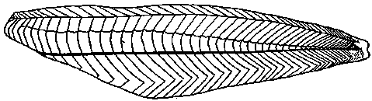
Fig.: 1.1 Fish muscle
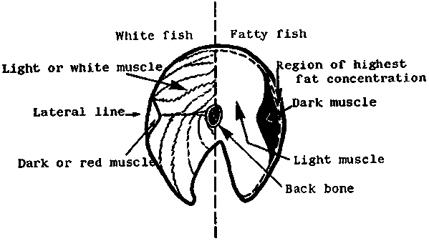
Fig. 1.2 White Fish muscle (FAO CORPORATE DOCUMENT REPOSITORY)

Fisheries especially provide food when other food sources are at a seasonal crisis (Babalola et al., 2011). Moreover, consumption of fish has been related to health benefits as the long chain PUFA is of great attention in the field of prevention of human coronary artery diseases, improvement of retina and brain development, decreased incidence of breast cancer, rheumatoid, arthritis, multiple sclerosis, asthma, psoriasis, inflammatory bowel disease and regulation of prostaglandin synthesis (Dhaneesh et al., 2012). Recent studies have shown that fish protein is said to be of excellent quality with a higher biological value. Fishes play a significant role in the development of neuron in infants and in fat glycomic control (Mozaffarian et al., 2005). It had been estimated that about 80% of the animal protein in our diet comes from fish (Begum M et al., 2010).
1.3 Principal components of fish muscle
The principal components of fish muscle are –
Water- Approximately 80% of the weight of a fresh fish fillet is constituted by water but average content of water of fatty fish is about 70%. In fresh fish muscle the water content is strongly bound to the proteins and cannot be easily removed even under higher pressure. However, some of the water contents may be lost which contains dissolved substances. When the spawning time approaches in the living fishes, water contents increases where as protein content decreases
Protein- Approximated protein contents in the fish muscle are usually 15 to 20%, but in some rare species the values are lower than 15% or higher than 28%. Some of the amino acids are essentially required in human diet for the good health. Moreover, for the economic utilization of a diet, amino acids must be present in requisite proportions. Fish proteins are generally enriched in two essential amino acids called lysine and methionine. Thus fish food provides good nutritional requirements to human diet and is favourably compared with that provided by meat, milk and eggs.
Fats- The ratio of highest to lowest fat values is more than 300 to 1 (FAO, 2001). Fatty fishes usually show remarkable seasonal variations in the fat content. The water content of a fish generally falls with the rise in fat content maintaining a constant value between the sum of water and fat values at about 80%. But the protein content of a fish is directly proportional to the fat content. The fat values of fatty fishes are not distributed uniformly throughout the flesh of the species. The fat content of the muscle of a white liver is usually below 1%.
The minor components of fish muscle includes-
- Carbohydrates
- Minerals & vitamins
Carbohydrates- In white fish muscle carbohydrate content is generally too small to play a significant role in the human diet.
Minerals &Vitamins- Minerals & vitamins have vital importance in the human diet not only to upgrade a good health but also for the maintenance of life itself. Fish provides well balanced set of minerals in usable form. There are two groups of vitamins. Some are fat soluble such as Vit A, D, E & K and some are water soluble such as Vit B & C.More or less all the vitamins, required for the good human health are present in fish.
1.4 Proximate Composition of Fish:
Proximate analysis mainly focuses on the quantification of several nutritional contents of fish. The nature and quantity of nutrients in most animals is dependent on their feeding habits. The nutritional characteristics of fish product are of keen interest to consumers. The flesh of fish in good condition is consisted of five main chemical component as protein, lipid, water, mineral and vitamins.
Proximate analysis are experimented adopting several standard methods to estimate vital components of nutritional status of fish; such as moisture, protein lipid and ash. The nature and quantity of nutrients in most animals are dependent on their feeding habits. The nutritional characteristics of fish product are of keen interest to consumers.
Fish fillet is comprised of many components such as moisture, lipids, proteins, vitamins and minerals. All of them contribute towards the total meal composition. The composition of fish body is affected by both exogenous and endogenous factors (Huss, 1995). The exogenous factors affect the body composition as well as the diet of the fish (composition, frequency) and also their existing environment (salinity, temperature). A number of researchers examined the influence of temperature, light, pH and the oxygen concentration on the proximate composition of fish. The endogenous factors are genetic and linked to the life stage, size, age, sex and anatomical position in the fish (Huss, 1995).
1.5 Fatty acid Profile:
Fish gains importance from medical point of views also. Previous researchers reported the presence of high content of polyunsaturated fatty acids (PUFA) in the fish flesh and fish oil which make them beneficial in decreasing the serum cholesterol.(Stansby., 1985).The PUFAs are very much effective for an age related disease like macular degeneration(AMD) in elderly (Johnson et al.,2006).For the paediatric population, the PUFAs are essential in the prevention of asthma ,a major health problem (Artemis et al., 2002).Poly unsaturated fatty acids are also vitally important for another health problem ,attention–deficiency hypatic disorder ( Meyer et al .,2009). Fish lipids are the prime sources of polyunsaturated fatty acids (PUFAs) especially eicosapentaenoic acid (EPA; C₂₀₅) and docosahexaenoic acid (DHA; C₂₂₆) (Osamam et al., 2015). These two essential fatty acids cannot be synthesized by human body and hence should be obtained from the diet.
Lipids & fatty acids play a vital role in membrane biochemistry and directly linked to the membrane-mediated process in human such as osmoregulation, nutrient assimilation and transport (Haliloglu et al., 2004). Lipids are major sources of metabolic energy and essential for the formation of cell and tissue membrane (Babu et al., 2010). Fatty acids in fish oil are vital source of omega-3-fatty acids, which play a significant role in human nutrition, disease prevention and health promotion (Frenous et al., 2014).
The specific knowledge of fish composition is essential for its scientific utilization. Fish meat contains significantly low lipids and higher water content than beef or chicken and hence favoured over other white or red meats (Neil, 1996; Nestel, 2000).
Many evidences suggested that fish meat and oil is enriched with high amount of polyunsaturated fatty acids which are important in lowering the serum cholestoral to prevent the coronary heart disease (Nordev et al., 2001; Turkmen et al., 2005). Consumption of fish promotes the defence mechanism for the protection against invasion of human pathogens because fish food contains antimicrobial peptide (Ravichandran et al., 2010). Fishes can reduce the risk of developing dementia, including Alzheimer’s diseases (Grant, 1997). Fish fed mothers can give birth to healthy babies. The omega-3-fatty acids are transmitted to breast milk. Fish oil holds good in treating dys-lipidemia in diabetes (Friedberg et al., 1998). Consuming fish during pregency reduce the risk of delivery of a premature baby (Olsen and Secher., 2002).
Polyunsaturated fatty acids (PUFA) have been recognized as important substances with beneficial properties for the improvement of visual function (Carlson et al., 2013).Fish oil is rich in (PUFA). Fish is referred to as the ‘rich food of the poor’ (Béné et al., 2005). India is one of the 17 global mega biodiversity hot spot. This country is native place to many freshwater fish species. About 450 species, out of the 765 fresh water species are categorized as small indigenous fishes, defined as fish that grow up to 25-30 cm in length. The small fish species are of huge demand of different communities of the country. In the last few years the interest for quality of food, dietary fats as well as their effects on human health has been significantly increased. It is commonly known that the diet having low fatty acids is always healthier but for the sake of both proper development and perfect functioning the human body is in need of a specific amount of fats (Bratu et al., 2013).
The intake of foodstuffs which include large contents of saturated fatty acids is associated with major health problems like as heart disease, diabetes, cancer, therefore the diet must contain unsaturated fatty acids. PUFA, especially W-3 fatty acids (DHA, EPA) are known as essential fatty acids as the human body cannot synthesize them and hence they must be provided from the diet (Fournier et Al., 2006). Fishes are regarded as the main natural source of essential fatty acids in human diet (especially EPA and DHA). Fish oil is studied to have the highest amount of w-3 PUFA (Rodrigueng et at., 2010; Mbatia et al., 2010; Russo et al., 2009).
1.6 Amino acid profile of Fish:
In most third world countries, food insecurity is one of the alarming issues of national concern (Owage et al., 2010). Fish food is enriched with high nutritive value especially high quality edible protein comprised of the ten essential amino acids in acceptable contents for the human consumption. Fish meal provides essential omega 3 fatty acids, vitamins A, B , D and a lot of minerals as like as Calcium, Potassium Phosphorous, iron, copper and iodine needed for both infant and adult food supplements. (Owaga et el., 2010; Saito et al., 1997).For this, the fish industries are regarded as very important sector. It contributes to the alleviation of food insecurity (Owaga et al., 2010). Incidentally, small fishes are admired in all classes of the society due to their good taste, high availability and definitely for their comparatively low price. These small fishes are nutrient dense and sometimes overlooked (Roos et al., 2007).
The fish products are the most important sources of animal proteins in the human diet. It includes all the ten essential amino acids in permitted quantity for human consumption. Fish protein is enriched with methionine, lysine and low with tryptophan compared to mammalian nutrients required for supplementing infant as well as adult diets (Abdullahi et al .,2001). Fish proteins are rich in essential amino acids (EAA) and needed for the acceleration of growth, reproduction and synthesis of vitamins
1.7 Mineral Profile :-
Developing countries face challenges by nutritional problems due to poverty, natural disasters, political imbalances (Mogobe et al., 2015). The chemical elements which are needed for the normal maintenance of the human body are known as essential elements in human nutrition (Jiang et al., 2015). These elements take part in many biochemical reactions viz Calcium, magnesium and phosphorus are vitally important in the formation of bones and teeth; sodium and potassium jointly work in the transmission of nerve impulses and controlling the electrolyte balance; zinc is mainly found as a cofactor in enzyme reactions, iron forms part of the haemoglobin molecule which carry oxygen throughout the body (Alas et al., 2014; Ansah et al., 2012). Human being may suffer from many diseases like anaemia, osteoporosis, goitre, stunted growth and genetic disorders etc. caused by mineral deficiencies (Bhandari & Banjara, 2014; Fumio et al., 2012; Asieh et al., 2011; Watanabe et al., 1997). As per the report of the WHO, about 2 billion of the world’s population are being suffered from mineral as well as vitamin deficiencies and the majority of them belong to the third world countries (FAO/WHO, 2001). Micronutrient deficiencies are highly pronounced in the populations of developing countries (Kawarazuka & Bene, 2011). Fish stores minerals in the head and viscera, so, the small fishes which are eaten whoel, may have a significant contribution towards micronutrients intakes (Mogobe et al., 2015).
1.8 Fish diversity
The Northeast India has a unique topography and watershed pattern and hence an attractive field for ichthyological studies. This part of India is identified as a global hot spot of freshwater fish diversity (Koltelate & Whitten, 1996). Recently many new species have been documented from the status of northeast India (Sen & Biswas, 1994; Biswas, 1997; Menon et al., 2000; Vishwanath & Shanta, 2004) opening the scope for exploring on the nutritional qualities of the fishes. The fish food is included in the diet of almost all the communities. A lot of works has been done on the nutritional status of fish, but only few attentions glimpsed on the small fish species. All around the country it is evidenced that the small fishes of low market cost, are consumed mostly by the common people due to their availabilities in all seasons.
In India rivers make the backbone of capture fisheries. Including major and minor, at least 113 rivers are there in this country (Baro et al., 2014). A mixture of distinctive habitats in a river qualify it one of the most productive eco system on the mother earth (Das & Sharma, 2012). Due to the presence of number of endemic fish species, the North East India is familiar as ‘Global hotspot’ for fish faunal diversity (Baro et al., 2014). An area of 101232 ha of Assam, India is covered with fresh water wet lands. The nearest wet lands are the only source of fish for the rural poor people (Baruah et al., 2000). The nutritional aspects of fish species available in the local wet lands were chosen for the topic of study in the present work. The proper information of the nutritional values of these small fishes may increase their market value and these might be commercially more exploited.
1.9 Scope of studies:-
The Kokrajhar district is enriched with many ponds, beels, wetlands and water tanks. The lion’s share of total fish production originates from diplaibeel, Gour beel, Haloidal beel and above all the Gauranga river. Its strategic location is blessed with beautiful forests with flora and fauna.
The knowledge of the nutritional quality of the small fishes will make the door open to study about the extent of potentiality of the small fish species. It will open the door to the researches to investigate the advantage and disadvantage of consuming the small fishes. The present work will make the local people aware of the nutritional values of the fishes they consume. The studies on nutritional contents of small indigenous fishes are important to assure the local people about the vital role of this small fish on the human health and also to highlight the excellence of these fishes as a useful product for commercialization. The small fishes are widely appreciated by the poor villagers due to ease of their availability in the local water bodies like ponds, beels and many other wet lands. The small species are sometimes overlooked and are not commercially explored to a large extent as compared to the costly popular large fishes. The health condition of the poor people is mainly concerned to the food values of the most available natural species. Quantification of the nutrients of small selected fishes will ensure the common people about their benefits. It will help the nutritionists and dieticians to provide ‘dietary guidelines’ for the well being of the society (Mahanty et al., 2011). The research work on this area will make the community forwarded to adopt the necessary measures for the sustainable development of the aquatic resources. The local people would become serious enough to take all the necessary measures to protect the tiny creatures.
1.10 Aims and objectives of the research:
The aims and objectives of the present work are pointed out as below:
- To study on the proximate composition of selected small fish species from Kokrajhar BTAD, Assam;
- To estimate the amino acid profile of the selected fish species.
- To find out the fatty acid, mineral and vitamin contents of the selected small fishes.
- To study the diversities of small fish species in Kokrajhar BTAD, Assam and their habitat quality
- To highlight the nutritional importance of selected small fishes to the consumers.

CHAPTER-II
Review of Literature

2.1 Review of Literature:
Fish species had received tremendous attention to the researchers due to the excellence in its nutritional aspects. In the age of globalization the entire world speaks in harmony specially in the field of research works. Experimental horizon broadens the natural resources with a vision to construct a healthy world in a healthy environment.
Fish have high nutritive value enriched with essential nutrients, unique protein content of high quality and easy digestibility. Fish contains essential and non essential amino acids in desirable quantities. Important omega-3-fatty acids, vitamins A, B, D and a variety of minerals such as calcium, phosphorus, potassium, iron, copper and iodine needed for supplementing both infant and adult diets (Owaga et al., 2010). Fish meat and oil contains high amount of polyunsaturated fatty acids that are important in decreasing the serum cholesterol leading to prevent coronary heart diseases and lowering the risk of Alzheimer’s diseases and also the risk of developing dementia. Regular consumption of fish promotes the defence mechanism, against invasion of human pathogens due to the presence of antimicrobial peptide in the fish food. (Ravichandran et al, 2010)
2.2 Literature survey in International background:
Fish consumption is of growing importance because it provides the high content of health significant omega-3-PUFAs, particularly eicosapentaenoci acid (20:5n-3, EPF) and dicosahexaenoic acid (22:6n-3,DHA) (Elvevoll et al., 2000).
Varljen et al., 2003 studied on lipid classes and fatty acid composition of Diplodus vulgaris and Conger canger originating from the Adriatic Sea. Their study reported that both

fish species contain appreciable levels of n-3-polyunsaturated fatty acids (PUFA) and would be suitable for highly unsaturated low fat diets.
Nazeer et al. 2008 reported that a major content of lipid was accumulated in liver (6.22%) when compared with remaining organs like muscle (2.7%) and skin (1.0%). However, the muscle contained more cholesterol than liver and skin. The vitamin contents and fatty acids composition of Rainbow Trout (Ondorynchus mykiss) from the region of Central Bulgaria was investigated by Starcheve et al., 2010. Their study revealed that the lipid fraction contains sustainable amounts of fatty acids and fair contents of fat soluble vitamins (A, E, D₃) in the fresh edible tissues of Rainbow trout.
Sutharshiny et al., 2011 studied on total lipid and cholesterol contents in the flesh of the five important commercial fishes from water bodies around Jaffna Peninsula, Sri Lanka. Similarly, Daniel et al., 2015 studied on proximate composition of three commercial fishes commonly consumed in Akwa IBOM state, Nigeria and pointed out that the studied fishes were rich in crude protein, lipid, moisture and ash needed for nutritional requirements of human being.
Ashraf and co-workers (Ashraf et al, 2011) worked on nutritional values of wild and cultivated silver Carp (Hypophthalmichthys molitrix) and grass carp (Ctenapharyngodon idella). Their study revealed that Grass Carp contained higher protein and lipid contents and lower moisture contents than Silver Carp.
Ahmed et al., 2012 worked on the nutrient composition of indigenous and exotic fishes of rainfed water logged paddy fields in Lakshmipur, Bangladesh. A comparative characterization of lipids and nutrient content of Pangasius pangasius sutchi available in Bangladesh was studied by Islam et al, 2012. Minar et al., 2012 studied on proximate composition of hilsa in laboratory condition and found higher fat contents in hilsa fish than many other freshwater fish species.
Chalamaiah along with his colleagues (Chalamaiah et al,. 2012 carried on literature survey on fish protein hydrolysates, proximate composition, amino acid composition, antioxidant activities and applications. The paper highlighted on the excellent fish protein with good amino acid balanced bioactive peptides.

Investigations on total lipid, phospholipid and cholesterol contents of six commercially important fishes of Tulicorin, South east coast of India were done by Immaculate and his coworkers (Immaculate et al., 2013). They ensured that the estimated lipid, phospholipid and cholesterol contents of he studied fishes carry nutritional values.
The identification of fatty acid profile, lipid characterization and nutritional status of Clarius batrachus was carried out by Islam and his team ( Islam et al., 2013) .The result of their study concluded the fatty acid profile of C batrachus such that lauric acid (2.6%),palmitic acid (37.41%),oleic acid(49.1%) and stearic acid (3.6%),arachidic acid (3.04%),behanic acid(4.21%) respectively.
The study of proximate compostion and fatty acid profile in some commercially important fish species from lake Kainji, Nigeria was performed by Effiong et al. , 2013. Tasbozen and others ( Tasbozen et al., 2013) worked on nutritional composition of spiny eel (Mastacembelus mastacembelus) caught from the Ataturk Dam Lake in Turkey .Their investigation concluded that spiny eel is a beneficial source of food supplement for the human health.
Agnes and his team (Agnes et al., 2013) studied on nutritional levels in edible marine fish Paratrnateus niger and its depletion during storage. The study reports revealed the cause of decrease in nutrition quality of the fishes due to microbial activity. Akhirebulu and his team (Akhirerbulu et al., 2013) worked on variation of amino acid and fatty acid profiles of parts of cultured Helerobranchus bidorsalies (Geoffroy Saint – Hilaire, 1809). The study revealed that the cultured cat fish should be consumed in whole for the sake of full nutritional benefits.
Abbas et al., 2013 worked on Notopterus notopterus and Rita rita, the two indigenous small fishes found in India, Bangladesh, Pakistan and other regions of Asia. Ali et al., 2013 went through a research on the biochemical variation among some pond fishes and observed the antioxidant enzyme activities of the fishes to establish environmental impact of toxic effect on anthrogenic pollution on pond.
Alfa in together with his colleagues (Alfa et al., 2014) studied on proximate composition and mineral components of some species of fish sold in Bida Fish market. The study reported a high contents of potassium (K) in the selectd fishes.

Firlianty along with other researchers (Firlianty et al., 2014) investigated on protein profile and amino acid profile of vacuum drying and freeze dying of Famiyhamidae collected
from Central Kalimantan, Indonesia. The study report concluded that the powder products possessed 14 complete important amino acid.
Zhang and colleagues ( Zhang et al., 2014) investigated on the lipod contents fatty acid profiles and nutritional quality of nine wild caught freshwater fish species of the Yangze Basin, China. They reported that fatty acid profiles were different among the fish species and they experimentally established the potentiality of the fish species as dietary sources of essential fatty acids from the nutritional stand point.
The research report of Farid et al., 2014 on the fish species Shoal (Channa striatus) and Taki (Channa punctatus), revealed that studied fresh fish species contained high moisture and low protein contents.
Oromadike (Oromadike., 2015) investigated on the proximate compostion of wild African catfish chrysichthys nigrodigitatus (Lacepede 1802). He reported high protein contents and semi high oil contents of the studied species.
Bogard and the group (Bogard et al., 2015) worked on the nutritional composition of important fish species in Bangladesh and potential contribution to recommended nutrient intakes.
The nutrient composition of important fish species in Bangladesh and potential contribution to recommended nutrient intakes were investigated by Bogard and his colleagues ( Bogard et al.,2015) The research work concluded significant contributions of small indigenous fishes containing rich nutrient profiles, to the pregnant as well as lactating mothers. Fish foods are beneficial in the development of neuron in infants and in fat glycemic control (Mozaffarian et al., 2015). Moreover, fish has a good contribution towards essential amino acids, specifically lysine which is low in cereals, providing nutritional balance in the quality of mixed diet (FAO, 2005).
Magondu and colleagues( Magondu et al., 2016) carried on growth performance of milkfish (Chanos Chanos Forsskal) fed on formulated and non formulated diets made from locally available ingredients in South Coast region, Kenya. The analysed result revealved that

the fishes which were fed on formulated diet showed higher mean weight gain than them which were fed on non formulated diets.
Teame et al., 2016 studied on proximate and mineral composition of some commercially important fish species of Tekeze reservoir and lake Hashenge, Ethiopia. Kaisar and team (Kaisar et al., 2017) experimented on quality aspect and heavy metal contents of fresh and dry salted Hilsa (Tenualosa ilisha) of Bangladesh. Their work documented that the fish
species Hilsa can be regarded as a fatty fish. The concentrations of heavy metals in the studied fish species were found to be of acceptable range for human consumption.
2.3 Literature survey in National background:
In view of searching about the improvement of health status of the community and upliftment of the commercial potentiality it is important to estimate the nutritional profile of the food fishes available in the entire region of the country. A comparative study about the body composition of different small indigenous species, shoal fish and ilish were performed by Begam and her group (Begum et al.,2010) . They observed that the small fishes contained good nutritional value and not less than the larger fish helping to decresase the nutrient deficiency of the people.
To ensure the maximum utilization of the food fishes the world of biochemistry is investigating for their proximate contents (Ghelichpour and Shabanpour, 2011).
Fishes are highlighted as an important source of Vitamin A, D and E. There are large number of literatures reporting the significance of fish in brain development, and learning in children in protecting vision and eye health, decreasing incidence of breast cancer, rheumatoid arthritis, multiple sclerosis, asthma, psoriasis, inflammatory bowel disease and regulation of prostaglanding synthesis (Dhaneesh et al., 2012).
Jakhar and his team (Jakhar et al., 2012) Andhra Prades, India investigated on four common Indian fishes Catla (Catla catla), Rohu (Labeo rohita), Magur (Clarius batrachus) and Pangas (Pangasian oclonhypophthalmus). The result of their studies revealved the importance of fish nutrition in the human diet for preventing many life risk disease like heart problems, cholesterol and many nerve oriented problems. The study concluded that the lipid content of the fishes were inversely related to the moisture contents of the species.
The proximate compostion and macro and micro mineral elements of some smoke-dried hill stream fishes from Manipur, India were studied by Hei and his group (Hei et al., 2012). They documented that the fishes were good sources of minerals, protein and other nutrients needed for the balanced diet of human being.
The study reported that the proximate composition of fish depends on season and also on age, sex, reproducing cycle, breeding season and region of catch.Roy and her colleagues ( Roy et al, 2012) studied the bioenergetics and microbial status of leaf fish Nandus nandus (Ham, 1822). The study concluded the presence of fair contents of protein in the fish Nandus nandus. The fish was documented to be in acceptable range as far as the total microbial flora in the fish is concerned. The fish species were found to feed more in summer than in winter.
The estimation of proximate, amino acids, fatty acids and mineral composition of mullet (Mugil cephalus) of Parangipettai, South east coast of India was carried out by Kumaran and co-researchers ( Kumaran et al., 2012) . The study documented that the flesh of Mugil cephalus contained important w-3 and w-6 fatty acids and hence could be recommended for daily human consumption.
Marichamy and group (Marichamy et al., 2012) experimented on proximate and mineral composition of 12 edible fishes of Parangipettai coastal waters. They ensured the nutrient significance of the fishes for the sake of human health.
Sankar with his group ( Sankar et al., 2013) studied the chemical composition and nutritional value of Anchory (Stalephorus commersonil) caught form Kerala coast, India. Their analysis demonstrated high nutrient contents of the studied species and also rich in PUFA & MUFA, low sodium, high potassium and calcium. Pawar and team ( Pawar et al., 2013) studied on fish muscle protein, highest sources of energy .
The estimation of moisture content in fish species gives the amount of water contained by the fish body. One of the major proximate constituents is the quality of moisture content of the fish. According to Rahman and his group (Rahman et al., 2014) the moisture content was the most abundant composition of the C. punctatus and A. mola of ponds. The studies of Bijayalakshmi and group (Bijayalakshmi et al,2014) revealed the simalar report of moisture content on the same species.
Ramharsha with the team (Romharsha et al., in 2014) Manipur, India worked on the proximate compostion of some hill stream fishes viz, Neolissochilus stracheyi, Labeo pangusia and semi plotus manipurenls. They reported high protein contents of the species and justified the same by the omnivons feeding habit of the studied fishes species.
According to the research report of Bijayalakshmi and group ( Bijayalakshmi et al., 2014) the small indigenous fish species namely Channa striata, Trichogaster fasciatus and Puntuys sophore contained higher lipid content than the other fish species.
Kumar with his colleagues (Kumar et al., 2014) worked on the evaluation of nutrients in Trash fish, Parangipettai (South east coast of India).Tthe result of the study concluded that fatty acids such as saturated, mono saturated and poly saturated fatty acids were highly present in Leiognathus dussumiri.
Ray and his team (Ray et al., 2014) investigated on antioxidant potential and nutrient contenst of selected small indigenous species of fish. The study suggested the presence of appreciable amount of nutrients and antioxidants in the fishes.
Palami and group ( Palami et al., 2014) worked on proximate and major mineral compostion of 23 medium sized marine fin fishes landed in the Thoothkidi Coast of India. Their research work reported that most of fishes were rich sources of phosphorus.
Mahanty with the team ( Mahanty et al., 2014) studied on proximate composition, amino acid, fatty acid and micronutrient profiles of small indigenous fish Puntius sophore:. Their work recorded that the studied fish species was rich in proteins and minerals. The essential amino acids, Histidine was most prominent in that species. Moreover the fish Puncius sophore was rich in unsaturated fatty acid, specially oleic acid.Mahanty with colleagues (Mahanty et al., 2014) studied on amino acid composition of 27 fishes and their importance in clinical nutrition. The experimental result showed that the cold water species were rich in lysine and aspartic acid. Marine fishes were rich in leucine while the small indigenous fishes, in histidine.
Vijayakumar and his colleagues (Vijaykumar et al., 2014) studied on the proximate composition of Clupeidae and Engraulidae. The study discussed on the variation of the nutritional contents from species to species.
Debnath and his team (Debnath et al.,2014) worked on protein and mineral compostion of some local fishes of Tripura, India. The selected fish species Amblypharyngodon mola, Esomus. danricus, Puntius sophore, Channa fasciata, Labeo. bata, Catla catla, Labeo. rohita and Cirrhinus. mrigala were analyzed and the reports concluded that all the fish species were nutritionally competitive even in their dried state. The study revealed that the small indigenous fishes were highly nutritive and these species can assure the nutritional security of the poor classes owing to their low cost and tremendous availability.
Gogoi and groups ( Gogoi et al., 2015) studied on Morphometric and meristic study of Amblypharyngodon mola from different habitats of Assam. The report revealed no change in meristic counts with increase in body length of the studied fish species.
Anusuya and Hemlata (Anusuya & Hemalatha, 2016) in Tamil Nadu investigated on nutritive composition of Channa striatus fish after 2, 4-D pesticide treatment and concluded that there was a detorious effect of 2, 4-D usage in aquaculture vicinity.

CHAPTER-III

Materials and Methods

3.1 The Study Area:
The fisheries, ponds, beels including river of the Kokrajhar district constitute the study area of present work. The districts Kokrajhar covers an area of 3,169.2 Km² having a population of 8,86,999 according to census 2011 and population density of 280 per Km². Kokrajhar Town is the head quarter of the Bodoland Territorial Council (BTC) located in the extreme north on the north bank of the Brahmaputra river in the state of Assam, in north east region of India, by the foothills of Bhutan. Kokrajhar district is Located at Latitude-26.4⁰, Longitude-90.2⁰ and having elevation/altitude of 50-43 metres above the sea level. The district shares its border with Bongaigaon District to the East , Dhubri District to the South, Coachbehar District to the west . It is sharing Border with West Bengal State to the west.
Amongst the Tribal population Bodos, Rabhas and less quantity of Garos are the inhabitants in this area. The other communities like Rajbangshis, Sarania, Tea communities, Santhal, Oraon etc. are also resident of BTC. Moreover, other general communities like Bengali, Assamese, Nepali and few numbers of Hindi speaking people are also found in the area.
3.2 Survey on small fish species consumed by the Bodo communities
Some of the Bodo dominated areas of Kokrajhar district were surveyed to know about the small fish species which are popularly consumed by them as food. A set of questionnaires (Appendix-I) had been carried out by interactions with some of the villagers of different age groups. Same types of questions were asked to all of them to get steady information about the highly consumed small fishes.

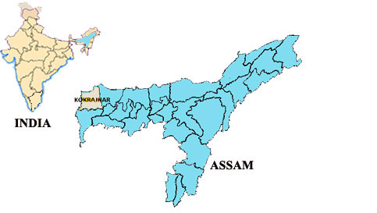

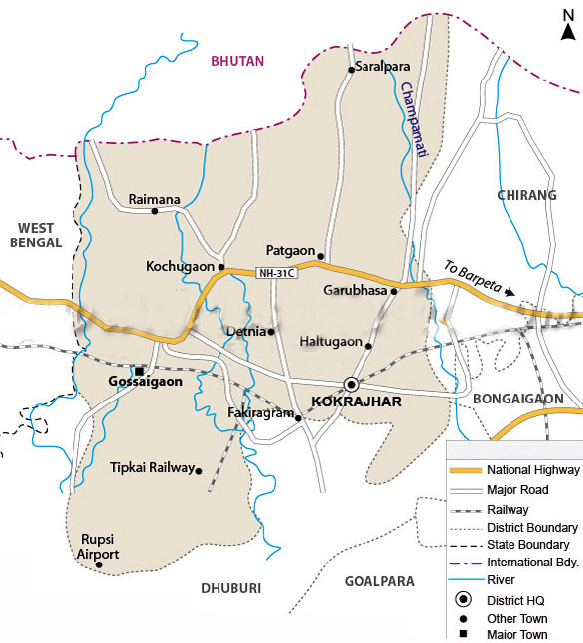

Fig.: 1.3 Map of Kokrajhar district

3.3 Description of the selected species:

- Boroli (Barilius vagra): The colour of this fish with beautiful combination of different shades, is very attractive. It is fish of small size, growing up to 12.5 cm. This species is widely distributed in Asian countries, Afghanistan, Pakistan, India, Nepal, Bangladesh and Sri Lanka. Adults of this fish species live in hill streams with gravelly and rocky bottom (Talwar and Jhingran , 1991.)

- Bothia (Neoeucirrhichthys maydelli): This species have a quite variable colour pattern. It has dark spots on the caudal fin which are quite distinctive. A dark, white-ringed spot can be seen at the centre of the caudal fin. N. maydelli also have a truncate or rounded tail (Hamilton, 1822)
This species are distributed in India, Nepal and Bangladesh. In India it's known from the Teesta river system in North Bengal and the Garo Hills in Meghalaya.
- Chanda (Chanda nama): The elongate glassy perchlet, Chanda nama is a native to an area of south Asia from Pakistan to Burma, in the Indo-Malaya ecozone. It reaches a maximum overall length of 11 cm. The species inhabits canals, ponds, streams and flooded rice paddies, in both fresh and blackish water and is found in particular abaundance during the rainy season.

- Cheng (Channa gachua): It is a dwarf snakehead fish attains up to 20 cm. The species has an elongated lateral body. The dorsal of this species is greenish and the anal is dirty pale bluish-green; both are edged with black. The upper edge has a red lateral margin and the lower a white sideward band. The caudal fin is rounded and marginally edged, first with black and then red with blue-green interspaces. This species is found in Asian countries from Pakistan to Indonesia. It is found in almost all wetlands in canals, rivers and lakes and especially in muddy water.

- Darikana (Rasbora daniconius): The species, Rasbora daniconius has an elongated body, oblong and compressed with small mouth (Talwar and Jhingran 1991.). This species is widely distributed in Asia mainly in Mekong, Chao Phraya and Salween basins, northern Malay Peninsula, westwards to the Indus and Sri Lanka (Rainboth, 1996). The species is found in a variety of habitats like ponds, canals, haors, streams, rivers and inundated fields.
- Goroi (Channa punctatus): It is commonly known as spotted snake head. Channa Punctatus are small fishes with smaller eyes allocated on the anterior of head. Fish body is slight brown on the back which is faded beneath.

- Kholihona (Trichogaster fasciata): The fish body is strongly compressed dorsal and abdominal profile is equally convex. It is one of the most colourful fish species of the region. Available in both lentic and lotic systems.

- Kokila (Xenentodon cancila): Xenentodon cancila (freshwater garfish) is a species of needlefish. This species has an elongate body with long, beak-like jaws filled with teeth. The dorsal and anal fins are positioned far back along the body close to the tail. (Sterba, 1962). The body is silvery-green, darker above and lighter below with a dark band running horizontally along the flank. The male fish often having anal and dorsal fins with a black edge. It can reach upto a length of 40 cm
The freshwater garfish is widely distributed across South and Southeast Asia from India and Sri Lanka to the Malaysian Peninsula (Riehl, R; Baensch, H 1996). The species eats animals such as fish and frogs.

- Mola (Amblypharyngodon mola): It is known as Indian Carpet. The body of Amblypharyngodon mola is laterally compressed and dorsal. Their caudal fin is deeply forked with pointed lobes. Dark markings are traced in dorsal and anal fins. The body colour of the fish is light greenish on black and silvery at sides and beneath. Maximum body length is reported to be 8cm (Bhuiyan, 1964) 20 cm (Talwar and Jhingran, 1991) 9.2 cm ( Hussain, 1999). There is a conspicuous silvery lateral bound running from gill covers to base of caudal fin.

- Turi (Macrognathus pancalus): It is commonly known as Stripped spiny eel. The species inhabits in slow and shallow water of rivers of plains and estuaries. It is a common food fish in the region and also a potential aquarium fish.

3.4 Study of Fish diversity:
A detailed survey of various water bodies of the Kokrajhar district was carried out for one year. Locally used fish traps like Jekhai, Sen, Khoka etc. as well as several fishing gears such as, gill nets, cast net, hooks and lines were used to collect various small fishes from their habitats. All of the species were photographed in fresh condition and then preserved in 10% formalin solution. The fish species were identified following Talwar and Jhingran (1991) and Vishwanath et al. (2007). The vernacular names of the species were collected by questionnaires with the local people and fisherman and also from the Department. of Fisheries, Kokrajhar branch. Mean total length, breadth and somatic weight of the species were noted down (Table 1.2).
3.5 Preparation of samples:
The muscle for selected fishes was separated from their body just after washing. A sharp blade of stainless steel was used for dressing the fish species except A. mola due to the smaller size of the species. A. Mola was used in whole for the parameters of samples. The samples were dressed, beheaded, deskinned and filtered as per manual followed by thorough washing with distilled water. The fillet of the fish samples were minced, homogenized, packaged, labelled and stored frozen until analysis. Fishes were thawed and the bone and skin were separated from the flesh to carry on the proximate analysis.

3.6 Proximate composition:

The chemical composition of fish varies significantly between species and also among the individual fishes within the same species with the variation of age, sex, and season. Protein and ash content do not show much variation. The detailed protocols applied in the present study for the analysis of proximate composition of the studied fish species are given below

3.6.1 Moisture:

The moisture content of the fish species was determined by FSSI Lab. Manual.

Procedure: The ground fish sample was taken in a clean dry petri dish and kept in an oven at 105ºC for 2 hours. It was then cooled in a desiccators and weighed (w1).About 10 gm portion of the sample (w2) was taken in the preweighed petri dish and then kept in the oven at 105˚C overnight .The dish was cooled in a desiccator and weighed again (w3).Once again the petri dish was kept in the oven for half an hour and cooled as before and finally weighed to obtain the reproducible weights .

3.6.2 Ash:

The ash content of the fish species was determined by FSSI Lab. Manual.

Procedure: Silica crucible was heated to 600 ºC in a muffle furnace for one hour, cooled in a desiccator and weighed (W₁). 2g of dried sample was weighed accurately in to a crucible and heated at low flame by keeping on a clay triangle to char the organic matter (W₂). The charred material was then placed inside the previously set (600 ºC) muffle furnace and heated for 6-8 hrs which gave a grayish white ash. The crucible was cooled in a desiccator and weighed (W₃). The crucible was heated again for further 30 mins to confirm completion of ashing, cooled and weighed again.
Calculation:
Where,
W₁= Weight of crucible,
W₂ = Weight of dry matter and crucible,
W₃ = Weight of crucible after ashing
3.6.3 Whole Protein:

The protein content of the fish species was determined by method IS:7219:1973 (RA 2005)
Principle: The nitrogenous compounds in the sample are converted in ammonium sulfate by boiling with concentrated sulfuric acid. Upon distillation with excess alkali, the ammonia is liberated which is estimated by titration with standardized sulfuric acid.
Procedure:
Exactly 0.1-0.2 g of wet sample was weighed in to a Kjeldahl flask. A pinch of digestion mixture (copper sulphate and potassium sulphate were mixed in the ratio 1:8 and finely powdered) and 10 ml of concentrated sulphuric acid was added. It was then digested over a sand bath by heating slowly till the solution starts boiling and then vigorously until the solution becomes colourless. The sample was then cooled and made up to the desired volume (100ml).
A conical flask containing 10 ml of boric acid with few drops of boric acid indicator (pink in colour) was placed at the receiving end of the distillation apparatus in such a way that the tip of the condenser is slightly immersed in boric acid. 5ml of the made up sample was pipetted out in to the distillation apparatus. 10ml of 40% NaOH as shown excess by phenolphthalein indicator was added in to the distillation unit followed by rinsing with little distilled water. The unit was made air tight. The content was steam distilled for 5minutes. The colour of the solution turns green. The flask was lowered and the condenser tip was washed with little water.
The green solution in the receiving flask is green at this stage. The content was titrated against N/100 sulphuric acid until the original pink colour was restored. The volume of acid used for titration was noted. The distillation and titration process was repeated to get concordant value.
Calculation
1000ml 1N H₂SO₄ =14g N₂
1ml 1 N H₂SO₄ = 0.014g N₂
1ml 0.01 N N/100 H₂SO₄= 0.00014g nitrogen or (0.14/1000)

3.6.4 Crude Lipid:

The crude fat content of the fish species was determined by FSSI Lab mannual.

Procedure:

10 gm of dried fish sample (W₁) was placed in a thumble placed in a soxhlet apparatus and approximately 200ml ether was added and distilled for 16 hrs. After cooling the apparatus, the solvent was filtered in to a pre-weighed conical flask (W₂). The ether was then removed by evaporation and the flask with lipid was dried at 80-100 ºC, cooled in a desicator and weighed (W₃).
Calculation:
The fat content was then calculated using the formula
Fat content (g/100g) = (W₃-W₂)/ W₁ x 100

3.6.5 Carbohydrates:

The carbohydrate content was determined according to AOAC (1995) and it was calculated using the formula:

Carbohydrate content = 100 – (protein (%) + moisture (%) + fat (%) + ash(%))

3.7 Amino acid analysis:

High Performance Liquid Chromatography (HPLC) (method QA.16.5.10/AOAC 19th edition) was employed for determination of amino acid contents of the fish samples.
Preparation of hydrolysed amino acid Sample: About 100 mg of homogenized fish mince was weighed in to a test tube filled with nitrogen and digested at 120 º C for 24 hrs in an oven. The contents of the test tube was cooled and filtered using Whatman No 1 filter paper. The filtrate was then evaporated in a vacuum flash evaporator. The contents were made acid free by repeated washing with distilled water and subsequent evaporation.
HPLC analysis: 20 µL of the hydrolyzed sample was injected in HPLC (1260 Infinity) equipped with a C18 reverse phase (RP) column and a fluorescence detector. The amino acids were identified the concentration of each type of Amino acids were calculated using the formula-

3.8 Fatty acid analysis:

Gas Chromatography- Mass Spectrometry (GC/MS) (method QA.996.06/AOAC 19th edition) was employed to determine the Fatty acid contents in the fish samples.

3.8.1 Preparation of fatty acid methyl ester (FAME):

5g of lipid was taken in a round bottom flask (125mL) and saponified with alcoholic KOH solution (50mL). The mixture was then refluxed for 45 minutes on a water bath. The reaction mixture was then allowed to cool and then neutralized by HCl (5N). Alcohol was removed from the neutralized solution by evaporation over a steam bath. The pH of the solution was adjusted by adding concentrated HCl. The acidified aqueous mixture was then extracted three times with 20 mL ether in a separating funnel. Ether was then removed from the extract to give a fatty acid mixture which was then esterified with methanolic solution of sulphuric acid ( 0.25 M) After esterification, the mixture was dissolved in ether (25mL) and washed with dilute sodium carbonate solution in a separating funnel until effervescence ceased. It was then washed with water, dried over anhydrous Na₂SO₄ and finally ether was removed to give fatty acid methyl ester (FAME) mixture.

3.8.2 GC/MS Analysis of the methyl esters of lipids:
The FAMEs were quantified by injecting 1 µL (30:1 split ratio) into GC-MS. The fatty acids were identified and quantified using a GC (Trace GC Ultra, Thermo Scientific) The MS conditions were as follows; ionization voltage 70 eV, Mass range of 45-600 and the scan time equal to the GC run time.
The fatty acids in the mixture were identified by comparing its relative retention volume (Clark JM, 1964) The area of each chromatogram peak was determined by multiplying the height of the peak by width of the peak at one half of the height. The percentage of fatty acid contribution to each peak was calculated. After that response factor (R_{i}) for each fatty acid was calculated by the following equation.
R_{i} = (P_{Si}/ Ps_{C11:0}) x (W_{C11:0}/W_{i})
Where, P_{Si} = Peak area of individual fatty acid in mixed FAME standard solutions, Ps_{C11:0} = peak area of C_{11:0} fatty acid in mixed FAMEs standard solution, W_{C11:0} = Weight of internal standard in mixed FAMEs standard solution and W_{i} = Weight of individual FAME in mixed FAMEs standard solution.
The amount of the individual triglycerides, W_{TG} of each samples were then calculated using the following formula.
W_{TGi} = W_{FAMEi} x f_{TGi}
Where, P_{ti} = Peak area of fatty acid I in test portion, Wt_{C11:0} = weight of C_{11:0} internal standard in test portion, 1.0067 = conversion of internal standard from TG to FAME, Pt_{c11:0} = peak area of C_{11:0} internal standard in test portion and f_{TG} = conversion factor for FAME to TGs for individual fatty acid.
Retention time of fatty acid of known standards and conversion factor for FAMEs to TGs for individual fatty acids were listed in Appendice-II.

3.9 Mineral Analysis
3.9.1 Analysis of Fe, Zn & Ca:
Atomic Absorption Spectroscopy (AAS) (method AOAC 19th edition) was employed for quantitative determination of Fe, Zn and Ca in the fish samples.
Procedure: Chemical analysis for the estimation of the trace elements (Fe, Zn and Ca) in fishes were performed with the Flame Atomic Absorption Spectrophotometer (AAS). The technique involved the following steps:
The stock standard solutions of 100 ppm of Fe, Ca, Zn, salts with deionized water were prepared. Standard solutions of these metal ions were prepared by suitable dilution of the stock standard solutions. The samples of the fish were diluted to a known volume and both the samples and the standard solutions were analysed by a Flame AAS (Model: AAS 280(000)).

Calculation :
The concentration of metal is detected in mg/l and

3.9.2 Analysis of Phosphorous:

UV-Visible Spectrophotometer (UV-VIS) (Method IS:1482.8:200) was employed for quantitative determination of Phosphorous content in the fish samples.

Procedure: The ash obtained from the crude ash content analysis was mixed with 5 mL water and 5 mL HCl and boiled for 5 minutes on hot plate. The solution was then cooled to room temperature and brought to sign at 50 mL water. In parallel a procedural blank was also prepared. 10 mL of the prepared solution were transferred into 50 mL calibrated flask and 20 mL of molybdate-ascorbic acid solution was added. Five standard solution of Phosphorous were prepared and 20 mL of molybdate-ascorbic acid solution was added and the sample prepared along with the standard solutions were placed in a metal basket and it was immersed in a boiling water bath for 15 minutes. The flasks were then cooled to room temperature and the colour of the solutions turned blue.

Phosphorous calibration curve solutions
Standard solutions | Blank | Std 1 | Std 2 | Std 3 | Std 4 | Std 5
Concentration (mg/L) | 0.0 | 5.0 | 10.0 | 20.0 | 40.0 | 50.0

The absorbance of the standard solutions and sample solutions were read at wavelength 430 nm in a UV-VIS Spectrophotometer ( Cary 60 Model No 2.00)

The Phosphorous content were expressed in mg/100g and was calculated using the formula

Phosphorous content ( mg/100g) = (V₂/V₁)xC_{read} x 50 / m

Where, m = Weight of sample, V₁ = Volume of solution utilized for colour reaction, V₂= Volume where the ash was brought to 50 mL and C_{read}= Amount of phosphorous from calibration curve.

3.10 Vitamin Analysis:

High Performance Liquid Chromatography (HPLC) ( Method QA:16.5.3/AOAC 19th edition) was employed for determination of Vitamin A and D in the fish samples.
Procedure: Oil extracted from fish meat as described (Folch et al., 1957) earlier under fatty acids was used for analysis of fat soluble vitamins. About 0.15 g fish oil was refluxed with 25 mL methanol and 150% potassium hydroxide (KOH) in water bath for 30 min. It was then extracted with 50 mL petroleum ether. The petroleum ether layer was collected, concentrated and dissolved in 5mL acetonitrile (ACN). 100 µL of sample is then injected in a HPLC (HPLC 1260 Infinity) equipped with C18 RP column and UV detector. The fat soluble vitamins A&D were identified and quantified by comparing retention times and peak area with those of vitamins standards respectively (R7632, C9756, T3251 and M5625, Sigma-Aldrich).
Then the concentration of each type of Vitamin were calculated using the formula-

3.11 Analysis of some water quality paramaters:
3.11.1 Collection, pre-treatment and preservation of samples
Water samples were collected randomly from three beels and one river surrounding the Kokrajhar town during January-March of 2016. They were stored in pre-cleaned 250 ml polyethylene bottles and BOD bottles in triplicates and brought to laboratory for further analysis. The samples were collected from 12-15 cm beneath the water surface. All the precautionary measures were adopted during sampling.
3.10.2 Physico-chemical analysis
The collected samples were experimented to analyse different physic-chemical parameters such as pH, temperature, TDS, alkalinity, BOD, COD, DO, turbidity and salinity by following the standard protocols as per APHA 22nd Edition (2012). Samples were analyzed immediately for parameters like temperature, which need to be determined instantly.
A quality controlled procedure was steadily maintained throughout. The instruments were recalibrated. All chemicals and reagents used were of analytical grade. For all solutions distilled water was used. The standard solutions were made by diluting the stock solution.
3.11 Statistical analysis
Simple correlation and regression equations were applied for analysis of certain biological parameters. The statistical packages viz., MS Excel, Minitab 11 were used in the entire experiments of the present study.

CHAPTER-IV
Result & Discussion

4.1 Analysis of Fish diversity
In the present work, the study of Ichthyofaunal diversity of the fish species reported that quantitatively seventy seven ichthyospecies belonged to 53 genera, 26 families and 9 orders from the different water bodies of Kokrajhrar District of BTAD, Assam, India. Table 1.11 illustrates the biological classification of the fish species including their scientific names, order, family, vernacular name (Assamese and Bodo), food status and conservation status (IUCN).
All the fish species were broadly categorized into seven groups. They are namely, Indian major/minor carps, Exotic carps established in Assam, Live fishes, Cat fishes, Feather back, Ornamental fishes and River fishes representing 10, 4, 10, 23, 2, 18 and 10 species respectively. Out of the nine orders, the most dominant was cypriniformes with thirty one species (40.26%) followed by Siluriformes with twenty three species (29.87%) (Fig 1.4a). The results were agreed to the previous reports (Chakravartty et al., 2012; Das and Sarmah, 2014). The order Perciformes, Synbranchiformes, Clupeiformes, Osteoglossiformes was represented by 12, 3, 3, 2 species respectively. Only one species had been recorded from the order Beloniformes, Cyprinodontiformes and Tertaodontiformes. Among the 26 families, Cyprinidae with 26 ichthyospecies (37.66%) was the most diverse followed by Bagridae with 7 species (9.09%) (Fig 1.4b). Dubey et al., 2012; Baro and Sharma, 2014; Das and Sarmah, 2014 had also similar observation. Channidae possesed six species. Four species belonged to Siluridae family whereas families Sisoridae and Schilbeidae contained three species each .Only two species were lodged by five families viz. Clariidae, Clupeidae, Mastacembelidae, Notopteridae and Osphronemidae. Labeo genus possessing seven species was highlighted to be the most diverse followed by the genus Channa with six species. Amongst the 77 recorded species, 74 were considered as food fish while only three species viz. Erethistes pusillus, Tetraodon cutcutia and Aplocheilus panchax as not food fishes. It was found that 36 fish species were recorded to be commercially important food fish (Biswas and Sugunan, 2008). In addition to the commercial importance Chitala chitala and Tor tor had sport values (Biswas and Sugunan, 2008)

Table 1.1: Showing the diversity of fishes with special reference to their taxonomic distribution, vernacular name, habitat and conservation status
Family | Name of the Species | Bodo name | Assamese name | Habitat/Water bodies | Con. status*
Cyprinidae | Labeo rohita (Hamilton, 1822) | Rhou | Rhou | Rivers/beels/tanks & ponds | LC
Cyprinidae | Labeo bata (Hamilton, 1822) | Bata | Bata | Rivers/beels/tanks & ponds | LC
Cyprinidae | Labeo calbasu (Hamilton, 1822) | Bahu | Kalbasu | Rivers/beels/tanks & ponds | LC
Cyprinidae | Labeo gonius (Hamilton, 1822) | Kursa | Gonia | Rivers/beels/tanks & ponds | LC
Cyprinidae | Bangana dero (Hamilton, 1822) | Maso | Gorea | River running water | Vu
Cyprinidae | Labeo dyocheilus (McClelland, 1839) |  | Lasu | Brahmaputra river | LC
Cyprinidae | Labeo pangusia (Hamilton, 1822) |  | Nandani | Rivers/beels/tanks & ponds | NT
Cyprinidae | Gibelion catla (Hamilton, 1822) | Catla | Catla | Rivers/beels/tanks & ponds | LC
Cyprinidae | Cirrhinus mrigala (Bloch, 1795) | Mirkha | Mirika | Rivers/beels/tanks & ponds | LC
Cyprinidae | Cirrhinus reba (Hamilton, 1822) | Lasim | Laseem | Rivers/beels/tanks & ponds | LC
Cyprinidae | Cyprinus carpio (Hamilton, 1822) | Common carp | Common carp | Rivers/beels/tanks & ponds | Vu
Cyprinidae | Ctenophryngodon idella  (Valenciennes, 1844) | Grass carp | Grass carp | Rivers/beels/tanks & ponds | NE
Cyprinidae | Hypothalmichthys molitrix  (Valenciennes, 1844) | Silver carp | Silver carp | Rivers/beels/tanks & ponds | NE
Cyprinidae | Hypothalmichthys nobilis  (Richardson, (1845) | Popular large head carp | Popular large head carp | Rivers/beels/tanks & ponds | NE
Channidae | Channa punctata (Bloch, 1793) | Gwri | Goroi | Beels/low-lying area/tanks / ponds | LC
Channidae | Channa striata (Bloch, 1793) | Shol | Shol | Beels/low-lying area/tanks / ponds | LC
Channidae | Channa gachua (Hamilton, 1822) | Nasrai | Cheng | Beels/low-lying area/tanks / ponds | LC
Channidae | Channa marulius (Hamilton, 1822) | Nasrai nisla | Chengeli | Beels/low-lying area/tanks / ponds | LC
Channidae | Channa stewartii (Hamilton, 1822) | Sal | Sal | Beels/low-lying area/tanks / ponds | LC
Channidae | Channa barca (Hamilton, 1822) | Nasrai Borkhaw | Garaka cheng | Beels/low-lying area/tanks / ponds | DD
Synbrachidae | Monopterus cuchia (Hamilton, 1822) | Cuchia | Cuchia | Beels/low-lying area/tanks / ponds | LC
Mastacembelidae | Mastacembelus armatus  (Hamilton, 1822) | Bami | Bami | River/beels/low-lying area/tanks / ponds | LC
Family | Name of the Species | Bodo name | Assamese name | Habitat/Water bodies | Con. status*
Mastacembelidae | Mastacembelus pancalus (Hamilton, 1822) | Thuri | Tura/Tora | River/beels/low-lying area/tanks / ponds | NE
Actinopterygii | Anabus testudineus (Bloch, 1792) | Kawai | Koi | Beels/low-lying area/tanks / ponds | NE
Siluridae | Wallago attu (Bloch and Schneider, 1801) | Borali | Borali | River/beels/low-lying area/tanks / ponds | NT
Siluridae | Ompok pabo (Hamilton, 1822) | Phabo | Pabhoh | River/beels/low-lying area/tanks / ponds | NT
Siluridae | Ompok pabda (Hamilton, 1822) | Phabo | Pabda | River/beels/low-lying area/tanks / ponds | NT
Siluridae | Ompok bimaculatus(Bloch, 1794) | Phabo | Pabhoh | River/beels/low-lying area/tanks / ponds | NT
Bagridae | Mystus tengra (Hamilton, 1822) | Thengana | Tingorah | River/beels/low-lying area/tanks / ponds | LC
Bagridae | Mystus cavasius (Hamilton, 1822) | Thengera gidid | Bor Singorah | River/beels/low-lying area/tanks / ponds | LC
Bagridae | Mystus vittatus (Bloch, 1794) | Thengera khujri | Haru Tingorah | River/beels/low-lying area/tanks / ponds | LC
Bagridae | Hemibagrus menoda (Hamilton, 1822) |  | Gagol | River/beels/low-lying area/tanks / ponds | LC
Bagridae | Aorichthyus aor (Hamilton, 1822) | Aari | Aari | River/beels/low-lying area/tanks / ponds | NE
Schilbeidae | Eutropiichthyus vacha (Hamilton, 1822) |  | Basa | River/beels/low-lying area/tanks / ponds | NE
Pangasiidae | Pangasius pangasius (Hamilton, 1822) | Pangas | Pangas | River/beels/low-lying area/tanks / ponds | LC
Clariidae | Clarias batrachus (Linneaeus, 1758) | Magur | Magur | Beels/low-lying area/tanks / ponds | LC
Clariidae | Clarias gariepinus (Burchell, 1822) | Thailand magur | Thailand magur | Beels/low-lying area/tanks / ponds | LC
Family | Name of the Species | Bodo name | Assamese name | Habitat/Water bodies | Con. status*
Heteropneustidae | Heteropneustes fossilis (Bloch, 1794) | Singi | Singi | Beels/low-lying area/tanks / ponds | LC
Sisoridae | Gagata cenia (Hamilton, 1822) |  | Keyakatta | Beels/low-lying area/tanks / ponds | LC
Sisoridae | Gagata gagata (Hamilton, 1822) |  | Keyakatta | Beels/low-lying area/tanks / ponds | LC
Sisoridae | Bagarius bagarius (Hamilton, 1822) |  | Garua | River/beels/low-lying area/tanks / ponds | NT
Schilbeidae | Cluisoma garua(Hamilton, 1822) |  | Neria | River/beels/low-lying area/tanks / ponds | NE
Chacidae | Chaca chaca (Hamilton, 1822) |  | Kurkuri | River/beels/low-lying area/tanks / ponds | LC
Bagridae | Rita rita (Hamilton, 1822) | Ritha | Ritha | River/beels/low-lying area/tanks / ponds | LC
Erithistidae | Erithistes pusillus (Bleeker, 1854) |  | Sakmaka | River/beels/low-lying area/tanks / ponds | NE
Bagridae | Batasio batasio (Hamilton, 1822) |  | Batachi | River/beels/low-lying area/tanks / ponds | LC
Schilbeidae | Ailia coila (Hamilton, 1822) |  | Kadali | River/beels/low-lying area/tanks / ponds | NT
Notopteridae | Chitala chitala (Hamilton, 1822) | Sital | Chital | River/beels/low-lying area/tanks / ponds | NT
Notopteridae | Notopterus noptopterus (Pallas, 1769) |  | Kanduli | River/beels/low-lying area/tanks / ponds | NE
Osphronemidae | Trichogatser fasciata (Bloch & Schneider,1801) |  | Kholihana | Beels/low-lying area/tanks / ponds | NE
Osphronemidae | Trichogatser colisa (Hamilton, 1822) |  | Bhasaylee | Beels/low-lying area/tanks / ponds | NE
Tetraodontidae | Tertradon cutcutia (Hamilton, 1822) | Gangatopa | Gangatope | Beels/low-lying area/tanks / ponds | NE
Ambassidae | Chanda nama (Hamilton, 1822) | Chanda | Chanda | Beels/low-lying area/tanks / ponds | LC
Cichlidae | Oreochromis mossambicus (Peters, 1852) | Japani Kawai | Japani Koi | Beels/low-lying area/tanks / ponds | NT
Cobitidae | Neoeucirrhichthys maydelli (Hamilton, 1822) | Bala Bothia | Botia | Beels/low-lying area/tanks / ponds | LC
Family | Name of the Species | Bodo name | Assamese name | Habitat/Water bodies | Con. status*
Botiidae | Botia dario (Hamilton, 1822) | Bala Khwa | Rani botia | Beels/low-lying area/tanks / ponds | LC
Cyprinidae | Pethia ticto ticto (Hamilton, 1822) | Pitikri | Puthi | Beels/low-lying area/tanks / ponds | LC
Cyprinidae | Systomus sarana (Hamilton, 1822) | Chinese puthi | Cheniputhi | River/beels/low-lying area/tanks / ponds | LC
Cyprinidae | Barbonymus gonionotus | Jaba puthi | Java puthi | Beels/low-lying area/tanks / ponds | LC
Cyprinidae | Rasbora daniconius (Hamilton, 1822) | Donkina | Darikona | Beels/low-lying area/tanks / ponds | LC
Cyprinidae | Rasbora elanga (Hamilton, 1822) | Eleng | Eleng | Beels/low-lying area/tanks / ponds | NE
Cyprinidae | Danio dangila (Hamilton, 1822) |  | Laupati | Beels/low-lying area/tanks / ponds | LC
Cyprinidae | Amblypharyngodon mola (Hamilton, 1822) | Mawa | Mola | Beels/low-lying area/tanks / ponds | LC
Cyprinidae | Aspidoparia morar (Hamilton, 1822) | Boirali | Boriala | Beels/low-lying area/tanks / ponds | LC
Nandidae | Nandus nandus (Hamilton-Buchanan 1822) | Thothajambhi | Bhetki | Beels/low-lying area/tanks / ponds | LC
Clupeidae | Gudusia chapra (Hamilton, 1822) | Korti | Karoti | Beels/low-lying area/tanks / ponds | LC
Engraulidae | Setipinna phasa (Hamilton, 1822) |  | Salo/Chato | Beels/low-lying area/tanks / ponds | LC
Clupeidae | Tenualosa ilisha (Hamilton, 1822) | Ilish | Ilish | Brahmaputra river | LC
Cyprinidae | Chela atpar (Hamilton, 1822) |  | Selkona | Brahmaputra river | NE
Cyprinidae | Chela cachius (Hamilton, 1822) |  | Laupati | Brahmaputra river | LC
Cyprinidae | Oxygatser gora (Hamilton, 1822) |  | Gora Chela | Brahmaputra river | NE
Cyprinidae | Tor tor (Hamilton, 1822) |  | Pithia | River running water | NT
Cyprinidae | Tor putitora (Hamilton, 1822) | Jonga | Jonga pithia | River running water | EN
Belonidae | Xenentodon cancila (Hamilton, 1822) | Khankhila | Kokila | River/beel/tanks & ponds | LC
Aplocheilidae | Aplocheilus panchax (Hamilton, 1822) |  | Kanopna | River | LC
Cyprinidae | Barilius barna (Hamilton, 1822) |  | Balisonda | River | LC
Cyprinidae | Barilius bendelisis (Hamilton, 1807) |  |  | River running water | LC

Con. Status: Conservation status based on IUCN report (2010); EN: Endangered; Vu: Vulnerable; NT: Near threatened; LC: Least concern; NE: Not evaluated; DD: Data deficient

As per the conservation status (IUCN), Tor putitora was found to be the only fish species that placed under endangered category. Out of the remaining 76 recorded species Bangana (Labeo) dero was marked as vulnerable (Vu) (2.60%), 10 near threatened (NT) (12.99%), 47 least concerned (LC) (61.04%), 16 not evaluated (NE) (20.78%) and the single species Channa barca was recorded to be data deficient (Fig 1.4c).

Fig.: 1.4a Number of species under various orders

Fig.: 1.4b Number of species distributed under each family

Fig.: 1.4c Percentage of species under various categories as per IUCN status

4.2 Survey on fish species consumed by the Bodo communities:

The response of the field survey was positive. People were very much interested regarding catching the small fishes available in nearby river, beel and other wetlands. They consume these small fishes in their daily diet. The responses are summarized below:-

- What are the different types of fishes available in the water bodies of your locality?
Ans: The small fishes like moa, puthi, bothia, borali, chanda, ptimutura, kawai, cheng, goroi, kokila, darikona, turi, kholihona, tengera etc. are very much available in the local ponds and nearby wetlands.
- How do you catch the fish for your dietary item?
Ans: We use different gears of bamboo.
- What fishes you generally prefer in your daily diet?
Ans: Local small living fishes are very much appreciated in our daily diet.
- Whether the popular large fishes are used in your regular diet?
Ans: We cannot afford to purchase the popular large fishes regularly.
- What are the small fishes you consume regularly?
Ans: The small fishes like cheng, goroi, mola, chanda etc. are commonly included in our regular meal.
- Whether the small fishes which you consume have any commercial value?
Ans: The fishes which we regularly consume are having very less commercial value
because these are accepted mainly by the poorers.
- Where from you collect the small fishes for regular consumption?
Ans: The fishes are easily collected from ponds, ditches, small rivers and the nearby waterlogged areas.
After analyzing the survey report it is justified that the small fishes available in the local area were of keen interest to the Bodo communities. Due to their extreme availability and lower market price these fishes are regularly included in their diet. The local people cannot afford to the costly popular large fishes which are well known to be one of the good supplement for the protein and many other health nutrients. Keeping in mind about the specific time period of the research work, out of these available fishes only ten small fishes were selected for study in the current work. These fishes are widely consumed by the local Bodo people. The selected species were enlisted in table 1.2 below.

Table: 1.2 List of fish species selected for the present work

Sample No | Scientific name of species
1 | Barilius vagra (Hamilton, 1822)
2 | Neoeucirrhichthys maydelli (Hamilton, 1822)
3 | Chanda nama (Hamilton, 1822)
4 | Channa gachua (Hamilton, 1822)
5 | Rasbora daniconius (Hamilton, 1822)
6 | Channa punctatus (Bloch, 1793)
7 | Trichogaster fasciata (Bloch & Schneider,1801)
8 | Xenentodon cancila (Hamilton, 1822)
9 | Amblypharyngodon mola (Hamilton, 1822)
10 | Macrognathus pancalus (Hamilton, 1822)

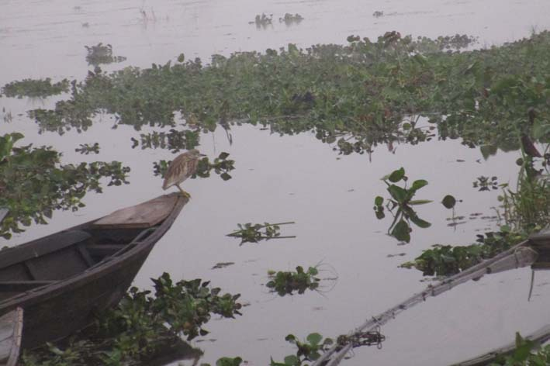  Fig.:1.5.1 Fish Catching area in Diplai Beel | 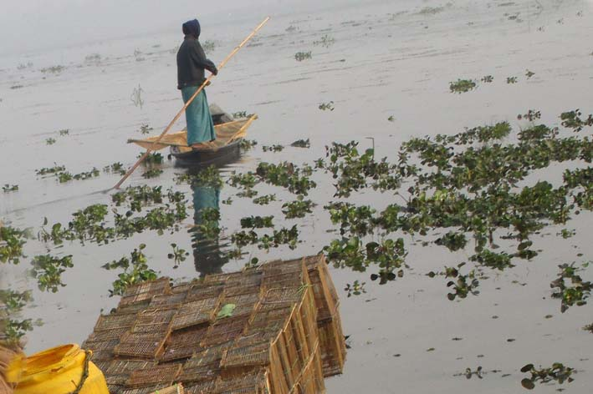  Fig.: 1.5.2 People catching fish in Gaurang river
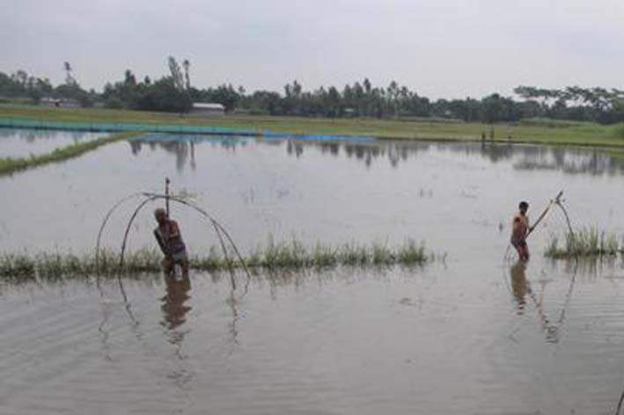  Fig.: 1.5.3 People catching fish in wetlands | 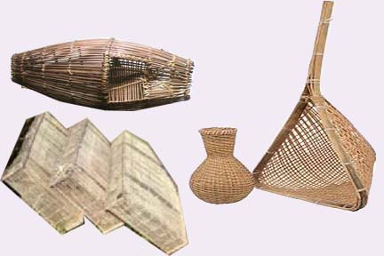  Fig.: 1.5.4 Some fish gears commonly used by bodo people
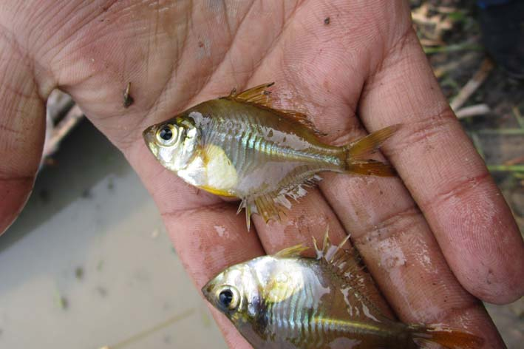  Fig.: 1.5.5 Chanda nama collected at fishing sites | 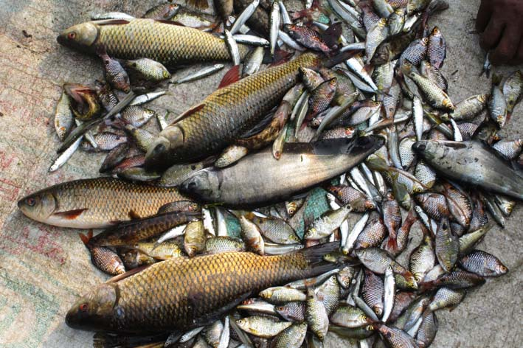  Fig.: 1.5.6 Some fishes selling in village market

4.3 Description of the selected fish

Kingdom: Animalia  Phylum: Chordata  Class: Actinopterygii  Order: Cypriniformes  Family: Cyprinidae  Genus: Barilius  Scientific Name: Barilius vagra (Hamilton, 1822)  Local Name: Boroli | 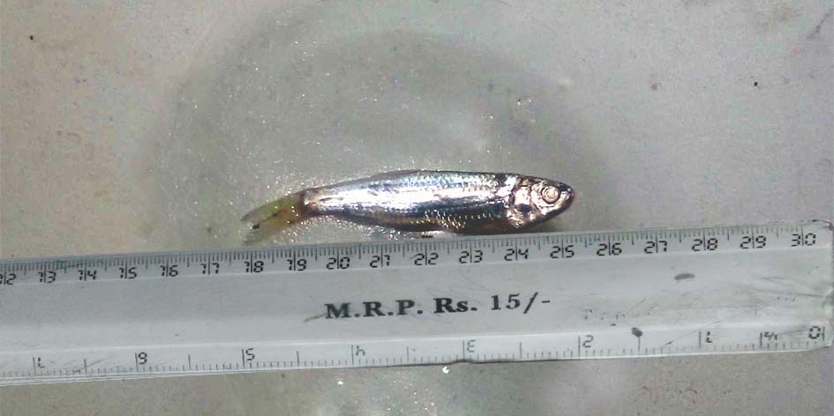  Fig.: 2.1.1 Barilius vagra
Kingdom: Animalia  Phylum: Chordata  Class: Actinopterygii  Order:  Cypriniformes  Family: Cobitidae  Genus: Neoeucirrhichthys  ScientificName: N. Maydelli (Hamilton, 2822) Local Name: Bothia | 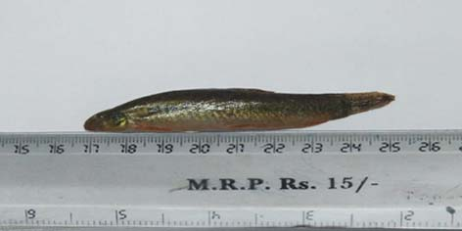  Fig.:2.1.2 N. maydelli
Kingdom: Animalia  Phylum: Chordata  Class: Actinopterygii  Order: Perciformes  Family: Abassidae  Genus: Chanda  Scientific Name: Chanda nama (Hamilton, 1822)  Local Name: Chanda | 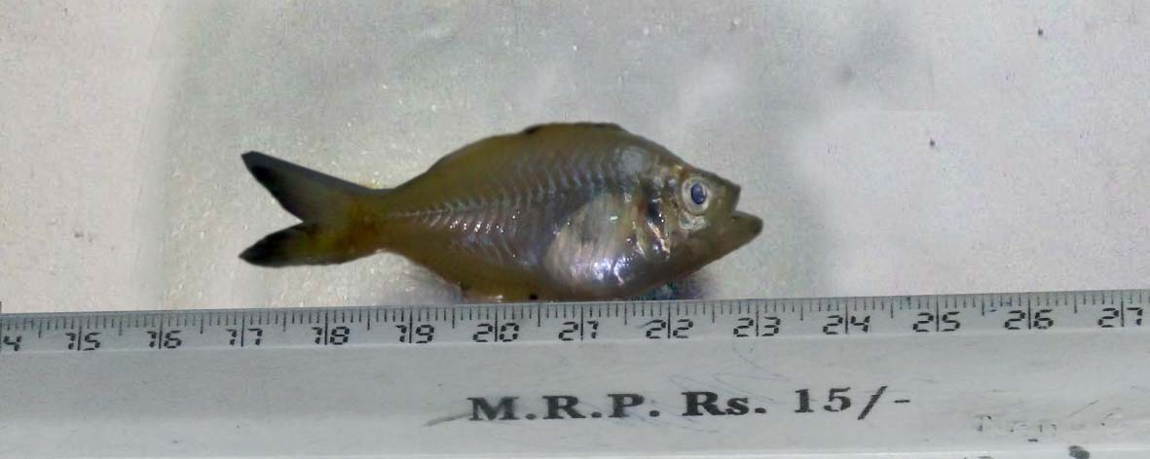  Fig.: 2.1.3 Chanda nama
Kingdom: Animalia  Phylum: Chordata  Class: Actinopterygii  Order: Perciformes  Family: Channidae  Genus: Channa  Scientific Name: Channa gachua (Hamilton, 1822)  Local Name: Cheng | 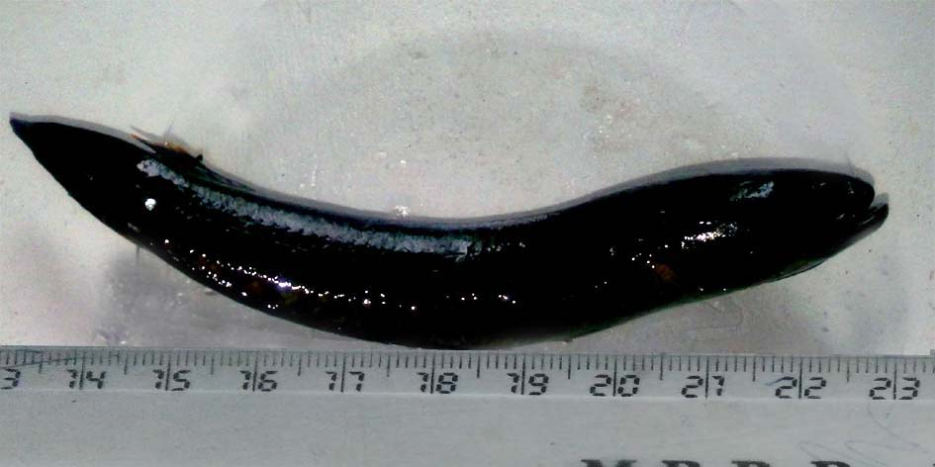  Fig.: 2.1.4 Channa gachua
Kingdom: Animalia  Phylum: Chordata  Class: Actinopterygii  Order: Cypriniformes  Family: Cypriniformes  Genus: Rasbora  Scientific Name: Rasbora daniconius (Hamilton, 1822)  Local Name: Darikana | 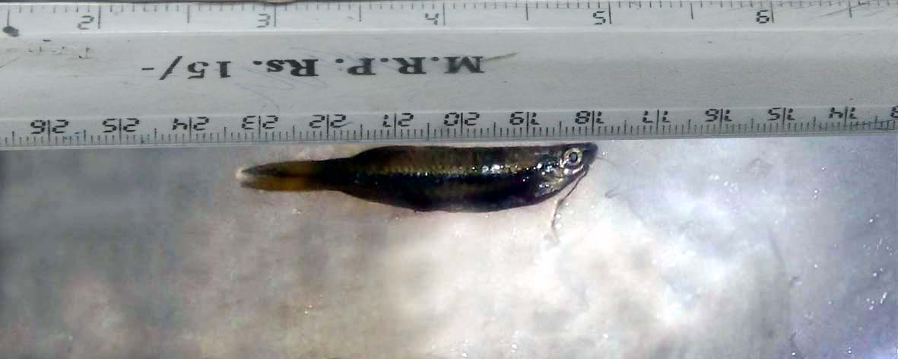  Fig.: 2.1.5 Rasbora daniconius
Kingdom: Animalia  Phylum: Chordata  Class: Actinopterygii  Order: Perciforms  Family: Channadae  Genus: Channa  Scientific Name: Channa punctatus (Bloch, 1793)  Local Name:Goroi | 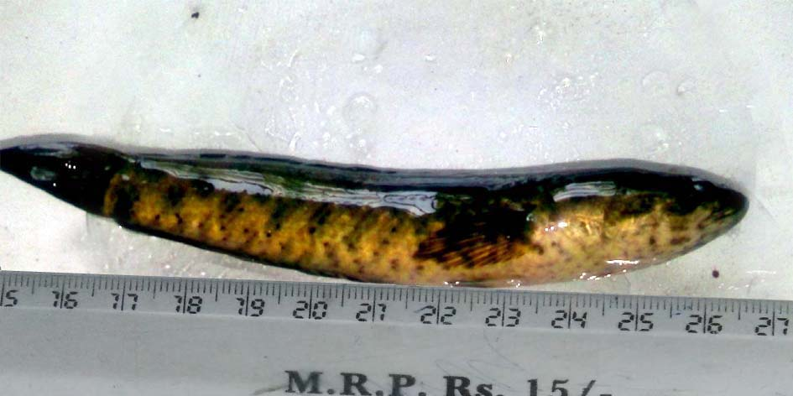  Fig.: 2.1.6 Channa punctatus
Kingdom: Animalia  Phylum: Chordata  Class: Osteichthyes  Order: Perciformes  Family: Anabantidae  Genus: Colisa  Scientific Name: Trichogaster fasciata (Bloch & Schneider,1801)  Local Name:Kholihona | 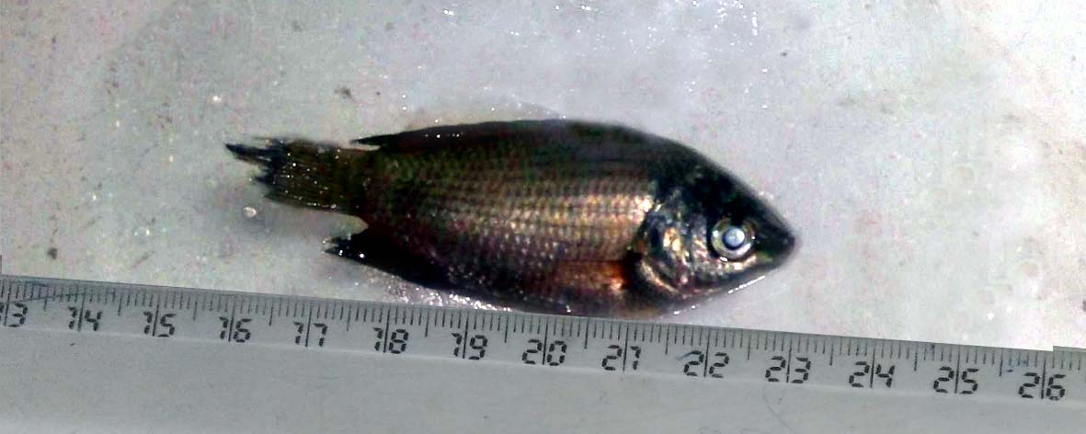  Fig.: 2.1.7 Trichogaster (Colisa) fasciata
Kingdom: Beloniforms  Phylum: Chordata  Class: Actinopterygii  Order:  Family: Belonidae  Genus: Xenentodon  Scientific Name: Xenentodon cancila (Hamilton, 1822)  Local Name:Kokila | 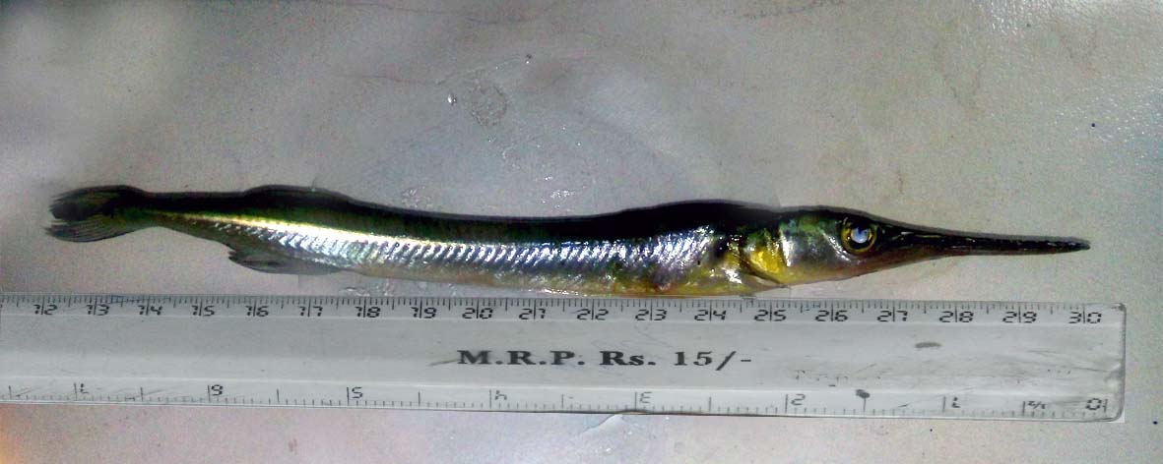  Fig.: 2.1.8 Xenentodon cancila
Kingdom: Animalia  Phylum: Chordata  Class: Actinopterygii  Order: Cypriniformes  Family: Cyprinidae  Genus: Amblypharyngodon  Scientific Name: Amblypharyngodon mola (Hamilton, 1822)  Local Name:Mola | 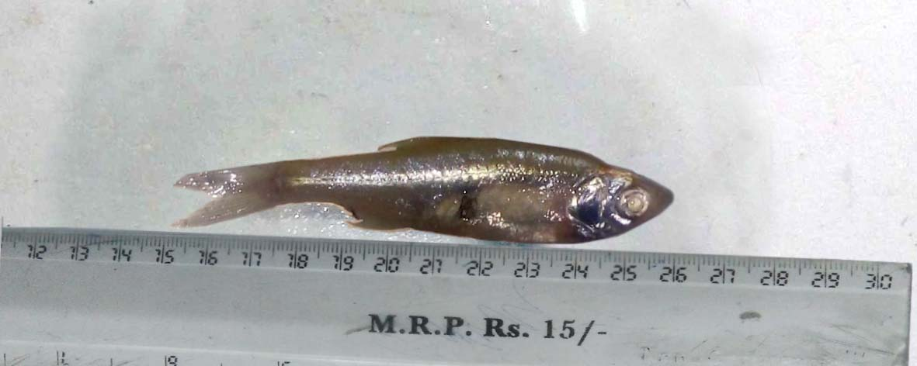  Fig.: 2.1.9 Amblypharyngodon mola
Kingdom: Animalia  Phylum: Chordata  Class: Actinopterygii  Order: Synbranchiformes  Family: Mastacembelidae  Genus: Macrognathus  Scientific Name: Macrognathus pancalus (Hamilton, 1822)  Local Name:Turi | 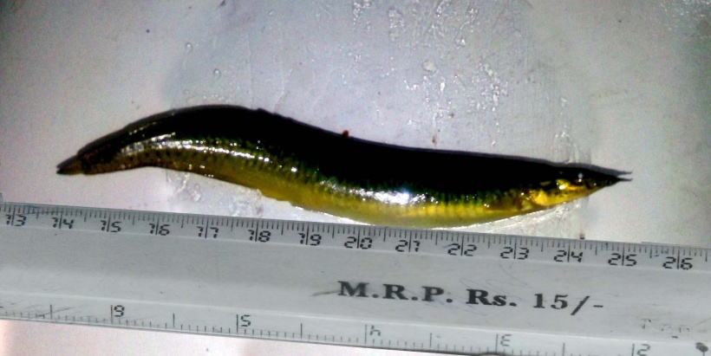  Fig.: 2.1.10 Macrognathus pancalu

The mean total length, breadth and somatic weight of all the species were noted down and reported in table 4.3.
Table 1.3. Measurement of length, breadth and weight

Sl No | Scientific name of species | Local Name | Length(cm) | Breadth(cm) | Weight(g)
1 | Barilius vagra | Bhoroli | 7.2 ± 0.6 | 1.3 ± 0.2 | 3.22 ± 0.40
2 | N. maydelli | Bothia | 8.4 ± 0.5 | 1.4 ± 0.3 | 5.21 ± 0.75
3 | Chanda nama | Chanda | 6.6 ± 0.4 | 2.1 ± 0.2 | 2.06 ± 0.51
4 | Channa gachua | Cheng | 11.3 ± 0.8 | 1.7 ± 0.05 | 13.41 ± 0.63
5 | Rasbora daniconius | Darikana | 4.5 ± 0.5 | 0.8 ± 0.02 | 0.85 ± 0.07
6 | Channa punctatus | Goroi | 12.6 ± 0.6 | 2.1 ± 0.2 | 17.15 ± 0.42
7 | Trichogatser fasciata | Kholisa | 6.3 ± 0.4 | 2.4 ± 0.2 | 5.44 ± 0.34
8 | Xenentodon cancila | Kokila | 18.1 ± 1.4 | 1.8 ± 0.3 | 18.79 ± 1.61
9 | Amblypharyngodon mola | Mola | 6.8 ± 0.4 | 1.9 ± 0.4 | 13.58 ± 0.52
10 | Macrognathus pancalus | Turi | 11.8 ± 0.8 | 1.7 ± 0.2 | 10.06 ± 1.05
4.4 Proximate composition

The proximate composition of all the fish species selected for the study are shown in table:4.4 below
Table 1.4 Proximate Composition of the selected fish species
Sl no. | Scientific name of species | Protein  (g/100g) | Crude Lipid  (g/100g) | Moisture  (g/100g) | Ash  (g/100g) | Carbohydrate  (g/100g)
1 | Barilius vagra | 17.30±0.02 | 5.19±0.02 | 73.89±0.08 | 3.36±0.01 | 5.20±0.08
2 | N. maydelli | 16.72±0.02 | 3.42±0.02 | 76.71±0.06 | 2.85±0.03 | 0.40±0.06
3 | Chanda nama | 14.86±0.02 | 11.09±0.01 | 68.12±0.12 | 5.59±0.02 | 0.33±0.04
4 | Channa gachua | 19.85±0.01 | 3.53±0.02 | 73.05±0.08 | 3.26±0.01 | 0.35±0.04
5 | Rasbora daniconius | 15.35±0.01 | 2.82±0.01 | 77.21±0.05 | 4.22±0.02 | 4.31±0.06
6 | Channa punctatus | 17.48±0.02 | 4.92±0.03 | 75.50±0.10 | 1.73±0.02 | 0.37±0.03
7 | Trichogatser fasciata | 17.22±0.04 | 5.84±0.03 | 73.51±0.15 | 2.95± | 0.48±0.03
8 | Xenentodon cancila | 17.41±0.01 | 1.58±0.01 | 77.07±0.05 | 3.55±0.02 | 0.30±0.03
9 | Amblypharyngodon mola | 15.43±0.02 | 2.94±0.02 | 71.50±0.12 | 3.94±.003 | 6.19±0.06
10 | Macrognathus pancalus | 14.26±0.02 | 5.08±0.04 | 70.96±0.05 | 5.79±0.04 | 3.91±0.04

Amongst the ten fish species, Channa gachua (Cheng) contained the maximum content of protein (19.85 g/100g) whereas the lowest value (14.26g/100g) of the same was possessed by Macrognathus pancalus. The amount of protein content ranged from 14.26 to 19.85g/100g. All the fish species were rich in protein and can be regarded as vital source of protein for human nutrition. The value of the protein contents of the selected fish species did not differ too much. It might be due to their similar absorption capability and conversion potentials of essential nutrients from the local environment (Adewole et. al., 2003). The good amounts of protein indicated that the small fishes are also beneficial for meeting our daily requirements of protein provided they are having a balanced amino acid. Fishes are advantageous due to their proteins of high digestibility (Albert, 1998). Several researchers have found richer protein contents when they investigated on fresh water fish species collected from different countries of the world (Aboluade & Abdullahi, 2005). For daily consumption, 24-56 g, 13-19 g and 71 g proteins are required by adult pregnant and lactating mothers respectively (Anon, 2002). It has been found that protein-calories malnutrition stands as primary factor responsible for nutritional pathology (Roger et al., 2005).

The lipid contents of the fish species experimentally ranges from 1.58 to 11.09 g/100g. The highest amount of lipid was shown by Chanda nama. Amongst them, Xenentodon cancila (Kokila) fish possessed the least amount of lipid. The difference in the lipid contents may be explained by the fact that the fishes show variations in their nutrition contents with the variation of season, species and geographical changes. Moreover, age variation and maturity in the same species may highlight significant changes in the total lipid (Piggot and Tucker, 1990). Usually the fat content changes more than any other proximate components of fish and it flashes on the variation in the way of storing fat in the particular species and the content are varied by the changing lifecycle and the availability of food of the species at the time when, sampled (Ababouch, 2005). The species of indigenous major carps are familiar as lean fish which store fat on the liver (Abobouch, 2005), whereas the migratory fishes like Ilish having high amount of dark muscle are said to be highly fatty (Alamentals, 2012). High lipid content of H. Ilisha was reported by many workers (Rao et al., 2012, Mohanty et al., 2012). The higher lipid content of Chanda nama could be attributed to relative feeding habits (Orban et al., 2007). Lipids and fatty acids play a vital role in membrane biochemistry and membrane mediated processes like as osmoregulation, nutrient assimilation and transport in fishes. The amount of lipids in fish also changes within species and habitat (Kumaran et al., 2013 and Das et al., 1978).
The amount of lipid contents in fishes differ greatly from species to species which is keenly related to food intake, sexual changes in context to spawning (Oduor-Odote et al, 2008). Within different parts of body also lipid contents show variation and even in different seasons the contents of lipid are differed. Higher lipids may be caused due to preparation for spawning. It was reported by Asma and Ashraf (2010) that there exists a linear relation between protein and age/size of fish in three carnivorous fish species (Wallagn altu, Mystus seenghala & Channa morutius) but totally opposite in case of lipid contents as there was steady decline in this parameter with increase in size.
The lipid contents of fish species were enormously varied as documented by many workers. Hossain et al. (2015) reported that Amblypharyngodon mola showed the maximum (6.28 ± 0.75) lipid content but in present study the same fish species possessed only 2.94% of lipid. The difference in value might be justified by different geographical positions. The highest lipid contents of Chanda nama (11.09%) followed by Macrognathus pancalus, Trichogaster fasciata, Barilius vagra, N. maydelli and Channa gachua indicated the particular small indigenous species to be nutritionally enriched and decent food suppliments.
The moisture contents of the small fish species under experimentation ranged from (68.12%) to (77.21%). The highest moisture value was contained by Rasbora daniconius and the lowest in Chanda nama, The moisture contents of the selected fishes were negatively correlated with the lipid contents and this fact was agreed with many previous researches (Jessica R. Begard et al, 2015). According to the study of Mazumder et al, the fish moisture steadily decreases with increase in body lipid. As per the report of Marichamy et al 2012, the value of moisture content of marine fishes averaged (74%). Generally freshwater fishes were experimentally established to have low lipid content (Zhimin Jhang et al. 2014) and high moisture contents. Present study revealed the finding of previous researchers to highlight good moisture contents of all the selected small fishes for study.
The ash contents of the fishes under study ranged from (1.73 %) to (5.79 %). The present report revealed the findings of previous researchers. According to the research work of Mazumder et al, 2008, the ash contents of A. Coila and Amblypharyngodon mola were also varied within (1.6 % to 3.2 %. Lower values of ash contents were reported in the experiment of Devadsan et al. (1978) on six freshwater fishes, L. rohita (1.31%), Catla Catla (0.93%), Cirrihinus cirrhosus (0.91%) and Wallagn atta (0.72%). The ash content of Macrognathus pancalus fish revealed fair amount which supported FAO (2005) report. Ash contents reflect the mineral concentration present in the fish species (Eddy et al., 2004, FAO, 2005).
All the ten fish species under study showed low carbohydrate contents except Amblypharyngodon mola (6.19%), Barilius vagra (5.20%), Rasbora daniconius (4.31%)and Macrognathus pancalus (3.91%) and. Usually fishes have very low carbohydrate contents (USDA 2010). The poor contents of carbohydrates in the fishes may be attributed to the fact that glycogen has not much contribution to the reserves in the tissues of fish body (Das and Sahu, 2001 & Jayasre et al., 1994). There are very few fish species which are having higher values of carbohydrate contents. In the research report of Kumar et al., 2014, Sardinella longiceps & Stolephorus were having the values of carbohydrate contents 0.358% and 0.332% respectively. The present report of the lower carbohydrate contents of the studied fish species agreed with the research finding of S. Sutharsiny et al 2011. As a whole the proximate composites of fishes are widely varied with variations of enviormental conditions (Boran and Karacham, 2011).

4.5 Amino acid profile
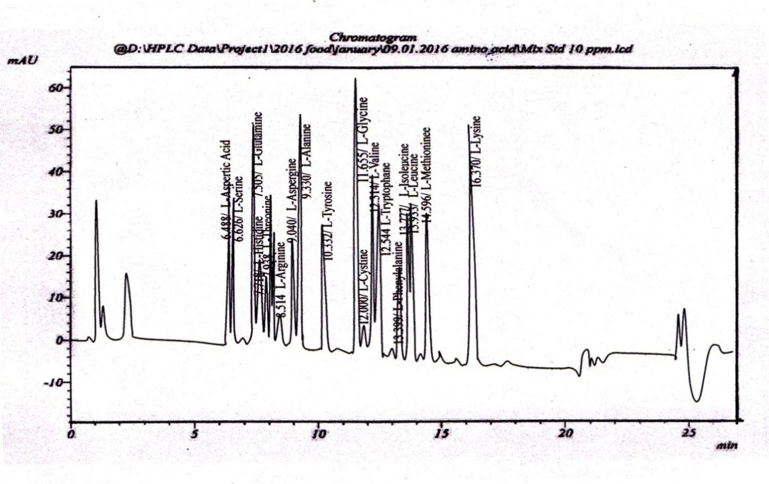
The following are the HPLC Chromatogram of amino acid profile of standard amino acid solutions along with those of the different fish samples.

Fig.: 2.3.1 HPLC Chromatogram of Amino acids of Standard Amino acid solution

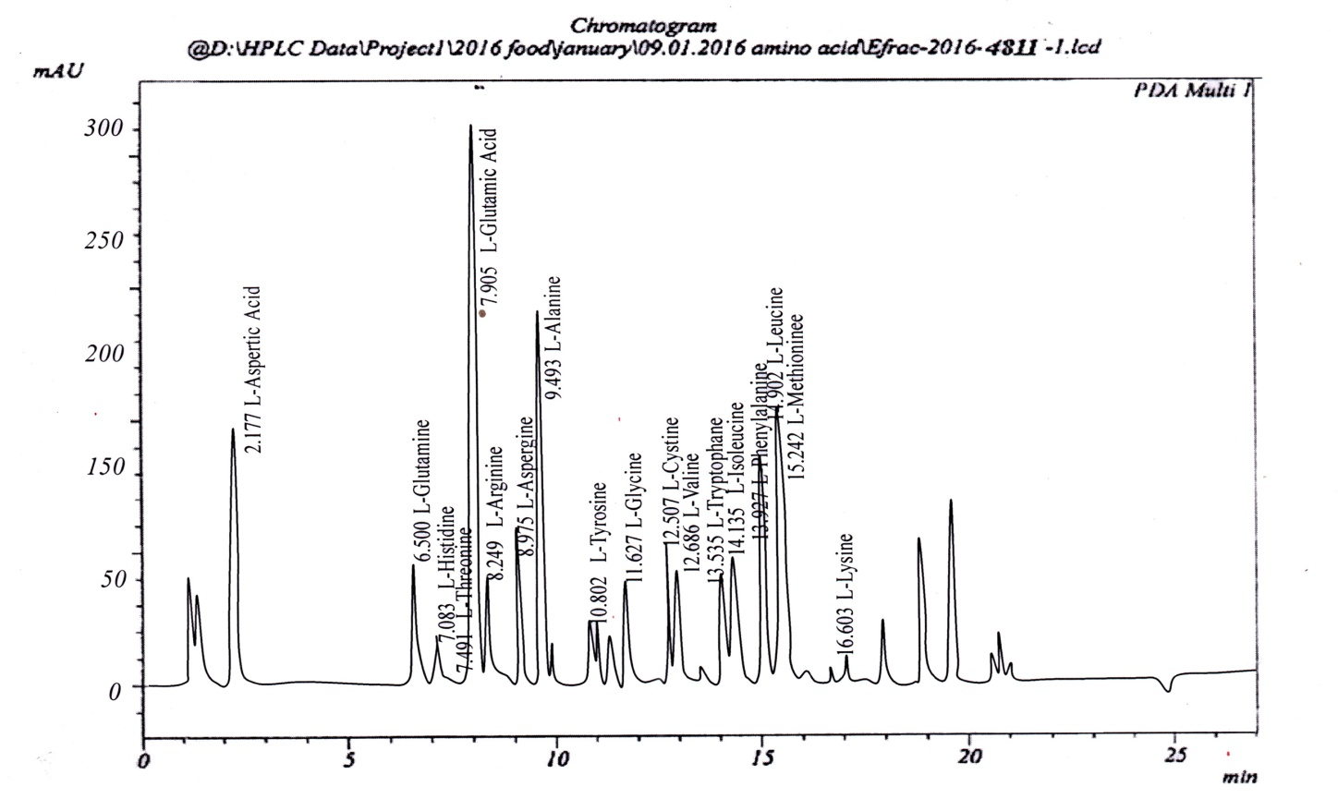Fig.: 2.3.2 HPLC Chromatogram of Amino acids of Barilius vagra

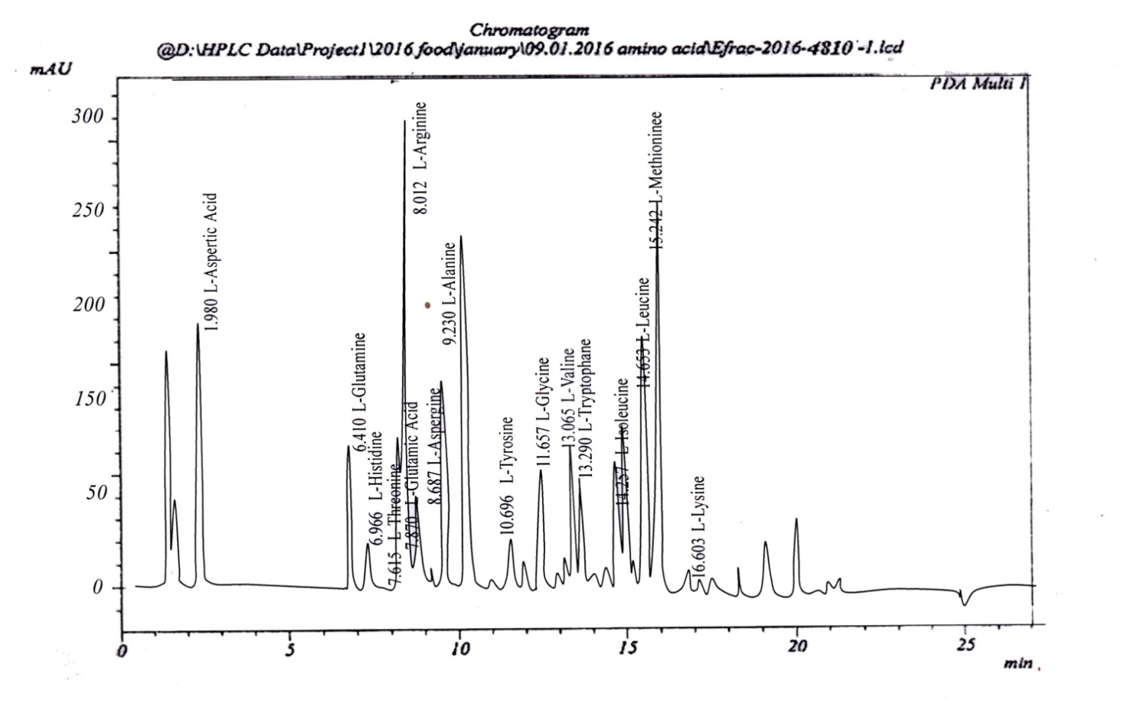

Fig.: 2.3.3 HPLC Chromatogram of Amino acids of Neoeucirrhichthys maydelli

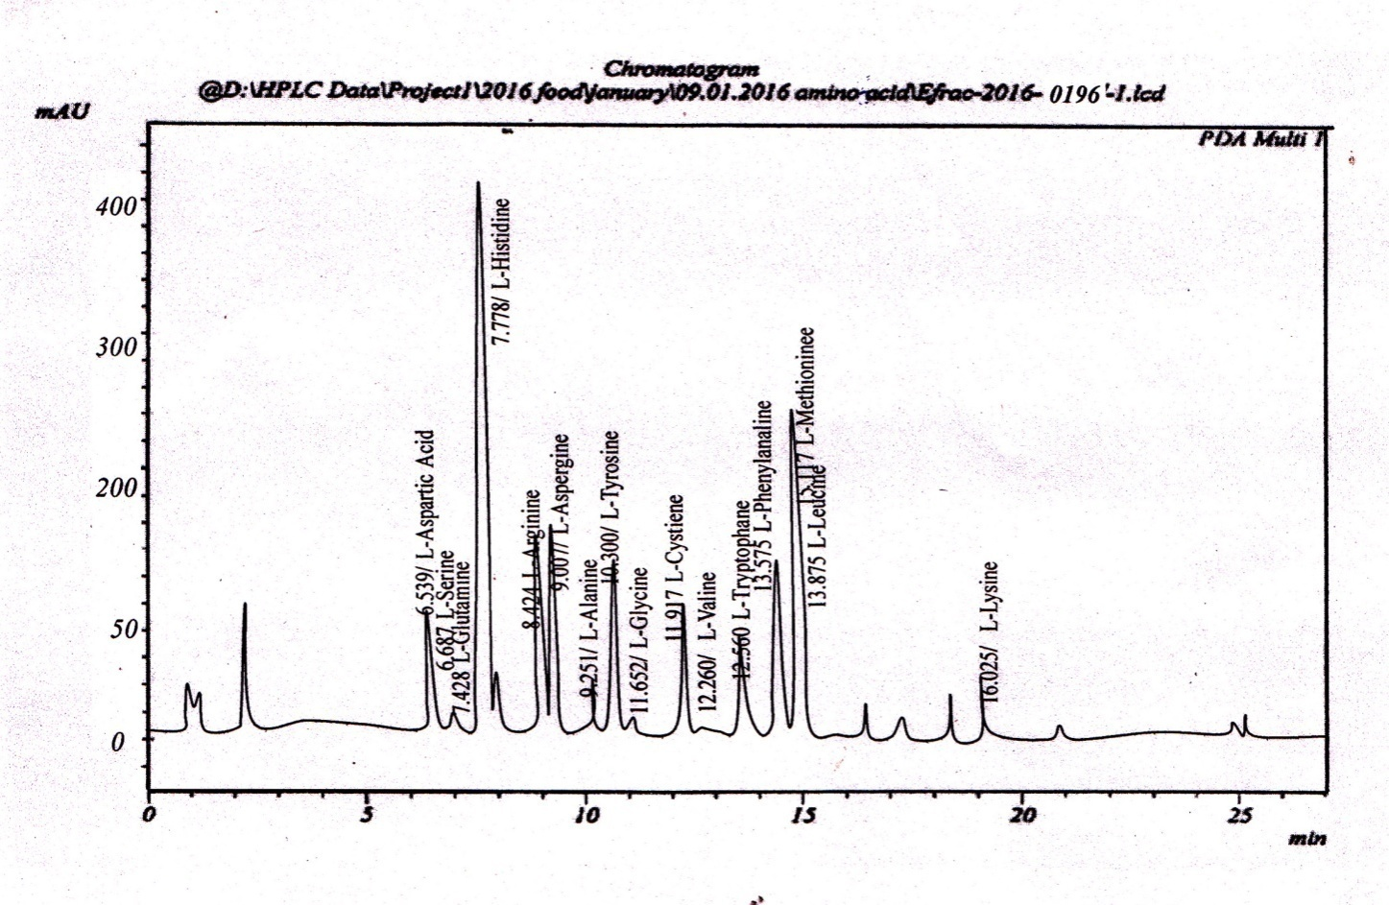
Fig.:2.3.4 HPLC Chromatogram of Amino acids of Chanda nama

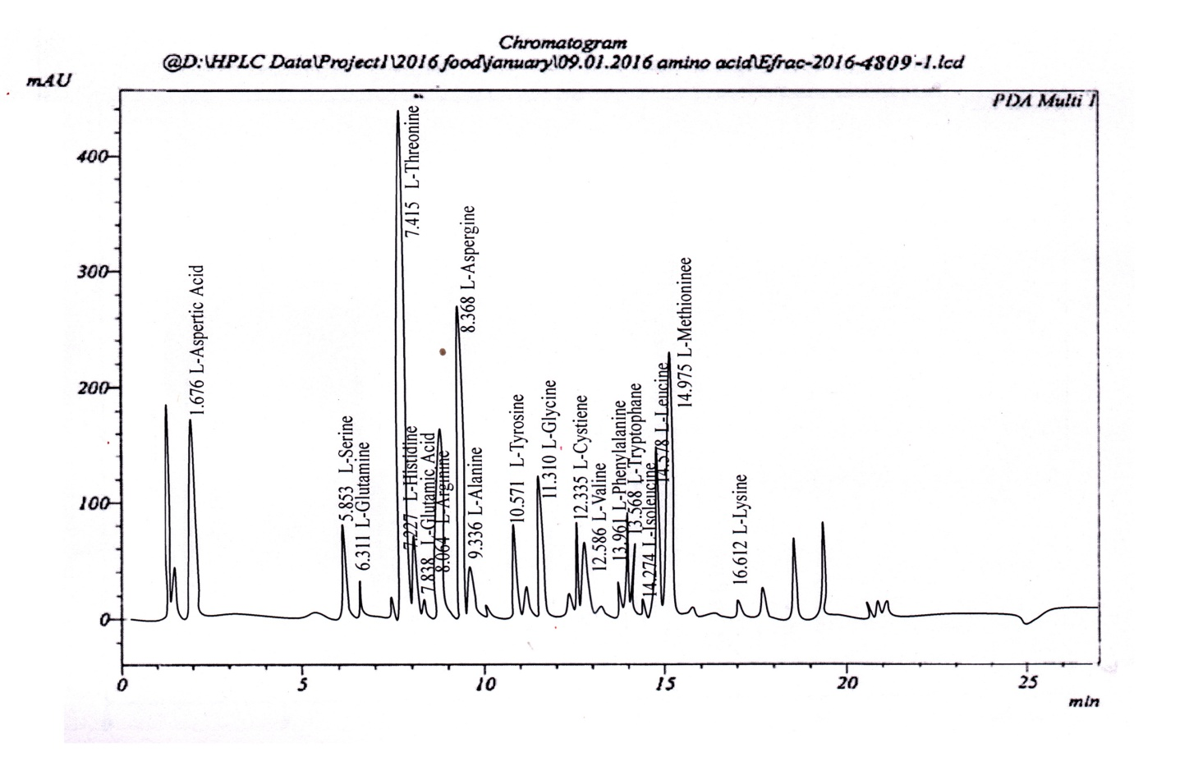
Fig.: 2.3.5 HPLC Chromatogram of Amino acids of Channa gachua

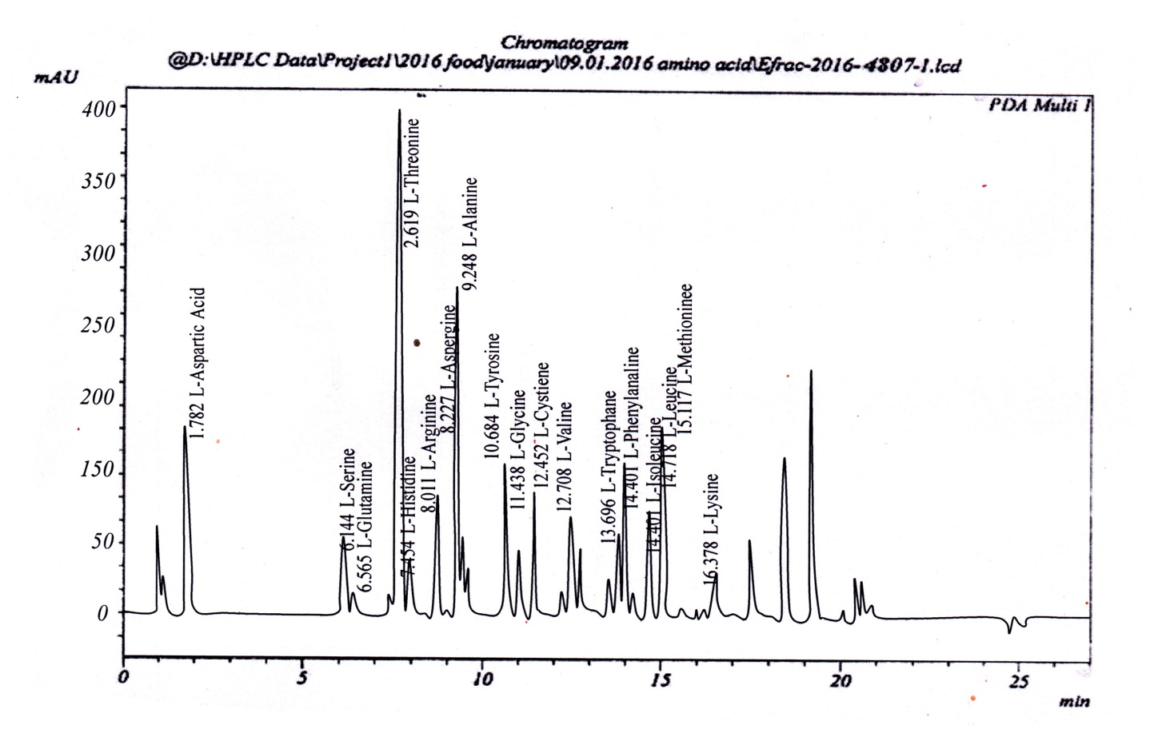
Fig.:. 2.3.6 HPLC Chromatogram of Amino acids of Rasbora daniconius

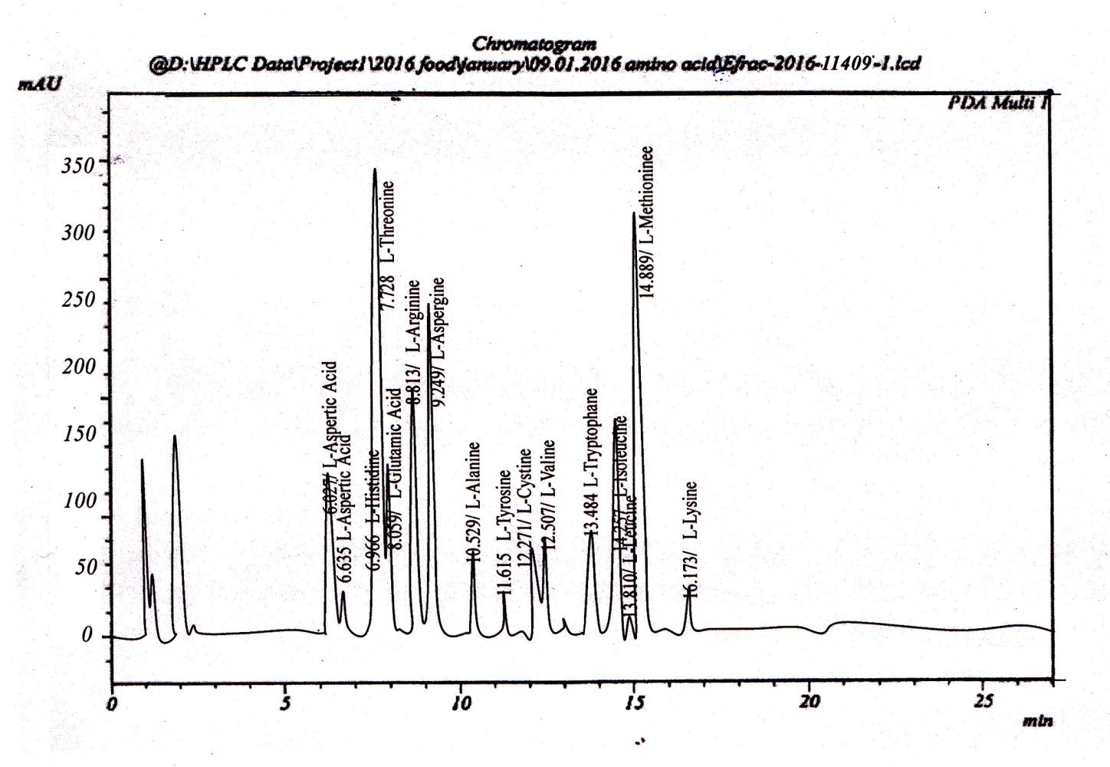Fig.: 2.3.7 HPLC Chromatogram of Amino acids of Channa punctatus

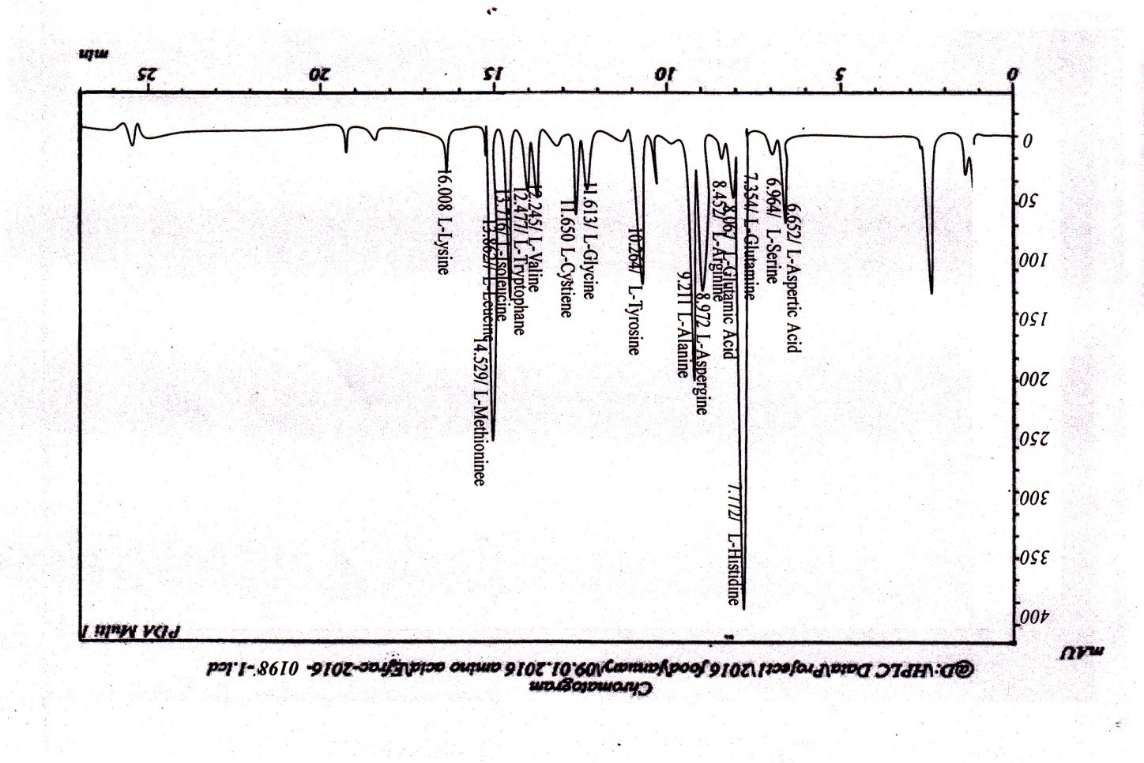

Fig.:. 2.3.8 HPLC Chromatogram of Amino acids of Trichogaster fasciata

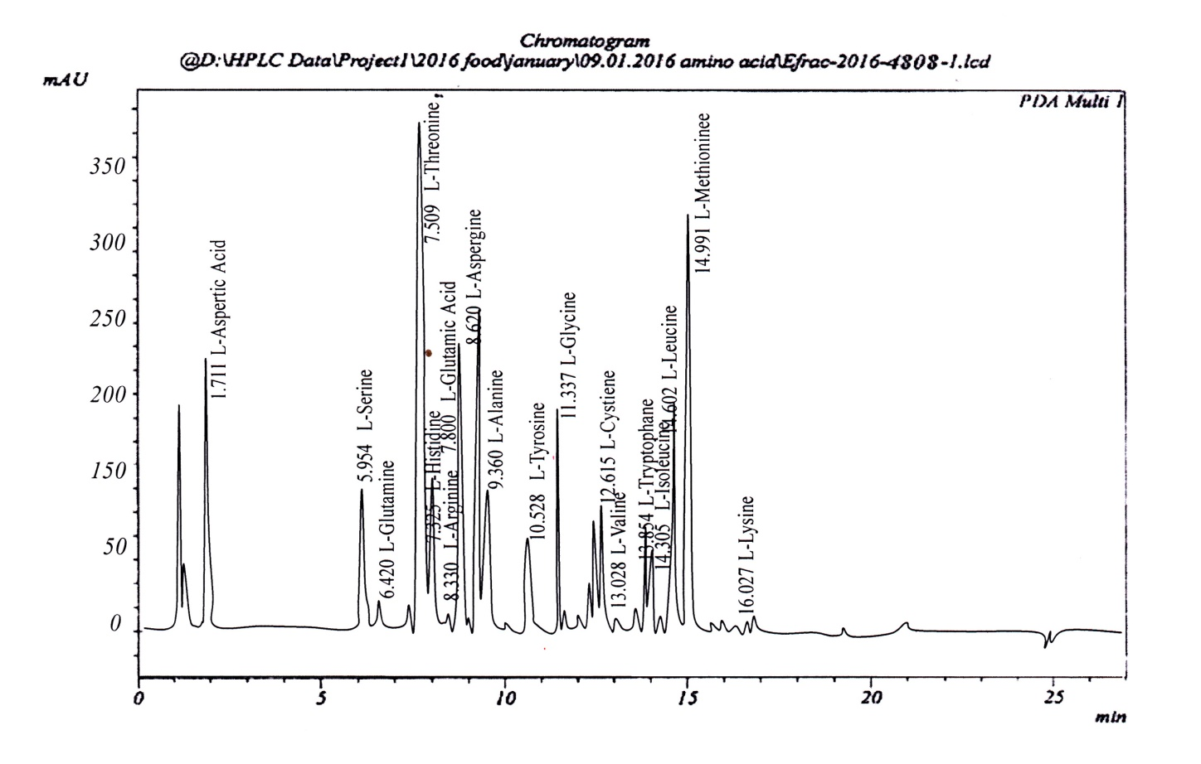
Fig.:2.3.9 HPLC Chromatogram of Amino acids of Xenentodon cancila

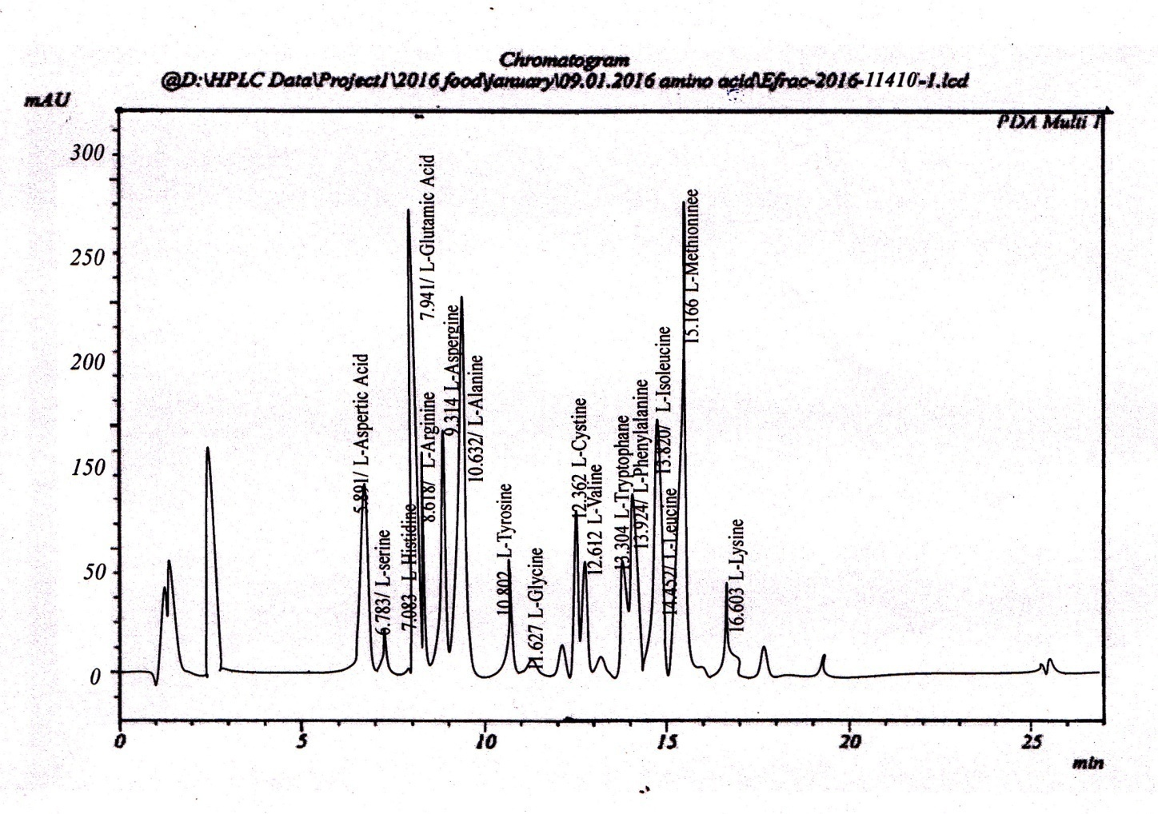
Fig.: 2.3.10 HPLC Chromatogram of Amino acids of Amblypharyngodon mola

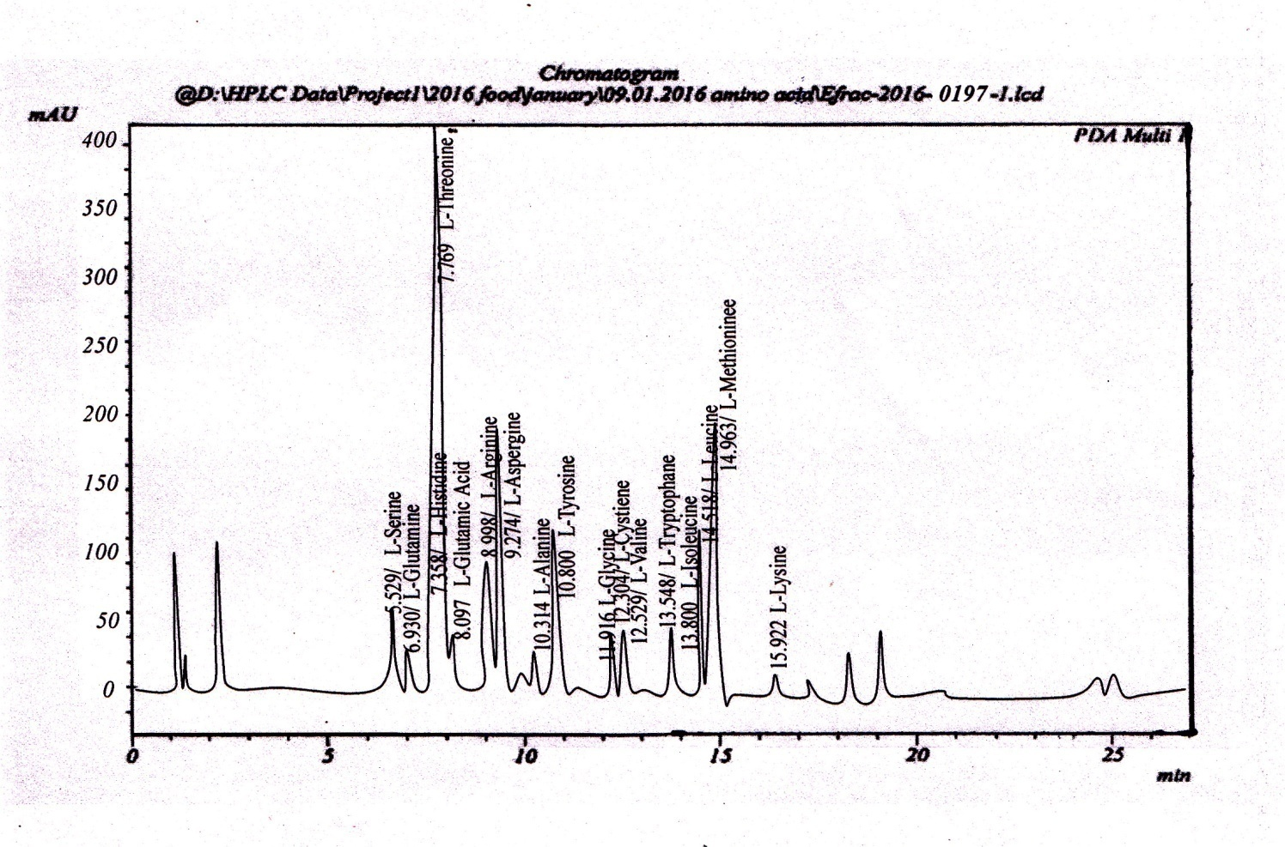
Fig.: 2.3.11 HPLC Chromatogram of Amino acids of Macrognathus pancalus

The data obtained from the HPLC chromatogram of standard amino acid solutions along with those of the different fish samples are shown in the following tables.
Table: 1.5 PeakTable for HPLC Data of amino acid/Mix std 10ppm solution
Peak# | Name | Ret. Time | Area | Area %
1 | L-Aspertic acid | 6.488 | 205025 | 5.706
2 | L-Serine | 6.628 | 177134 | 4.930
3 | L-Glutamine | 7.502 | 252449 | 7.026
4 | L-Hisidine | 7.718 | 102270 | 2.846
5 | L-Threonine | 7.938 | 84588 | 2.354
6 | L-Glutamic acid | 8.158 | 201573 | 5.610
7 | L-Arginine | 8.514 | 74724 | 2.080
8 | L-Aspergine | 9.040 | 156411 | 4.353
9 | L-Alanine | 9.330 | 301622 | 8.394
10 | L-Tyrosine | 10.332 | 146217 | 4.069
11 | L-Glycine | 10.655 | 362129 | 10.078
12 | L-Cystiene | 12.000 | 47427 | 1.320
13 | L-Valine | 12.314 | 256453 | 7.137
14 | L-Tryptophane | 12.544 | 205993 | 5.733
15 | L-Phenylalanine | 13.399 | 111644 | 3.107
16 | L-Isoleucine | 13.777 | 191301 | 5.324
17 | L-Leucine | 13.933 | 193695 | 5.390
18 | L-Methionine | 14.596 | 207553 | 5.776
19 | L-Lysine | 16.370 | 315002 | 8.767
Total |  |  | 3593175 | 100.000

Table: 1.6 PeakTable for HPLC Data of amino acid of Barilius vagra
Peak # | Name | Area | Area %
1 | L-Alanine | 1686235 | 6.574
2 | L-Arginine | 581975.1 | 2.269
3 | L-Asperginine | 1104260 | 4.305
4 | L-Aspartic acid | 2327900 | 9.075
5 | L-Cystine | 89534.63 | 1.349
6 | L-Glutamic acid | 7834280 | 30.541
7 | L-Glutamine | 671509.7 | 2.618
8 | L-Glycine | 343216.1 | 1.338
9 | L-Tyrosine | 417828.3 | 1.629
10 | L-Histidine | 223836.6 | 0.873
11 | L-Isoleucene | 596897.5 | 2.327
12 | L-Leucine | 1477321 | 5.759
13 | L-Methionine | 7311995 | 28.505
14 | L-Phenylalanine | 149224.4 | 0.582
15 | L-Valine | 835656.5 | 3.258
Total |  | 25651671 | 100.000

Table: 1.7 PeakTable for HPLC Data of amino acid of Neoeucirrhichthys maydelli
Peak # | Name | Area | Area %
1 | L-Alanine | 880423.8 | 1.999
2 | L-Arginine | 5610837 | 12.741
3 | L-Asperginine | 149224.4 | 0.339
4 | L-Aspartic acid | 3148634 | 7.150
5 | L-Glutamic acid | 268603.9 | 0.610
6 | L-Glutamine | 1149028 | 2.609
7 | L-Glycine | 104457.1 | 0.237
8 | L-Histidine | 343216.1 | 0.779
9 | L-Isoleucene | 19399169 | 44.053
10 | L-Leucine | 850579 | 1.932
11 | L-Methionine | 10147258 | 23.043
12 | L-Tryptophan | 940113.6 | 2.135
13 | L-Valine | 1044571 | 2.372
Total |  | 44036114 | 100.000

Table: 1.8 PeakTable for HPLC Data of amino acid of Chanda nama

Peak # | Name | Area | Area %
1 | L-Alanine | 1999607 | 8.634
2 | L-Arginine | 238759 | 1.031
3 | L-Asperginine | 1581778 | 6.830
4 | L-Aspartic acid | 119379.5 | 0.515
5 | L-Glutamic acid | 417828.3 | 1.804
6 | L-Proline | 298448.8 | 1.289
7 | L-Serine | 969958.5 | 4.188
8 | L-Tyrosine | 492440.5 | 2.126
9 | L-Histidine | 12475158 | 53.866
10 | L-Isoleucene | 701354.6 | 3.028
11 | L-Leucine | 432750.7 | 1.869
12 | L-Lysine | 432750.7 | 1.869
13 | L-Phenylalanine | 1716080 | 7.411
14 | L-Threonine | 149224.4 | 0.644
15 | L-Tryptophan | 552130.2 | 2.384
16 | L-Valine | 581975.1 | 2.513
Total |  | 23159624 | 100.000

Table: 1.9 PeakTable for HPLC Data of amino acid of Channa gachua
Peak # | Name | Area | Area %
1 | L-Alanine | 208914.1 | 0.712
2 | L-Asperginine | 1432554 | 4.885
3 | L-Aspartic acid | 1566856 | 5.344
4 | L-Cystine | 432750.7 | 1.475
5 | L-Glutamic acid | 999803.3 | 3.410
6 | L-Glutamine | 179069.3 | 0.611
7 | L-Glycine | 537207.8 | 1.832
8 | L-Serine | 805811.6 | 2.748
9 | L-Tyrosine | 925191.1 | 3.155
10 | L-Histidine | 119379.5 | 0.407
11 | Leucine | 1074416 | 3.664
12 | L-Methionine | 6849399 | 23.359
13 | L-Phenylalanine | 552130.2 | 1.883
14 | L-Threonine | 12937754 | 44.122
15 | L-Tryptophan | 298448.8 | 1.018
16 | L-Valine | 402905.8 | 1.374
Total |  | 29322590 | 100.000

Table: 1.10 PeakTable for HPLC Data of amino acid of Rasbora daniconius
Peak # | Name | Area | Area %
1 | L-Alanine | 1313175 | 5.110
2 | L-Arginine | 343216.1 | 1.336
3 | L-Asperginine | 880423.8 | 3.426
4 | L-Aspartic acid | 1432554 | 5.575
5 | L-Cystine | 358138.5 | 1.394
6 | L-Glutamine | 89534.63 | 0.348
7 | L-Glycine | 417828.3 | 1.626
8 | L-Serine | 522285.3 | 2.033
9 | L-Tyrosine | 1283330 | 4.994
10 | L-Histidine | 134301.9 | 0.523
11 | L-Leucine | 805811.6 | 3.136
12 | L-Methionine | 4043981 | 15.738
13 | L-Phenylalanine | 3715687 | 14.460
14 | L-Threonine | 9714507 | 37.805
15 | L-Tryptophan | 328293.6 | 1.278
16 | L-Valine | 313371.2 | 1.220
Total |  | 25696438 | 100.000

Table: 1.11 PeakTable for HPLC Data of amino acid of Channa punctatus
Peaks | Name | Area | Area%
1 | L-Aspertic Acid | 10661 | 1877
2 | L-Serine | 726918 | 124491
3 | L- Glutamine | 7208 | 1533
4 | L- Histidine | 118965 | 26831
5 | L- Glutamic Acid | 456009 | 95177
6 | L- Arginine | 822052 | 190481
7 | L- Aspergine | 1873421 | 267301
8 | L-Alanine | 299843 | 64764
9 | L-Tyrosine | 7448 | 1504
10 | L- Glycine | 28736 | 6432
11 | L- Cystiene | 563620 | 96844
12 | L- Valine | 364923 | 74289
13 | L- Tryptophane | 52106 | 9022
14 | L- Phenylalanine | 444185 | 82791
15 | L- Isoleucine | 399426 | 70377
16 | L- Leucine | 1156676 | 179436
17 | L- Methionine | 2122639 | 344415
18 | L- Lysine | 13773 | 2277
19 | L- Threonine | 2748204 | 373777
Total |  | 12216812 | 2013619

Table: 1.12 PeakTable for HPLC Data of amino acid of Trichogaster fasciata
Peaks # | Name | Area | Area%
1 | L-Aspertic Acid | 557604 | 5.445
2 | L-Serine | 73029 | 0.713
3 | L- Glutamine | 3882 | 0.038
4 | L- Histidine | 3750594 | 36.624
5 | L- Glutamic Acid | 291258 | 2.844
6 | L- Arginine | 56746 | 0.554
7 | L- Aspergine | 835431 | 8.158
8 | L-Alanine | 1586643 | 15.494
9 | L-Tyrosine | 250786 | 2.449
10 | L- Glycine | 4334 | 0.042
11 | L- Cystiene | 9535 | 0.093
12 | L- Valine | 541874 | 5.291
13 | L- Tryptophane | 360751 | 3.523
14 | L- Phenylalanine | 62757 | 0.613
15 | L- Isoleucine | 385485 | 3.764
16 | L- Leucine | 321482 | 3.764
17 | L- Methionine | 1135823 | 11.091
18 | L- Lysine | 12658 | 0.123
Total |  | 10240670 | 100.000

Table: 1.13 PeakTable for HPLC Data of amino acid of Xenentodon cancila
Peak # | Name | Area | Area %
1 | L-Alanine | 447673.1 | 1.713
3 | L-Asperginine | 1611623 | 6.168
4 | L-Aspartic acid | 1507166 | 5.768
5 | L-Cystine | 402905.8 | 1.542
6 | L-Glutamic acid | 1089338 | 4.169
7 | L-Glutamine | 89534.63 | 0.343
8 | L-Glycine | 626742.4 | 2.399
10 | L-Serine | 865501.4 | 3.312
11 | L-Tyrosine | 492440.5 | 1.885
12 | L-Histidine | 119379.5 | 0.457
14 | L-Leucine | 1119183 | 4.283
16 | L-Methionine | 8580402 | 32.838
17 | L-Phenylalanine | 895346.3 | 3.427
18 | L-Threonine | 7729823 | 29.583
19 | L-Tryptophan | 552130.2 | 2.113
Total |  | 26129189 | 100.000

Table: 1.14 PeakTable for HPLC Data of amino acid of Amblypharyngodon mola
Peaks | Name | Area | Area%
1 | L-Aspertic Acid | 6380 | 0.000
2 | L-Serine | 4554 | 0.000
3 | L- Glutamine | 49764 | 0.000
4 | L- Histidine | 1911 | 0.000
5 | L- Glutamic Acid | 110495 | 0.000
6 | L- Arginine | 1901102 | 0.000
7 | L- Aspergine | 23662 | 0.000
8 | L-Alanine | 1653280 | 0.000
9 | L-Tyrosine | 333664 | 0.000
10 | L- Glycine | 2961 | 0.000
11 | L- Cystiene | 602640 | 0.000
12 | L- Valine | 379990 | 0.000
13 | L- Tryptophane | 53454 | 0.000
14 | L- Phenylalanine | 18344 | 0.000
15 | L- Isoleucine | 367135 | 0.000
16 | L- Leucine | 31106 | 0.000
17 | L- Methionine | 1883656 | 0.000
18 | L- Lysine | 30757 | 0.000
Total |  | 7454856

Table: 1.15 PeakTable for HPLC Data of amino acid of Macrognathus pancalus

Peaks # | Name | Area | Area%
1 | L-Serine | 514099 | 4.149
2 | L- Glutamine | 89692 | 0.724
3 | L- Histidine | 2728 | 0.022
4 | L- Threonine | 4239364 | 34.210
5 | L- Giutamic Acid | 227660 | 1.837
6 | L- Arginine | 702832 | 5.672
7 | L-Aspergine | 1766264 | 14.253
8 | L-Alanin | 186753 | 1.507
9 | L- Tyrosine | 774386 | 6.249
10 | L- Glycine | 5530 | 0.045
11 | L- Cystiene | 401298 | 3.283
12 | L- Valine | 282856 | 2.283
13 | L-Trytophane | 58992 | 0.476
14 | L- phenylanine | 360275 | 2.907
15 | L- Isoleucine | 251355 | 2.028
16 | L- leucine | 1000536 | 8.074
17 | L-Methionine | 1514883 | 12.225
18 | L- Lysine | 12533 | 0.101
Total |  | 12392037 | 100.000

Table: 2.1a Amino acid profile of the selected fish species
Sl. No. | Fish species | L-Alanine  g/100g | L-Arginine  g/100g | L-Asparagine  g/100g | L-Aspartic acid  g/100g | L-Cystine  g/100g | L-Glutamic acid  g/100g | L-Glutamine  g/100g | L-Glycine  g/100g | L-Proline  g/100g | L-Serine  g/100g
1 | Barilius vagra | 1.13 | 0.39 | 0.74 | 1.56 | 0.06 | 5.25 | 0.45 | 0.23 | BDL | BDL
2 | N. maydelli | 0.59 | 3.76 | 0.10 | 2.11 | BDL | 0.18 | 0.77 | 0.07 | BDL | BDL
3 | Chanda nama | 1.34 | 0.16 | 1.06 | 0.08 | BDL | 0.28 | BDL | BDL | 0.20 | 0.65
4 | Channa gachua | 0.14 | BDL | 0.96 | 1.05 | 0.29 | 0.67 | 0.12 | 0.36 | BDL | 0.54
5 | Rasbora daniconius | 0.88 | 0.23 | 0.59 | 0.96 | 0.24 | BDL | 0.06 | 0.28 | BDL | 0.35
6 | Channa punctatus | 0.26 | 0.72 | 0.78 | BDL | 0.31 | 0.31 | BDL | 0.14 | 0.12 | 0.47
7 | Trichogatser fasciata | 1.43 | 0.21 | 1.46 | 0.74 | BDL | 0.39 | BDL | BDL | 0.24 | 0.11
8 | Xenentodon cancila | 0.30 | BDL | 1.08 | 1.01 | 0.27 | 0.73 | 0.06 | 0.42 | BDL | 0.58
9 | Amblypharyngodon mola | 0.37 | BDL | 0.89 | BDL | 0.43 | 1.66 | BDL | 0.43 | 1.66 | BDL
10 | Macrognathus pancalus | 0.09 | 1.33 | 1.59 | BDL | 1.19 | 0.16 | BDL | BDL | 0.11 | 0.41

Table: 2.1b Amino acid profile of the selected fish species
Sl. No | Fish species | L-Tyrosine  (g/100g) | L-Histidine  (g/100g) | L-Isoleucine  (g/100g) | L-Leucine  (g/100g) | L-Lysine  (g/100g) | L-Meth-  -ionine(g/100g) | L-Phenyl-  -alanine (g/100g) | L-Threonine  (g/100g) | L-Trypto-  phan (g/100g) | L-Valine  (g/100g)
1 | Barilius vagra | 0.28 | 0.15 | 0.40 | 0.99 | BDL | 4.90 | 0.10 | BDL | BDL | 0.56
2 | N maydelli | BDL | 0.23 | 0.13 | 0.57 | BDL | 6.80 | BDL | BDL | 0.63 | 0.70
3 | Chanda nama | 0.33 | 8.36 | 0.47 | 0.29 | BDL | 1.15 | 0.10 | BDL | 0.37 | 0.39
4 | Channa gachua | 0.62 | 0.08 | BDL | 0.72 | BDL | 4.59 | 0.37 | 8.67 | 0.20 | 0.27
5 | Rasbora daniconius | 0.86 | 0.09 | BDL | 0.54 | BDL | 2.71 | 0.49 | 6.51 | 0.22 | 0.21
6 | Channa punctatus | BDL | 0.18 | 0.24 | 2.68 | BDL | 9.42 | 0.30 | 3.27 | 0.06 | 0.23
7 | Trichogatser fasciata | 0.47 | 10.0 | 0.51 | 0.45 | BDL | 1.49 | 0.15 | BDL | 0.48 | 0.58
8 | Xenentodon cancila | 0.33 | 0.08 | BDL | 0.75 | BDL | 5.75 | 0.60 | 5.18 | 0.37 | BDL
9 | Amblypharyngodon mola | BDL | 0.16 | BDL | BDL | BDL | 0.29 | BDL | 0.17 | 0.07 | 0.31
10 | Macrognathus pancalus | 0.75 | BDL | 0.19 | 0.73 | BDL | 1.03 | 0.46 | 7.07 | BDL | 1.03
BDL=Below Detectable Limit

The amino acid contents of the fish species selected is shown in table 1.4 (a) and 1.4 (b) Dietery protein provide substrates needed for synthesizing body proteins and also other nitrogen-containing compounds and the amount of amino acid contents in food proteins determine the nutritional quality of protein (Young et al., 1994). In the present study the amount of almost all the essential and non essential amino acids in the selected fish species were recorded. The presence of non essential amino acids like Alanine, Aspartic acid, glycine, serine, Tyrosine were recorded to be in less quantity in the fish species. Fair content of glutamic acid in Barilius vagra was resulted by the present study. The highest contents (10.0%) of essential amino acid histidine was found in Trichogatser fasciata which was followed by (8.36%) in Chanda nama . Another essential amino acid Methionine was highly quantified (9.42%) in Channa gachua followed by (6.80%) & (5.75%) in N. maydelli and Xenentodon cancila respectively. Threonine, the another non essential amino acid was high in Channa gachua (8.67%) followed by (7.07%), (6.51%) & (5.18%) in Macrognathus pancalus , Rasbora daniconius and Xenentodon cancila respectively. Body composition is found to be changing from one species to another species and also habite (Ashraf et al., 2011).
As per the report of Joint FAO/WHO/UNU Expert consultation on protein and amino acid requirements in human nutrition, WHO Technical Report Series No. 935, 2007, the necessary amounts of amino acid required by healthy living of an adult body are as follows : Histidine (15), isolucine (30), Leucine (59), lysine (45), methionine (16), cystine (6), threonine (15), tryotophan (60) and valine (26). Oluwaniyi et al., 2009 found the presence of higher amount of glutamic acid in their four studied species Clupea harengus, Scomber scombrus, Trachurus trachurus and Urophycis tenuis. This result shows similarity with the present work that among all the non essential amino acids, glutamic acid was highlighted in all the ten studied species. In the language of Ashraf et al., 2011, the amount of phenylalanine, valine, arginine, lysine and tyrosine were in higher contents in grass carp whereas the contents of alanine, glutamic acid, and methylalanine and valine were mostly prominent in silver carp. This was justified by limiting feeding scope of grass crap than silver carp. It was concluded the grass crap ws superior to silver crap. The fishes which feed on low protein diet get more effected by essential amino acids than the fishes which consume high protein diet (Ashraf et al., 2011).
Fish muscle is made of very good composition of amino acid. It is the vital source of nutrients as well as requisite contents of amino acid that are easy to digest by all age groups of human being (Venugopal et al., 1996 & Yanez, et al., 1976). Fish bodies are covered by a shawl of water mass, hence the muscle fibres need lesser structural support compared to the muscles of land animals (Huttin et al., 1976). In the present work of the essential amino acids like phenylalanine, valine, tryptophan, threonine, isolucine, methionine, histidine, arginine, leucine and lysine were detected.
Methionine is one of the most important amino acid lacking of which shows deficiency symptoms prominently. It helps in the production of sulphur which helps normal metabolism. It is also required for the synthesis of haemoglobin and glutathione which fight against free radicals (Akhirevbulu et al., 2013). The dominating amino acids of proteins are known to be the precursors of several coenzymes, hormones , nucleic acids and other molecules which meet the essential requirement for life. A sufficient intake of dietary protein is needed to strength cellular integrity and function and also for good health and reproduction (Haeaibam Romsharsha et al., 2014).
As per the data the Hawaibam Romharsha et al., 2014, glutamic acid was amounted to be the highest (20.04%) in semiplotus manipurensis in comparison to other two studied fish species N. stracheyi & L. pangusia. In the present study, Barilius vagra contained the highest content of glutamic acid (5.25 gm) amongst the ten studied species. Aspartic acid was recoded to be in significant contents in all the studied fish species in the work of Hawaibam et al 2014. But in the present work the said non essential amino acid, was found to be of lower amounts. It may be explained by the differences in their feeding habits. The essential amino acids like Methionine, Thremine, Valine, Histidine, Phenylalanine, Leucine were recorded to be present in more or less good amounts. Histidine was recorded to be highest in Trichogatser fasciata (10.0) followed by Chanda nama (8.36). Threonine was found to be mostly contained by Channa gachua (8.67) which was followed by Macrognathus pancalus (7.07), Rasbora daniconius (6.51) and Xenentodon cancila (5.18). Threonine is widely used for the treatment of nerve disorders including spinal spasticity, multiple sclerosis familial spastic paraparesus and also amyotrophic lateral sclerosis (K. Hyland, 2007). In accordance with the result analysis of Mahanty et al., 2014, amongst 27 food fishes, the species S. Waitei contained the highest content of Threonine. From the present investigation it may be concluded that the small food fish Channa gachua of BTAD, Kokrajhar area can be used to serve as a natural supplementation for threonine. Another very important branched chain amino acid, isoleucine is required for the formation of muscle as well as propagation of the normal growth of the same (Charlton, 2006). Although in lesser amount, Isoleucine was found to be present in all the studied species. The patients having chronic renal failure face the complicacy of low plasma level of the branched chain amino acids like leucine, isoleucine and valine when they are under hemodialysis. The crucial abnormalities in the plasma amino acid pool can be recovered with the proper high protein supplementation (Bordin et al., 2013). The studied food fishes can be recommended as ideal dietary supplementations for human health.
  - Fatty acid Profile

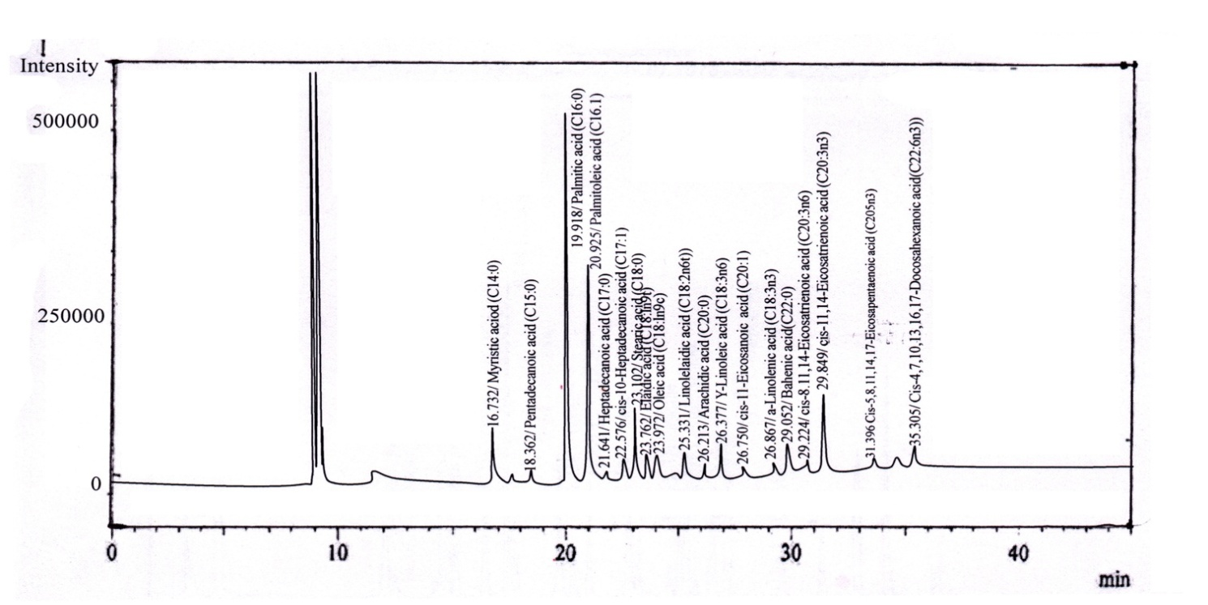
The following are the GC-MS Chromatogram of fatty acids profile of the different fish samples.
Fig.: 2.4.1 GC-MS Chromatogram of Fatty acids in Barilius vagra
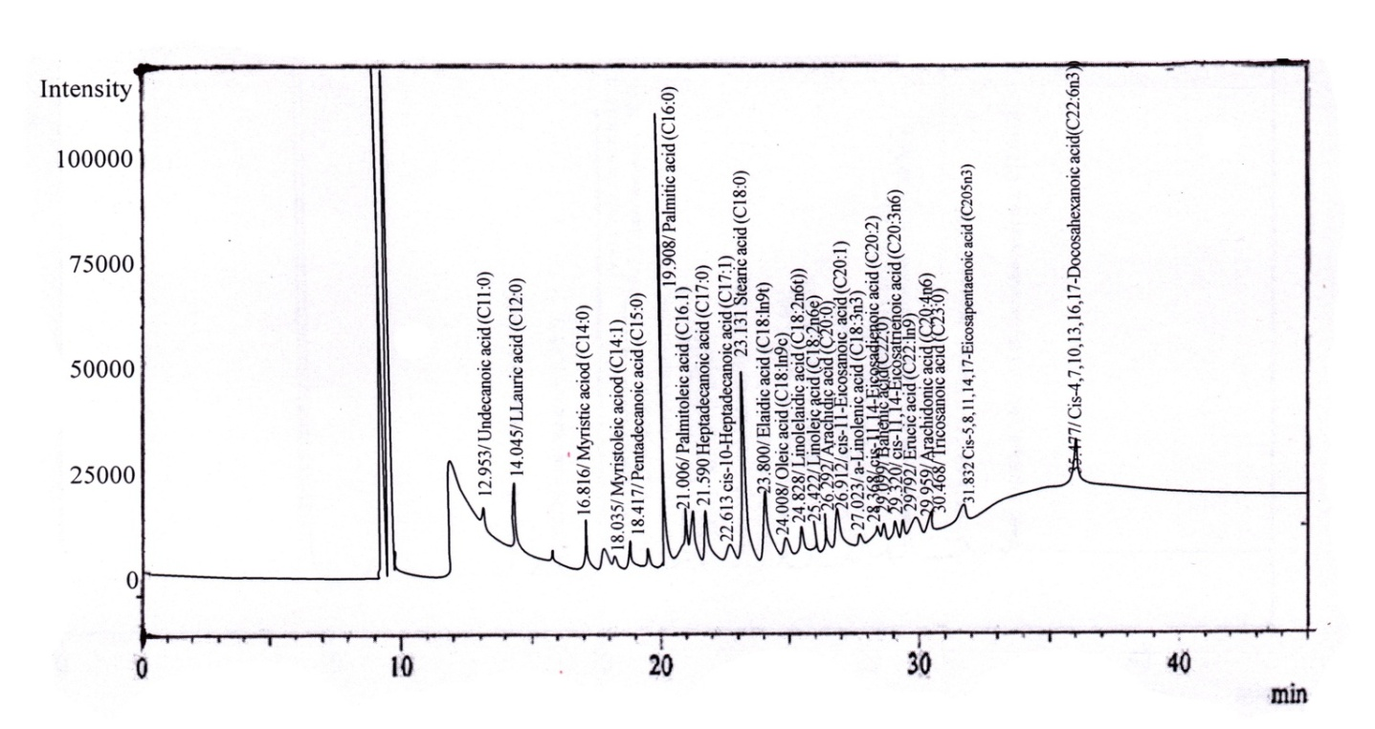

Fig.: 2.4.2 GC-MS Chromatogram of Fatty acids in Neoeucirrhichthys maydelli

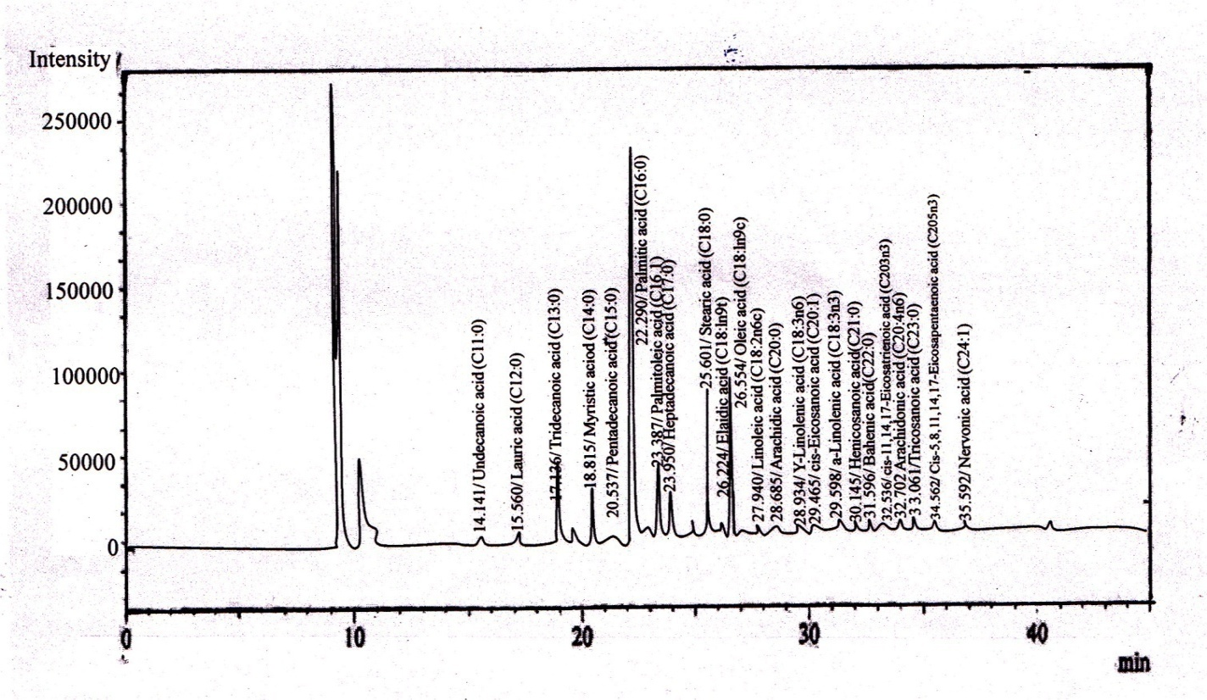

Fig.: 2.4.3 GC-MS Chromatogram of Fatty acids in Chanda nama

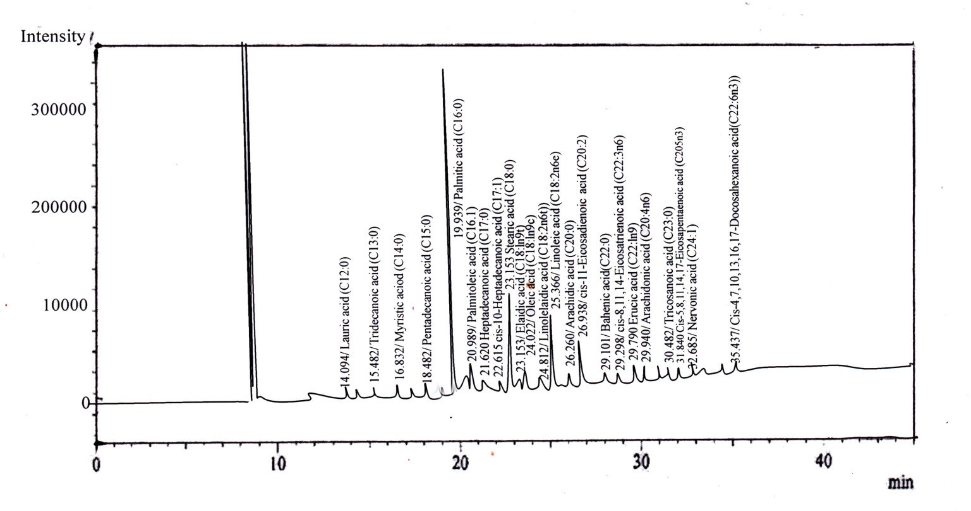

Fig.: 2.4.4 GC-MS Chromatogram of Fatty acids in Channa gachua

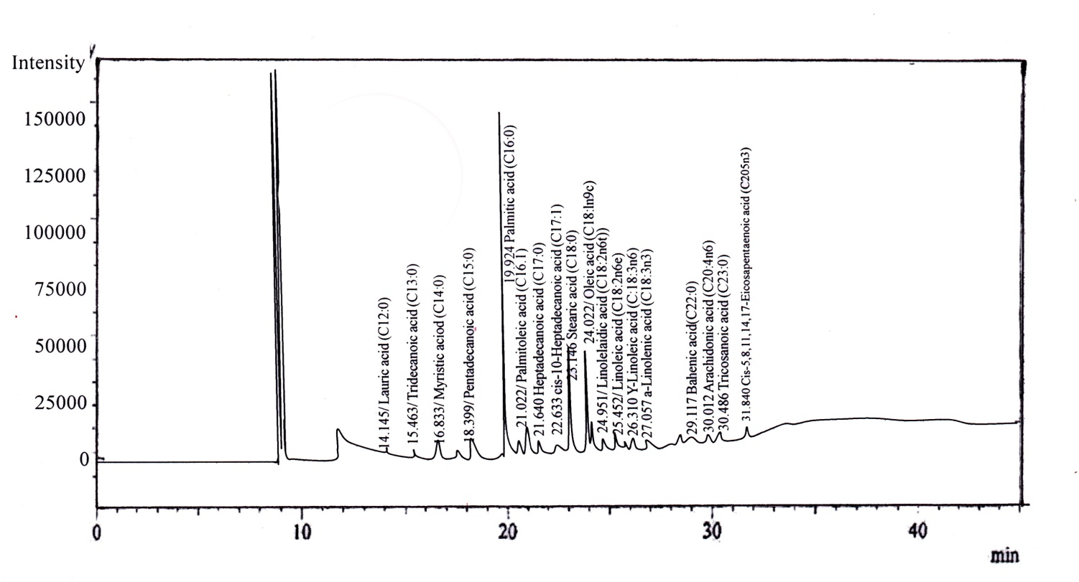

Fig.: 2.2.4 GC-MS Chromatogram of Fatty acids in Rasbora daniconius

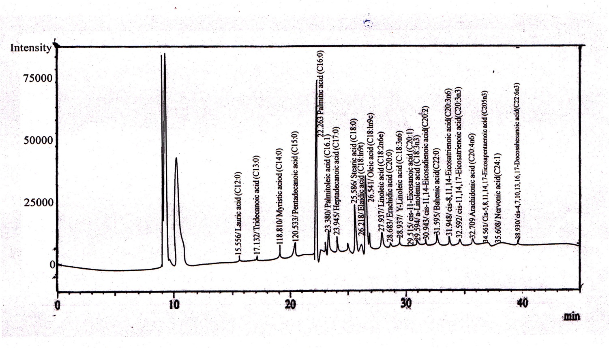

Fig.: 2.4.6 GC-MS Chromatogram of Fatty acids in Channa punctatus

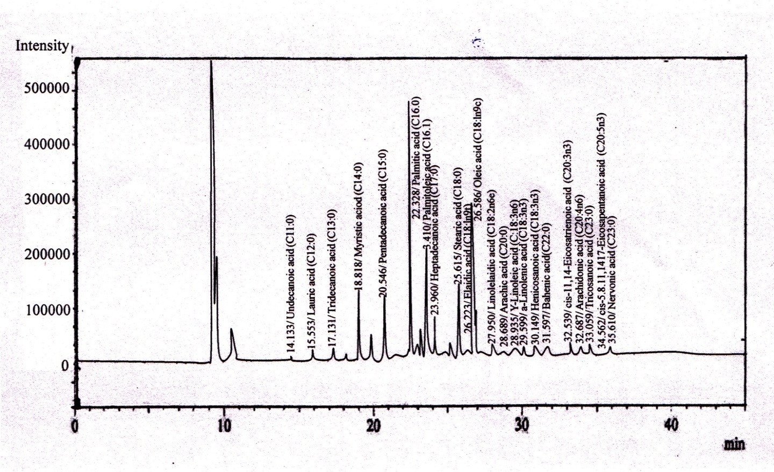

Fig.: 2.4.7 GC-MS Chromatogram of Fatty acids in Trichogaster fasciata

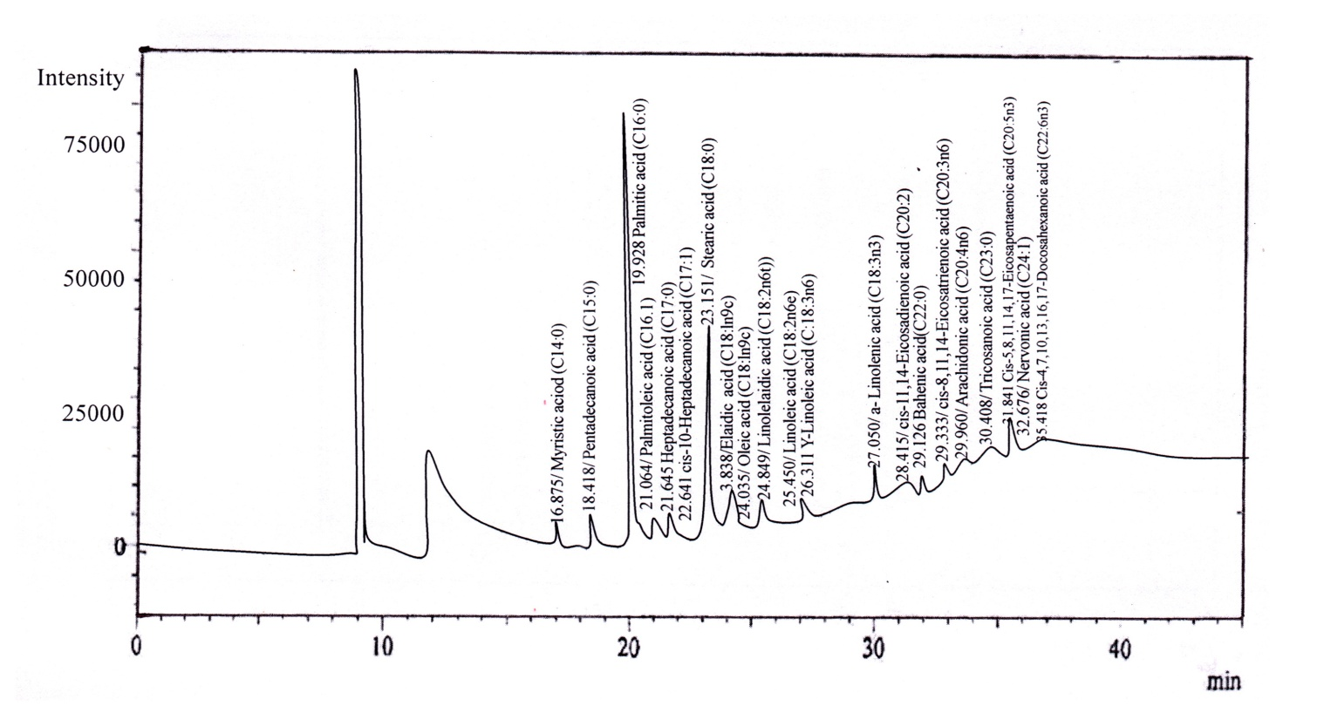

Fig.: 2.4.8 GC-MS Chromatogram of Fatty acids in Xenentodon cancila

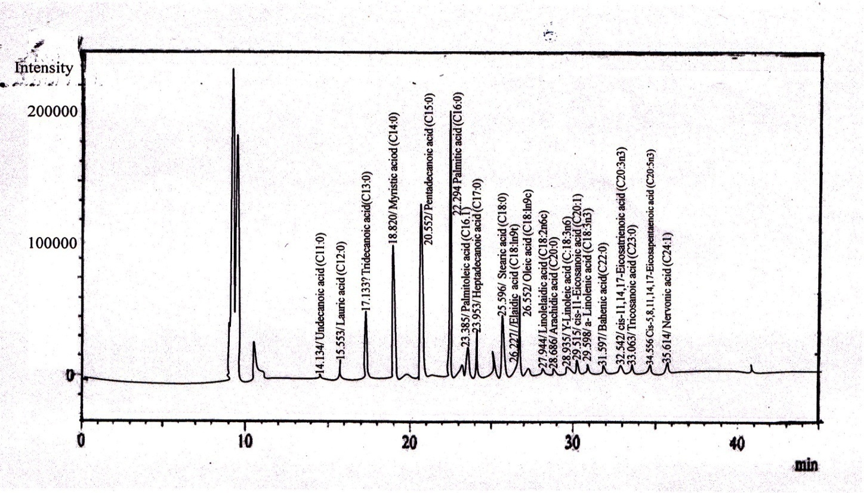

Fig.: 2.4.9 GC-MS Chromatogram of Fatty acids in Amblypharyngodon mola

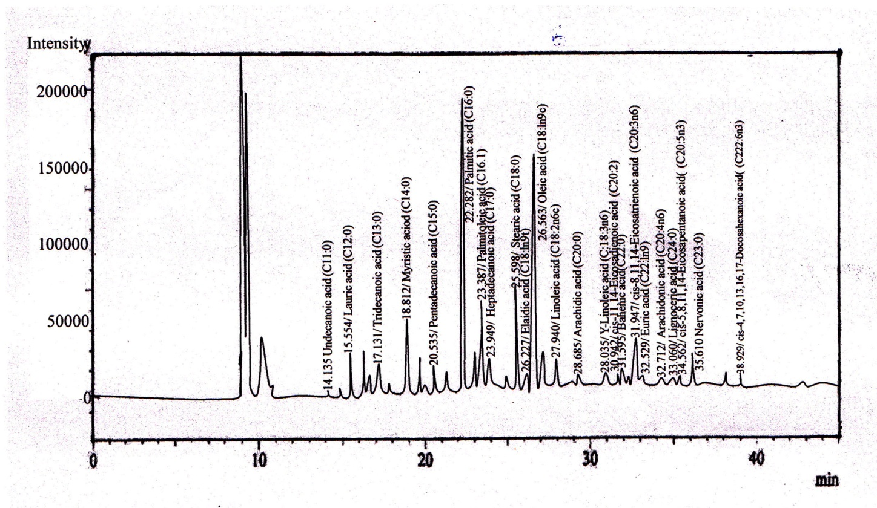
Fig.: 2.4.10 GC-MS Chromatogram of Fatty acids in Macrognathus pancalus

The data obtained from the GC-MS chromatogram of fatty acid profile of the different fish samples are shown in the following tables.
Table:2.1.1 Peak Table for Fatty acids in Barilius vagra

Peak# | Name | Ret.Time | Area | Height | Area%
1 | Myristic Acid(C14:0) | 16.732 | 499216 | 69300 | 5.9788
2 | Pentadecanoic acid(C15:0) | 18.632 | 101566 | 10872 | 1.2522
3 | Palmitic acid(C16:0) | 19.918 | 2888329 | 480160 | 31.5915
4 | Palmitoleic acid(C16:1) | 20.925 | 1525163 | 275485 | 18.2658
5 | Heptadecanoic acid(C17:0) | 21.641 | 82088 | 7040 | 0.9831
6 | Cis-10-Heptadecanoic acid(C17:1) | 22.576 | 178438 | 23546 | 2.1370
7 | Stearic acid (C18:0) | 23.102 | 503541 | 92319 | 6.0306
8 | Elaidic acid(C18:1n9t) | 23.762 | 43953 | 8685 | 0.5264
9 | Oleic acid(C18:1n96) | 23.972 | 713903 | 95060 | 8.5499
10 | Linoleic acid(C18:2n6c) | 25.331 | 217218 | 29027 | 2.6015
11 | Arachidic acid(C20:0) | 26.213 | 17648 | 3237 | 0.2114
12 | Y-Linolenic acid(C18:3n6) | 26.377 | 58973 | 6319 | 0.7063
13 | Cis-11-Eicosenoic acid(C20:1) | 26.750 | 28418 | 7377 | 0.3403
14 | a-Linoleic acid(C18:3n3) | 26.867 | 357499 | 18417 | 4.2815
15 | Behenic acid(C22:0) | 29.052 | 14799 | 2853 | 0.1772
16 | Cis-8,11,14-Eicosatrienoic acid(C20:3n6) | 29.224 | 59707 | 5878 | 0.7151
17 | Cis-11,14,17-Eicosatrienoic acid(C20:3n3) | 29.849 | 246559 | 43537 | 2.9529
18 | Cis-5,8,11,14,17-Eicosapentaenoic acid(C20:5n3) | 31.396 | 575218 | 98695 | 6.8890
19 | Cis-4,7,10,13,16,17-Docosahexanoica acid(C22:6n3) | 35.305 | 234600 | 37837 | 2.8096
Total |  |  | 8349833 | 1345614 | 100.0000

Table: 2.2.2 .Peak Table Fatty acids of Neoeucirrhichthys maydelli

Peak# | Name | Ret.Time | Area | Height | Area%
1 | Undecanoic acid(C11:0) | 12.953 | 18833 | 2687 | 0.9604
2 | Lauric acid(C12:0) | 14.013 | 90372 | 12434 | 4.6086
3 | Myristic acid(C14:0) | 16.816 | 97433 | 30890 | 4.9687
4 | Myristoleic acid(C14:1) | 18.035 | 14470 | 1157 | 0.2379
5 | Pentadecanoic acid(C15:0) | 18.117 | 19192 | 1802 | 2.5239
6 | Palmitic acid(C16:0) | 19.908 | 617612 | 99752 | 31.4957
7 | Palmitoleic acid(C16:1) | 21.006 | 50963 | 7348 | 2.5989
8 | Heptadecanoic acid(C17:0) | 21.590 | 99340 | 10716 | 5.0660
9 | Cis-10-Heptadecanoic acid(C17:1) | 22.613 | 24089 | 2312 | 1.2285
10 | Stearic acid( C18:0) | 23.131 | 277120 | 41882 | 14.1320
11 | Elaidic acid(C18:9nt) | 23.800 | 24131 | 4826 | 1.2306
12 | Oleic acid(C18:1n9c) | 24.008 | 379892 | 40517 | 19.3720
13 | Linolelaidic acid(C18:2n6t) | 24.828 | 11427 | 1760 | 0.5827
14 | Linoleic acid(C18:2n6c) | 25.422 | 50091 | 5966 | 2.5544
15 | Arachidic acid(C20:0) | 26.292 | 9158 | 1276 | 0.4676
16 | Cis-11,14-Eicosadienoic acid(C20:1) | 26.912 | 37539 | 6963 | 1.9143
17 | a-Linolenic acid( C18:3n3) | 27.023 | 33815 | 4036 | 1.7244
18 | Cis-11,14-Eicosadienoic acid(C20:2) | 28.368 | 8515 | 1252 | 0.4343
19 | Behenic acid(C22:0) | 29.099 | 13268 | 2041 | 0.6766
20 | Cis-8,11,14-Eicosatrienoic acid(C20:3n6) | 29.320 | 7793 | 978 | 0.3974
21 | Erucic acid(C22:1n9) | 29.792 | 3801 | 652 | 0.1938
22 | Arachidonic acid(C20:4n6) | 29.959 | 25259 | 3458 | 1.2881
23 | Tricosanoic acid(C23:0) | 30.468 | 4139 | 772 | 0.2111
24 | Cis-5,8,13,16,17-Eicosapentaenoic acid(C20:5n3) | 31.832 | 9485 | 1493 | 0.4837
25 | Cis-4,7,10,13,16,17-Docosahexanoica acid(C22:6n3) | 35.447 | 2921 | 431 | 0.1490
Total |  |  | 1960938 | 270401 | 100.0000

Table: 2.2.3.Peak Table of Fatty acids of Chanda nama

Peak# | Name | Ret.Time | Area | Height | Area%
1 | Undecanoic acid(C11:0) | 14.141 | 7633 | 2281 | 0.3794
2 | Lauric acid(C12:0) | 15.560 | 16225 | 4666 | 0.8064
3 | Tridecanoic acid(C13:0) | 17.136 | 22471 | 6521 | 1.1168
4 | Myristic acid(C14:0) | 18.815 | 142297 | 41400 | 7.0722
5 | Pentadecanoic acid(C15:0) | 20.537 | 94133 | 27371 | 4.6785
6 | Palmitic acid(C16:0) | 22.290 | 813944 | 218854 | 40.4534
7 | Palmitoleic acid(C16:1) | 23.387 | 121281 | 35525 | 6.0277
8 | Heptadecanoic acid(C17:0) | 23.950 | 78950 | 23362 | 3.9239
9 | Stearic acid(C18:0) | 25.601 | 259948 | 76815 | 12.9195
10 | Elaidic acid(C18:9nt) | 26.224 | 23917 | 4223 | 1.1887
11 | Oleic acid(C18:1n9c) | 26.554 | 351279 | 82297 | 17.4588
12 | Linoleic acid(C18:2n6c) | 27.940 | 17138 | 4816 | 0.8518
13 | Arachidic acid(C20:0) | 28.685 | 14408 | 4264 | 0.7161
14 | Y-Linolenic acid( C18:3n3) | 28.934 | 4292 | 1167 | 0.2133
15 | Cis-11-Eicosenoic acid(C20:1) | 29.465 | 5922 | 1284 | 0.2943
16 | a-Linolenic acid(C18:3n3) | 29.598 | 5558 | 1655 | 0.2762
17 | Henicosanoic acid(C21:0) | 30.145 | 1841 | 612 | 0.0915
18 | Behenic acid(C22:0) | 31.596 | 9648 | 2776 | 0.4795
19 | Cis-11 ,14,17-Eicosatrienoic acid(C20:3n3) | 32.536 | 2523 | 664 | 0.1254
20 | Arachidonic acid(C20:4n6) | 32.702 | 1548 | 395 | 0.0770
21 | Tricosanoic acid(C23:0) | 33.061 | 2614 | 773 | 0.1299
22 | Cis-5,8,11,14,17-Eicosapentaenoic acid(C20:5n3) | 34.562 | 9010 | 2062 | 0.4478
23 | Nervonic acid(C24:1) | 35.592 | 5472 | 1611 | 0.2719
Total |  |  | 2012052 | 545394 | 100.0000

Table: 2.2.4 Peak Table of Fatty acids of Channa gachua

Peak# | Name | Ret.time | Area | Height | Area%
1 | Lauric acid(C12:0) | 14.094 | 27351 | 3383 | 0.5718
2 | Tridecanoic acid(C13:0) | 15.482 | 1253 | 611 | 0.0889
3 | Myristic acid(C14:0) | 16.882 | 79115 | 8984 | 1.6541
4 | Pentadecanoic acid(C15:0) | 18.182 | 45883 | 1816 | 0.9593
5 | Palmitic acid(C16:0) | 19.939 | 1660477 | 306317 | 34.7171
6 | Palmitoleic acid(C16:1) | 20.989 | 165480 | 24574 | 3.4598
7 | Heptadecanoic acid(C17:0) | 21.620 | 97360 | 9589 | 2.0356
8 | Cis-10-Heptadecanoic acid(C17:1) | 22.615 | 31102 | 3272 | 0.7130
9 | Stearic acid(C18:0) | 23.153 | 508383 | 87111 | 10.6292
10 | Elaidic acid(C18:9nt) | 23.816 | 23983 | 4936 | 0.5011
11 | Oleic acid(C18:1n9c) | 24.022 | 1110275 | 188316 | 23.8107
12 | Linolelaidic acid(C18:2n6t) | 24.812 | 33186 | 58960 | 0.6938
13 | Linoleic acid(C18:2n6e) | 25.306 | 115371 | 61775 | 8.6843
14 | Arachidic acid(C20:0) | 26.260 | 26318 | 4844 | 0.5509
15 | Cis-11-Eicosenoic acid(C20:1) | 26.938 | 201737 | 37302 | 4.2179
16 | a-Linolenic acid(C18:3n3) | 27.017 | 78036 | 16351 | 1.6316
17 | Cis-11,14-Eicosadienoic acid(C20:2) | 28.365 | 37101 | 4052 | 0.7757
18 | Behenic acid(C22:0) | 29.101 | 23536 | 4173 | 0.4921
19 | Cis-8,11 ,14-Eicosatrienoic acid(C20:3n6) | 29.298 | 26336 | 3422 | 0.5506
20 | Erneic acid(C22:1n9) | 29.790 | 21030 | 3988 | 0.4397
21 | Arachidonic acid(C20:4n6) | 29.940 | 91050 | 14177 | 1.9037
22 | Tricosanoic acid(C23:0) | 30.482 | 5287 | 1116 | 0.1105
23 | Cis-5,8,11,14,17-Eicosapentaenoic acid(C20:5n3) | 31.840 | 19857 | 3399 | 0.4152
24 | Nervonic acid(C24:1) | 32.685 | 4207 | 831 | 0.0880
25 | Cis-4,7,10,13,16,17-Docosahexanoica acid(C22:6n3) | 35.437 | 13141 | 1997 | 0.2748
Total |  |  | 4782885 | 805502 | 100.0000

Table: 2.2.5 .Peak Table of Fatty acids of Rasbora daniconius

Peak# | Name | Ret.time | Area | Height | Area%
1 | Lauric acid(C12:0) | 14.145 | 7166 | 820 | 0.3946
2 | Tridecanoic acid(C13:0) | 15.463 | 16821 | 1409 | 0.9262
3 | Myristic acid(C14:0) | 16.833 | 76951 | 8490 | 4.2371
4 | Pentadecanoic acid(C15:0) | 18.399 | 71080 | 7718 | 3.9138
5 | Palmitic acid(C16:0) | 19.924 | 792896 | 136809 | 43.6589
6 | Palmitoleic acid(C16:1) | 21.022 | 105860 | 10671 | 5.8289
7 | Heptadecanoic acid(C17:0) | 21.640 | 54401 | 5054 | 2.9955
8 | Cis-10-Heptadecanoic acid(C17:1) | 22.633 | 15485 | 1587 | 0.8527
9 | Stearic acid(C18:0) | 23.146 | 266109 | 40385 | 14.6526
10 | Oleic acid(C18:1n9e) | 24.022 | 301631 | 38062 | 16.6086
11 | Linolelaidic acid(C18:2n6t) | 24.851 | 7858 | 927 | 0.4327
12 | Linoleic acid(C18:2n6e) | 25.452 | 35562 | 3874 | 1.9581
13 | Y-Linolenic acid(C18:3n6) | 26.310 | 7961 | 1139 | 0.4383
14 | a-Linolenic acid(C18:3n3) | 27.057 | 20555 | 1375 | 1.1318
15 | Behenic acid(C22:0) | 29.117 | 12720 | 1720 | 0.7001
16 | Arachidonic acid(C20:4n6) | 30.012 | 4094 | 582 | 0.2251
17 | Tricosanoic acid(C23:0) | 30.486 | 4139 | 784 | 0.2279
18 | Cis-5,8,11,14,17-Eicosapentaenoic acid(C20:5n3) | 31.840 | 14827 | 2627 | 0.8161
Total |  |  | 1816116 | 264033 | 100.0000

Table: 2.2.6 Peak Table of Fatty acids of Channa punctatus

Peak# | Name | Ret.Time | Area | Height | Area%
1 | Lauric acid(C12:0) | 15.556 | 4108 | 1236 | 0.6273
2 | Tridecanoic acid(C13:0) | 17.132 | 6059 | 1739 | 0.9253
3 | Myristic acid(C14:0) | 18.810 | 24051 | 6771 | 3.6730
4 | Pentadecanoic acid(C15:0) | 20.533 | 28166 | 8231 | 4.3013
5 | Palmitic acid(C16:0) | 22.263 | 235553 | 68936 | 35.9723
6 | Palmitoleic acid(C16:1) | 23.380 | 38317 | 9591 | 5.8515
7 | Heptadecanoic acid(C17:0) | 23.945 | 21435 | 6296 | 3.2734
8 | Stearic acid(C18:0) | 25.586 | 76169 | 22614 | 11.6321
9 | Elaidic acid(C18:1n9t) | 26.218 | 11773 | 1949 | 1.7979
10 | Oleic acid(C18:1n9e) | 26.541 | 126297 | 29779 | 19.2873
11 | Linoleic acid(C18:2n6e) | 27.937 | 24285 | 6639 | 3.7087
12 | Arachidic acid(C20:0) | 28.683 | 6228 | 1699 | 0.9511
13 | Y-Linolenic acid(C18:3n6) | 28.936 | 1627 | 453 | 0.2484
14 | Cis-11-Eicosenoic acid(C20:0) | 29.515 | 17029 | 3502 | 2.605
15 | a-Linolenic acid(C18:3n3) | 29.594 | 30082 | 974 | 0.4706
16 | Cis-11,14-Eicosadienoic acid(C20:2) | 30.943 | 4943 | 933 | 0.7549
17 | Behenic acid(C22:0) | 31.595 | 3894 | 1169 | 0.5947
18 | Cis-8,11,14-Eicosatrienoic acid(C20:3n6) | 31.948 | 1000 | 298 | 0.1527
19 | Cis-11,14,17-Eicosatrienoic acid(C20:3n3) | 32.532 | 3355 | 842 | 0.5123
20 | Arachidonic acid(C20:4n6) | 32.709 | 7484 | 1941 | 1.1429
21 | Tricosanoic acid(C23:0) | 33.058 | 1499 | 410 | 0.2290
22 | Cis-5,8,11,14,17-Eicosapentaenoic acid(C20:5n3) | 34.561 | 4103 | 1060 | 0.6266
23 | Nervonic acid(C24:1) | 35.608 | 1590 | 397 | 0.2428
24 | Cis-4,7,10,13,16,17-Docosahexanoica acid(C22:6n3) | 38.930 | 2771 | 608 | 0.4232
Total |  |  | 654818 | 178067 | 100.0000

Table: 2.2.7 Peak Table of Fatty acids of Trichogaster fasciata

Peak# | Name | Ret.Time | Area | Height | Area%
1 | Undecanoic acid(C11:0) | 14.133 | 17070 | 5120 | 0.2973
2 | Lauric acid(C12:0) | 15.553 | 35604 | 10424 | 0.6200
3 | Tridecanoic acid(C13:0) | 17.131 | 33378 | 22357 | 1.3475
4 | Myristic acid(C14:0) | 18.818 | 369510 | 105093 | 6.4350
5 | Pentadecanoic acid(C15:0) | 20.546 | 375278 | 107206 | 6.5355
6 | Palmitic acid(C16:0) | 22.328 | 2079891 | 446638 | 36.2214
7 | Palmitoleic acid(C16:1) | 23.410 | 675275 | 172078 | 11.7596
8 | Heptadecanoic acid(C17:0) | 23.960 | 211568 | 63088 | 3.6845
9 | Stearic acid(C18:0) | 25.615 | 436375 | 122506 | 7.5995
10 | Elaidic acid(C18:1n9t) | 26.233 | 21929 | 5287 | 0.3819
11 | Oleic acid(C18:1n9c) | 26.586 | 1267658 | 254866 | 22.0763
12 | Linoleic acid(C18:2n6c) | 27.950 | 32460 | 7667 | 0.5653
13 | Arachidic acid(C20:0) | 28.689 | 35532 | 10561 | 0.6188
14 | Y-Linolenic acid(C18:3n6) | 28.935 | 9024 | 2574 | 0.1572
15 | a-Linolenic acid(C18:3n3) | 29.599 | 27726 | 8111 | 0.4828
16 | Henicosanoic acid(C21:0) | 30.149 | 11518 | 3560 | 0.206
17 | Behenic acid(C22:0) | 31.597 | 20810 | 6094 | 0.3624
18 | Cis-11,14,17-Eicosatrienoic acid(C20:3n3) | 32.539 | 3085 | 931 | 0.0537
19 | Arachidonic acid(C20:4n6) | 32.687 | 4562 | 1099 | 0.0795
20 | Tricosanoic acid(C23:0) | 33.059 | 10913 | 3129 | 0.1900
21 | Cis-5,8,11,14,17-Eicosapentaenoic acid(C20:5n3) | 34.562 | 15005 | 4081 | 0.2613
22 | Nervonic acid(C24:1) | 33.610 | 409 | 1034 | 0.0698
Total |  |  | 5742162 | 1363504 | 100.0000

Table: 2.2.8 Peak Table of Fatty acids of Xenentodon cancila

Peak# | Name | Ret.Time | Area | Height | Area%
1 | Myristic acid(C14:0) | 16.875 | 35628 | 3509 | 2.9034
2 | Pentadecanoic acid(C15:0) | 18.418 | 48700 | 4913 | 3.9686
3 | Palmitic acid(C16:0) | 19.928 | 440958 | 69626 | 35.9341
4 | Palmitoleic acid(C16:1) | 21.064 | 21476 | 2993 | 1.7501
5 | Heptadecanoic acid(C17:0) | 21.645 | 42314 | 4316 | 3.4482
6 | Cis-10-Heptadecanoic acid(C17:1) | 22.641 | 14158 | 1215 | 1.1537
7 | Stearic acid(C18:0) | 23.151 | 213511 | 31696 | 17.3992
8 | Elaidic acid(C18:1n9t) | 23.838 | 5222 | 1178 | 0.4255
9 | Oleic acid(C18:1n9c) | 24.035 | 228338 | 24628 | 18.6075
10 | Linolelaidic acid(C18:2n6t) | 24.849 | 6298 | 961 | 0.5132
11 | Linoleic acid(C18:2n6c) | 25.450 | 34329 | 4210 | 2.7975
12 | Y-Linolenic acid(C18:3n6) | 26.331 | 3556 | 580 | 0.2898
13 | a-Linolenic acid(C18:3n3) | 27.050 | 22254 | 1736 | 1.8135
14 | Cis-11,14-Eicosadienoic acid(C20:2) | 28.415 | 4320 | 639 | 0.3521
15 | Behenic acid(C22:0) | 29.126 | 5889 | 1147 | 0.4799
16 | Cis-8,11,14-Eicosatrienoic acid(C20:3n6) | 29.333 | 6478 | 833 | 0.5279
17 | Arachidonic acid(C20:4n6) | 29.960 | 38892 | 5982 | 3.1694
18 | Tricosanoic acid(C23:0) | 30.498 | 2674 | 547 | 0.2179
19 | Cis-5,8,11,14,17-Eicosapentaenoic acid(C20:5n3) | 31.841 | 13648 | 2485 | 1.1122
20 | Nervonic acid(C24:1) | 32.676 | 5256 | 1099 | 0.4283
21 | Cis-4,7,10,13,16,17-Docosahexanoica acid(C22:6n3) | 35.418 | 33232 | 4691 | 2.7081
Total |  |  | 1227131 | 168984 | 100.0000

Table: 2.2.9 Peak Table of Fatty acids of Amblypharyngodon mola

Peak# | Name | Ret.Time | Area | Height | Area%
1 | Undecanoic acid(C11:0) | 14.134 | 7912 | 2383 | 0.2719
2 | Lauric acid(C12:0) | 15.553 | 55249 | 16271 | 1.8991
3 | Tridecanoic acid(C13:0) | 17.133 | 192716 | 56572 | 6.6243
4 | Myristic acid(C14:0) | 18.820 | 415162 | 120181 | 14.2705
5 | Pentadecanoic acid(C15:0) | 20.552 | 556562 | 157224 | 19.1309
6 | Palmitic acid(C16:0) | 22.294 | 929120 | 241700 | 31.9370
7 | Palmitoleic acid(C16:1) | 23.385 | 72276 | 21629 | 2.4844
8 | Heptadecanoic acid(C17:0) | 23.953 | 144043 | 42808 | 4.9512
9 | Stearic acid(C18:0) | 25.596 | 179489 | 52770 | 6.1696
10 | Elaidic acid(C18:1n9t) | 26.227 | 4294 | 1154 | 0.1476
11 | Oleic acid(C18:1n9c) | 26.552 | 280295 | 71739 | 9.6347
12 | Linoleic acid(C18:2n6c) | 27.944 | 12538 | 3262 | 0.4310
13 | Arachidic acid(C20:0) | 28.686 | 11168 | 3173 | 0.3839
14 | Y-Linolenic acid(C18:3n6) | 28.935 | 4091 | 1137 | 0.1406
15 | Cis-11-Eicosenoic acid(C20:1) | 29.515 | 14285 | 3229 | 0.4910
16 | a-Linolenic acid(C18:3n3) | 29.598 | 10173 | 2886 | 0.3497
17 | Behenic acid(C22:0) | 31.597 | 6304 | 1680 | 0.2167
18 | Cis-11,14,17-Eicosatrienoic acid(C20:3n3) | 32.542 | 2669 | 712 | 0.0918
19 | Tricosanoic acid(C23:0) | 33.063 | 3031 | 720 | 0.1042
20 | Cis-5,8,11,14,17-Eicosapentaenoic acid(C20:5n3) | 34.566 | 6078 | 1502 | 0.2089
21 | Nervonic acid(C24:1) | 35.614 | 1773 | 467 | 0.0609
Total |  |  | 2909228 | 100.0000 | 100.0000

Table: 2.2.10 Peak Table of Fatty acids of Macrognathus pancalus

Peak# | Name | Ret.Time | Area | Height | Area%
1 | Undecanoic acid(C11:0) | 14.141 | 7633 | 2281 | 0.3794
2 | Lauric acid(C12:0) | 15.560 | 16225 | 4666 | 0.8064
3 | Tridecanoic acid(C13:0) | 17.136 | 22471 | 6521 | 1.1168
4 | Myristic acid(C14:0) | 18.815 | 142297 | 41400 | 7.0722
5 | Pentadecanoic acid(C15:0) | 20.537 | 94133 | 27371 | 4.6785
6 | Palmitic acid(C16:0) | 22.290 | 813944 | 218854 | 40.4534
7 | Palmitoleic acid(C16:1) | 23.387 | 121281 | 35525 | 6.0277
8 | Heptadecanoic acid(C17:0) | 23.950 | 78950 | 23362 | 3.9239
9 | Stearic acid(C18:0) | 25.601 | 259948 | 76815 | 12.9195
10 | Elaidic acid(C18:1n9t) | 26.224 | 23917 | 4223 | 1.1887
11 | Oleic acid(C18:1n9c) | 26.554 | 351279 | 82297 | 17.4588
12 | Linoleic acid(C18:2n6c) | 27.940 | 17138 | 4816 | 0.8518
13 | Arachidic acid(C20:0) | 28.685 | 14408 | 4264 | 0.7161
14 | Y-Linolenic acid(C18:3n6) | 28.934 | 4292 | 1167 | 0.2133
15 | Cis-11-Eicosenoic acid(C20:1) | 29.465 | 5922 | 1284 | 0.2943
16 | a-Linolenic acid(C18:3n3) | 29.598 | 5558 | 1655 | 0.2762
17 | Henicosanoic acid(C21:0) | 30.145 | 1841 | 612 | 0.0915
18 | Behenic acid(C22:0) | 31.596 | 9648 | 2776 | 0.4795
19 | Cis-11,14,17-Eicosatrienoic acid(C20:3n3) | 32.536 | 2523 | 664 | 0.1254
20 | Arachidonic acid(C20:4n6) | 32.702 | 1548 | 395 | 0.0770
21 | Tricosanoic acid(C23:0) | 33.061 | 2614 | 773 | 0.1299
22 | Cis-5,8,11,14,17-Eicosapentaenoic acid(C20:5n3) | 34.562 | 9010 | 2062 | 0.4478
23 | Nervonic acid(C24:1) | 35.592 | 5472 | 1611 | 0.2719
Total |  |  | 2012052 | 545394 | 100.0000

Table: 2.3a Fatty acid profile of the selected fish species. (UOM=g/100g)
Sl. No. | Fish species | Undecan-oic acid | Lauric acid | Tridecan-oic acid | Myristic acid | Myristoleic acid | Pentadecanoic acid | Palmitic acid | Palmitoleic acid | Heptadecan-oic acid | Heptadecen-oic acid
1 | Barilius vagra | BDL | BDL | BDL | 0.31 | BDL | 0.06 | 1.80 | 0.95 | 0.05 | 0.11
2 | N. maydelli | 0.03 | 0.16 | BDL | 0.17 | 0.03 | 0.09 | 1.08 | 0.09 | 0.17 | 0.04
3 | Chanda nama | BDL | BDL | 0.12 | 0.78 | BDL | 0.52 | 4.49 | 0.69 | 0.44 | BDL
4 | Channa gachua | BDL | 0.02 | 0.003 | 0.06 | BDL | 0.03 | 1.23 | 0.12 | 0.17 | 0.03
5 | Rasbora daniconius | BDL | 0.01 | 0.03 | 0.12 | BDL | 0.11 | 1.23 | 0.16 | 0.08 | 0.02
6 | Channa punctatus | BDL | BDL | BDL | 0.18 | BDL | BDL | BDL | 0.29 | BDL | BDL
7 | Trichogatser fasciata | BDL | BDL | 0.12 | 0.38 | BDL | 0.38 | 4.49 | 0.69 | 0.22 | BDL
8 | Xenentodon cancila | BDL | BDL | BDL | 0.05 | BDL | 0.06 | 0.57 | 0.03 | 0.05 | 0.02
9 | Amblypharyngodon mola | BDL | BDL | 0.19 | 0.42 | BDL | 0.56 | 0.94 | BDL | 0.15 | BDL
10 | Macrognathus pancalus | BDL | 0.18 | 0.13 | 0.13 | 0.31 | 0.12 | 1.35 | 0.44 | 0.14 | BDL

Table: 2.3b Fatty acid profile of the selected fish species
Sl. No | Fish species | Stearic acid | Oleic acid | Elaidic acid | Linoleic acid | Linolelaidic acid | ɤ-linolenic acid | α-linolenic acid | Arachidic acid | Cis -11-eicosenoic acid | Cis-11,14-eicosadienoic acid
1 | Barilius vagra | 0.31 | 0.44 | 0.03 | 0.14 | BDL | 0.04 | 0.22 | 0.11 | 0.02 | BDL
2 | N. maydelli | 0.48 | 0.66 | 0.04 | 0.09 | 0.02 | BDL | 0.06 | 0.02 | 0.07 | 0.01
3 | Chanda nama | 1.43 | 1.94 | 0.13 | BDL | BDL | BDL | BDL | BDL | BDL | BDL
4 | Channa gachua | 0.38 | 0.84 | 0.02 | 0.31 | 0.02 | BDL | 0.06 | 0.02 | 0.15 | 0.03
5 | Rasbora daniconius | 0.41 | 0.47 | BDL | 0.06 | 0.01 | 0.01 | 0.03 | BDL | BDL | BDL
6 | Channa punctatus | 0.57 | 0.95 | BDL | 0.18 | BDL | BDL | BDL | BDL | 0.13 | BDL
7 | Trichogatser fasciata | 0.44 | 1.29 | 0.13 | BDL | BDL | BDL | BDL | BDL | BDL | BDL
8 | Xenentodon cancila | 0.27 | 0.29 | 0.007 | 0.04 | 0.008 | 0.005 | 0.03 | BDL | BDL | 0.006
9 | Amblypharyngodon mola | 0.18 | 0.28 | BDL | BDL | BDL | BDL | BDL | BDL | BDL | BDL
10 | Macrognathus pancalus | 0.44 | 1.26 | BDL | 0.13 | BDL | BDL | BDL | BDL | BDL | BDL
BDL=Below Detectable Limit
Table: 2.3c Fatty acid profile of the selected fish species. (UOM=g/100g)
Sl. No | Fish species | Cis-8,11,14-eicosatrienoic acid | Cis-11,14,17-eicosatrienoic acid | Arachid-onic acid | Cis-5,8,11,14,17-eicosapentaenoic acid | Behenic acid | Erucic acid | Cis-13,16-docosahexaenoic acid | Cis-4,7,10,13,16,19-docosahexaenoic acid | Tricosan-oic acid | Nervonic acid
1 | Barilius vagra | 0.04 | 0.03 | BDL | 0.36 | 0.009 | BDL | BDL | 0.15 | BDL | BDL
2 | N. maydelli | 0.01 | BDL | 0.04 | 0.02 | 0.02 | 0.007 | BDL | 0.005 | 0.007 | BDL
3 | Chanda nama | BDL | BDL | BDL | BDL | BDL | BDL | BDL | BDL | BDL | BDL
4 | Channa gachua | 0.02 | BDL | 0.07 | 0.01 | BDL | 0.02 | BDL | 0.01 | 0.004 | 0.003
5 | Rasbora daniconius | BDL | BDL | 0.006 | BDL | BDL | BDL | BDL | BDL | BDL | BDL
6 | Channa punctatus | BDL | BDL | BDL | BDL | BDL | BDL | BDL | BDL | BDL | BDL
7 | Trichogatser fasciata | BDL | BDL | BDL | BDL | BDL | BDL | BDL | BDL | BDL | BDL
8 | Xenentodon cancila | 0.008 | BDL | 0.05 | 0.02 | 0.008 | BDL | BDL | 0.04 | 0.003 | 0.007
9 | Amblypharyngodon mola | BDL | BDL | BDL | BDL | BDL | BDL | BDL | BDL | BDL | BDL
10 | Macrognathus pancalus | BDL | BDL | BDL | BDL | BDL | BDL | BDL | BDL | BDL | BDL
BDL=Below Detectable Limit

The fatty acid contents of the selected fish species are shown in table 1.6 (a), .6(b) and 1.6(c) The present investigation recorded the fatty acid compositions of all the fish species. The fatty acids were not present in higher contents in the studied fishes. Although in lower amounts palmitic acid was detected in fair values and present in all the fish species oleic acid & stearic acid, were present in all of the studied fishes but in lower contents. A total numbers of 39 individual fatty acids had been analysed for the selected small fish species. Amongest them palmitic acid was predominantly detected in all the fish species. It was followed by oleic acid, stearic acid and palmitoleic acid. The present study indicated that the small fish species cannot be regarded as highly fatty fishes.
Palmitic acid was recorded as the significant saturated fatty acid in all the studied species. Ackman, 1980 investigated that palmitic acid was a vital substance in fish and its level was not affected by diet. The present work confirms that the selected fish species contained lower amount of Omega-6 & Omega-3 fatty acids. Harper et al., 2001 studied that a lower proportion of Omega-6 to Omega-3 fatty acids is appreciated in reducing the risk of Chronic disease in the developing countries. In this context, it is attributed that all the small fish species could be recommended safely for human consumption. Simopoulos, 2008 further studied that a balanced n-6:n-3 PUFA ratio is widely accepted in the prevention of cardiovascular disease. This fact agreed to higher risk of life alarming problems with low intake of n-3, rather that high n-6 intake (FAO, 2010). The presence of free fatty acids above 1.5% throws an indication of unsuitability of the lipid for the sake of edible purpose ( Molla et al., 2007). The record of lower percentage of free fatty acids in the lipids of studied species might be a conclusion that the fishes are suitable for edible purpose.
The experimental data of the fatty acid profile of the fish species Clarias batrachus by Rafikul Islam et al., 2013, studied that the species contained palmitic acid (37.41%) lauric acid (2.60%), Arachielic acid (3.04%), Behenic acid (4.21%). In the present report also, palmilic acid was in higher content than the other in all the studied species. Amongest them species Chanda nama and Xenentodon cancila was found to contain same amount (4.49%) of palmitic acid which was followed by oleic acid (1.94%), stearic acid (1.43%). Fishes are not able to synthesize any fatty acids of the Omega-6 and Omega-3 series without the presence of a precursor with this structure in their diet. All the fish species are not having the same abilty to elongate and desaturate fatty acids (Stancheva et al., 2010). The ratio of Omega-3:Omega-6 fatty acids between (0.2-1.6gm) would make a nutritionous human diet. (Stanchava et al., 2010). The present research work found a lower range of the fatty acids. The feeding habits of the fish species may determine the significance of the lower contents of fatty acids among the fish species.
4.7 Mineral profile

Table 2.4: Measurement of absorbance of standard Iron (Fe) solutions:
Solution | Cal Zero | Std 1 | Std 2 | Std 3 | Std 4 | Std 5

SET-I
Concentration (mg/L) | 0.000 | 0.200 | 0.500 | 1.000 | 2.000 | 3.000
Mean Absorbance | 0.0009 | 0.0212 | 0.0407 | 0.0763 | 0.1410 | 0.2025

SET-II
Concentration (mg/L) | 0.000 | 0.200 | 0.500 | 1.000 | 2.000 | 3.000
Mean Absorbance | 0.0022 | 0.016 | 0.0344 | 0.0625 | 0.122 | 0.1791

Fig.: 2.5.1a Calibration curve-I for standard Iron Solutions

Fig.: 2.5.1b Calibration curve-II for standard Iron Solutions

Table: 2.5 Iron content in different fish species

Calculated from calibration curve-I
Sample. No. | Species | Absorbance | Concentration  (mg/L) | Iron Content (mg/100g)
1 | Barili vagra | 0.1312 | 1.883 | 9.15
2 | Neoeucirrhichthys maydelli | 0.0854 | 1.192 | 5.95
4 | Channa gachua | 0.0713 | 0.979 | 4.84
5 | Rasbora daniconius | 0.0240 | 0.266 | 12.84
8 | Xenentodon cancila | 0.0578 | 0.775 | 3.83
Calculated from calibration curve-II
3 | Chanda nama | 0.525 | 0.0341 | 3.9
6 | Channa punctatus | 0.501 | 0.0327 | 3.67
7 | Trichogatser fasciata | 1.975 | 0.1197 | 18.23
9 | Amblypharyngodon mola | 0.565 | 0.0365 | 4.31
10 | Macrognathus pancalus | 0.510 | 0.0332 | 3.75

Table 2.6: Measurement of absorbance of standard Zinc (Zn) solutions:
Standard solutions | Cal Zero | Std 1 | Std 2 | Std 3 | Std 4 | Std 5 | Std 6

SET-I
Concentration | 0.0000 | 0.0500 | 0.2000 | 0.5000 | 0.8000 | 1.0000 | 1.5000
Mean Absorbance | 0.0019 | 0.0265 | 0.0879 | 0.2012 | 0.2968 | 0.3536 | 0.4701

SET-II
Concentration (mg/L) | 0.0000 | 0.0500 | 0.2000 | 0.5000 | 0.8000 | 1.0000 | 1.5000
Mean Absorbance | 0.0006 | 0.0198 | 0.0786 | 0.162 | 0.2608 | 0.3158 | 0.4207

Fig.: 2.5.2a Calibration curve-I for standard Zinc solutions

Fig.: 2.5.2bCalibration curve-II for standard Zinc Solutions

Table: 2.6 Zinc content in different species

Calculated from calibration curve-I
Sample. No. | Species | Absorbance | Concentration  (mg/L) | Zinc Content (mg/100g)
1 | Barili vagra | 0.1760 | 0.4858 | 2.36
2 | Neoeucirrhichthys maydelli | 0.2025 | 0.5695 | 2.84
4 | Channa gachua | 0.5374 | 0.1924 | 2.66
5 | Rasbora daniconius | 0.3272 | 0.9623 | 4.64
8 | Xenentodon cancila | 0.2051 | 0.5774 | 2.86
Calculated from calibration curve-II
3 | Chanda nama | 0.3193 | 0.1057 | 3.18
6 | Channa punctatus | 0.1580 | 0.0597 | 1.57
7 | Trichogatser fasciata | 0.3010 | 0.1005 | 2.98
9 | Amblypharyngodon mola | 0.4738 | 0.1498 | 4.73
10 | Macrognathus pancalus | 0.1444 | 0.0558 | 1.44

Table 2.7: Measurement of absorbance of phosphorous (P) solutions:
Standard solutions | Blank | Std 1 | Std 2 | Std 3 | Std 4 | Std 5
Concentration (mg/L) | 0.0 | 5.0 | 10.0 | 20.0 | 40.0 | 50.0
Absorbance | 0.00 | 0.0549 | 0.1242 | 0.2216 | 0.4412 | 0.5572

Fig.: 2.5.3 Calibration curve for standard Phosphorous solutions

Table 2.8: Phosphorous content in different fish species
Sample No. | Species | Absorbance | Concentration (mg/L) | Phosphorous Content (mg/100g)
1 | Barili vagra | 0.0685 | 5.8 | 891.81
2 | Neoeucirrhichthys maydelli | 0.0620 | 5.2 | 825.64
3 | Chanda nama | 0.1745 | 15.4 | 2470.00
4 | Channa gachua | 0.0476 | 3.9 | 616.79
5 | Rasbora daniconius | 0.0957 | 8.2 | 1246.55
6 | Channa punctatus | 0.2228 | 19.8 | 3170.00
7 | Trichogaster fasciata | 0.2469 | 22 | 3520.00
8 | Xenentodon cancila | 0.0638 | 5.3 | 858.78
9 | Amblypharyngodon mola | 0.1414 | 12.4 | 1990.00
10 | Macrognathus pancalus | 0.1161 | 10.1 | 1620.00

Table 2.9 Measurement of absorbance of Calcium (Ca) solutions
Standard solutions | Cal Zero | Std 1 | Std 2 | Std 3 | Std 4 | Std 5

SET-I
Concentration | 0.000 | 0.050 | 0.200 | 0.500 | 0.800 | 1.000
Mean Absorbance | 0.0018 | 0.0117 | 0.0332 | 0.0733 | 0.1238 | 0.159

SET-II
Concentration (mg/L) | 0.000 | 0.500 | 1.000 | 1.500 | 2.000 | -
Absorbance | 0.0011 | 0.0653 | 0.1169 | 0.1823 | 0.2459 | -

Table: 2.5.4a Calibration curve-I for standard Calcium solutions

Fig.: 2.5.4b Calibration curve-II for standard Calcium Solutions

Table 2.10: Calcium content in different fish species

Calculated from calibration curve-I
Sample No. | Species | Absorbance | Concentration  (mg/L) | Calcium Content  (mg/100g)
1 | Barili vagra | 0.0446 | 0.279 | 636.91
2 | Neoeucirrhichthys maydelli | 0.0408 | 0.254 | 591.20
4 | Channa gachua | 0.378 | 0.235 | 539.39
5 | Rasbora daniconius | 0.0487 | 0.306 | 697.39
8 | Xenentodon cancila | 0.0447 | 0.279 | 647.75
Calculated from calibration curve-II
3 | Chanda nama | 0.811 | 0.0994 | 807.93
6 | Channa punctatus | 0.675 | 0.0829 | 672.98
7 | Trichogaster fasciata | 1.661 | 0.2025 | 1640.00
9 | Amblypharyngodon mola | 1.466 | 0.1788 | 731.10
10 | Macrognathus pancalus | 0.783 | 0.0960 | 389.32

Table 2.11 Mineral (Fe, Zn, P & Ca) contents in different fish species
Sl No | Scientific name of species | Iron (mg/100g) | Zinc (mg/100g) | Phosphorous (mg/100g) | Calcium (mg/100g)
1 | Barilius vagra | 9.15 | 2.36 | 891.81 | 636.91
2 | N. maydelli | 5.95 | 2.84 | 825.64 | 591.20
3 | Chanda nama | 3.90 | 3.18 | 2470.00 | 807.93
4 | Channa gachua | 4.84 | 2.66 | 616.79 | 539.39
5 | Rasbora daniconius | 12.84 | 4.64 | 1246.55 | 697.39
6 | Channa punctatus | 3.67 | 1.57 | 3170.00 | 672.98
7 | Trichogaster fasciata | 18.23 | 2.98 | 3520.00 | 1640.00
8 | Xenentodon cancila | 3.83 | 2.86 | 858.78 | 647.75
9 | Amblypharyngodon mola | 4.31 | 4.73 | 1990.00 | 731.10
10 | Macrognathus pancalus | 3.75 | 1.44 | 1620.00 | 389.32

Fig.: 2.5.5a Comparision of Iron (Fe) and Zinc (Zn) content in different fish specie

Fig.: 2.5.5b Comparision of Phosphorous (P) and Calcium (Ca) content in different fish species

Fish is an important source of mineral like Potassium, phosphorous, iron, sodium, magnesium, iodine, zinc, calcium etc. Mineral components find their vital importance for human nutrition (Love, 1957). Some of the trace elements such as iron, manganese and iodine are adequately present in fish species (Borgstrom, 1962). The present study had been done on quantification of some selected minerals like iron, zinc, phosphorus and calcium which are very essential minerals for human (Burch, R.E. et al., 1975). Many keys functions in human body are performed by Iron. It is highly demanded in several stages of human being such as growing period, menstrual loss and pregnancy. Iron deficiency may cause major problem when the intake is insufficient (Belitz, et al., 2001).
In the present investigation the iron contents were sufficiently higher in all the fish species. Highest content of iron (18.23 mg) was recorded in Trichogatser fasciata. It was followed by Rasbora daniconius (12.84 mg), Barilius vagra (9.15 mg), N. maydelli (5.95 mg), Channa gachua (4.84 mg). The content of zinc were also in a good amount in all the studied small fishes. The highest content of zinc was found in Amblypharyngodon mola (4.73mg) which was followed by Rasbora daniconius (4.64mg), Xenentodon cancila (2.86mg), Noemacheilus corica (2.84mg), Channa gachua (2.66mg), Barilius vagra (2.36mg).
The contents of phosphorus was highest in Trichogatser fasciata (3520 mg/100g) which was followed by Channa punctatus (3170 mg/100g) and Chanda nama (2470 mg/100g). Further more, the calcium contents was highest in Trichogatser fasciata (1640 mg/100g) followed by Chanda nama (807.93mg/100g) and Amblypharyngdon mola (731.10 mg/100g)
The amount of mineral as well as metal contained in a fish species are changed with the change of environmental condition (Ambedkar et al., 2011). The minerals paly vital role in skelatal formarion, maintenance of colloidal systems, regulation of acid – base equilibrium. Major components of some biologically important compounds like as hormones and enzymes etc. are made of the minerals (Lal, 1995, Netal, 2007). Different types of biochemical structural and functional pathologies are caused by mineral deficiencies (Sankar et al., 2013). As per the project report of (Tasbozan et al., 2013), the calcium contents of spiny eel was found to be 254 mg Kg⁻¹. According to Martinez-Valverde et al., blue whitling was found to contain 5.3 mg Kg⁻¹ of Zn and 4 mg Kg⁻¹ of Fe. Celik M. et al., reported that rainbow trout contained 5.45 mg Kg⁻¹ of Zn and 4.15 mg Kg⁻¹ of Fe.
Being a trace element Fe is to be present in lower quantities in fish flesh. The daily intake of Fe for the human body is 8-15 mg Kg⁻¹ 0f body weight (Oksuz et al., 2009). Iron is having tremendous importance in the formation of hemoglobin which is essential for the formation of red blood cells (Mller et al., 2013 & Oksuz et al., 2009). Hossain et al., 2015 documented that Batasio tengana (Tengra) possessed 2.02 mg Kg⁻¹ of Fe and marked as a good supplemental source of Fe. In the present investigation the macro elements P & Ca of the studied fishes were in higher quantities. But the micro elements viz., Iron & zinc were of minimum contents. The abundance in the values of macro elements than the micro elements might be attributed to the fact that the body needs more amounts of marco elements for the sake of structure and function. Phosphorus is not only the main constituent of the fish skeleton. It is included in adenosine polyphosphates which is the vital component for the release of energy and also in phospholipids (Nair et a.,, 2001).
The mineral contents of individual species are dependent on the abundance of the elements in their local enviorment, capacity of diet absorption and their accumulation as preferred (Hei et al., 2012).
The micro elements like Fe and Zn are vitally important for the formation of skeleton structure, transfer of electrons, regulation of acid-base equilibrium as well as osmoregulation. Minerals are also important components of harmones, enzymes and vitamins. Many a biochemical mechanisms are activated by the minerals. By the presence of different minerals in the fish body help in excretion of several inorganic elements allowing the fish to live in a dynamic equilibrium with the aquatic medium (Committee on animal nutrition, 1993). Lacking in the contents of these elements lead to different diseases in the body. Fe is the vital element for the metabolism of almost entire living organisms. A lot of procedures of cellular metabolism are dependent on zinc (Hei et al., 2012).
In human body calcium is the most abundant mineral as at least 20% of the weight of the body. It plays the versatile role in human body as like as for the growth, bone formation, coagulation of blood, formation of milk, absorption of vitamin D etc. It is mainly associated with bones and formation of tooth.
Calcium deficiency lead to rickets, osteomalacia and osteoporosis (Anderson, 1982). As per the research report of Islam et al., 2013, the calcium contents of C. batrachus was 210.10 mg/Kg. The present work documented the highest calcium contents were recorded in kholisa (1640 mg). Phosphorous is one of the major constituents of all the animal cells. All the natural foods contain phosphorus. People consuming large quantities of aluminum hydroxide antacids suffer from secondary phosphate depletion. This can lead to weakening of muscles and body pain. The diseases which affect kidneys and bones may disturb phosphate metabolism in the body (Rosenquist et al., 1996). In the present work, highest contents of phosphorous was found in kholisa fish (3520 mg), Iron is an essential life supporting elements for one and the all living beings. Iron plays the vital role in cellular metabolism. The primary function of iron includes the transportation of oxygen to the tissues (heamoglobin). One of the life threatening problem, anemia is caused by the deficiency of iron. Mostly nursing mothers, children, adolescent girls are attacked by anemia. In the present study all the selected fish species are rich in iron contents. The highest iron contents were found in kholisa fish (18.23 gm). Another micronutrient zinc was also highly contained by all the selected ten fishes, The small fish Amblypharyngodon mola contained the highest amount of zinc (4.73 mg) amongst all other fishes. It is the vital part of 110 metalloenzymes as well as other cellular components. It has its enormous importance for the synthesis of protein, RNA, DNA and also for the transportation of vitamin A. Zn has its vital role in the protection of heart damage after a heart attack (Islam et al 2013). The most alarming symptoms of zinc deficiency include growth retardation, anaemia and impaired sexual development, skin changes, loss of appetite, white opaque spots on finger nails (A.H. Molla, Biochemical and nutritional studies of the Bangladeshi fishes).

4.8 Vitamin Profie
Several literatures justified that fish is a good source of vitamins like A, D, E and K. The contents of Vitamin A originated from fish food is easily demonstrated to the human body than the same from plant source (Liu , 2003). As far as the human health is concened, Vitamin A is mainly required for normal vision and growth of the bones.
The HPLC Chromatogram analysis of the fish samples selected were shown in next set of figures

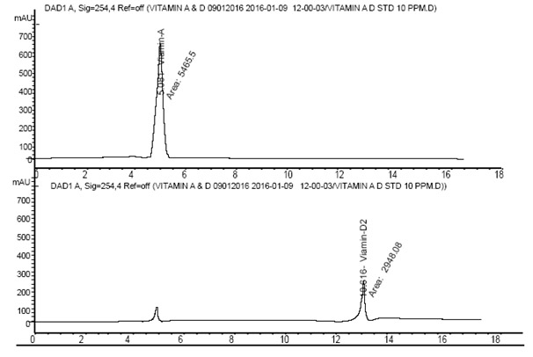
Fig.: 2.7.1 HPLC Chromatogram of Standard Vitamin Aand Vitamin D solutions
AREA PERCENT REPORT

Peak RetTime Type Width Area Area Name
(Min) (Min) (mAU*S)
1 5.081 MM 0.1627 5465.49854 100.0000 Vitamin-A
2 10.616 MM 0.2648 29848.07886 100.0000 Vitamin-D2
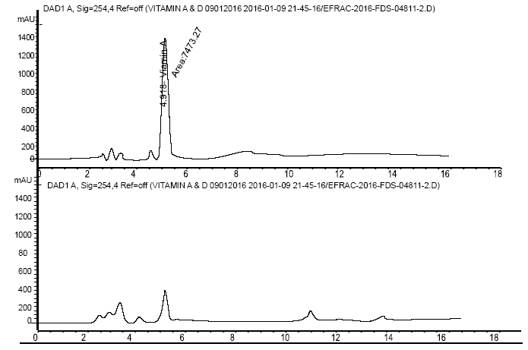
Fig.: 2.7.2a HPLC Chromatogram of Barilius Vagra
AREA PERCENT REPORT

Peak RetTime Type Width Area Area Name
(Min) (Min) (mAU*S)
1 4.918 MM 0.2022 7473.26563 100.0000 Vitamin-A
Totals : 7473.26563

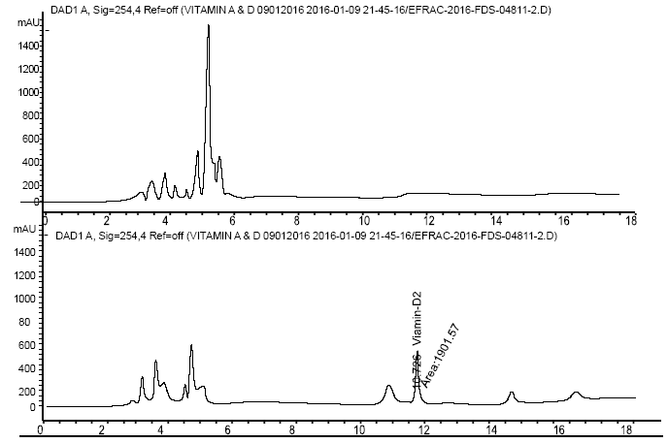
Fig.: 2.7.2b HPLC Chromatogram of Barilius Vagra
AREA PERCENT REPORT

Peak RetTime Type Width Area Area Name
(Min) (Min) (mAU*S)
1 10.726 MM 0.2022 1901.15740 100.0000 Vitamin-D2
Totals : 1901.15740

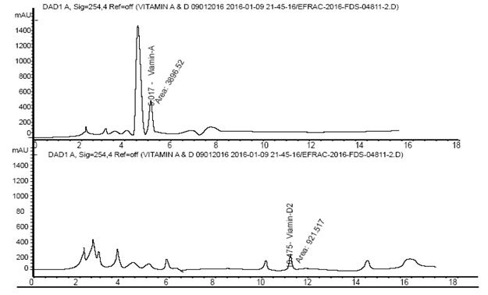

Fig.: 2.7.3 HPLC Chromatogram of Neoeucirrhichthys maydelli
AREA PERCENT REPORT

Peak RetTime Type Width Area Area Name
(Min) (Min) (mAU*S)
1 5.017 MM 0.2233 3896.52173 100.0000 Vitamin-A
2 10.475 MM 0.3239 921.51709 100.0000 Vitamin D
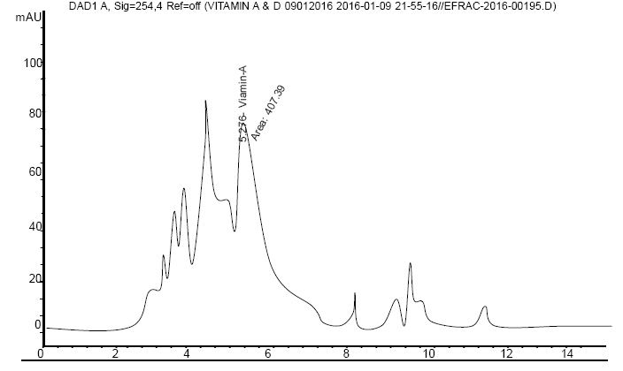

Figure 2.7.4 HPLC Chromatogram of Chanda nama

AREA PERCENT REPORT

Peak RetTime Type Width Area Area Name
(Min) (Min) (mAU*S)
1 5.276 MM 0.1875 407.39180 100.0000 Vitamin-A
2 2.332 MM 0.0000 0.0000 0.0000 Vitamin-D
Totals : 407.39180

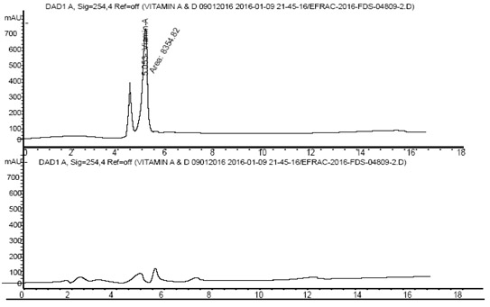
Fig.: 2.7.5a HPLC Chromatogram of Channa gachua
AREA PERCENT REPORT

Peak RetTime Type Width Area Area Name
(Min) (Min) (mAU*S)
1. 5.053 MM 0.1850 8354.81836 100.0000 Vitamin-A
Totals : 8354.81836

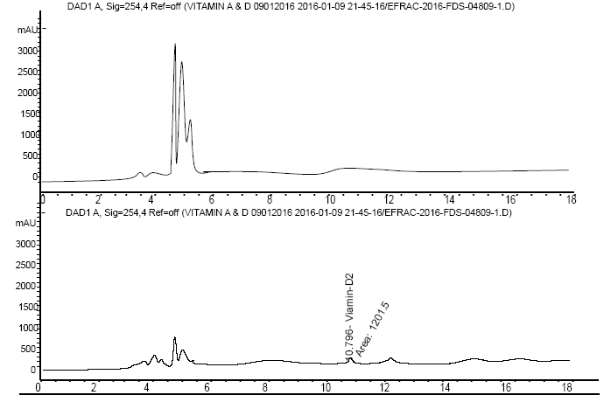
Fig.: 2.7.5b HPLC Chromatogram of Channa gachua
AREA PERCENT REPORT

Peak RetTime Type Width Area Area Name
(Min) (Min) (mAU*S)
1 10.796 MM 0.3671 1201.49902 100.0000 Vitamin-D2
Totals : 1201.49902

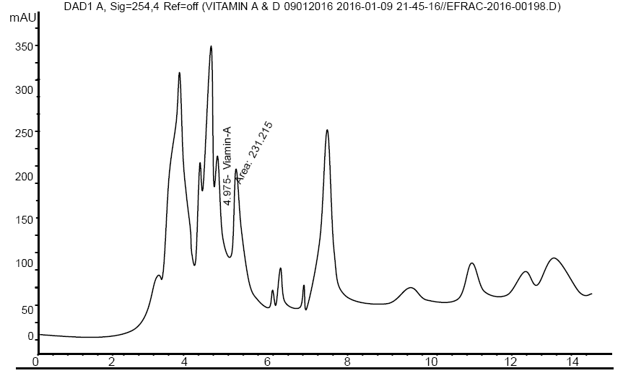

Fig.: 2.7.6 HPLC Chromatogram of Channa punctatus

AREA PERCENT REPORT

Peak RetTime Type Width Area Area Name
(Min) (Min) (mAU*S)
1 4.975 MM 0.1335 231.21461 100.0000 Vitamin-A
2 9.542 MM 0.0000 0.0000 0.0000 Vitamin-D
Totals : 231.21461

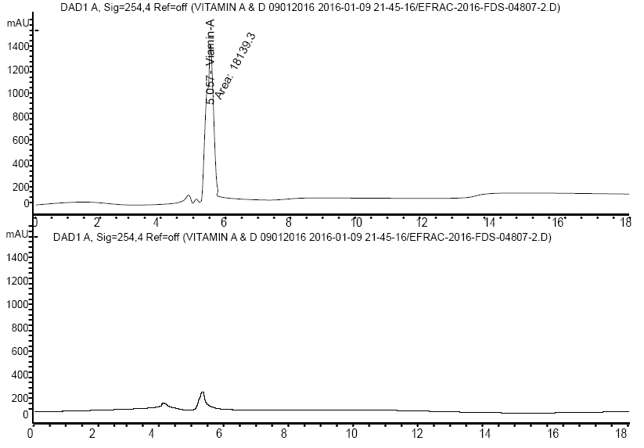
Fig.: 2.7.7a HPLC Chromatogram of Rasbora daniconius
AREA PERCENT REPORT

Peak RetTime Type Width Area Area Name
(Min) (Min) (mAU*S)
1 5.057 MM 0.1825 1.81393e4 100.0000 Vitamin-A
Totals : 1.81393e4

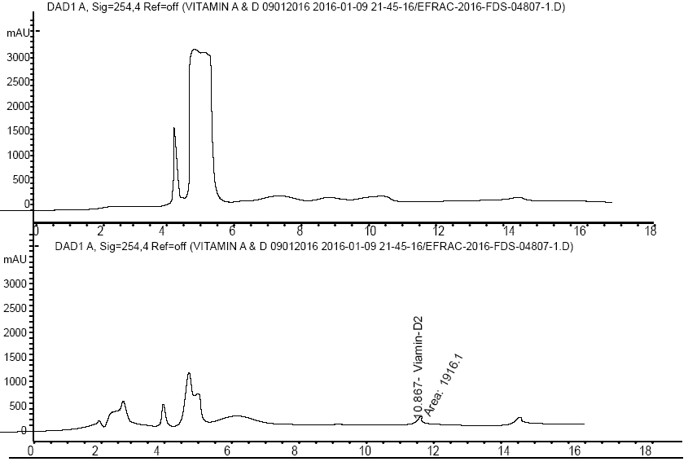
Fig.: 2.7.7b HPLC Chromatogram of Rasbora daniconius
AREA PERCENT REPORT

Peak RetTime Type Width Area Area Name
(Min) (Min) (mAU*S)
1 10.867 MM 0.3014 1916.09998 100.0000 Vitamin-D2
Totals : 1916.09998

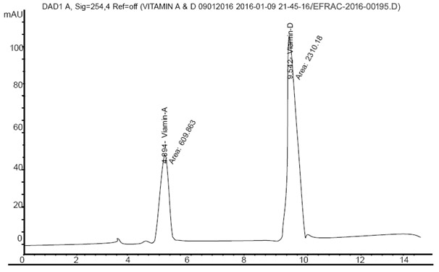
Fig.: 2.7.8 HPLC Chromatogram of Trichogaster fasciata

AREA PERCENT REPORT

Peak RetTime Type Width Area Area Name
(Min) (Min) (mAU*S)
1 4.894 MM 0.2161 609.86255 20.8854 Vitamin-A
2 9.542 MM 0.3526 2310.17896 79.1146 Vitamin-D
Totals : 2920.04150

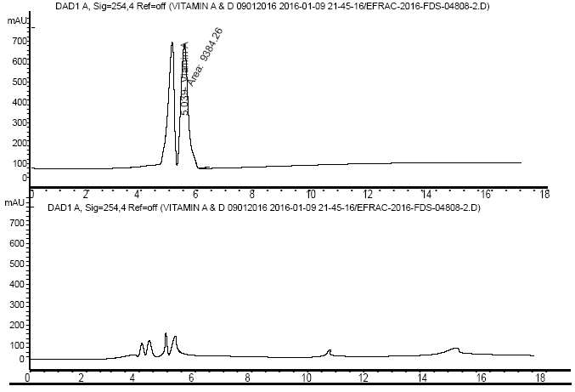
Fig.:: 2.7.9a HPLC Chromatogram of Xenentodon cancila

AREA PERCENT REPORT

Peak RetTime Type Width Area Area Name
(Min) (Min) (mAU*S)
1 5.039 MM 0.2086 9384.26465 100.0000 Vitamin-A
Totals : 9384.26465

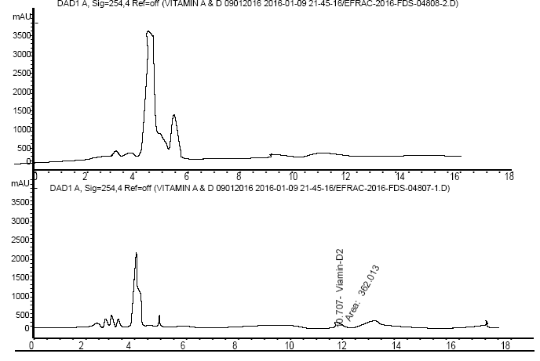
Fig.: 2.7.9b HPLC Chromatogram of Xenentodon cancila

AREA PERCENT REPORT

Peak RetTime Type Width Area Area Name
(Min) (Min) (mAU*S)
1 10.707 MM 0.4039 362.01273 100.0000 Vitamin-D2
Totals : 362.01273

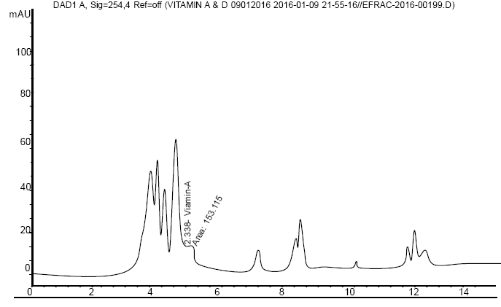

Fig.: 2.7.10 HPLC Chromatogram of Amblypharyngodon mola

AREA PERCENT REPORT

Peak RetTime Type Width Area Area Name
(Min) (Min) (mAU*S)
1 2.338 MM 0.1894 0.0000 0.0000 Vitamin-A
2 1.232 MM 0.1243 0.0000 0.0000 Vitamin-D
Totals : 0.0000

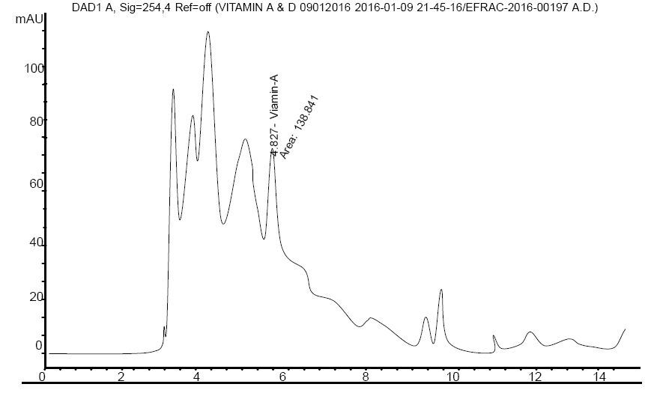

Fig.: 2.7.11 HPLC Chromatogram of Macrognathus pancalus

AREA PERCENT REPORT

Peak RetTime Type Width Area Area Name
(Min) (Min) (mAU*S)
1 4.827 MM 0.2114 138.84105 100.0000 Vitamin-A
2 9.542 MM 0.0000 0.0000 0.0000 Vitamin-D
Totals : 138.84105

Vitamin A and Vitamin D content in the selected fish species in this study is shown in table: 1.9
Table: 3.1 Vitamin A and Vitamin D content in different fish species

Sl No | Scientific name of species | Vitamin A (µg/100g) | Vitamin D (µg/100g)
1 | Barilius vagra | 672.57 | 31.73
2 | Neoeucirrhichthys maydelli | 34.97 | 15.33
3 | Chanda nama | 378.96 | BDL
4 | Channa gachua | 756.04 | 20.16
5 | Rasbora daniconius | 1644.38 | 32.20
6 | Channa punctatus | 248.76 | BDL
7 | T. Colisa fasciata | 18.88 | BDL
8 | Xenentodon cancila | 849.51 | 6.08
9 | Amblypharyngodon mola | BDL | BDL
10 | Macrognathus pancalus | 111.85 | BDL
BDL= Below Detectable Limit

Fig.: 2.7 Comparision of Vitamin-A & D content in different fish species

Vitamin A derivative Retinolic acid is the regulator of gene expression which is needed in the development of epithelial tissue (Roos et al., 2003). The present study revealed that all the ten studied small fishes were rich source of vitamin A. The highest contents of Vitamin A (1644.38 µg/100g) was found in the small fish Rasbora daniconius and the lowest of the same value (111.85 µg/100g) was shown by Trichogatser fasciata.
Vitamin D has its crucial role in regulating calcium phosphate balance in such way that stimulates calcium absorption by the small intestine and hence promoting bone metabolism The fat soluble vitamins are documented to be the vital nutrients which control many biologically important processes in human body. The vitamin D contents of the selected fishes ranged from 6.08 µg/100g to 32.20 µg/100g. The maximum value of Vitamin D (32.20 µg/100g ) was found in Barilius vagra.
In the present study the fat soluble vitamins A & D were studied in the selected small fishes. Deficiency of Vitamin A is a mojor health problem in most of the developing countries. The specific diseases caused by the deficiency of Vitamin A include Night blindness and keratomalacia significantly in children and reproducible women (West, 2002). Previous researches established that the life risks of children below five years are mostly reduced with a status of good vitamin A. Many commonly consumed freshwater fish species were found to contain an excellent amounts of Vitamin A in the form of retinal and 3, 4 dehydroretinal isomers with the relative amounts changing with the species (Roos et al., 2002). Vitamin A (Retinol) palys a key role as the visual pigment of the vertebrate eyes (Mahanty et al., 2013). The small indigenous fish Amblypharyngodon mola was found to contain very high contents of Vitamin A (Kongstak et al., 2008). A mole was investigated to conclude that the contents of Vitamin A were stored mainly in the eyes and viscera (Roos et al., 2002).
In the present study the small fish Rasbora daniconius contained the highest amount of Vitamin A (1644.38 µg/100g) which was followed by (849.51µg/100g) in Xenentodon cancila . As per the present work, the small fish Rasbora daniconius contained the highest amount of Vitamin D (32.20 µg/100g) also.

4.9 Physicochemical analysis of water bodies
The physicochemical analysis of some water bodies of the study area area shown in Table: 1.10
Table: 3.2 Physicochemical parameters of the water samples
Sl No | Test Parameters | Gaurang River | Gour Beel | Diplai Beel | Haloidal Beel
1 | pH value | 7.1 | 6.8 | 7.0 | 7.3
2 | Temperature (ºC) | 24 | 23 | 24 | 23
3 | Total Dissolved Solid (TDS) (mg/L) | 48 | 346 | 16.0 | 50.0
4 | Dissolve Oxygen (DO) (mg/L) | 7.65 | 6.21 | 7.46 | 7.65
5 | Biochemical Oxygen Demand (BOD) (mg/L) | 1.6 | 2.4 | 1.2 | 1.5
6 | Chemical Oxygen Demand (COD) (mg/L) | 5.76 | 9.60 | 4.80 | 5.76
7 | Alkalinity (mg/L) | 12 | 14.0 | 4.0 | 6.0
8 | Turbidity (Nephelometric Turbiditu Unit, NTU) | 7.7 | 130.0 | 5.0 | 24.0
9 | Salinity (Practical Salinity Unit, PSU) | 0.05 | 0.32 | 0.02 | 0.05
10 | Viscosity (mm²/S) | 0.9118 | 0.9359 | 0.9125 | 0.9328
(1NTU= 1/3 mg/L & 1 PSU= 1g/Kg)

Fig.: 2.8.1 Variations of pH in different water bodies

Fig.:2.8.2 Variations of temperature in different water bodies

Fig.: 2.8.3 Variations of TDS in different water bodies

Fig.:2.8.4 Variations of dissolve oxygen in different water bodies

Fig.: 2.8.5 Variations of BOD in different water bodies

Fig.: 2.8.6 Variations of COD in different water bodies

Fig.: 2.8.7 Variations of alkalinity in different water bodies

Fig.: 2.8.8 Variations of Turbidity in different water bodies

Fig.: 2.8.9 Variations of Salinity in different water bodies

Fig.: 2.8.10 Variations of Viscosity in different water bodies

4.9.1 Measurement of pH
The pH value ranged from 6.8 to 7.3 as shown in Fig.:2.8.1. Maximum pH was recorded in Haloidol beel whereas the minimum was found in Gour Beel. The study of Choudhury et al, 2013 revealed a pH range of 7.0 - 8.3. Shrivastava et al., 2013 also reported a similar range of pH of 6.93 - 7.55. They studied the physico-chemical status of different surface waters of pond water of Surguja District Chattisgarh, India. Sharma et al., 2013 reported that in India, many small confined water pockets are particularly alkaline in nature. This type of alkaline nature was justified in this present study. The pH values of all the water samples were in the alkaline range. Islam et al., 2014 reported that this pH has been noted to be productive and thus up to snuff for pisciculture.
4.9.2 Measurement of temperature
Temperature is the measure of hotness of any substance. It insigate the physical and chemical characteristics of water and also impinge the aquatic lives in it. Good knowledge about temperature prior to study an water habitat is very much important for fish culture. According to Hemlata et al., 2014, the Guidelines for water Quality Management for fish culture in Tripura the optimum temperature is 24˚C - 30˚C. So far the current work is concerned the least variation of temperature from 23˚C-24˚C was recorded which is well within the guidelines limit (Fig.:2.8.2). Maximum temperature was recorded in Gaurang river and Diplai beel.
4.9.3 Measurement of total dissolved solid (TDS)
In the current study the TDS values were in the range from 16 mg/L to 346 mg/L (Fig.:2.8.3). Maximum value of TDS was found in Gour beel and the minimum was in Diplai beel. High value of TDS insinuate the increased nutriment status of water body which leads to eutrophication of aquatic bodies as repoted by Swarnalatha et al., 1998 & Singh et al.,2015. Yadav et al., 2012 reported that the water having more than 500mg/L of TDS values are not acclaimed for drinking purpose. The present work manifested that the selected water samples may be used for drinking by the local communities.
4.9.4 Determination of Dissolved Oxygen (DO)
Dissolved oxygen is an essential component to delineate man-made pollutants. According to Dixit et al., 2005, the presence of DO is awfully necessitous to maintain the aquatic lives and balancing different pollutions which make the aquatic bodies healthy. Quantification of DO values stands for the key test for any kind of pollution in water. In the present study dissolved oxygen ranged from 6.21 to 7.65 mg/L (Fig.:2.8.4). Maximum DO was traced in Gaurang river and Haloidal beel i.e. 7.65 mg/L. Similar observations were also made by Bhavimani and Puttaiah, 2014. According to Adakole, 2000, the concentration of DO not less than 5.0 mg/L is suitable for aquatic lives. Thus all the sites are good for aquatic life in general and fishes in particular.
4.9.5 Determination of Biological Oxygen Demand (BOD)
BOD is dissolved oxygen required by micro organism for aerobic decomposition of organic matter present in water. Jain et al.,2000, have considered BOD as an important parameter in aquatic system to analyze the level of water pollution. Fig.:2.8.5 shows the values of BOD were in the range from 1.2 to 2.4 mg/L. The maximum value of BOD was found in Gour beel. The least value was recorded in Diplai beel. If the BOD value of water is less than 1.0 mg/L then water is considered as pollution free, if it is between 2.0 to 9.0 mg/L then water is considered as polluted but in moderate level and if it is higher than 10.0 mg/L then water is considered as highly polluted (Adakole, 2000). The present study revealed the water samples being moderately polluted.
4.9.6 Determination of Chemical Oxygen Demand (COD)
Fig.:2.8.6 shows the variation in COD of different water bodies. The value of COD were in the range from 4.8 to 9.6 mg/L. COD determines the oxygen required for chemical oxidation of all organic matters viz. biodegradable and non-biodegradable by a strong chemical oxidant as repoted by Mahananda et al., 2010. The maximum COD level for fish culture is below 50 mg/L as per the Guidelines for water Quality Management for fish culture in Tripura (Hemlata et al, 2014). In the present study the COD values of all the four aquatic system were well within the permissible range and was found to be suitable for pisciculture.
4.9.7 Determination of total alkalinity
Total alkalinity of the water samples ranged from 4-14 mg/L (Fig.:2.8.7). Highest alkalinity was recorded in Gour Beel and the lowest in Diplai beel. According to Yadav et al., 2013, alkalinity in most natural water estimates the amount of carbonates and bicarbonates whose salts get hydrolysed in solution and produced hydroxyl ions. It is used as a measure of productivity (Hulayal et al, 2011).
4.9.8 Determination of turbidity
Turbidity values of the water samples in the present study ranged from 5 NTU -130 NTU (Fig.:2.8.8). Turbid water is generally unpalatable for aesthetic problem. Turbidity is generated flow of muddy water from neighbouring the water sampling habitat or water bottom lodging fish and muskrats. In the current study all water samples have the turbidity level within the legitimate range of World Health Organization. As per Zweigh (Zweigh, 1989), turbidity of 20-30 NTU is pertinent for pisciculture. Thus the turbidity of Halwadol beel (24 NTU) was more suitable for fish culture compared to the other three.
4.9.9 Determination of salinity
Salinity of the studied water samples ranged from 0.02-0.32 PSU (Fig.:2.8.9). Salinity implies the measure of saltiness of a water body. Low salinity implies the sites have more dissolved oxygen which is required for the aquatic life.

4.9.10 Determination of viscosity
Viscosity of the studied water bodies ranged from 0.9118-0.9359 mm²/S (Fig.:2.8.10). The highest value was recorded in Gour Beel and the lowest in Gaurang river.
The ideal values of various physico-chemical parameters (Boyd, 1998) for freshwater aquaculture are presented in Appendice-I.

4.10 Comparision of small fish species with some popular large fish species

4.10.1 Comparision of market value

After thorough survey in some of the village areas of Kokrajhar district, it wasclearly highlighted that the available small fish species posses lower market value than some of the popular large fishes as shown in table below.

Table: 4.1Market values of different fish species
Fish Species | Local name | Market value (Rs./kg) | Fish Species | Local name |  | Market value  (Rs./kg)
B. vagra | Boroli | 200.00 | L. Rohita | Rahu |  | 350.00
N. maydelli | Bothia | 180.00 | C. Catla | Catla |  | 300.00
C. nama | Chanda | 80.00 | T, ilisha | Hilsha |  | 600.00
C. gachua | Cheng | 150.00 | W. attu | Boal |  | 350.00
R. daniconius | Darikana | 100.00 | S. aor | Eir |  | 600.00
C. punctatus | Goroi | 150.00 | C. idella | G. Carp |  | 250.00
C. fasciata | Kholihona | 120.00 | H. molitrix | S. Carp |  | 250.00
X. cancila | Kokila | 120.00 | C. chitala | Chital |  | 600.00
A. mola | Mola | 150.00 | C. striata | Shol |  | 350.00
M. pancalus | Turi | 160.00 | P. cancrivorus | Kuchia |  | 400.00

The poor villagers cannot afford readily to get the popular large fishes. Rather the small species were mostly admired by the below poverty groups.The small fishes had been less exploited commercially

4.10.2 Comparision of Proximate composition

Table: 4.2 Proximate composition of small fish species compared with those of some popular large fish species
Sl no. | Scientific name of species | Protein  (g/100g) | Crude Lipid  (g/100g) | Moisture  (g/100g) | Ash  (g/100g) | Carbohydrate  (g/100g)
1 | B. vagra | 17.30 | 5.19 | 73.89 | 3.36 | 5.20
2 | N. maydelli | 16.72 | 3.42 | 76.71 | 2.85 | 0.40
3 | C. nama | 14.86 | 11.09 | 68.12 | 5.59 | 0.33
4 | C. gachua | 19.85 | 3.53 | 73.05 | 3.26 | 0.35
5 | R. daniconius | 15.35 | 2.82 | 77.21 | 4.22 | 4.31
6 | C. punctatus | 17.48 | 4.92 | 75.50 | 1.73 | 0.37
7 | C. fasciata | 17.22 | 5.84 | 73.51 | 2.95 | 0.48
8 | X. cancila | 17.41 | 1.58 | 77.07 | 3.55 | 0.30
9 | A. mola | 15.43 | 2.94 | 71.50 | 3.94 | 6.19
10 | M. pancalus | 14.26 | 5.08 | 70.96 | 5.79 | 3.91
11 | L. Rohita | 17 | 1 | 77 | 1.23 | 4
12 | C. Catla | 19 | 2 | 74 | 1.22 | 3
13 | T. ilisha | 22 | 19 | 54 | 1.4 | 3
14 | W. attu | 15 | 3 | 73 | 4.46 | 8
15 | S. aor | 16 | 1 | 78 | 2.0 | 3
16 | C. idella | 15.2 | 1.1 | 80.2 | 1.1 | 2.4
17 | H. molitrix | 17.2 | 4.1 | 77.8 | 1.0 | 0.1
18 | C. chitala | 19 | 2 | 75 | 1.0 | 3
19 | C. striata | 16 | 2 | 78 | 1.2 | 2
20 | P. cancrivorus | 38 | 1 | 139 | 2.9

Going through the literature on the nutritional aspects of some commonly available popular large fishes, it was pointed out that the nutritional values of those popular large fishes do not vary remarkably with the nutritional contents of the small fishes which are easily available here, there and everywhere of the local areas.

4.10.3 Comparision of mineral content
Table: 4.3 Mineral content (Fe, Zn, P & Ca) of small fish species compared with those of some popular large fish species
Sl No | Scientific name of species | Iron (mg/100g) | Zinc (mg/100g) | Phosphorous (mg/100g) | Calcium (mg/100g)
1 | B. vagra | 9.15 | 2.36 | 891.81 | 636.91
2 | N. maydelli | 5.95 | 2.84 | 825.64 | 591.20
3 | C. nama | 3.90 | 3.18 | 2470.00 | 807.93
4 | C. gachua | 4.84 | 2.66 | 616.79 | 539.39
5 | R. daniconius | 12.84 | 4.64 | 1246.55 | 697.39
6 | C. punctatus | 3.67 | 1.57 | 3170.00 | 672.98
7 | C. fasciata | 18.23 | 2.98 | 3520.00 | 1640.00
8 | X. cancila | 3.83 | 2.86 | 858.78 | 647.75
9 | A. mola | 4.31 | 4.73 | 1990.00 | 731.10
10 | M. pancalus | 3.75 | 1.44 | 1620.00 | 389.32
11 | L. Rohita | 1 | 1.0 | 175 | 650
12 | C. Catla | 1 | 1.1 | 255 | 530
13 | T, ilisha | 2 | 1.2 | 280 | 180
14 | W. attu | 1 |  | 490 | 160
15 | S. aor | 1 | 2.13 | 180 | 380
16 | C. idella | 0.46 | 0.91 | 190 | 54
17 | H. molitrix | 4.4 | 1.4 | - | 903
18 | C. chitala | 3 |  | 250 | 180
19 | C. striata | 0 | 0.41 | 95 | 140
20 | P. cancrivorus | 1 | 3.3 | 441 | 40.8

The comparision of some of the mineral contents also revealed that those small fishes which the poor villagers incude in their diet have a high mineral contents compared to those of some popular large fishes. The studied small fishes were thus found to be nutritionally competitive with the popular large fish species.

CHAPTER-V
Summary

In the present study quantitative analysis was performed for the nutritional contents of ten selected small food fishes. The studied small fishes are mostly consumed by the local communities of Kokrajhar, BTAD, Assam. These are easily available and of low costs. In rainy seasons these fishes are found in each of the wet lands, ponds, beels, lakes etc. The rural poor people of the local area consume the fish food regularly and also sell them in the nearest market. Most of the small fishes are available throughout the year. Nutritional informations about the fish species make them pronounced for both human consumption as well as commercialization.
The experimental investigations of the nutritional contents of the studied fishes concluded that all of them were rich in protein contents. Amongst them, the highest contents of protein were shown by channa gachua (19.85g/100g) and the lowest of the same was reported by Macrognathus pancalus (14.26g/100g). Maximum amount of Crude lipid was possessed by Chanda nama (11.09g/100g) and the lowest was shown by the species Xenentodon cancila (1.58g/100g). The fish species Rasbora daniconius was found to contain highest moisture values (77.21g/100g and the lowest moisture contents were recorded by Chanda nama (68.12g/100g). Highest contents of ash was possessd by Macrognathus pancalus (5.79g/100g) and the lowest value of the same was found in the species Channa punctatus. All the studied fishes were of low carbohydrate contents.
All the studied fish species were found to contain fair contents of amino acid. The highest contents (10.0%) of essential amino acid histidine was found in Trichogaster fasciata which was followed by (8.36%) in Chanda nama. Another essential amino acid methionine was highly recorded (9.42%) in Channa gachua. Threonine, the non essential amino acid was also highly contained (8.67%) by the same fish species, Channa gachua. The studied fish species can be recommended as ideal dietary supplementation for human health. The fatty acid profiling of the studied fish species revealed that all of the ten fishes contained low amounts of fatty acids. Palmitic acid was predominantly present in all the fish species. The presence of lower percentage of free fatty acids in the lipids of studied species might be a conclusion that the fishes are suitable for edible purposes.
All of the ten fish species were reported to have good contents of selected micro and macro elements like iron, zinc and calcium, phosphorus. The presence of the minerals in the studied fishes highlighted them to have vital potentialities regarding human health functions.
The presence of fat soluble vitamins, Vitamin A and Vitamin D is the selected fish species concluded the major role of the fish species to enrich a balanced human diet for regular consumption
On the basis of the experimental findings of the present study, it can be concluded that the common people may readily include the small fishes in their reular diet at lower expenses. Moreover, the selected small food fishes are enriched in nutritional contents. Due to their low cost and larger abundance the small fish species might be ignored and commercially less exploited. Most of the people are having an idea that popular large and costly fishes are only good for health and consumed deliciously by the communities. The poor people cannot afford so much and prefer to buy the small fishes of low cost. These small fishes are available in ponds, beels, lakes, rivers and also in wet places in the rainy season. Many local villagers opt for carrying on livelihood being a fisherman. A lot of traditional concepts lead the rural people to consume certain foods for the recovery of certain diseases. Lack of proper investigations about the nutritional properties of the small food fishes make them overlooked by the commercial sector. Proper care is not taken by the government side for the sustainable development of the fish species.
Worldwide several works had so far been done on the nutritional analysis of fish flesh and oil. But not any detailed works had been offered on the nutritional contents of small food fishes of Kokrajhar, B.T.A.D., Assam.
For the sake of less market value these small fishes had not been given major importance by the industrialists as well as the researchers. By the passage of time people starts to think seriously about the healthy life. The wind of science and technology touch each and every corners of human life. All the natural resources are given priority to make them more enriched. As the small fishes are mostly available and more appreciated by the poorers for their low cost, scientific investigations must be carried out on their nutritional values for the development of both entire communities as well as commercialization of the lesser known fish species.
From the experiment carried out for water quality it can be concuded that all the water samples from different water bodies of Kokrajhar were suitable for drinking, bathing as well as other household activities. These water bodies can be used as place for several aquatic organisms
including fishes. However, ample care should be taken for the sustanenance of the water quality of the aquatic bodies available in this area.
The scientific informations with respect to the taxonomic position, varnicular name, edible as well as conservation status of the different fishes were gathered by investigating the Ichthyofunal diversity of fish species of the study area. The Ichthyological survey also showed that the study area is diversed in different fish fauna with vital economic potentialities. The government as well as the local people of the area should conserve the diversity by regular monitoring the fish fauna, analyzing the water quality of the different water habitats and controlling the anthropogenic activities.
Due to the lack of proper knowledge, investigation and infra structure fascilities for the research work in fisheries sector, the pisiculturists are not encouraged to contribute much in the healthy fish production of the state of Assam. The present work concludes that the studied small food fishes are nutrient- rich and can be recommended as a vital health suppliments.It can be summerised that the nutritional studies of the lesser known small food fishes carry a key role to develop scientific awareness among the rural poor people and creative attempts to utilize the fishes in the light of commercialization.

* * * * * * * * * * * * * *

REFERENCES

Ababouch, L. (2005) Lipids. FAO Fisheries and Aquaculture Department, Rome, Italy. Available from: http://www.fao.org/fishery/topic/14826/en (retrieved 27.03.14).
Aboluade, D.S. and Abdullahi, S.A. (2005). Proximate and Mineral contents in component parts of some freshwater species in Zaria, Nigerian Food Journal, 23:41-44
Ackman, R.R. (1988). Concern for utilization of marine lipids and oils. Food Technology, 42:151-155.
Adakole, J.A. (2000). The effects of domestic, agriculture and industrial effluents on the water quality and biota of Bindare stream, Zaria – Nigeria, PhD Thesis, Department of Biological Sciences, Ahmadu Bello University, Zaria, Nigeria, 256
Adefemi, O.S. (2011). Chemical Composition of Tilapia mosambis fish from major dams in Ekiti-State, Nigeria, African Journal of Food Science, 5(10): 550-554.
Adewole, O.S., Fawole, O.O. and Omotosho, J.S. (2003). Concentration of selected elements in some freshwater fishes in Nigeria, Science Focus, 4: 106-108.
Ahmed, S., Rahman, A.F.M. A., Mustafa, M.G., Hussain, M. B. and Nahar, N. (2012). Nutrient Composition of Indegenous and Exotic Fishes of Rainfed Water logged Paddy Fields in Lakshmipur, Bangladesh. World Journal of Zoology, 7(2): 135-140.
Akhirevbulu, C. J. and Okanji, V. A. (2013), Variation of Proximate Composition, Amino acid and Fatty acid profiles of parts of cultured Heterobranchus bidorsalis (Geoffroy Saint-Hilaire, 1809). Nigerian Journal of Agriculture, Food and Environmental, 9(4):7-12.
Alasalvar C., Taylor K.D.A., Zubcov E., Shahidi F., Alexis M. (2002): Differentiation of cultured and wild sea bass (Dicentrarchus labrax): total lipid content, fatty acid and trace mineral composition. Food Chemistry, 79: 145-150.
Albert, J. S., Lanno, M.J., Yuri T. (1998). Testing Hypothesis of neural evaluation in gymnoliform electric fishes using phylogenetic character data, Evolution, 52: 1760-1780.
Alfa, Y.M., NDA-Umar, U.I., Salihu A.B. and NMA, N.Y. (2014). Proximate composition and mineral components of some species of fish sold in Bida fish market. International Journal of Current Research in chemistry and Pharmaceutical Sciences, 1(8):19-24
Ali Aberoumand (2012). Proximate composition of less known some processed and fresh fish species for determination of the nutritive values in Iran, Journal of Agricultural Technology 8(3): 917-922.
Alvarez, V., Trigo,M., Lois, S., Fernadez, D., Medina, I., Aubourg, S. P.(2009). Comparative Lipid Composition Study in Farmed and Wild Blackspot Seabream (Pagellus bogaraveo),Czech Journal of Food Science, 27: 274-276
Ambedkar, G. and Muniyan, M. (2011). Accumulation of metals in the five commercially important freshwater fishes available in Vellar river, Tamil Nadu, India., Archives of Applied Science Research, 3: 261-264.
Anderson, L.L., and Thomas, E. Lad. (1982). Autopsy findings in squamous‐cell carcinoma of the esophagus. Cancer, 50(8): 1587-1590.
Andrew, A.E. (2001). Fish Processing Technology, University of Horin Press, Nigeria. 7-8.
Anusuya, and Hemalatha, S. (2014). Nutritive composition of Channa Striatus fish after 2,4-D Pesticide treatment, Internet Jounral of Food Safety. 16: 9-11.
AOAC. (2012) Official Methods of Analysis. (19thedn), AOAC International, Maryland, USA.
APHA-AWWA-WPCF. (2012) Standard methods for the examination of water and wastewater. American Public Health Association (APHA), 22nd edition. Washington. DC. 201-204.
Ashraf, M., Zafar ,A., Rauf, A., Mehboob, S. and Querishsi, A.N. (2011), Nutritional values of wild and cultivated silver carp (Hyphopthalmicthys molitirx) and grass carp (Ctenopharyngodon idella), International Journal of Agriculture and Biology, 13: 210-214
Asma, Z. and Ashraf, M. (2010). Comparative Studies on the Seasonal Variations in the nutritional values of three carnivorous fish species (Accepted for Presentation on “The 3rd Global Fisheries Conference.” held in Egypt.
Atlasa, A, Ozcan, M.M. and Harmankaya, M. (2014). Mineral contents of head, Candal, Central fleshy part, and spinal columns of some fishes. Environmental Monitoring and Assessment, 186: 889-894.
Babu, A., Kesavan, K., Annaduri, D. and Rajagopal, S.(2010). Bursa spinosa, A meso gastropod fit for human consumption. Advance Journal of food Science and Technology, 2(1):79-83.
Balk, E., Chung, M., Lichtenstein, A., Chew, P., Kupelnick, B., Lawrence, A., and Lau, J.( 2004). Effects of omega-3 fatty acids on cardiovascular risk factors and intermediate markers of cardiovascular disease. Evidence report/technology assessment (Summary), 93, 1.
Baro, D. C., and Sharma, S. (2014). Ichthyofaunal diversity from Sonkosh river, Assam, India, The Clarion-International Multidisciplinary Journal, 3(1): 18-24.
Baruah, U.K., Bhagowati, A.K., Talukdar , R.K. and Saharia, P.K.(2000). Beal Fisheries of Assam community based Co-management Imperative, Naga, The ICLARM Quarterly, 23(2).
Babalola, A. F., Adeyemi, R.S., Olusola, A. O., Salaudeen, M. M., Olajuyigbe, O. O. and Akande, G.R. (2011). Proximate and Mineral composition in the flesh of five commercial fish species in Nigeria. Journal of Food Safety, 13: 208-213.
Begum, M., Pal, H.K., Islam, M.A. and Alam, M.J. (2010). Length-weight relationship and growth condition of Mystus gulio (Ham) in different months and sexes. University Journal of Zoology, Rajasthan University, 28:73-75.
Belitz, H. D., Grosch, W. and Scieberle, P. (2001). Food Chemistry, Springer Berlin, Heideberg, New York 5: pp 258–260, 681
Bene, C. and Heck, S. (2005). Fish and Food Security in Africa NAGA, World Fish Center Quarterly, 28 (3): 8-13
Beula Agnes, S (2013), Nuritiona Level in Edible Marine Fish Parastromateus niger and its Depletion During Storage. International Journal of Engineering Science Invention, 2(2): 51-55.
Bhandari S, Banjara, M.R..(2014). Micronutrients Deficiency, a Hidden Hunger in Nepal: Prevalence, causes, consequences and solutions. International Scholarly Research Notices, 15:1-9.
Bhatti, H. K.(1943). On the relative value of certain larvivorous fishes from the Punjab, with notes on their habits and habitats. Indian Journal of Veterinary Science, 13(4): 315-325
Bhuiyan, A L. (1964). Fishes of Dacca. Asiatic Society of Pakistan, Dacca, pp148
Bijayalakshim, C, Nagasepam, R.S., Indira, N. and Shomorendra, M. (2014). Estimation of moisture and total lipid content of Estimation of moisture and total lipid content of some small indegenous fishes of Manipur. International Journal of Science of Research, 3(12).
Biswas, A.K. and Abu-zeid, M. (eds) (1997). Sustainable water development from the perspective of the South : Issues and constraints in River Basin Planning and Management, , Oxford University Press, New Delhi.
Blanchet, C., Dewailly, E., Ayotte, P., and Bruneau, S. (2000). Contribution of selected traditional and market foods to the diet of Nunavik Inuit women. Canadian journal of Dietetic Practice and Research, 61(2): 50-59
Boran, G. and Karacam, H. (2011),Seasonal changes in proximate composition of some fish species from the black sea. Turkish Journal Fisheries and Aquatic Sciences, 11: 1-5.
Bordin, K., Kunitake, M. T., Aracava, K. K., and Trindade, C. S. F.. Changes in food caused by deep fat frying-A review, Archivos latinoamericanos de nutricion, 63(1): 5-13.
Borgstrom, G.(1962). Shellfish protein-nutritive aspects. Fish as food, 2: 115-147.
Boyd, C.E. (1998). Water Quality for Pond Aquaculture. Research and Development Series No. 43. International Center for Aquaculture and Aquatic Environments, Alabama Agricultural Experiment Station,Auburn University, Alabama.
Bratu, A., Mihalache, M., Hanganu, A., Chira, Nicoleta-Aurelia., Todasca, Maria-Cristina and Rosca, S. (2013). Quantitative determination of fatty acids from fish oils using GC-MS method and 1H-NMR spectroscopy. UPB Scientific Bulletin, Series B: Chemistry and Materials Science, 75(2): 23-32
Cahu C, Salen, E and Lorgeril, M.D. (2004). Farmed and wild fish in the prevention of cardiovascular disease; Assesing possible differences in lipid nutritional values. Nutrition metabolism and cardiovascular disease 14:34-41.
Chakravartty, P., Chakravartty, M., and Sharma, S. (2012). A Survey on the Fish Diversity with Special Reference to the Classified Ornamental Fishes and their Prospects in the Kapla Beel of Barpeta District Science, The Science Probe, 1(2): 12-21.
Chalamaiah, M, Kumar, B. D., Hemalatha, R. and Jyothirmayi, T. (2012). Fish protein hydrolyslates. Proximate composition, amino acids composition, antioxidant activities and applications. A review. Food chemistry, 135: 3020-3038.
Charlton, M. (2006). Branched-chain amino acid enriched supplements as therapy for liver disease, The Journal of nutrition, 136(1): 295-298.
Choudhury, P., Dhakad, N.K. and Jain, R. (2014). Studies on Physico-chemical Parameters of Bilawali Tank, Indore (M.P)India, IOSR Journal Of Environmental Science, Toxicology and Food Technology, 8(1): 37-40.
Chukwuemeka, U., Ndukwe G.I. and Audu, T.O. (2008). Comparison of Fatty Acids Profile of Some Freshwater and Marine Fishes, Journal of Food Safety, 10: 9-17
Clark, J. M. (1964). Experimental biochemistry. WH Freeman and Company, USA.
Craig, S. and Helfrich, L.A. (2002). Understanding fish nutrition feeds and feeding, Virginia Cooperative extension, knowledge for the common wealth): Virginia Tech Publication: 420-256.
CSIR, (1962). Fish and fisheries, Raw materials India, 4:132.
Dahl, E., Fritzell, J., and Lahelma, E. (2006). Welfare State regimes and health inequalities. In Siegrist, J. and Marnot, M (eds) Social inequalities in health. Oxford University Press, Oxford, 193-222.
Damsgaard, C.T., Schack-Nielson L, Michaelsen KF, Fruekilde M-B, Hels, O. and Lauritzen, L (2006). Fish Oil affects blood pressure and the plasma lipid profile in healthy Danish infants. Journal of Nutrition, 136:94-99.
Dand, Ch. Baro and Sharma, S. (2014). Ichthyofaunal diversity from Sankosh river, Assam, India, The Clarion International Multidisciplinary Journal, 3(1):18-24.
Daniel Imaobang, E. (2015). Proximate composition of three commercial fishes commonly consumed in Akwa Ibom state, Nigeria, Internaltional Journal of Multidiscilinary Academic Research, 3(1): 9-13.
Das, B. and Sharma, S. (2012). A comparison of fish diversity of Kapili and Jamuna rivers of Karbi Anglong District, Assam. 2012. The Science Probe, 1(1): 21-29.
Das, H. P. (1978). Studies on the Grey Mullet, Mugil cephalus (Linnaeus) from the Goa waters. Diss. Ph. D thesis submitted to university of Bombay.
Das, M., and Sarmah, J. (2014). A Study on Ichthyo-Diversity Of Jia Bharali River, Assam, India. Reviews of Literature, 2(3): 1.
Das, Snehalata P., Sahu, S. K. (2001). Biochemical changes induced by mercury in the liver of penaeid prawns Penaeus indicus and P. monodon (Crustacea penaeidae) from Rashikulya Estuary East Coast of India, Indian Journal of Geo-marine Sciences, 30(4): 246-252.
Debnath, C., Sahoo, L., Singha A., Yadav, G.S., Datta, M. and Ngachan, S.V. (2014). Protein and mineral composition of some local fishes of Tripura, India. Indian Journal of Hill Farming, 27(1): 120-123
Dhaneesh, K.V., Naushad, K.M, Ajith Kumar, T.T. (2012). Nutritional Evalution of commercially Important fish species of Lakshadweep Archipelago, India, PLOSONE 7(9): 4539.
Dixit, A.K. (2015). Study of physico-chemical parameters of different pond water of Bilaspur District, Chhattishgarh, India, Environmental Skeptics and Critics, 4(3): 89.
Dubey, A. K., Shukla, S. K., and Verma, H. (2012). Ichthyo-Diversity of Banisagar Dam at Chhatarpur, Madhya Pradesh, India. International Journal of Fisheries and Aquaculture, 2(3): 157-161.
Dubey, B., Pal, A.K. and Singh, G. (2011). Assessment of ambient particulate matter in coal mining area. Eastern India, International Journal of Applied Sciences, 3(1):1-11.
Dubey, J.P. (1995). Duration of immunity to shedding of Toxoplasma gandii oocysts by cats. Journal of Parasitology, 81: 410-415.
Ederm, D.O. (2009).Vitamin A, A review, Asian Journal of Clinical Nutrition, 1:65-82.
Efflong, B.N. and Fakunle, J. (2013). Proximate composition and fatty acid profile in some commercially important fish species from Lake Kainji, Nigeria. International Journal of Biology, Pharmacy and Allied Sciences, 2(4): 849-856.
Elagba, H.A.M., Rabie, A. and Masour, H.M. (2010). Proximate compostion , amino acid and mineral contents of five commercial Nile fishes in Sudan. African Journal of food science, 4(10):650-654.
Elvevoll, E. O. and James, D.G. (2000). ‘Potential benefits of fish for maternal, fetal neonatal nutrition: a review of literature. Food, Nutrition and Agriculture, 27: 28-39
Esther, W.M., Maroko, Mokaya, Agwala, Ototo, Kobingi Nyakeya, Jane Nyamora.2016. Growth performance of milkfish (Channos Chanos Forskal) fed on formulated and non formulated diets made from locally available ingredients in South Coast region, Kenya. International Journal of fisheries and aquatic studies, 4(1):288-293.
Eyo, A.A. (2001). Fish Processing Technology in the tropic, University of llorin Press llorin, Nigeria, 1-20
FAO, (2001) The composition of Fish, FAO in partnership with Support unit for International Fisheries and Aquatic Research, SIFAR.
FAO/WHO. (2001). Human vitamin and mineral composition of some selected fresh water fishes in Nigeria, Journal of Food. Safety, 9: 52-55.
Farid, F.B., Latifa, G.A, Nahid, M.N and Begum, M. (2014). Comparative study of dry and pickle salted shoal (C.strialus; Bloch, 1801) at room temperature (27-310c). International Journal of Fisheries and Aquatic Studies, 2(1): 157-163.
Farzana, A., Hafeez-ur-Raham, M., Ashraf, M. and Iqbal, K.J. (2013). Body composition of feather back notopterus notopterus and Rita rita from Balloki Headworks-Pakistan, Journal of Agriculture Food and Applied Science, 1(4): 126-129.
Fawole, O. O., Ogundiran, M. A., Ayandiran, T. A., and Olagunju, O. F. (2007). Proximate and mineral composition in some selected fresh water fishes in Nigeria. Journal of Food Safety, 9: 52-55.
Felt, O, Buri, P, Gurny, R. (1980). Chitosan: A unique Polysacharide for drug delivery. Drug Development and Industrial Pharmacy, 24:979-993
Firlianty, E. Suprayinto, Hardoko, H. Nursyan .(2014). Protein profile and amino acid profile of vaccum drying and freeze drying of family Channidae collected from central Kalimantar, Indonesia, International Journal of Biosciences, 5(8): 75-83
Folch, J., Lees, M., and Sloane-Stanley, G. H. (1957). A simple method for the isolation and purification of total lipids from animal tissues. Journal of Biological Chemistry, 226(1): 497-509.
Foran, J.A., Carpenter, D.O., Hamilton, M.C., Knuth B.A. and Schwager, S.J.(2005). Rish-Based consumption advice for farmol Atlantic and wild pacific salmon contaminated with dioxin like compounds. Environmental Health Perspective, 33: 552-556.
Fournier, V., Juaneda, P., Destaillats, F. F., Dionise, P. Lambelet, J.L. and Berdeaux, O. (2006). Analysis of eicosapentaenoic and docosahexaenoic acid geometrical isomers formed during fish oil deodorization. Journal of Chromatography A, 1129: 21-28.
Friedberg, C. E., Janssen, M. J., Heine, R. J. and Grobbe D.E. (1998). Fish oil and glycemic control in diabetes. A meta-analysis. Diabetes care, 21:494-500.
Fumio, K., Yasuo, K., Terue, K., Yoshimori, K, Hideki, K, Baatar, P, Judger, O. and Uliziburen, C. (2012). Influence of essential trace minerals and micronutrient insufficiencies on harmful metal overland in a Mongolian patient with multiple sclerosis. Current Aging Science, 5: 115-125.
Ghelichpour, M. and Shabanpour, B. (2011). The investigation of proximate composition and Protein solubility in processed mullet fillets. International Food Research Journal, 18(4): 11343-13475
Grant, W. B. (1997). Dietary links to Alzheimer’s disease. Alzheimer’s Disease Review, 2: 42-55.
Haliloglu, H.I., Bayer, A. Sirkecioglu, A.N. Ara. SM. And Atamanalp, M. (2004). Comparison of fatty acid composition in some tissues of rainbow trot (Oncorhynchus mykiss) living in seawater and freshwater. Food Chemistry, 86: 55-59.
Harper, Charles R., and Terry A. Jacobson. (2013). The fats of life: the role of omega-3 fatty acids in the prevention of coronary heart disease. Archives of internal Medicine, 161(18): 2185-2192.
Hels, O., Hassan, N., Tetens, H. and Thilsted, S.H. (2002). Food consumption energy and nutrient intake and nutritional status in rural Bangladesh : Changes from 1981-82 to 1995-96. Europian Journal of Clinical Nutrition, 57:586-594.
Hei, A. and Sarojanlini, C. (2012). Proximate composition, macro and micro elements of some smoke dried hill stream fishes from Manipur, India. Nature and Science, 10(1): 59-65
Hemalatha, B., Puttaiah, E.T.(2014). Fish Culture and Physico-chemical Characteristics of Madikoppa Pond, Dharwad Tq/Dist, Karnatak. Hydrology Current Research, 5(1): 162.
Hossain, M.A., Afsana, K. and Azad Shah, A.K.M.(1999). Nutrititonal value of some small indigenous fish species (SIS) of Bangladesh. Bangladesh Journal of Fish, 3(1):77-85.
Hsich, B.T., Chang, C.Y., Chang, Y.C., and Cheng, K.Y. (2011). Relationship between the level of essential metal elements and in human hair and coronary heart disease. Journal of Radionalytical and Nuclear Chemistry., 290: 165-169.
Hulyal, S.B. and Kaliwal, B.B. (2011). Seasonal variations in physico-chemical characteristics of Almatti reservoir of Bijapur district, Karnataka State, International Journal of Environmental Protection, 1(1): 58-67.
Huss, H.H. (2005), Quality and Quality changes in fresh fish. FAO Fisheries Technical paper No.348, Food and Agriculture Organization (FAO) of the United Nations, Rome, Italy.
Hussain M, (1999), Design of Two Standard Steel Body Fishing Crafts for all Season Operation in the Bay of Bengal, National Marine Fisheries Seminar
Hyland, K. (2007), Inherited disorders affecting dopamine and serotonin: critical neurotransmitters derived from aromatic amino acids. The Journal of nutrition 137(6): 1568-1572.
Imaculate, K., Jeyasanta and Patterson, J. (2013). Total lipid, phospolipid and Cholesterol contents of six commercially important fishes of Tuticorin, Southeast Coast of India. Sky Journal of food Science, 2(6): 47-53.
Islam, M., Ahmed, A.M., Barman, B.(2014). Studies on physio-chemical properties of water in some selected sites of Deepor Beel (Ramsar site), Assam, India. The Clarion, 3(2): 25-32.
Islam, R., Mondal, L. K., Sheikh, L., Islam, Sk., and Atiqur, R .(2013).Nutritional Science and Food Technology, Herbal Open Access Journal, ISSN 2054-1848.
Jabeen, F, Choudhury H. and Sarma D. (2017). Length–weight relationships of Barilius bendelisis (Hamilton, 1807), Barilius shacra (Hamilton, 1822) and Barilius barna (Hamilton, 1822) from Manas River in Assam, India, Journal of Applied Ichthyology, 33:607-608
Jain, Y. and Dhamija, S.K. (2000). Studies on a polluted lentic water body of Jabalpur with special reference to its physico chemical and biological parameters. Journal of Environment and Pollution, 7(2):83-87.
Jakhar, J.K,. Pal, A.K, Devivaraprasad, A., Reddy, N.P., Sahu, G. Venkateshwarlu and Vardi H.K. (2012). Fatty acid composition of some selected Indian fishes. African Journal of Basic and Applied Sciences, 4(5):155-160.
Jayasree, V, Panilekar, A.H., Wahidull, S. and Kamat, S.Y.(1994). Seasonal changes in biochemical composition of Holothuria leucospilota (Echinodermata). Indian Journal of Marine Science, 23: 117-119
Jessica R. Bogard. Shakuntala, H. Thilsted, G., Marks, C., Wahab, M.A., Hossain, Mostafa A.R. Jakorsen, J., and Stangoulis, J. (2015). Nutrient composition of important fishes species in Bangladesh and potential contribution to recommended nutrient intakes. Journal of Food Composition and Analysis. 42: 120-133.
Jiang, J., Lu S, Zhang, H., Liu, G., Lin, k., Huang, W., Luo, R., Zhang, X., Tang, C. and Yu, Y. (2015).Dietary intake of human essential elements from a total diet study in Shenzhen Guangdong Province, China. Journal of Food Composition and Analysis, 39: 1-7.
Kaisar, M.A., Rasul, M.G., Mansur, M.A., Khan, M., Mazumder, B.X., and Hasan, M.M. (2017). Quality aspect and heavy metal contents of fresh and dry salted Hilsa (Tenualosa Ilisha) of Bangladesh. International Research Journal of Biological Science, 6(2): 16-21.
Kawarazuke, N, Bene, C. (2011). The potential role of small fish species in improving micronutrient deficiencies in developing countries. Building evidence Public Health Nutrition, 14: 1927-1938.
Kottelat, M. and Whitten, T.(1996). Freshwater biodiversity in Asia with special reference to fish world bank technical paper, Washington DC, 343: 1-59.
Kumar, A., Kumar S, Kanan, D., Babu Rao, N., Thirunavukkarasu P. and Soundarapandiyan P. (2014).Evalution of Nutrients in Trash Fish, Parangipettai (South East Coast of India). International Journal of Research in Fisheries and Aquaculture, 4(2): 82-85.
Kumar, D. and I.S. Yadav.(1992). Taramira (Eruca Sative Mill) research in India present status and future programme on yield enhancement. Advances in Oilseed Research, 1: 327-358.
Kumar, M. P., Annathi, A.R., Shakila, R.J. and Shanmugan, S.A. (2014). Proximate and major mineral composition of 23 medium sized Marine fishes landed in the Thoothukudi Coast of India. Journal of Nutrition and Food Sciences, 4: 1
Kumaran, R., Ravi, V., Gunalan B., Murugan, S. and Sundramanickam, A. (2012). Estimation of proximate amino acids, fatty acids and mineral compositions of mullet (Mugil cephalus) of Parangipettai, Southeast Coast of India. Advances in Applied Sciences Research, 3(4): 2015-2019
Kwansa-Ansah, E.E., Akota J, Adimalo, A.A. and Nam, D. (2012). Determination of toxic and essential elements in Tilapia species from Vilta lake with Indictivety coupled Plasma-Mass Spectrometry. International Journal of Environment Protection, 2:30-34.
Liu, R. H.(2003). Health benefits of fruit and vegetables are from additive and synergistic combinations of phytochemicals. The American journal of clinical nutrition,78(3): 517-520.
Love, R. M. (1957). The biochemical composition of fish. The physiology of fishes, 1: 401-418.
Mahananda, M.R., Mohanty, B.P., Behera, N.R. (2010). Physico-chemical analysis of surface and ground water of Bargarh District, Orissa, India. International Journal of Research and Reviews in Applied Sciences, 2(3): 284-295.
Mahanty, A., Ganguli, S., Verma, A, Saho, S, Mitra, P., Paria, P., Sharma, A.P., Singh, B..K., Mahanty, B.P.(2014). Nutrient profile of small indeginous fish Puntius sophore: Proximate composition, Amino acid, fatty acid and Micronutrient profiles. The National Academy of Sciences, India, 37(1): 39-44.
Marchioli, R.(2002). Early protection against sudden death by n-3 polyunsaturated fatty acids after myocardial infarction : Time course analysis, of the result of gissi prevenzione. Circulation, 105:1897-1903
Marichamy, G, Badhul, Haq, M.A., Vignesh, R., Sedhuraman, V. and Nagar, A.R. (2012). Assessment of proximate and mineral composition of Twenty edible fishes of Parangspettai coastal waters. International Journal of Pharma and Bio Sciences, 3 (2).
Mazid, A., Bastami, K.D., Khoshnood, R. and Eshaghi, N.(2011). Survey of some chemical compositions and fatty acids in cultured common carp (Cyyrinus carpio) and Grass crap (Ctenophar yngodon idella) Noshahr Iran. World Journal of Fish Marine Science, 3: 533-538.
Mazoffarian, D., Aro, A. and Willett,W.C. (2009). Health effects of trans-fatty acids: experimental and observational evidence. Europian Journal of Clinical Nutrition, 63(Suppl 2): 5-21
Mozaffarian, D., Ascherio A, Hu, F.B, Stampfer, M. J., Willett, W.C, Siscovick, D.S. and Rimm, E.B. (2005). Interplay between different polyunsaturated fatty acids and risk of coronary heart disease in men. Circulation, 111(2):157-64.
Mbatia, B., Adlercrentz, D., Adler Creutz, P., Mahadhy, A., Mulaa, F. and Mattiasson, B.(2010). Enzymatic oil extraction and positional analysis of w-3 fatty acids in Nile perch and salmon heads, Process Biochemistry, 45:815-819.
Meghadam, H.N., Mesgaran, M.D., Najafabadi, H.J. (2007). Determination of chemical composition mineral contents and protein quality of Iranian Kilka fish meal. International Journal Bultry Science, 6:354-361.
Menon, A.G.K., Devi, K.R. and Viswanath, W. (2000). A new species of Puntius (Cyprinidae : Cyprininae) from Manipur, India, Journal of. Bombay Natural History Society., 97(2):263-268.
Meyer, A, Eskandari, S, Grallath, S, Rentsch, D. (2006). Al GAT1, a high affinity transporter for gamma-aminobutyric acid in Arabidopsis thaliana. Journal of Biological Chemistry, 281(11):7197-204.
Minkin, S.E., Rahman, M.M and Halder, S.(1997). Fish biodiversity, human nutrition and environmental restoration in Bangladesh. In Openwater Fisheries of Bangladesh. The University Press Limited. Dhaka, Bangladesh. 75-88
Mitsch, W.J., Gosselink J.G.(1993). Wetalnds. 2nd edition. Van Nostrand-Reinhold, New York.
Mogobe, O., Mosepele, K. and Masamba, W.R.L. (2015). Essential mineral contents of common fish species in Chanoga, Okavango Delta, Botswana, 9(9): 480-486.
Mohanty, B.P., Paria P., Das D., Ganguly S., Mitra P, Verma A., Saho S, Mahanty A., Md. Aftabuddin, Behera B.K., Sankar T.V. and Sharma, A.P. (2012). Nutrient profile of Giant river catfish Sperata seenghala (Skyes). The National Academy of Sciences. India, 35 (3): 155-161
Mohanty, B.P. (2011) Fish as Health Food In: Handbook of Fisheries and Aquaculture: ISBN:978-81-7164-106-2-2nd edn., ICAR-DKMA, New Delhi, 35:843-861
Molla, A. H., Saha, C., Ahsan, M. S., Talukder, S. M., and Alam, M. T. (2007). Physico-chemical and microbiological investigation of the lipid from Bangladeshi fresh water fish Mystus vittatus. University Journal of Zoology, Rajshahi University, 26: 21-25.
Molur, S. and Walker, S. (1998). Report of the Workshop “Conservation and Management Plan for fresh fishes of India”. Zoo Outreach Organisation, Conservation Specialist Group of India, Coimbatore, India.
Manthey- Karl, M., Lehmann, I., Ostermeyer, U and Schroider, U..(2016). Natural Chemical composition of commercial fish species: Charasterisation of Pangasius, Wild and Farmed Turbot and Barramund; Foods, 5: 58.
Mookerjee, H.K., Ganguly, D.N. and Mallik, S.C. (1950). On the History of Ophicephus gachua, Zoological Society Bengal, 3(2): 169-179
Mozaffarian, D., Benjamin, E. J., Go, A. S., Arnett, D. K., Blaha, M. J., Cushman, M., Turner, M. B. (2015). Heart disease and stroke statistic (2015). A report from the American Heart Association. Circulation, 131(4): 29-39.
Mozaffarian, M.D., Razenn, N.L. Lewis, H. K., Gregory, L.B. Russell, P.T. and Devis S, S .(2003). Cardiac benefits of fish consumption may depend on type of fish meal consumed. Circulation, 107: 1372-1382.
Mridha, M.A.R., Narejo, NT, Uddin, M.S., Kabir M.S., Karim, M and Chowdhury, M.B.R. (2005). Resistance of Aeromanas spp. In the fish, catla catla, against some antibacterial agents (SC), Pakistan Journal of Zoology, 37(4):158.
Nair, P.G.V. and Mathew, S .(2001). Biochemical composition of fish and shell fish, Central Institute of Fisheries Technology, Cochin-682029 ICAR
Nath, A. K. and Banerjee, B. (2012). Comparative evaluation of body composition of Hilsa, Tenualosa ilisha (Hamilton,1822), in different size groups with special reference to fatty acids, in Hooghly estuarine system, West Bengal, India. Indian Journal of Fish, 59(2): 145–146
Nazeer, R.A., Sampath Kumar, N.S. Naqash, S.Y. Radhika, R. Kishore, R. and Bhatt, S.R. (2009). Lipid profiles of Threadfin beam (Nemipterus japonicas) organs. Indian Journal of Marine Sciences, 38 (4): 461-463.
Neil, J.S. (1997), Fish consumption oils and coronary heart diseases. The American Journal of Clinical Nutrition, 65: 1083-1086.
Nestel, P.J.N. (2000). Fish oil and cardiovascular disesase lipids and arterial function. American Journal of Clinical Nutrition, 71: 228-231.
Nijinkoue, J.M., Gouado I.,Tchoumbougnang, F.T., Yanga, J.H., Ndinteh, D.T., Fodjo, C.Y. and Schweigert, F.J. (2016). Proximate composition, mineral content and fatty acid profile of two marine fishes from Cameroonian coast: Pseudotolithus typus and Pseudotolithus elongates. NFS Journal, 4: 27-31
Nordov, A., Marchioli R., Arnesen H. and Videback J. (2011) .N-3 Polyunsaturated Fatty Acids and Cardiovascular Diseases. Lipids, 36(1): 127-129
Nowsad, A.K.M.A. (2007). Participatory training of trainers –A new approach applied in fish processing. Bangladesh Fisheries Research Forum, Dhaka, 328.
Naushad Ali, S.S., Tiwari, B.K., Singh, P., Tripathi, V., and A.B. Afidi. (2013). Biochemical variation among some species of pond fishes. Global Journal of Biology, Agricultural and Health Sciences, 2(2):1-6
O. Guizani, S. E., and Nizar, M. (2015). Atlantic mackerel amino acids and mineral contents from the Tunisian middle eastern coast. International Journal of Agricultural Policy and Research., 3(2):77-83
Oduor-Odote, P.M. and Kazungu, J.M. (2008). The body composition of low value fish and their preparati on into higer value snack food. Western Indian Ocean Journal of Marine science, 7: 111–117
Ojewola, G.S., Otteh, J.O. and Abasiekong, S.F. (2006). Effect of African Yam Bean Meat Based Diets Supplemented at varying levels with nutrase- Xyla Enzyme on Broiler starter, Agricultured Journal, 3:172-175.
Oksuz, A., Ozyilmaz, A., Aktas, M., Gercek, G., and Motte, J. (2009). A comparative study on proximate, mineral and fatty acid compositions of deep seawater rose shrimp (Parapenaeus lon-girostris, Lucas 1846) and red shrimp (Plesionika martia, A. Milne-Edwards, 1883). Journal of Animal Veterinary Advances., 8(1): 183–189.
Olsen, S.F. and Secher N.J. (2000). Low consumption of sea food in early pregnancy as a risk factor for preterm delivery: Prospective cohort study. BMJ 324-447
Oluwaniyi, O.O., Dosumu, O.O. (2009).Preliminary Studies on the effect of processing methods on the quality of three commonly consumed marine fishes in Nigeria. Biokemistri, 21(1): 42-48
Oramadike, C.E. (2015). Proximate composition and technological properties of Wild African catfish Chrysichthys nigrodigitatus (Lacepede 1802). American Journal of Agricultural Science, 2(2): 54-58
Orban, E., Nevigato T., Masci M., Di Lena G., Casini I., Caproni R., Gambelli L., De Angelis P., Rampacci M. (2007). Nutritional quality and safety of European perch (Perca fluviatilis) from three lakes of Central Italy. Food Chemistry, 100: 482-490.
Owaga, E.E, Onyango C, Njoroge, .A. (2010). Influence of selected washing treatments and dry temperatures on proximate composition of Dagaa (Rastrincobola argentea), a small pelagic fish species. African Journal of Food Agriculture Nutritional Development, 10(7):1-14.
Parihar, M.S., and Dubey, A.K. (1995). Lipid peroxidation and ascorbic acid status in respiratory organs of male and female fresh water cat fish Heteropneustes fossilis exposed to temperature increase Comp. Biochem Physiology, 112: 303-313
Pawar, S. and Sonawane, S.R. (2013). Fish Muscle protein Highest Source of Energy. International Journal Of Biodiversity and Conservation, 5(7): 433-435
Piggot, G.M. and Tucker, B.W. (1990). Seafood: Effects of Technology on Nutrition, Marcel Dekker Inc., New York
Rahaman, M. A., Shikha F.H., Hossian M. I., Asadujjam M., Nahar N. and M.M Rahaman. (2014). Comparative Study on Proximate Composition and Heavy Metal Concentration of Amblypharyngodon mola, Channa punctatus Collected from Pond Water and Open Water. American-Eurasian Journal of Toxicological Sciences, 6(4):131-135.
Rahman, A. K. (1989). Freshwater fishes of Bang;adesh. Zoological Society of Bangladesh, Department of Zoology, University of Dhaka, 364
Rainboth, W. J.(1996). Fishes of the Cambodian Mekong. FAO Species Identification Field Guide for Fishery Purposes, FAO, Rome, 265
Ramanujam, M.E., Devi, K.R., Indra, T. J. and T. Murugavel (2010). Vertebrate survery at Adyar Creek and estuary. Report submitted by Pitchandiculam Forest consultants to Chennai Rivers Restoration Trust. pp67.
Rao, B.M., Murthy, L.N., Mathew, S., Asha, K.K., Sankar, T.V. and Prasad, M.M. (2012). Changes in the nutritional profile of godavari hilsa shad, tenualosa ilisha (hamilton, 1822) during its anadromous migration from bay of bengal to the river Godavari. Indian Journal of Fish, 59(1): 125-132.
Ravichandran, S., Kumaravel, K., Rameshkumar, G., and Ajith Kumar, T. T. (2010). Antimicrobial peptides from the marine fishes. Research Journal of Immunology, 3(2): 146-156.
Ray, N. and Dhar, B. (2012). Study of Bioenergetics, Proximate Composition and Microbiological status of leaf fish Nandus nandus (Ham. 1822). Keanean Journal of Science, 1: 6974.
Riehl, R and Baensch, H.A. (1996). Aquarien Atlas, Band 1. 10th Editio. Mergus Verlag GmBH, Melle, Germany, 992
Robert E. Burch, Henry K. J. Hahn, James F. Sullivan.(1975). Newer aspects of the roles of zinc, manganese, and copper in human nutrition. Clinical chemistry, 21(4): 501-520.
Roger, P., Elie, F., Rose, L., Martin, F., Jacop, S., Mercy, A .B. and Felicite, M.T. (2005), Methods of preparation and nutritional evaluation of Dishes consumed in a malaria endemic zone in Cameroon (Ngali II). African Journal of Biotechnology., 4(3): 273-278.
Roos, N., Islam, M., Thilsted, S.H. (2003). Small fish is an important dietary source of vitamin A and calcium in rural Bangladesh. International Journal of Food Science and Nutrition, 54: 329-339.
Roos, N., Leth, T., Jakobsen, J., Thilsted, S.H. (2002). High vitamin A content in some small indigenous fish species in Bangladesh: perspectives for food-based strat-egies to reduce vitamin A deficiency. International Journal of Food Sciences and Nutrition, 53: 425–437.
Rosenquist, Thomas H., Anne Ratashak, S. and Selhub, J. (1996). Homocysteine induces congenital defects of the heart and neural tube: effect of folic acid. Proceedings of the National Academy of Sciences, 93(26): 15227-15232.
Roy, S., Ahmed, M.I.. Khatun, M.M, Bin Sayoed M.M., Saifuddin Shah M. and Golam Sarower M. (2014), Antioxidant Potential and nuitrient content of selected small indigenous species of fish pharmacology online. sitae. It Archieves, 2: 48-53.
Rubio-Rodriguez, N., Beltran, S., Jainme, S.M., de Diego, M.T. Sanz, J.R. Carballido. (2010). Production of Omega-3 polyunsaturated fatty acid concentrates. A review, Innovative Food Science and Emerging Technologies, 11 :1-12.
Russo, G. L. (2009). Dietary n-6 and n-3 polyunsaturated fatty acids: From biochemistry to clinical implications in cardiovascular prevention. Biochemical pharmacology, 77: 937-946.
Salito, H., Kenji, I. and Murase, T. (1997). The fatty acid compostion in Tuna (Bonito and Rithynnus pelamis) caught at three different localities from Tropic to temperate. Journal of Science, 73:53-59.
Sankar, T.V., Anandan, R., Mathew, S, Asha, K.K., Lakshmanan, P.T., Varkey, J, Anesh P.A. and Mahanty, B.P. (2013). Chemical composition and nutritional value of Anchovy (Stolephorus commersonii) Caught from Kerala Coast, India. European Journal of Experimental Biology, 3(1): 85-89
Sarkar, A, Upadhya, B. (2013). Assessment of the Variations in Physico-Chemical Characteristics of Water Quality of the Wetlands in District Mainpuri (UP) India. International Journal of Geology, Earth and Environmental Sciences, 3(1): 95-103.
Sen, N. and Biswas, B.K.(1994). On a new species of Nangra Day (Pisces : Siluriformes: Sisoridae) from Assam. N.E. India with a note on comparative studies of other known species. Records of Zoological Survey of India, 94 (2-4):441-446.
Sharma, M.S., Sharma, L.L. and Durve, V.S. (1984). Eutrophication of the lake Pichhola in Udaipur, Rajasthan. Poll Research, 39-44.
Shrivastava,S. and Kanungo,V. K. (2013). Physico-chemical Analysis of pond water of Surguja District Chattisgarh,India. International Journal Of Herbal Medicine, 1(4): 35-43.
Sidhu, K.S. (2003). Health benefits and potential risks related to consumption of fish or fish oil. Regulatory Toxicology and Pharmacology, 38: 3:336.
Silva, J.J., Astorage, G, Cubillos A. and Masson, L. (1991). Active Rheumatoid Arthritis : effect of dietary supplementation de Marco de
Singh, R.P. and Mathur, P. (2005). Investigation of variations in physico-chemical characteristics of a fresh water reservoir of Ajmer city, Rajasthan. Indian Journal of Environmental Sciences, 9(1): 57-61.
Siyanbola, M F. (2016). Proximate compostion and amino acid profiles of snakehead (Parachanna obscura) mudfish (Clarias gariepinus) and African pike (Hepsetus Odoe) in Igboho dam, South West Nigeria. Global Journal of Fisheries and Aquaculture, 4(4):317-324.
Stancheva, M., Merdzhanova, A., Dobreva, D. A., and Makedonski, L. (2010). Fatty acid composition and fat-soluble vitamins content of sprat (Sprattus sprattus) and goby (Neogobius rattan) from Bulgarian Black Sea. Ovidius University Annals of Chemistry, 21(1): 23-28.
Sterba, G. (1962) Freshwater Fishes of The World. Vista Books, London, 878
Susan, E Carlson, John Colombo, Byron J Gajewski, Kathleen M Gustafason, David Mundy, John Yeast, Michael K Georgieff, Lisa A Markley, Elizabeth H Kerling and D Jill Shaddy (2013). DHA supplementation and pregnancy outcomes. American Journal of Clinical Nutrition, 97(4):808-815.
Sutharshiny, S., and Sivashanthini, K. (2011). Total lipid and cholesterol content in the flesh of the five important commercial fishes from waters around Jaffna Peninsula, Sri Lanka. International Journal of Biology Chemistry, 6: 161-1969.
Swaranlatha, N. and Rao A.N. (1998). Ecological studies of Banjara lake with reference to water pollution. Journal of Environmental Biology, 19(2):179-186.
Talwar, P.K. and Jhingran, A.(1991). Inland fishes of India and adjacent countries. Oxford and IBH Publishing Co. New Delhi. 2:115-6.
Tanvir, H.M., Jilani Chowdhury A.K., Sarwer, M.G., Hasan, M.M. and Mst. S. Sharmin. (2016). American Journal of food and nutrition, 6(4):117-125.44.
Tasbozan, O., Gokcee, M. A., Celik, M., Tabakoglu, S.S.; Kucukgulmez, A. and Basusta, A. (2013). Nutritional Composition of Spiny eel (Mastacembelus mastacembelus) Caught from the Ataturk Dam Lake in Turkey, Journal of Applied Biological Sciences, 7(2): 78-82
Thilsted, S.H., Roos, N. and Hossain, N. (2005). The role of small indigenous fish species in food and nutrition security in Bangladesh. NAGA. The ICLARM Quarterly, 1:13-15.
Tsagay, T., Natarajan P, Tesfay Z, (2016). Proximate and mineral composition of some commercially important fish species of tekeze reservoir and lake Hashenge, Ethiopia. Journal of fisheries and aquatic studies, 4(1): 288-293.
Turkmen, A., Aro, T., Nurmi, T. and Kallio, H. (2005). Heavy metals in three commercially valuable fish species from Iskenderun Bay pf Northern East Mediterranean Sea. Turkey Food Chemistry, 91:167-172.
Varljen, J, Sulic, S., Brmalj,J., Baticic, L., Obersnel, V. and Kapovic, M.. (2003). Lipid Classes and Fatty acid Composition of Diplodus Vulgarus and Conger conger originating from the Adriatic Sea. Food Technology and Biotechnology, 41(2): 159-156.
Venugopal, V., and Shahidi, F. (1996) . Structure and composition of fish muscle. Food Reviews International, 12(2): 175-197.
Vijayakumar, N. Sakthivel, D. and Anandhan, V. (2014). Proximate compostion of clupeidae and Engraulidae inhabiting Thengaithittu Estuary Puducherry, South East Coast of India. Internation Journal of Science Inventions Today, 3(3): 298-309.
Viswanath, W. and Shant, K. (2004). A new nemacheiline fish of the genus Schistura McClelland (Cypriniforms : Balitoridae) from Manipur, India. Journal of Bombay Natural History and Society., 101:138-140.
Watanabe, T., Kiron, V. and Satoh, S.(1997). Trace minerals in fish nutrition. Aquaculture, 151: 185-207.
West, Keith P. (2002), Extent of vitamin A deficiency among preschool children and women of reproductive age. The Journal of Nutrition, 132(9): 2857-2866.
WHO/FAO/UNU expert consultation. Geneva, Switzerland. (WHO technical report series, No. 935)
Yadav, K.K., Gupta, N., Kumar, V., Arya, S., and Singh, D. (2012), Physico-chemical analysis of selected ground water samples of Agra city, India. Recent Research in Science and Technology, 4(11): 51-54.
Yadav, P., Yadav, V.K., Yadav, A.K. and Khare, P.K. (2013). Physico-chemical characteristics of a fresh water pond of Orai, U.P., Central India. Octa Journal of Biosciences, 1(2): 177-184.
Yanez, E., Ballester, D. and Monckeberg, F. (1976). Enzymatic fish protein hydrolyzate: chemical composition, nutritive value and use as a supplement to cereal protein. Journal of Food Science., 41: 1289-1292.
Young, Vernon R., and Pellett Peter L. (1994), Plant proteins in relation to human protein and amino acid nutrition. The American Journal of Clinical Nutrition, 59(5): 1203-1212.
Zhimin Zhang, Lianhua Liu, Congxin Xie, Dapeng Li, Jun Xu, Meng Zhang, Min Zhang .(2014). Lipid Contents, Fatty Acid Profiles and Nutritional Quality of Nine Wild Caught Freshwater Fish Species of the Yangtze Basin, China. Journal of Food and Nutrition Research, 7: 388-394.
Zweigh, R.D. (1989). Evolving water quality in a common carp and blue tilapia high production pond. Hydrobiologia, 171: 11-21.

Appendix-I

Questionaries during Survey on small fish species consumed by the Bodo communities

- What are the different types of fishes available in the water bodies of your locality?
Answers: ...............................................................................................................................
..............................................................................................................................................
- How do you catch the fish for your dietary item?
Answers: ...............................................................................................................................
..............................................................................................................................................
- What fishes you generally prefer in your daily diet?
Answers: ...............................................................................................................................
..............................................................................................................................................
- Whether the popular large fishes are used in your regular diet?
Answers: ...............................................................................................................................
..............................................................................................................................................
- What are the small fishes you consume regularly?
Answers: ...............................................................................................................................
..............................................................................................................................................
- Whether the small fishes which you consume have any commercial value?
Answers: ...............................................................................................................................
..............................................................................................................................................
- Where from you collect the small fishes for regular consumption?
Answers: ...............................................................................................................................
..............................................................................................................................................

The persons who had been interacted for the field survey are enlisted below:
1. Benudhar Gayari, Sillgari, Kokrajhar
2. Daniram Boro, Deeplai Beel, Kokrajhar
3. Bathuram Narzery, Gaurang, Kokrajhar.
4. Rinkhang Basumatary, Patgaon, Kokrajhar
5. Mihiram Daimary, Dotma, Kokrajhar.
6. Gambari Brahma, Batabari, Kokrajhar.
7. Bhanumati Narzery, Kachugaon, Kokrajhar.
8. Jaymati Basumatary, Santhaibari, Kokrajhar.
9. Binita Khaklary, Hlang Bazar, Kokrajhar.
10. Hungma Wary, Jaleswari, Kokrajhar.
11. Jaykhungur Narzery, Tipkai, Kokrajhar.
12. Ansuma Narzery, Diabari, Kokrajhar.

Appendix-II
Optimum water quality requirement for a fish
Sl. No. | Parameters | Optimum level
1. | Colour (colour unit) | Clear water with greenish hue  <100 colour unit
2. | Transparency (cm) | 30-40
3. | Turbidity (mg/l) | <30
4. | Solids (mg/l)  a. Total  b. Suspended | <500  30-200
5. | Temperature (⁰C)  a. Tropical climate  b. Temperate climate | 25-32  10-12
6. | pH | 6.5-8.5
7. | Hardness (mg/l) | 30-180
8. | Alkalinity (mg/l) | 50-300
9. | Chlorides (mg/l) | 31-50
10. | Salinity (ppt) | <0.5
11. | Dissolved oxygen (mg/l) | 5-10
12. | Total dissolved CO₂ free (mg/l) | <3
13. | Ammonia nitrogen (mg/l)  a. Unionised  b. Ionised | 0-0.1  0-1.0
14. | Nitrite nitrogen (mg/l) | 0-0.5
15. | Nitrate nitrogen (mg/l) | 0.1-3
16. | Total nitrogen (mg/l) | 0.5-4.5
17. | Total phosphorus (mg/l) | 0.05-0.4
18. | Potassium (mg/l) | 0.5-10
19. | Calcium (mg/l) | 75-150
20. | Silica (mg/l) | 4-16
21. | Iron (mg/l) | 0.01-0.3
22. | B.O.D. (mg/l) | <10
23. | C.O.D. (mg/l) | <50
24. | Hydrogen sulphide (mg/l) | <0.002
25. | Residual chlorine (mg/l) | <0.003
Appendix-III
Retention time of fatty acids and methyl ester (FAME)

Factors(f_{TG}) for conversion of FAMEs TG equivalents

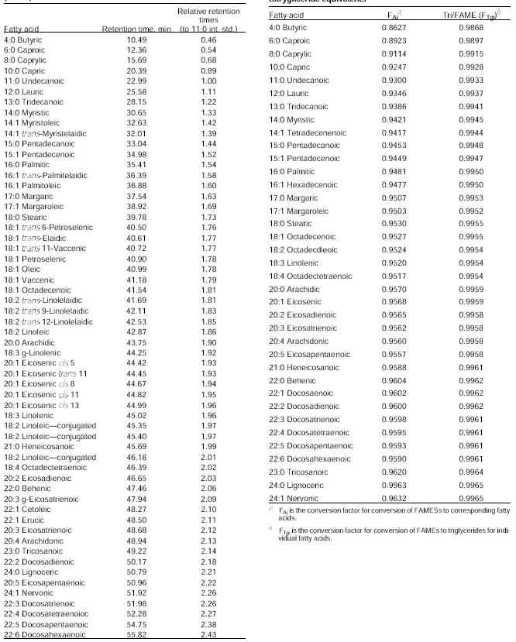

List of Publications:

1. Chakraborty, S., Brahma, B.K., and Goyal, A.K. (2015). Proximate Composition of Three Small Indegenous Fish Species Encountered In The Local Fish Market of Kokrajhar, BTAD, Assam. Indian Journal of Applied Research, 5(10): 712-714

2. Chakraborty, S., Brahma, B.K., and Goyal, A.K. (2016). Ichthyofaunal Diversity of Various Water Bodies of Kokrajhar Ditrict, BTAD, Assam. International Journal of Fundamental and Applied Sciences. 5(1): 9-16

3. Chakraborty, S., Kausor, M.A., Goyal, A.K., Basumatary, A.K. and Brahma, B.K. (2017) Studies on PhysicoChemical Parameters of Fish Inhabiting Four Water Bodies In the Vicinity of Kokrajhar, BTAD, Assam. International Journal of Applied Chemistry. 13(3) 409-420

